World Generator Documentation

Noise Config

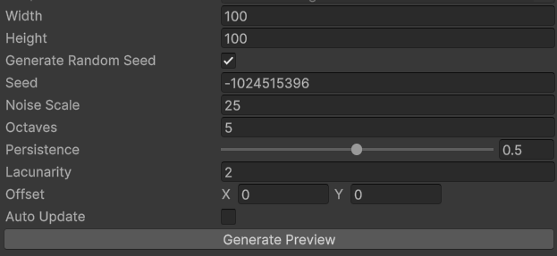

Width – width of the generated noise. Width is equal to the number of columns of the tiles on the tilemap.

Height – height of the generated noise. Height is equal to the number of rows of the tiles on the tilemap.

Generate Random Seed – if enabled the seed will be random every generation of the world. If disabled, the generator will use the seed defined in the config.

Seed – a number used to initialize a pseudorandom number generator.

Noise scale – scaling of the Perlin noise. Used to zoom in/out.

Octaves – number of Perlin noises that are added together to create a noise with more detail. The larger the value the more detailed the world will be. Note: more octaves increase the generation time.

Persistence – A multiplier that determines how quickly the amplitudes diminish for each successive octave in a Perlin-noise function. Increasing the persistence produces "rougher" world generation.

Lacunarity - A multiplier that determines how quickly the frequency increases for each successive octave in a Perlin noise function. The smaller the values the smoother the world generation.

Offset – offset of the Perlin noise.

Auto Update – If enabled, Perlin noise preview image will update automatically if any of the values described above change.

Generate Preview – generates Perlin-noise preview.

World Region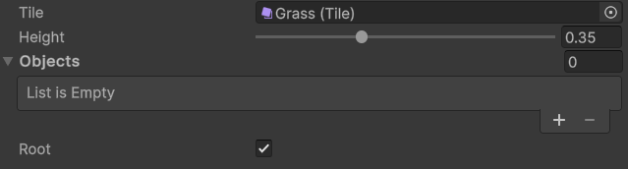

Tile – tile that represents this region. (TODO: multiple tiles for single region)

Height – height at which the region can appear on the height map. (Height map is generated using Perlin-noise, see above.)

Objects – list of “World Object”(s) (see below). World objects are randomly distributed in the region. E.g. trees, stones, resources, etc.

Root – If enabled, this region can be used to spawn a player.

World Object

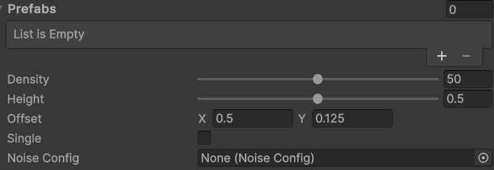

Prefabs – list of possible variations of one world object. E.g. trees of different types, stones of different types, etc.

Density – density of the objects in the possible generation area (PGA) (see below).

Height – height at which the world object can appear on the height map. This defines the PGA for the world object. The height map is generated according to the noise config (see below).

Offset – offset of the world object’s Prefab, starting from the center of the selected tile.

Single – if toggled, only one instance of that object can be generated.

Noise config – config of the Perlin noise, used to generate the height map for the PGA.

© 2025 Denis Cooper. All rights reserved.