Binary Classification:
Logistic Regression
xxx
nx = the length of input features ( also called n )
m = number of training/testing examples (also called mtrain or mtest)

x = one training example (which has nx input features)
X = all training examples in a row (X has m columns and nx rows)
X.shape = (nx,m)

y = one output value
Y = al training examples in a row (Y has m columns and 1 row)
Y.shape = (1,m)

- Logistical regression model and chart:
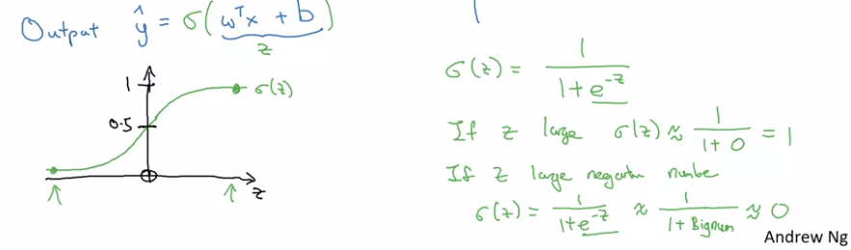

- Logistical regression loss function

- Logistical regression cost function

