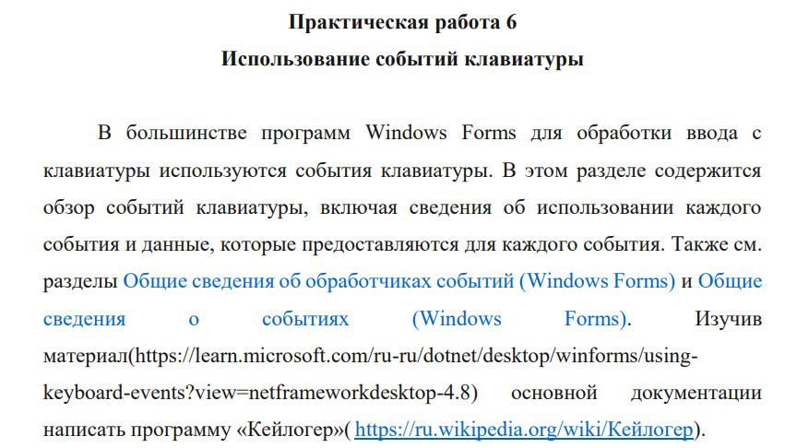

Листинг -1

public Form1()

{

InitializeComponent();

}

private void Form1_KeyDown(object sender, KeyEventArgs e)

{

label1.Text = "Down";

}

private async void Form1_KeyPress(object sender, KeyPressEventArgs e)

{

label3.Text = "Press";

label2.Text += e.KeyChar.ToString();

using (StreamWriter writer = new StreamWriter(@"C:\Users\Lenovo\Desktop\Практические 3 курс 2 полугодие\1.txt", true))

{

if (label2.Text.Length == 10)

{

await writer.WriteLineAsync(label2.Text);

}

}

}

private void Form1_KeyUp(object sender, KeyEventArgs e)

{

label3.Text = "Up";

}

private void Form1_Load(object sender, EventArgs e)

{

}

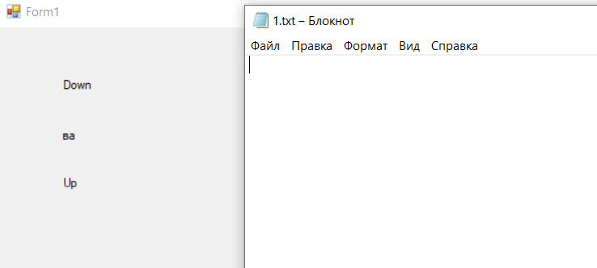

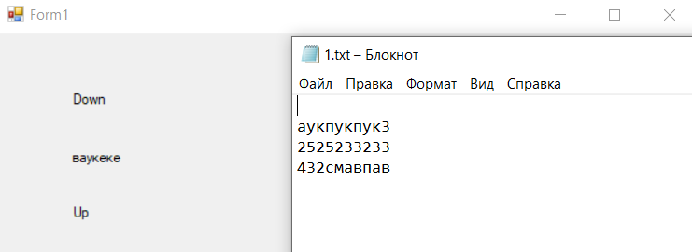

Ссылка на гитхаб:

<https://github.com/Alexandrov911/PR6Sistem.git>