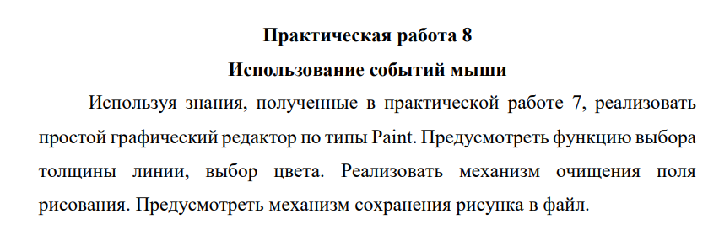

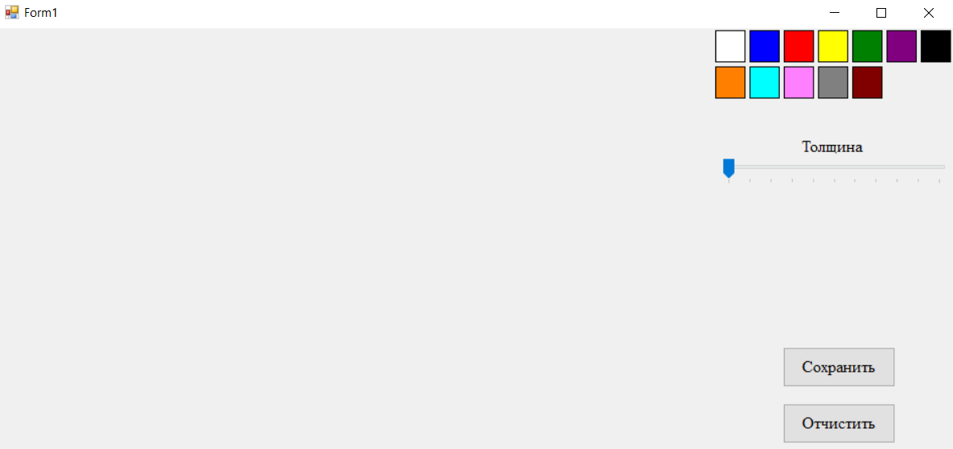

Рисунок -1 Интерфейс программы

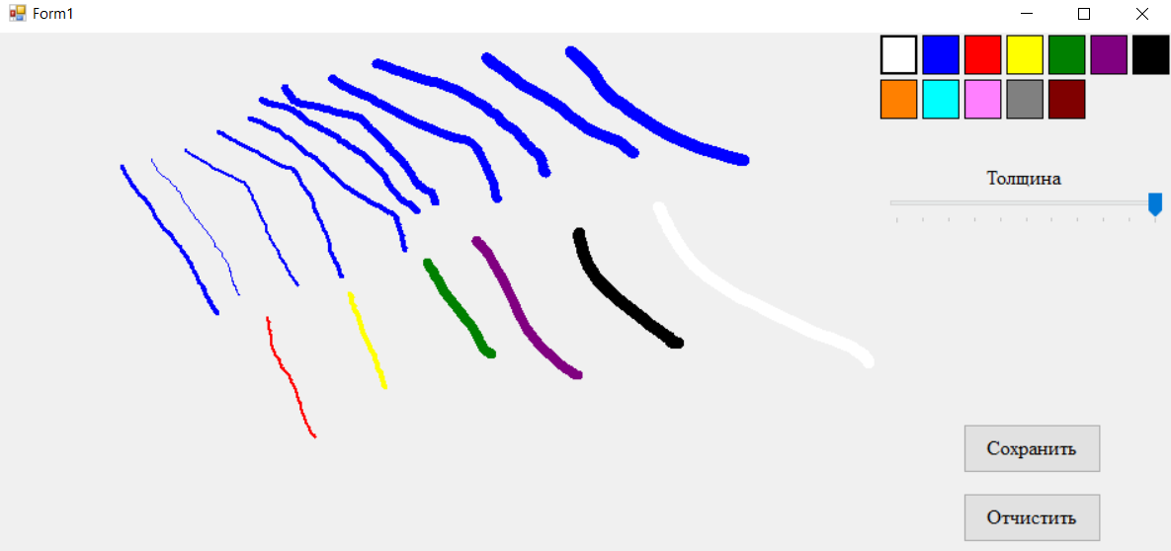

Рисунок -2 Механизм рисования, выбора цвета, выбора толщины

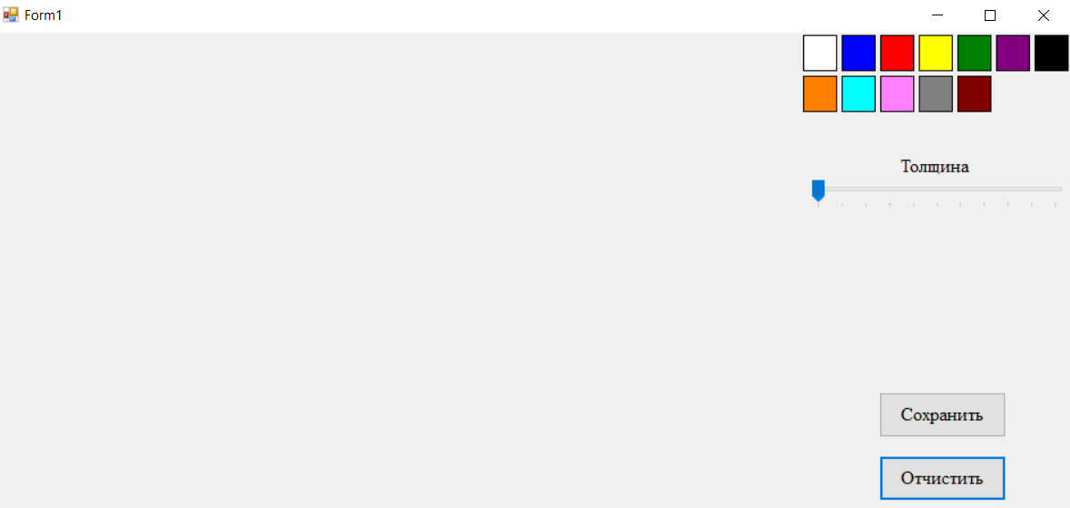

Рисунок -3 Механизм удаления поля рисования

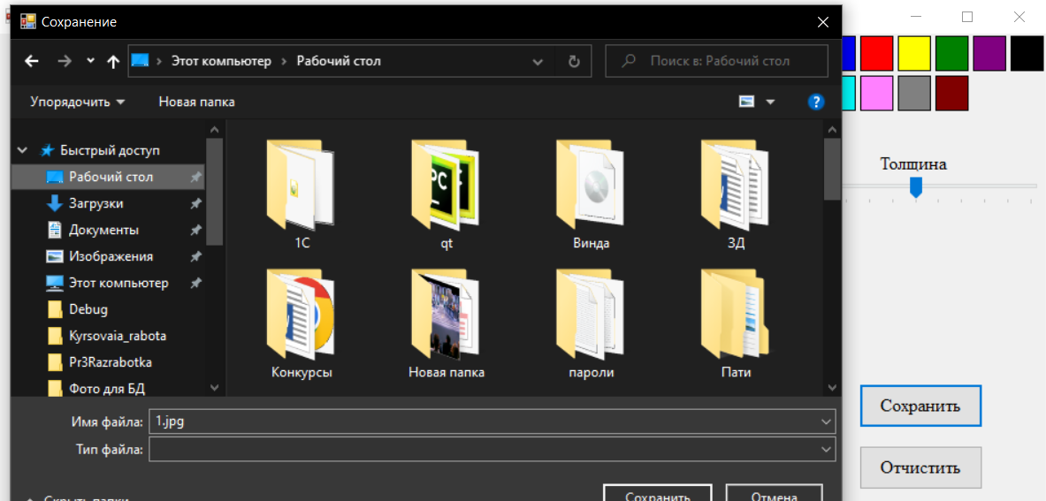

Рисунок -4 Сохранение рисунка

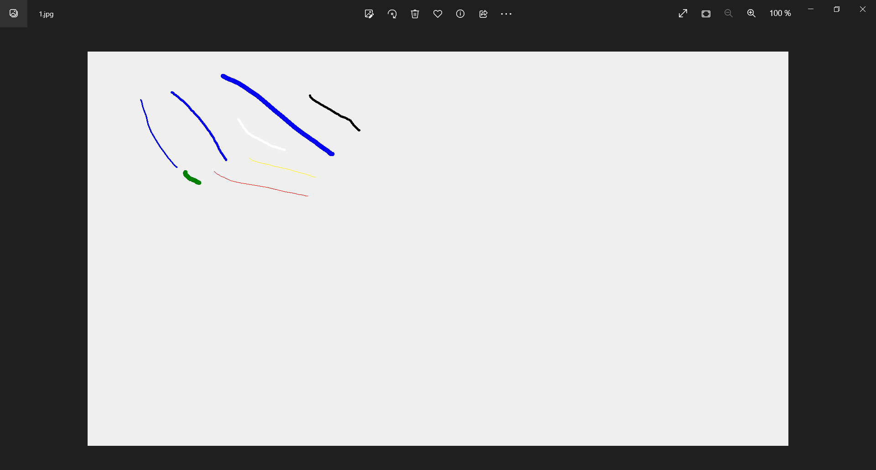

Рисунок -5 Результат сохранения рисунка

Листинг 1

public Form1()

{

InitializeComponent();

SetSize();

}

private class ArrayPoints

{

private int index = 0;

private Point[] points;

public ArrayPoints(int size)

{

if (size <= 0)

{

size = 2;

}

points = new Point[size];

}

public void SetPoint(int x, int y)

{

if (index >= points.Length)

{

index = 0;

}

points[index] = new Point(x, y);

index++;

}

public void ResetPoints()

{

index = 0;

}

public int GetCountPoints()

{

return index;

}

public Point[] GetPoints()

{

return points;

}

}

private bool isMouse = false;

private ArrayPoints arrayPoints = new ArrayPoints(2);

Bitmap map = new Bitmap(100, 100);

Graphics graphics;

Pen pen = new Pen(Color.Black, 3f);

private void SetSize()

{

Rectangle rectangle = Screen.PrimaryScreen.Bounds;

map = new Bitmap(rectangle.Width, rectangle.Height);

graphics = Graphics.FromImage(map);

pen.StartCap = System.Drawing.Drawing2D.LineCap.Round;

pen.EndCap = System.Drawing.Drawing2D.LineCap.Round;

}

private void pictureBox1_MouseDown(object sender, MouseEventArgs e)

{

isMouse = true;

}

private void pictureBox1_MouseUp(object sender, MouseEventArgs e)

{

isMouse = false;

arrayPoints.ResetPoints();

}

private void pictureBox1_MouseLeave(object sender, EventArgs e)

{

}

private void pictureBox1_MouseMove(object sender, MouseEventArgs e)

{

if (!isMouse)

{

return;

}

arrayPoints.SetPoint(e.X, e.Y);

if (arrayPoints.GetCountPoints() >= 2)

{

graphics.DrawLines(pen,arrayPoints.GetPoints());

pictureBox1.Image = map;

arrayPoints.SetPoint(e.X, e.Y);

}

}

private void button3_Click(object sender, EventArgs e)

{

pen.Color = ((Button)sender).BackColor;

}

private void button4_Click(object sender, EventArgs e)

{

pen.Color = ((Button)sender).BackColor;

}

private void button5_Click(object sender, EventArgs e)

{

pen.Color = ((Button)sender).BackColor;

}

private void button6_Click(object sender, EventArgs e)

{

pen.Color = ((Button)sender).BackColor;

}

private void button7_Click(object sender, EventArgs e)

{

pen.Color = ((Button)sender).BackColor;

}

private void button8_Click(object sender, EventArgs e)

{

pen.Color = ((Button)sender).BackColor;

}

private void button9_Click(object sender, EventArgs e)

{

pen.Color = ((Button)sender).BackColor;

}

private void button10_Click(object sender, EventArgs e)

{

pen.Color = ((Button)sender).BackColor;

}

private void button11_Click(object sender, EventArgs e)

{

pen.Color = ((Button)sender).BackColor;

}

private void button12_Click(object sender, EventArgs e)

{

pen.Color = ((Button)sender).BackColor;

}

private void button13_Click(object sender, EventArgs e)

{

pen.Color = ((Button)sender).BackColor;

}

private void button14_Click(object sender, EventArgs e)

{

pen.Color = ((Button)sender).BackColor;

}

private void button2_Click(object sender, EventArgs e)

{

graphics.Clear(pictureBox1.BackColor);

pictureBox1.Image = map;

}

private void trackBar1_ValueChanged(object sender, EventArgs e)

{

pen.Width = trackBar1.Value;

}

private void button1_Click(object sender, EventArgs e)

{

if (saveFileDialog1.ShowDialog() == DialogResult.OK)

{

pictureBox1.Image.Save(saveFileDialog1.FileName);

}

}

Ссылка на гитхаб:

<https://github.com/Alexandrov911/Pr8Sistem.git>