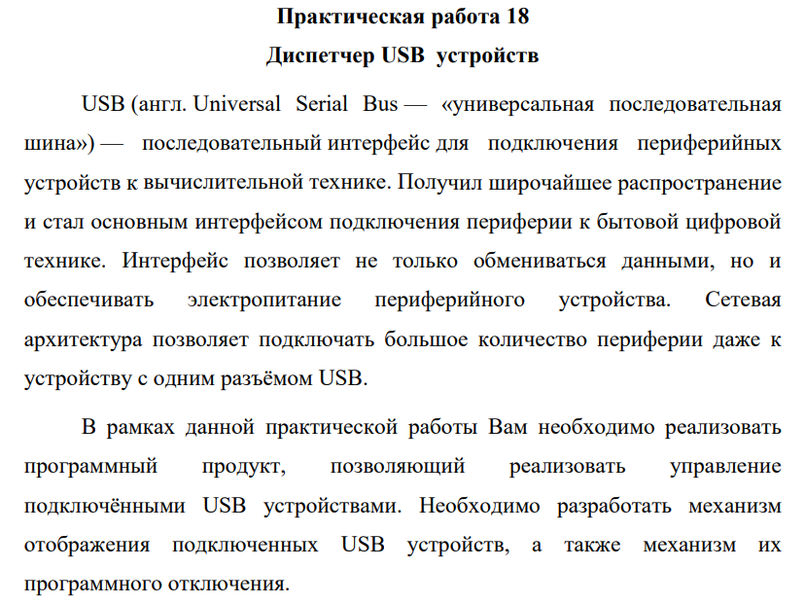

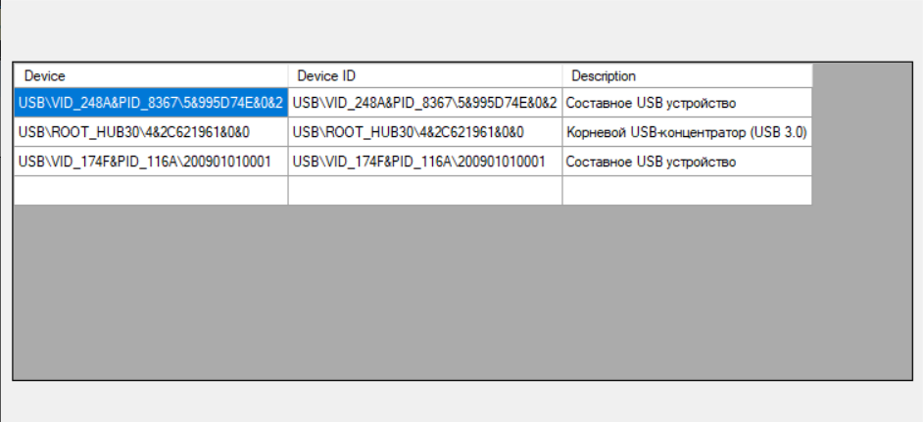

Рисунок 1 – Интерфейс программы

Листинг:

dataGridView1.RowHeadersVisible = false;

dataGridView1.ColumnCount = 3;

dataGridView1.Columns[0].Name = "Device";

dataGridView1.Columns[1].Name = "Device ID";

dataGridView1.Columns[2].Name = "Description";

dataGridView1.AutoSizeColumnsMode = DataGridViewAutoSizeColumnsMode.AllCells;

ManagementObjectSearcher device_searcher = new ManagementObjectSearcher("SELECT * FROM Win32_USBHub");

foreach (ManagementObject usb_device in device_searcher.Get())

{

var device = usb_device.Properties["DeviceID"].Value.ToString();

var deviceID = usb_device.Properties["PNPDeviceID"].Value.ToString();

var desc = usb_device.Properties["Description"].Value.ToString();

dataGridView1.Rows.Add(device, deviceID, desc);

}

Ссылка на гитхаб:

<https://github.com/Alexandrov911/PR18siTEm.git>