Totsy Mobile Store View

\*\*Modification made on April 27, 2012

For getting rid of the caching problem in mobile site we decide to re-construct the mobile structure. We setup a new store view called ‘mobile’ which base on totsy’s default store view but using different template and layout ( also skin ) . We also made changes in Mage.php to detect the user agent and switch customer to correct store view base on the user agent they are using.

Same as setting up of Mamasource store view, setup mobile store view can follow the steps below:

1. Go to admin panel, System->Manage Stores
2. Click Create Store View type following information

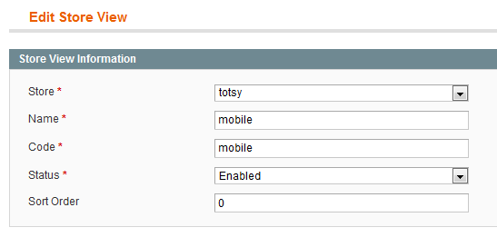

1. Save Store View
2. Go to System -> Configuration, then click ‘Design’ on the left list
3. Switch Store to ‘mobile’ and fill in the following setup to the left form

Set up templates, skin, layout and default themes to iphone, which is a theme you can find under

design/frontend/enterprise/

and

skin/frontend/enterprise/

