PTK - ZAP Integration Stability Plan
Close Readiness v2, Lifecycle Contracts, and Chrome/Edge Stabilization
Prepared for OWASP PTK / ZAP add-on integration discussions - 28 May 2026

Executive summary
The main instability is not just Chrome/Edge browser behavior. The deeper issue is that ZAP Client Spider browser-task lifecycle and PTK engine/publisher lifecycle are currently coupled too tightly. User-editable plan settings such as pageLoadTime and shutdownTime can reduce races, but they cannot prove that PTK engines are still making progress, that findings have been flushed, or that Java has imported those findings as ZAP alerts. The fix should be an explicit close-readiness contract: ZAP asks PTK whether a browser may close; PTK reports progress and activity; ZAP waits while activity changes; ZAP requests graceful stop/drain when activity stalls; and ZAP only closes cleanly after terminal progress plus publisher-drained evidence. A hard timeout remains, but it should produce a forced/incomplete lifecycle result rather than pretending the run was clean.
Immediate conclusion | Action
Do not rely on plan timeouts as the stability contract. | Move the wait/close policy into the PTK ZAP add-on and base it on PTK activity/progress evidence.
Local browser/tab close is not global PTK session close. | Split browser task state from PTK session state; never clear global zapid/session state for browser_tab_safe_to_close.
Findings must be flushed and acknowledged before clean close. | Upgrade /ptk/alert from batch-level success to per-finding accepted/rejected acknowledgement.
WebSocket can help later, but is not first. | First fix the existing callback/progress contract and small source bugs; then consider WebSocket for background control.

Contents
1. Sources and assumptions
2. Current source-level findings
3. Why plan timeouts are the wrong stability mechanism
4. Communication and lifecycle model
5. Close Readiness v2 contract
6. Progress/activity payload design
7. Finding flush and import acknowledgement
8. Implementation plan
9. Testing plan
10. Release gates
11. Codex discussion alignment
12. Recommended next actions

1. Sources and assumptions
This document is based on the latest uploaded src.zip, the shared Codex discussion text, and the official ZAP documentation for browser-extension integration and Client Spider behavior.
Source | Relevant points used in this plan
ZAP Browser Extension Integration documentation | Add-ons can wrap browser extensions under src/main/zapHomeFiles/selenium; Chrome/Edge extensions must be unpacked; supported communication uses the Client add-on callback mechanism; direct ZAP API calls from a browser extension are unsupported; WebSockets are recommended if the add-on needs to send data back to the extension.
ZAP Client Spider documentation | Client Spider uses browser windows in parallel, supports page-load and shutdown timing controls, and shuts down after no new events are seen for shutdownTime. These are crawl/task controls, not PTK engine-drain guarantees.
Uploaded src.zip | Current code findings were checked against ExtensionPtk.java, zapBridge.js, zapTransport.js, and PtkAlertHandler.java.
Shared Codex discussion | Confirms the proposed split between ZAP/PTK session state and browser task/tab state, and recommends fixing concrete P0/P1 bugs before introducing WebSocket or a production ptk-wait job.

2. Current source-level findings
The latest uploaded source still contains several small but high-impact contract issues. These are not theoretical; they are visible in the code paths that run during browser launch, progress reporting, alert import, and browser close.
Priority | Finding | Evidence in latest upload | Impact | Recommended fix
P0 | Edge extension registration is incomplete. | ExtensionPtk.java defines PTK_CHROMIUM_BROWSERS as Chrome + Edge at lines 293-294, and configures browser arguments for both, but ensurePtkSeleniumExtensionsConfigured registers the unpacked PTK extension only for Browser.CHROME and Browser.FIREFOX at lines 473-474. | Edge may receive PTK-related browser arguments while the actual PTK extension is not explicitly registered for Selenium-owned Edge. This can produce Chrome/Edge asymmetry and false stability conclusions from profile leftovers. | Register the unpacked PTK extension for Browser.EDGE as well as Browser.CHROME. Add a regression test that Selenium options contain PTK entries for Chrome, Edge, and Firefox.
P0 | browser_tab_safe_to_close still clears global zapid/session state. | The branch at ExtensionPtk.java lines 2909-2940 logs browser_tab_safe_to_close and then calls clearTrackingState(zapid). clearTrackingState at lines 1428-1445 remembers the zapid as closed and removes scanProgress, scanStatus, sessionIdByZapId, targetUrlByZapId, etc. | A local/non-owner tab close can erase the global PTK session, causing later progress to be ignored and making owner-tab close look invalid or incomplete. | Replace clearTrackingState(zapid) in the browser_tab_safe_to_close branch with recordBrowserLocalCloseOnly(...). Do not add the zapid to closedZapIds and do not remove session/progress maps.
P1 | postTerminalProgressForClose uses isReady(), but transport exposes isActive(). | zapBridge.js calls this.transport.isReady?.() around line 794; zapTransport.js exposes isActive() around line 633. Optional chaining returns undefined, so the close fallback can report zap_progress_not_ready. | Terminal fallback progress during browser close can fail silently or be skipped, weakening the clean-close contract. | Add zapTransport.isReady() as an alias for isActive(), and update zapBridge.js to use isActive() directly where possible.
P1 | tabId === 0 is rejected. | zapBridge.js sets safeTabId at line 2190 and then checks if (!safeTabId || !targetUrl) at line 2191. | Low-probability correctness bug. A valid tab ID of 0 would be treated as missing. | Use safeTabId === null || safeTabId < 0 || !targetUrl.
P1 | /ptk/alert acknowledgement is too coarse. | ExtensionPtk.java returns only result=OK and alertsRaised at lines 2465-2468. The browser-side publisher cannot know which finding IDs were accepted, skipped, or rejected. | The publisher may mark findings as published after an HTTP success even if Java skipped them because of mapping, invalid URL, or missing SiteTree/history match. | Return per-finding accepted/rejected IDs and reason counts. Mark findings published only after accepted/rejected acknowledgement.
P1 | Close waiting is still static-budget based. | Current close loop waits while !isSafeToClose(zapid), sleeps one second, follows up every 15 attempts, and forces after max attempts or budget exhaustion around lines 2952-3004. | The logic does not use meaningful progress/activity deltas as the primary reason to keep waiting or to request stop/drain. | Replace fixed waiting with adaptive activity-based waiting: keep waiting while activity changes, stop/drain when activity is stale, force only after hard timeout plus final drain attempt.

3. Why plan timeouts are the wrong stability mechanism
ZAP Client Spider timing parameters are crawl controls. They do not represent PTK engine work or finding import state. Increasing shutdownTime or pageLoadTime can reduce one class of races, but users can change those values and they still cannot prove that PTK is done.
Plan/control knob | What it controls | Why it is insufficient for PTK stability
pageLoadTime | How long the Client Spider waits after loading a page. | Does not prove DAST/IAST/SAST engines completed or that the publisher drained findings.
shutdownTime | Quiet period after the last Client Spider action before the spider shuts down. | Helps late client-map events arrive, but does not prove PTK engine queues are empty or terminal.
numberOfBrowsers | Parallel browser windows / maximum concurrency. | Not a guarantee that exactly N PTK sessions will launch; depends on runnable tasks and discoveries.
maximumDuration | Client Spider run cap. | Bounds the crawl, but cannot differentiate a clean PTK terminal state from a forced browser close.

Therefore the stability mechanism must live in the integration contract: ZAP should wait based on PTK activity/progress, request graceful stop/drain when activity becomes stale, and only accept clean close after terminal progress plus publisher-drained evidence.

4. Communication and lifecycle model
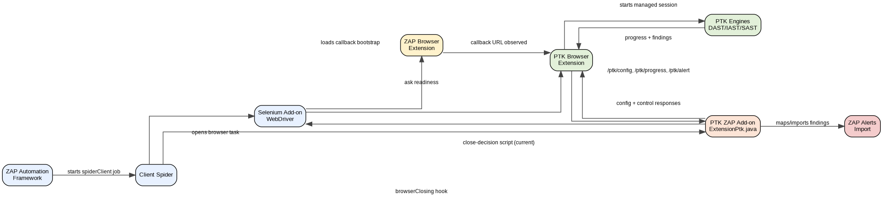
Figure 1. Current PTK - ZAP communication model.

4.1 Endpoint contract
Endpoint | Direction | Current purpose | v2 contract requirement
/ptk/config | PTK extension -> ZAP add-on | Fetch mode, rulepacks, optional ZAP history seeds. | Return contractVersion, zapid, browserid, configVersion, modulePackVersion, zapHistorySeedVersion, target scope, and close policy defaults.
/ptk/progress | PTK extension -> ZAP add-on | Callback/ready/running/terminal progress. | Report phase, sessionId, ownerTabId, targetUrl, activitySeq/fingerprint, closeReadiness, engine telemetry, and publisher drain state. Java may return control commands such as graceful_stop_and_drain.
/ptk/alert | PTK extension -> ZAP add-on | Post mapped findings in batches. | Return accepted/rejected IDs and skipped reason counts; browser publisher only resolves findings after acknowledgement.
/ptk/ping | PTK extension -> ZAP add-on | Reserved/debug. | Make it a real health endpoint returning contractVersion, addonVersion, zapid state, session state, and last progress timestamp.

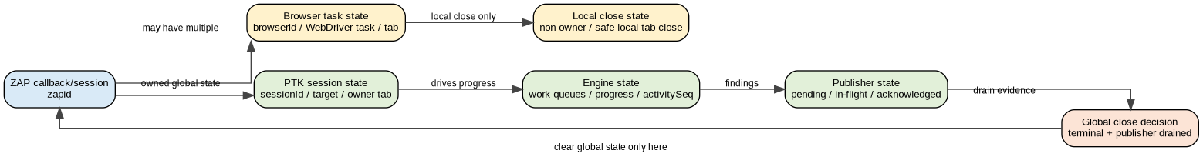
Figure 2. Required split between browser task state and global PTK session state.

4.2 Core invariant
A ZAP browser close request is not a PTK stop request.

ZAP may close a local/non-owner tab without ending PTK.
ZAP may close the owner tab cleanly only after PTK terminal progress and publisher-drained evidence.
ZAP may force close only after a hard timeout and a final drain attempt, and the run must be marked forced/incomplete.

5. Close Readiness v2 contract
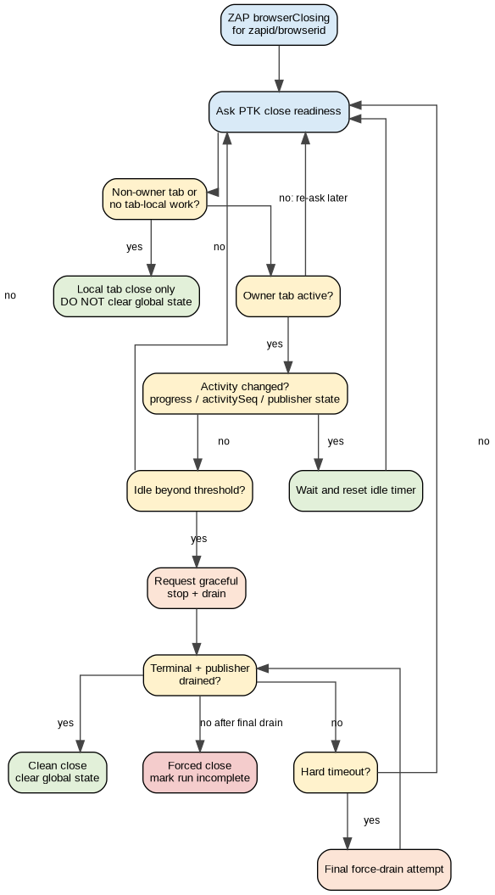
Figure 3. Adaptive Close Readiness v2 flow.

5.1 The desired conversation
ZAP: I need to close this browser/task.
PTK: This is the owner tab; still working; progress=30; activitySeq=42; publisher.drained=false.
ZAP: Activity changed, so I will wait and ask again.
PTK: Still working; progress=35; activitySeq=48; publisher.pendingFindings=2.
ZAP: Activity changed again, so I will keep waiting.
PTK: No new activity for the idle threshold.
ZAP: Please stop gracefully and drain findings.
PTK: Engines stopped; publisher flushed; terminal progress posted; safeToClose=true.
ZAP: Clean close accepted.

5.2 Adaptive close policy
Policy value | Suggested default | Reason
closeAskIntervalMs | 15 seconds | Matches the existing follow-up cadence and avoids excessive WebDriver calls.
activeProgressIdleMs | 60 seconds | If meaningful PTK activity changed within this window, keep waiting. If not, request graceful stop/drain.
noProgressStartupGraceMs | 25 seconds | Allows callback/config/session startup when browser close arrives early in multi-browser runs.
gracefulStopDrainMs | 30 seconds | After Java requests stop/drain, allow pending findings to flush and terminal progress to post.
hardCloseMaxMs | 5-7 minutes | Absolute cap so browsers cannot hang indefinitely. Forced close must be recorded as incomplete.
lastChanceDrainMs | 10-15 seconds | Final best-effort flush before forced close.

Decision rule:
- Meaningful activity changed -> wait and reset idle timer.
- No meaningful activity for activeProgressIdleMs -> request graceful stop + drain.
- Terminal progress + publisher.drained=true -> clean close.
- Hard timeout reached -> request final drain, then force close and mark lifecycle failure/warning.

6. Progress/activity payload design
Progress percentage alone is not enough. DAST can continue working while the percentage is flat because total planned work can grow when new URLs or request candidates are discovered. The extension should include a monotonic activity sequence or activity fingerprint that changes when engines, queues, findings, or publisher state change.

6.1 Recommended /ptk/progress payload
{
"contractVersion": 2,
"zapid": "zap-uuid",
"browserid": "edge-headless",
"sessionId": "ptk-session-id",
"ownerTabId": 123,
"targetUrl": "http://target/",
"phase": "running",
"status": "running",
"progress": 35,
"activitySeq": 42,
"activityFingerprint": "hash-of-engine-and-publisher-state",
"lastActivityAt": 1780000000000,
"closeReadiness": {
"scope": "global_session",
"ownerTab": true,
"activeBrowserWork": true,
"safeToClose": false,
"reason": "active_work"
},
"publisher": {
"pendingFindings": 4,
"inFlightBatches": 0,
"lastBatchSeq": 10,
"lastAckSeq": 9,
"drained": false
},
"engines": {
"DAST": {
"status": "running",
"progress": 31,
"telemetry": {
"activeTasks": 1,
"requestQueue": 5,
"pendingPlans": 2,
"executed": 120,
"planned": 300,
"findingsCount": 3
}
}
}
}

6.2 What counts as meaningful activity?
Signal | Meaning
activitySeq increased | Strongest signal that PTK itself observed meaningful work.
activityFingerprint changed | Fallback signal when counters or publisher state changed.
progress increased or phase/status changed | Human-readable progress moved forward.
engine queue/task counters changed | PTK still has active engine work even if percent stayed flat.
findings count changed | New results were produced and may still need publishing.
publisher pending/in-flight/ack state changed | The finding drain is still moving.
lastActivityAt increased | PTK explicitly reported recent work.

7. Finding flush and import acknowledgement
The browser publisher cannot treat HTTP success as finding import success. Java may accept a batch but skip individual findings because of invalid URLs, missing mapping, missing SiteTree match, or alert construction failure. The close contract should only treat the publisher as drained when all exportable findings are accepted or known-rejected with a reason.

7.1 Recommended /ptk/alert response
{
"result": "OK",
"batchId": "DAST-12",
"received": 37,
"accepted": 30,
"alertsRaised": 30,
"skipped": {
"missingMapping": 2,
"missingSiteTreeMatch": 4,
"invalidUrl": 1
},
"acceptedFindingIds": ["a", "b", "c"],
"rejectedFindingIds": [
{ "id": "x", "reason": "missingSiteTreeMatch" }
]
}
Java response for finding | Publisher state
accepted/imported | Mark as published/imported.
rejected with reason | Mark as known rejected; do not retry forever; expose reason in diagnostics.
missing from response | Keep pending; retry or fail the drain.
HTTP/network failure | Keep pending; retry before terminal close.

Publisher drain should be true only when pending mapped findings = 0, in-flight batches = 0, unacknowledged findings = 0, and two stable drain passes have completed.

8. Implementation plan
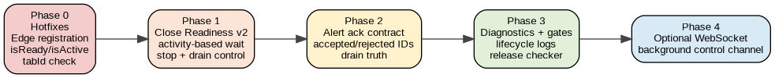
Figure 4. Recommended implementation sequence.
Phase | Scope | Changes | Why this order
Phase 0 - hotfixes | Small ZAP + extension correctness fixes | Register PTK for Edge; stop clearing global state on browser_tab_safe_to_close; add zapTransport.isReady() alias / use isActive(); fix tabId check. | These are concrete bugs with high instability impact and low architectural risk.
Phase 1 - Close Readiness v2 | Existing callback/progress channel | Add PtkZapSessionState; add activitySeq/fingerprint and publisher fields; implement adaptive close loop; return closeRequested control from /ptk/progress; require terminal + publisher.drained for clean close. | Removes dependence on user-editable plan timeouts without introducing a new channel.
Phase 2 - Alert acknowledgement | ZAP and browser publisher contract | Replace alertsRaised-only response with accepted/rejected IDs and skipped reason counts; mark publisher drained only after acknowledgement. | Makes finding drain truthful and explains mismatches.
Phase 3 - Diagnostics and gates | Logs, checker, release matrix | Add PTK_CONTRACT logs; update release checker to assert lifecycle phases; warn on lower-than-max fan-out but fail on forced close/invalid session/missing expected findings. | Makes unstable boundaries visible and reproducible.
Phase 4 - Optional WebSocket | Long-term control channel | Move ZAP -> PTK close/control commands from WebDriver page JS to extension background WebSocket. | Useful after the contract is stable; avoids page unload/MV3/content-script timing fragility.

8.1 Phase 0 details
// ExtensionPtk.java: register PTK extension for Edge too
changed |= ensureBrowserExtension(extensions, chromiumPath, Browser.CHROME, "Chromium");
changed |= ensureBrowserExtension(extensions, chromiumPath, Browser.EDGE, "Edge");
changed |= ensureBrowserExtension(extensions, xpiPath, Browser.FIREFOX, "Firefox");

// browser_tab_safe_to_close branch
recordBrowserLocalCloseOnly(zapid, browserid, closeDecision);
return; // do not call clearTrackingState(zapid)

// zapTransport.js
isReady() {
return this.isActive();
}

// zapBridge.js
if (!sessionId || !effectiveZapId || !this.transport.isActive?.()) {
return { ok: false, posted: false, reason: 'zap_progress_not_ready' };
}

// zapBridge.js tab check
if (safeTabId === null || safeTabId < 0 || !targetUrl) {
return;
}

8.2 Phase 1 Java close loop pseudo-code
onBrowserClosing(zapid, browserid):
state = sessionState(zapid)
hardDeadline = now + hardCloseMaxMs

decision = askPtkCloseDecision()

if decision == LOCAL_TAB_SAFE:
recordBrowserLocalCloseOnly(zapid, browserid)
return cleanLocalClose

while now < hardDeadline:
snapshot = state.latestProgressSnapshot()

if snapshot.terminal && snapshot.publisherDrained && snapshot.safeToCloseAfterCloseRequest:
clearGlobalSessionState(zapid)
return cleanGlobalClose

if snapshot.meaningfulActivityChanged():
state.lastMeaningfulActivityAt = now
sleep(1 second)
continue

if now - state.lastMeaningfulActivityAt < activeProgressIdleMs:
if shouldAskAgain(closeAskIntervalMs):
decision = askPtkCloseDecision()
sleep(1 second)
continue

if !state.stopRequested:
requestGracefulStopAndDrain(zapid)
state.stopRequestedAt = now

if now - state.stopRequestedAt < gracefulStopDrainMs:
sleep(1 second)
continue

break

requestFinalForceDrain(zapid)
wait(lastChanceDrainMs)

if latestSnapshot.terminal && latestSnapshot.publisherDrained:
clearGlobalSessionState(zapid)
return cleanGlobalClose

markForcedClose(zapid)
clearGlobalSessionState(zapid)
return forcedClose

9. Testing plan

9.1 Unit tests
Area | Test
Selenium extension registration | After configuration, Chrome, Edge, and Firefox extension entries exist. Edge must not rely only on Chromium browser arguments.
Local tab close | Seed progress/session maps, process browser_tab_safe_to_close, assert global state is still present and zapid was not added to closedZapIds.
Late progress | After local tab close, send /ptk/progress for same zapid; assert progress updates are accepted.
Global safe close | Only terminal progress + publisher.drained + safeToClose after close request clears global state.
postTerminalProgressForClose | Verify transport isActive/isReady mismatch is fixed and terminal fallback can post.
tab ID | Verify tabId=0 does not fail due to falsy check.
Alert import result | Verify accepted/skipped/rejected reason counts for missing mapping, invalid URL, missing SiteTree match, and success.

9.2 Integration matrix
Browser | Mode | numberOfBrowsers | Must prove
Chrome | headed | 1 | Baseline callback/config/session/progress/alert/clean-close path.
Chrome | headless | 1 | Headless path stable.
Chrome | headless | 5 | No forced close; lower worker fan-out is warning only if sessions/findings are healthy.
Edge | headed | 1 | PTK extension explicitly registered and visible; callback/config/session established.
Edge | headless | 1 | Same as headed, with no profile-leftover dependency.
Edge | headless | 5 | Primary regression gate for Chrome/Edge timing.
Firefox | headless | 1 | Comparison baseline.
Firefox | headless | 5 | Multi-worker comparison baseline.

10. Release gates
Gate | Required? | Interpretation
browser_launched | Yes | At least one ZAP-owned browser worker loaded the target.
callback_detected | Yes | PTK saw the ZAP callback URL and activated transport.
config_served + config_applied | Yes | ZAP-controlled rulepacks/config were applied. Fallback mode should be explicit and usually fail release runs.
session_started with sessionId | Yes | Callback progress alone is not a PTK scan.
progress_update with activity evidence | Yes | Proves engines/publisher are alive or gives a clear idle reason.
alert_batch_imported or rejected with reason | Yes when findings expected | Differentiates engine coverage, import mapping, and SiteTree matching failures.
publisher_drained | Yes | Proves findings were flushed or explicitly rejected.
terminal_posted | Yes | PTK reached terminal state.
clean_close | Yes | Terminal + publisher drained accepted by Java.
forced_close | Must be absent | Run should fail or warn as incomplete; do not treat as clean.
exact browser worker count equals numberOfBrowsers | No | Warn only. numberOfBrowsers is concurrency capacity, not a promise that exactly N windows launch.

11. Codex discussion alignment
The shared Codex discussion agrees with the main direction: first fix the concrete P0/P1 bugs, split ZAP/PTK session state from browser task/tab state, and avoid jumping straight to WebSocket or a production ptk-wait job before the existing contract is correct.
Codex discussion point | Position in this plan
Edge extension registration incomplete | Confirmed in latest source and included as Phase 0.
browser_tab_safe_to_close clears global state | Confirmed in latest source and treated as the highest-impact lifecycle bug.
isReady/isActive mismatch | Confirmed and included as small extension hotfix.
tabId check wrong | Confirmed and included as small extension hotfix.
Alert acknowledgement too coarse | Included as Phase 2 contract change.
Do not jump straight to WebSocket | Agreed. WebSocket is Phase 4 optional after contract stabilization.
Do not add production ptk-wait casually | Agreed. Start with release/test tooling and diagnostics; promote only if maintainers accept the contract.
Close readiness must not trust browser state alone | Agreed. Java must combine browser decision with terminal progress, publisher state, import ack, and timeout policy.

12. Recommended next actions
Order | Action | Owner | Acceptance check
1 | Patch Edge extension registration. | ZAP add-on | Selenium options show PTK extension configured for Chrome, Edge, and Firefox.
2 | Patch browser_tab_safe_to_close to local-close only. | ZAP add-on | Local close branch does not call clearTrackingState and does not remember zapid as recently closed.
3 | Patch isReady/isActive and tabId checks. | PTK extension | Terminal close fallback can post progress; tabId=0 check no longer uses falsy logic.
4 | Add structured PTK_CONTRACT logs. | Both | Logs show callback_detected, config_applied, session_started, progress_update, close_requested, publisher_drained, terminal_posted, clean_close/forced_close.
5 | Implement Close Readiness v2 payload and adaptive close loop. | Both | Changing activity resets wait; stale activity requests graceful stop/drain; clean close requires terminal + publisher.drained.
6 | Upgrade /ptk/alert ack. | Both | Publisher marks findings resolved only after accepted/rejected ID acknowledgement.
7 | Upgrade release checker. | Test tooling | Fails forced close/invalid session; warns on lower fan-out; explains missing findings by engine/import/rejection reason.

Final target contract
A ZAP browser close request is not a PTK stop request.

When ZAP needs to close a browser:
1. ZAP asks PTK for close readiness.
2. PTK reports owner/non-owner scope, activity, progress, and publisher state.
3. ZAP waits while PTK activity changes.
4. If activity stalls, ZAP requests graceful stop and drain.
5. PTK flushes findings and posts terminal progress.
6. ZAP cleanly closes only after terminal + publisher drained.
7. If hard timeout is reached, ZAP makes one final drain request, then forces close and records forced_close.

