PTK - ZAP Lifecycle Contract and Stability Analysis
Communication contracts, automation instability root causes, and stabilization plan
Prepared from the uploaded ZAP_PTK source archive and the current PTK/ZAP lifecycle discussion.
Date: 28 May 2026

Executive Summary
The current PTK/ZAP add-on mostly follows the ZAP Pluggable Browser Extension Integration model: the bundled PTK extension talks back to ZAP through the ZAP client callback URL, and the Java add-on receives /ptk/config, /ptk/progress, and /ptk/alert requests through a ClientCallBackImplementor named ptk.
The unstable Chrome/Edge automation behavior is most likely caused by lifecycle-boundary issues rather than a single rule failure. ZAP Client Spider has a browser-task lifecycle; PTK has an engine/session lifecycle; findings are imported through an asynchronous publisher. A clean integration needs a contract that keeps those lifecycles separate.
- P0: Edge appears not to be explicitly registered with the PTK unpacked extension, even though Edge browser arguments are configured.
- P0: browser_tab_safe_to_close currently clears global zapid tracking, contradicting the intended local-tab-close contract.
- P0/P1: postTerminalProgressForClose checks transport.isReady(), but zapTransport exposes isActive(), so terminal fallback progress can fail.
- P1: Close decisions rely on WebDriver page-context JavaScript, which is fragile in Chrome/Edge/MV3/headless and during tab unload.
- P1: /ptk/alert acknowledges transport success but does not give enough import-by-finding reasons, so browser-side findings can be marked published even if ZAP did not import them.

1. Official ZAP Integration Requirements
The target integration should use the ZAP Pluggable Browser Extension Integration pattern. The important requirements are:
- Bundle the browser extension under src/main/zapHomeFiles/selenium. For Chrome/Edge, the extension must be unpacked. For Firefox, use the XPI artifact.
- Depend on the ZAP client add-on and register a ClientCallBackImplementor.
- Use the callback path https://zap/zapCallBackUrl/<secret>/<implementorName>, with implementorName = ptk.
- Do not call the ZAP API directly from the browser extension. The callback URL is a secret and must not leak to target pages.
- For ZAP-to-extension control, prefer a WebSocket/control channel after the extension has learned the callback secret.
Primary references: ZAP Browser Extension Integration; ZAP Client Side Integration Automation; ZAP Selenium add-on

2. Current PTK - ZAP Communication Topology
The current design is a callback-driven pipeline. ZAP launches browser workers; the PTK extension observes the ZAP callback URL; PTK posts config, progress, and findings back to the Java add-on; the Java add-on maps finding batches into ZAP alerts.
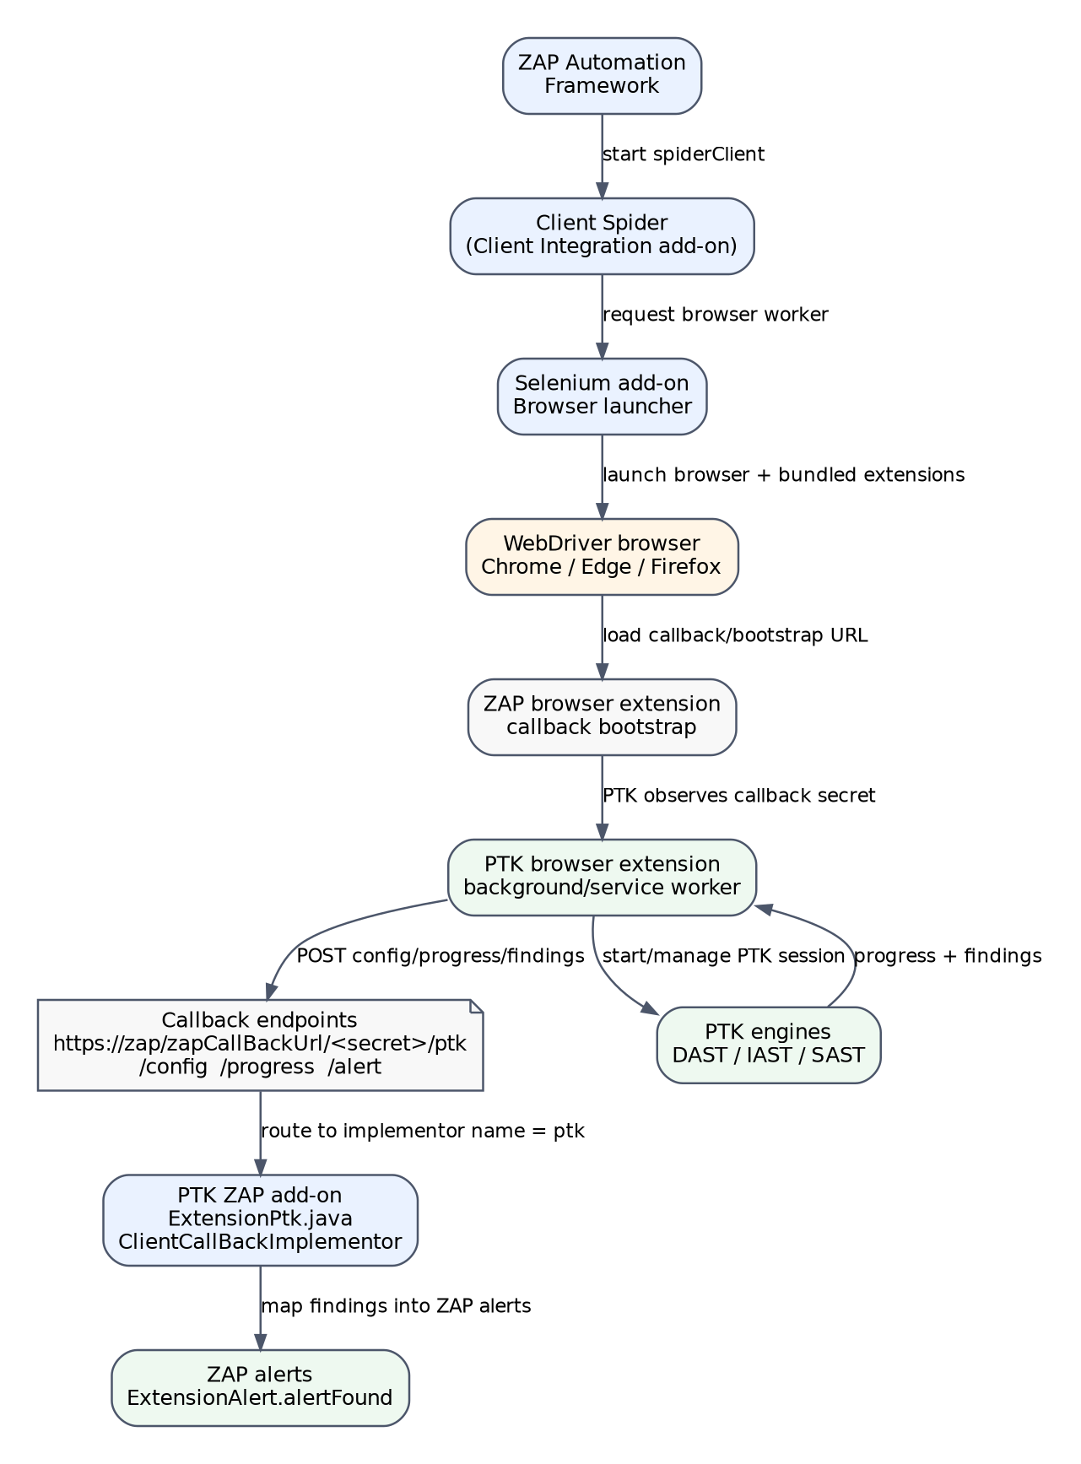
Figure 1. Current PTK - ZAP communication topology.

3. Runtime Lifecycle State Machine
The desired runtime contract should explicitly separate browser task lifecycle from PTK engine lifecycle. Callback detection is not a scan start. A browser close request is not proof that the PTK session is terminal. Terminal status should only be accepted once the publisher has drained or a bounded failure path is recorded.
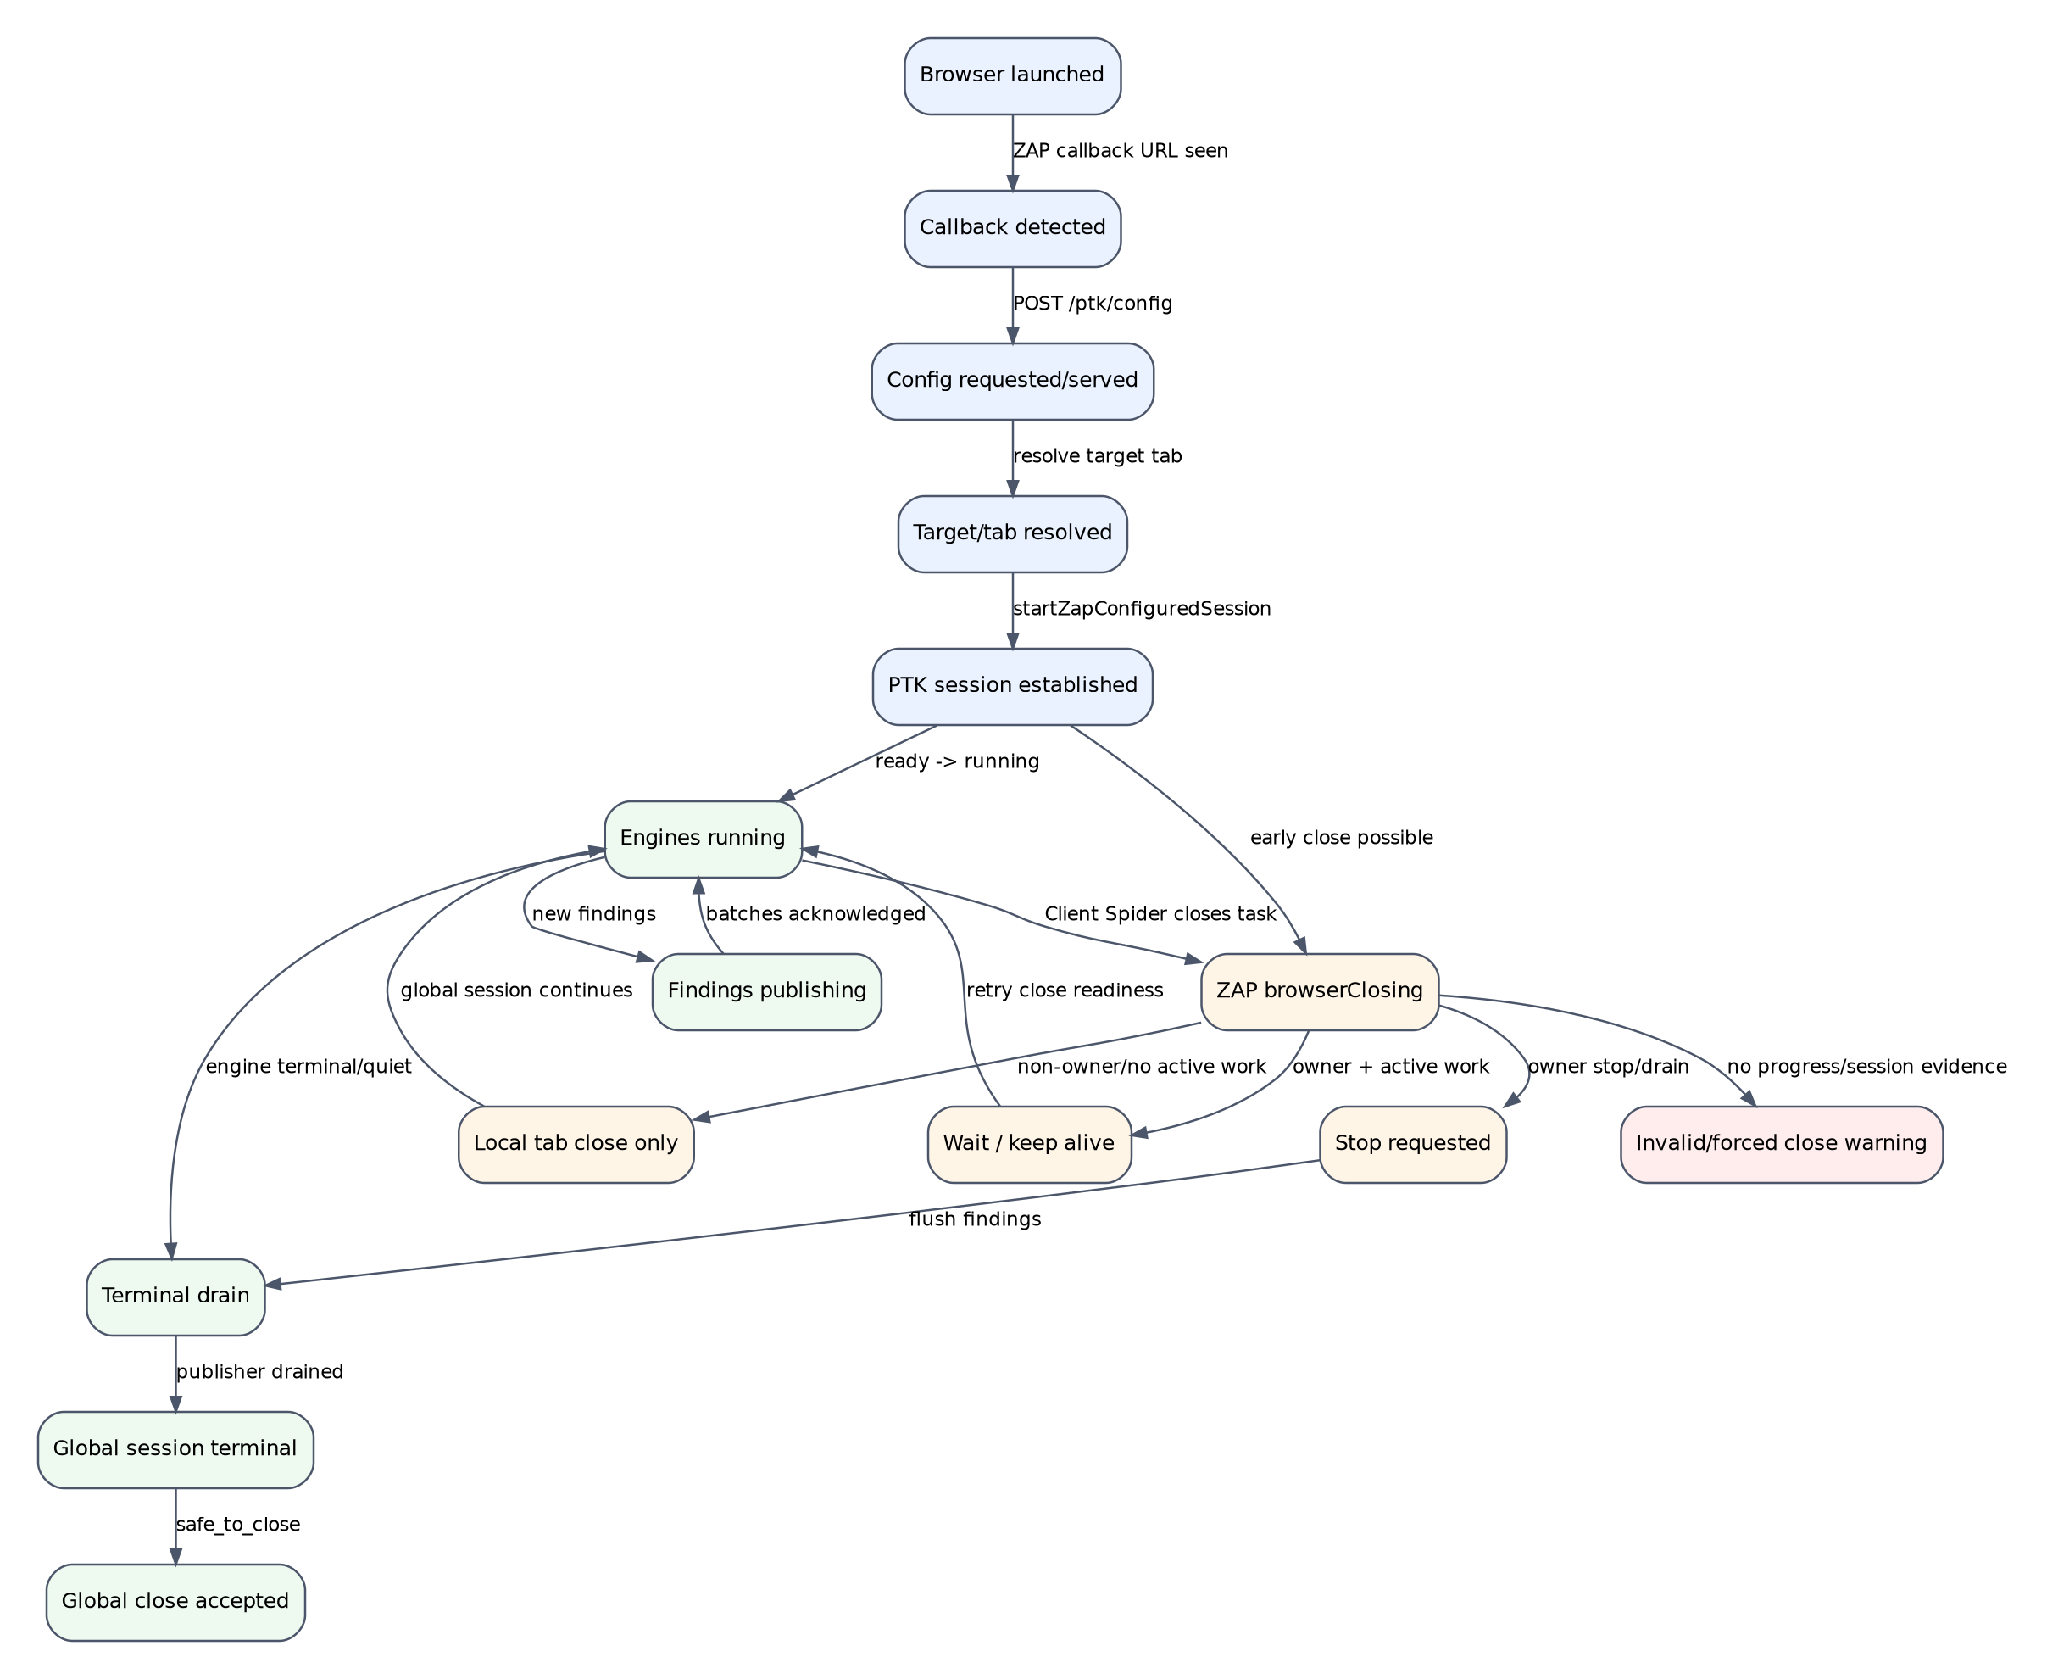
Figure 2. PTK session and browser-task state model.

4. Endpoint Contracts
Endpoint | Direction | Current purpose | Stable contract needed
/ptk/config | PTK extension -> ZAP add-on | Fetch PTK mode, rulepacks, and optional ZAP history seed URLs. | Return contractVersion, zapid, browserid, configVersion, enabled engines, timeout policy, and whether config was applied.
/ptk/progress | PTK extension -> ZAP add-on | Send callback, ready, running, terminal, and safe-to-close status. | Distinguish callback_detected, config_applied, target_resolved, session_started, running, draining, and terminal. Include sessionId, ownerTabId, closeReadiness, and publisher state.
/ptk/alert | PTK extension -> ZAP add-on | Import PTK findings as ZAP alerts. | Include batchId, seq, sessionId, scanId. Java should return received, imported, skipped counts, and rejected reasons.
/ptk/ping | Reserved/debug | Currently debug/future-use only. | Make it a real health endpoint returning add-on version, contract version, and callback state.

Recommended progress payload shape
{
"contractVersion": 2,
"zapid": "<zap-client-callback-uuid>",
"browserid": "<ptk-browser-instance-id>",
"sessionId": "<ptk-session-id>",
"ownerTabId": 123,
"targetUrl": "http://target/",
"phase": "running",
"status": "running",
"progress": 42,
"safeToClose": false,
"closeReadiness": {
"scope": "global_session",
"state": "active_work",
"activeBrowserWork": true,
"publisherDrained": false
},
"publisher": {
"pendingFindings": 3,
"lastBatchSeq": 12,
"drained": false
}
}

5. Source-Level Findings from the Uploaded Archive
The following findings come from the uploaded source archive. They are phrased as likely causes because the final failure depends on runtime timing, browser mode, and Client Spider scheduling.
Priority | Finding | Evidence / code area | Impact
P0 | Edge extension registration appears incomplete. | ExtensionPtk.java: PTK_CHROMIUM_BROWSERS includes Browser.CHROME and Browser.EDGE, but ensurePtkSeleniumExtensionsConfigured registers the unpacked extension for Browser.CHROME and the XPI for Browser.FIREFOX only. | Edge can receive browser arguments but may not receive the PTK unpacked extension. This can explain Edge-specific callback/config/session instability.
P0 | Local tab close clears global zapid/session state. | ExtensionPtk.java: browser_tab_safe_to_close branch calls clearTrackingState(zapid). clearTrackingState remembers the zapid as recently closed and removes scanProgress, scanStatus, sessionId, and target URL mappings. | A non-owner tab close can make later owner-session progress ignored for the same zapid. This can cause missing terminal progress, forced close, or missing findings.
P0/P1 | Terminal close fallback readiness check is mismatched. | zapBridge.js calls this.transport.isReady?.() in postTerminalProgressForClose(), while zapTransport.js exposes isActive() and no isReady(). | Close fallback terminal progress can return zap_progress_not_ready and never post the terminal status Java is waiting for.
P1 | Close decision is page-context dependent. | ExtensionPtk.java uses WebDriver executeAsyncScript to ask page-injected/bridge objects for PTK session progress and close readiness. | Chrome/Edge/MV3/headless runs can fail when the page is unloading, about:blank, navigating, or when the MV3 service worker/content bridge is not ready.
P1 | Alert import acknowledgement is too coarse. | PtkAlertHandler returns an alert count rather than accepted/rejected finding IDs and skip reasons. | The extension can mark findings as published even if Java skipped them due to mapping, invalid URL, or missing SiteTree/history message.
P2 | tabId check rejects falsy IDs. | zapBridge.js uses if (!safeTabId || !targetUrl). | Usually tab IDs are positive, so this is not likely the main failure, but the contract should use safeTabId == null or safeTabId < 0.

6. Highest-Risk Failure Path
The most serious observed contradiction is that a local tab close path can clear global PTK state. This makes a multi-browser run unstable because non-owner browser tasks may complete earlier than the owner PTK session.
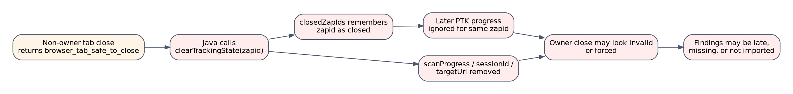
Figure 3. Current failure path caused by global state clear on local tab close.
Implementation invariant to enforce:
browser_tab_safe_to_close MUST NOT call clearTrackingState(zapid).
browser_tab_safe_to_close MUST NOT insert zapid into closedZapIds.
Only global safe_to_close / terminal / forced / invalid may clear global session state.

7. Desired Browser Close Contract
ZAP Client Spider can close a browser task while PTK is still doing engine-level work. The add-on must treat browserClosing as a request to close a browser worker, not as evidence that the PTK session is complete.
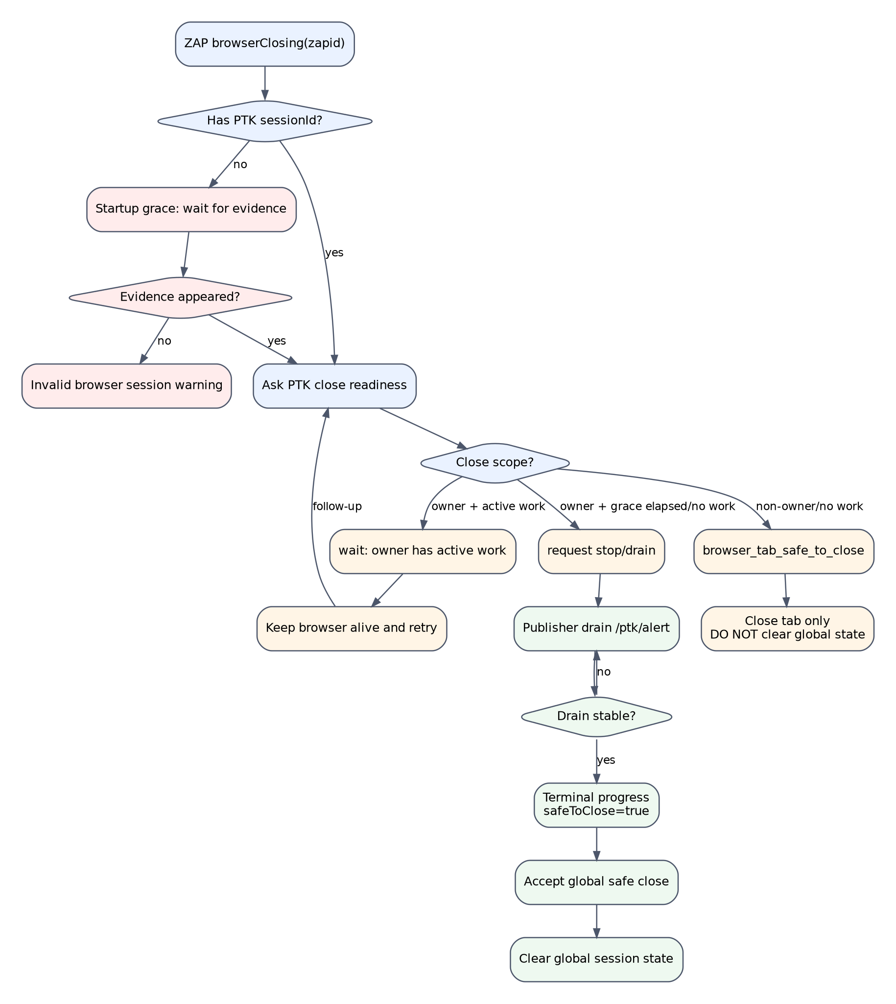
Figure 4. Desired close decision contract.
Decision | Meaning | Java behavior
browser_tab_safe_to_close | This WebDriver tab/window can close. It is local, not global. | Record local close only. Do not clear zapid/session/progress state.
wait | Owner tab still has concrete active work or terminal evidence is not available yet. | Keep browser alive within budget. Re-check readiness periodically.
safe_to_close | Global PTK session is terminal and publisher has drained, or a proven terminal close path completed. | Accept global close and clear global session state.
not_applicable / failed | Close decision could not be made. | Treat as startup/session issue unless in explicit manual config-only mode.
forced_closed | Close budget exhausted. | Record lifecycle warning/failure. Do not mark run as clean.

8. Better Contract Design

8.1 Split Java state into browser task state and PTK session state
The current use of a single clearTrackingState(zapid) makes it too easy to erase global PTK state from a local browser close path. Introduce explicit state objects and explicit clear methods.
class PtkZapSessionState {
String zapid;
String browserid;
String sessionId;
String targetUrl;
Integer ownerTabId;
boolean callbackSeen;
boolean configServed;
boolean sessionEstablished;
boolean terminalProgressSeen;
boolean publisherDrained;
boolean globalSafeToClose;
Set<String> closedBrowserTaskIds;
Map<String, PtkBrowserTaskState> browserTasks;
}
clearBrowserTaskState(zapid, browserid) // local only
clearGlobalSessionState(zapid, sessionId) // terminal/global only
markInvalidBrowserTask(zapid, browserid, reason)
markForcedGlobalClose(zapid, sessionId)

8.2 Add a PTK wait/barrier after spiderClient
Blocking browserClosing helps, but it is not the only barrier needed. The automation plan or release checker should wait for PTK sessions to become terminal and for the publisher to drain after Client Spider completes.
- type: spiderClient
parameters:
browserId: chrome-headless
numberOfBrowsers: 5
pageLoadTime: 5
shutdownTime: 20
- type: ptk-wait
parameters:
target: "http://target/"
minSessions: 1
timeout: 180
requireTerminal: true
requireNoForcedClose: true
requirePublisherDrained: true

8.3 Prefer WebSocket for ZAP -> PTK control
The current close decision path goes through WebDriver and page-context JavaScript. A more robust design is a direct add-on-to-extension control channel opened from the PTK background/service worker after the callback secret is known.
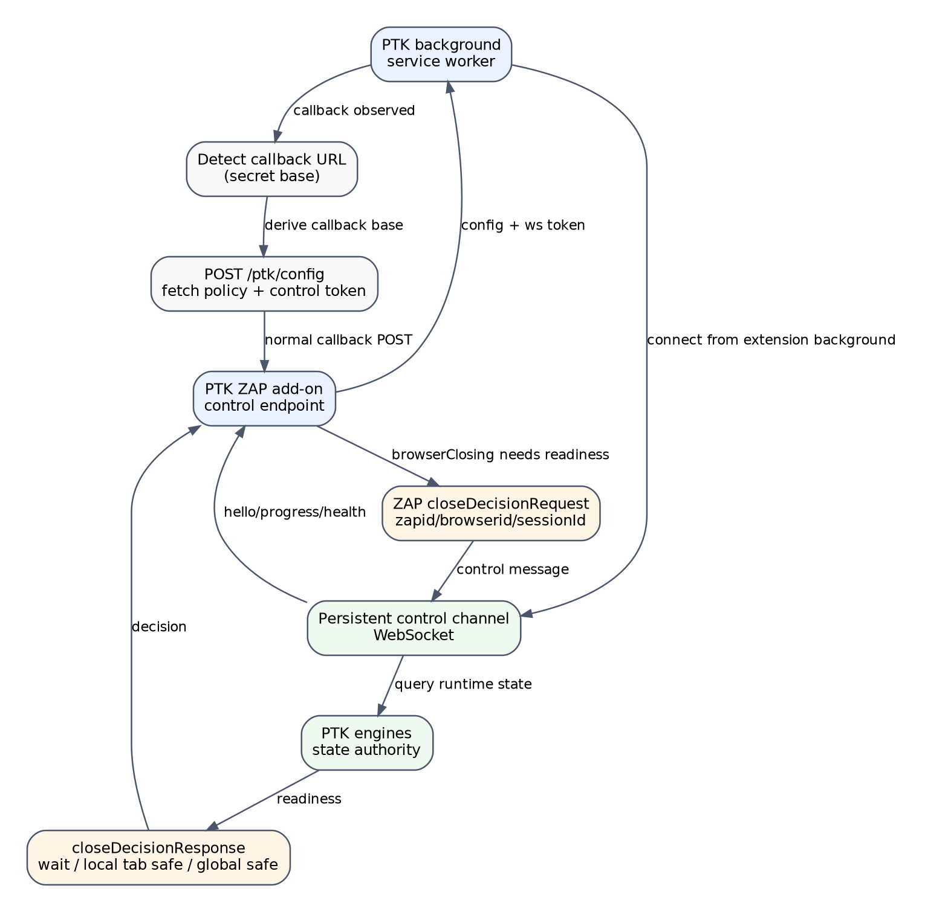
Figure 5. Recommended future WebSocket/control-channel contract.

9. Immediate Development Checklist
Order | Change | Expected effect
1 | Register the unpacked PTK extension for Browser.EDGE in ensurePtkSeleniumExtensionsConfigured. | Makes Edge behave like Chrome instead of receiving only arguments.
2 | Replace clearTrackingState(zapid) in the browser_tab_safe_to_close path with recordBrowserLocalClose(zapid,browserid,decision). | Prevents non-owner tab closes from invalidating the active global PTK session.
3 | Add zapTransport.isReady() as an alias for isActive(), and/or change postTerminalProgressForClose() to call isActive(). | Allows close fallback to post terminal progress.
4 | Change the tab ID check from !safeTabId to safeTabId == null || safeTabId < 0. | Tightens JS contract correctness.
5 | Add structured PTK_CONTRACT logs for each lifecycle phase. | Lets the release checker pinpoint which boundary failed.
6 | Return structured import results from /ptk/alert. | Differentiates engine misses from Java import/mapping/SiteTree misses.
7 | Add a PTK wait/barrier after spiderClient. | Prevents declaring a run finished before PTK drains.
8 | Move close readiness from WebDriver page JS to background/WebSocket control channel. | Long-term fix for Chrome/Edge/MV3/headless close races.

10. Test Plan

10.1 Unit tests
Area | Test | Pass condition
Java | Edge registration | Selenium browser extensions contain PTK entries for Chrome, Edge, and Firefox.
Java | Local tab close does not clear session | scanProgress, scanStatus, sessionIdByZapId, targetUrlByZapId remain after browser_tab_safe_to_close.
Java | Late progress after local close | A /ptk/progress update for the same zapid is accepted, not ignored as recently closed.
Java | Global safe close clears state | Only safe_to_close/terminal/forced/invalid paths clear global state.
Java | Alert import reasons | Missing mapping, missing SiteTree match, invalid URL, and successful raw-message import are each reported correctly.
JS | Terminal close readiness | postTerminalProgressForClose succeeds when transport is active.
JS | Close grace decisions | owner+active+grace => wait; non-owner+active => browser_tab_safe_to_close; terminal => safe_to_close.
JS | Config fallback | Config fetch failure is logged as degraded and not mistaken for ZAP-configured success.

10.2 Integration matrix
Browser | Mode | numberOfBrowsers | Required evidence
Chrome | headed | 1 | callback, config, session established, no forced close, expected import.
Chrome | headless | 1 | same as headed baseline.
Chrome | headless | 5 | at least one worker and one PTK session; lower fan-out is warning, not fail.
Edge | headed | 1 | PTK extension visible and callback/config/progress observed.
Edge | headless | 1 | same as Edge headed.
Edge | headless | 5 | primary regression gate; no local close clears global state.
Firefox | headless | 1 | comparison baseline.
Firefox | headless | 5 | comparison baseline for multi-worker close behavior.

11. Revised Release Gates
Gate | Must pass? | Reason
At least one ZAP-owned browser worker loaded the target | Yes | Proves Client Spider browser coverage started.
PTK callback detected | Yes | Proves the ZAP/extension callback bridge started.
Config served and applied | Yes unless fallback is explicitly tested | Proves ZAP-controlled PTK policy was applied.
PTK session established with non-empty sessionId | Yes | Callback progress alone is not a scan.
No forced_closed | Yes | Forced close means lifecycle uncertainty.
No global state cleared on local tab close | Yes | Prevents multi-browser truncation.
Publisher drained before terminal | Yes | Prevents missing late findings.
Expected findings imported or rejected with reason | Yes | Separates engine failure from import/mapping/SiteTree failure.

12. Structured Lifecycle Logs
Add a single structured log family across Java and JS so that automation reports can reconstruct the exact failure boundary.
PTK_CONTRACT zapid=... browserid=... sessionId=... phase=... status=... targetUrl=...
Suggested phases:
browser_launched
callback_detected
callback_progress_posted
config_requested
config_served
config_applied
target_resolved
session_start_requested
session_established
progress_running
alert_batch_sent
alert_batch_imported
close_requested
close_decision
publisher_drained
terminal_progress_posted
global_close_accepted
local_tab_closed
forced_closed

13. Corrections to the Lifecycle Contract Document
The Codex lifecycle document is directionally correct, but the implementation should be made to match its most important invariant: browser_tab_safe_to_close is local, not global.
- Add an explicit invariant: browser_tab_safe_to_close must not call clearTrackingState(zapid).
- State that closedZapIds is a global close guard and must not be used for local tab closes.
- Clarify that terminal progress from close fallback depends on zapTransport readiness and must call isActive/isReady consistently.
- Clarify that numberOfBrowsers is max concurrency and the release checker should fail only on no worker/session or lifecycle violations, not lower-than-max fan-out.
- Add a failure-boundary triage table: browser load -> callback -> config -> target resolve -> session -> finding generated -> alert imported -> report interpreted.

14. Recommended Fix Order
- Register Edge extension explicitly.
- Stop clearing global zapid/session state on browser_tab_safe_to_close.
- Fix the postTerminalProgressForClose readiness check.
- Fix the tabId check.
- Add structured lifecycle logs and update the weekly checker to assert phases.
- Add import-result reasons for /ptk/alert.
- Add a PTK wait/barrier after spiderClient.
- Move close readiness from WebDriver page JS to a WebSocket/background-channel contract.

Appendix A - Minimal Patch Sketches

A.1 Edge extension registration
changed |= ensureBrowserExtension(extensions, chromiumPath, Browser.CHROME, "Chromium");
changed |= ensureBrowserExtension(extensions, chromiumPath, Browser.EDGE, "Edge");
changed |= ensureBrowserExtension(extensions, xpiPath, Browser.FIREFOX, "Firefox");

A.2 Local tab close should not clear global state
if (PtkCloseContract.isBrowserLocalTabSafeToCloseDecision(closeDecision)) {
logCloseContractDecision(zapid, browserid, "browser_tab_safe_to_close", closeDecision);
logTimingSummary(zapid, browserid, "browser_close.local_tab", elapsed, closeExtra);
recordBrowserLocalClose(zapid, browserid, closeDecision);
return;
}
private void recordBrowserLocalClose(String zapid, String browserid, Map<String, Object> decision) {
// Local bookkeeping/logging only.
// Do NOT call rememberClosedZapId.
// Do NOT remove scanProgress, scanStatus, sessionIdByZapId, targetUrlByZapId.
}

A.3 Transport readiness alias
// zapTransport.js
isReady() { return this.isActive() }
// zapBridge.js
if (!sessionId || !effectiveZapId || !this.transport.isActive?.()) {
return { ok: false, posted: false, reason: 'zap_progress_not_ready' }
}

