DOCUMENTATION

ASSIGNMENT 3

ORDER MANAGEMENT APPLICATION

STUDENT NAME: Sarafinceanu Denisa
GROUP: 30422

CONTENTS

1. Assignment Objective 3
2. Problem Analysis, Modeling, Scenarios, Use Cases 3
3. Design 3
4. Implementation 3
5. Results 3
6. Conclusions 3
7. Bibliography 3

Assignment Objective
Main objective
- Design and implement an application for managing the client orders for a warehouse.
Sub-objectives
- Analyze the problem and identify requirements.
- Design the orders management application.
- Implement the orders management application.
- Test the orders management application.

Problem Analysis, Modeling, Scenarios, Use Cases
a) Analysis
This application simulates a real-life situation in which an employee can introduce clients with their data and products with their data. Based on the clients and products, the user can make orders containing the client identifier, product identifier and the quantity added, which will be decremented from that specific product.
b) Modelling
The interface the user interacts with is very suggestive, introducing their desired input data for the simulation. The user introduces the data he wants and in real time after he presses the button specific to the command, he can see the table update as he wants. The user has the possibility to add new data, delete and update the data which is already in the table.
Functional requirements:
- The application should allow an employee to add/delete/update a new client.
- The application should allow an employee to add/delete/update a new product.
- The application should allow an employee to visualize the client/product table and changes made by him.
- The application should allow an employee to select a client and a product and with them will make an order based on the value of the quantity desired; if the quantity possible for the product is less than the introduced quantity, the application will display a message.
Non-Functional requirements:
- The simulation application should be intuitive and easy to use by the user.
- The simulation application should detect any error in the input inserted by the user and give a warning if it is the case (email validation, stock validation).

c) Use cases:
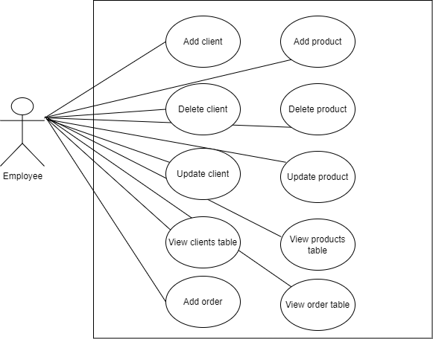

Figure 1: Use case diagram
Use case: add client/product
Primary actor: employee
Main success scenario:
1. The application displays a form designed to introduce data and visualize it in the table
2. The employee introduces the data for client/product in the specific text box
3. The user clicks on the “Add client/product” button
4. The application stores the client/product data in the database and displays an acknowledge message
Alternative sequence: Invalid values for the client/product’s data
- The user inserts an invalid email (for client) or a negative stock (for product)
- The application displays an error message and requests the user to insert valid values
- The scenario returns to step 2

Use case: update client/product
Primary actor: employee
Main success scenario:
1. The application displays a form designed to introduce data and visualize it in the table
2. The employee introduces the data for the client/product he wants to update (considering there is an existing row with the provided id)
3. The user clicks on the “Update client/product” button
4. The application updates the data inserted by the user, stores it in the database and displays an acknowledge message
Alternative sequence: Invalid values for the client/product’s data
- The user inserts an invalid id which is not existed in the database
- The user inserts an invalid email (for client) or a negative stock (for product)
- The scenario returns to step 2

Use case: delete client/product
Primary actor: employee
Main success scenario:
1. The application displays a form designed to introduce data and visualize it in the table
2. The employee introduces the id of the client/product he wants to delete in the specified text box
3. The user clicks on the “Delete client/product” button
4. The application deletes the data corresponding to the id inserted by the user, updates the database and displays an acknowledge message
Alternative sequence: Invalid values for the client/product’s data
- The user inserts an invalid id which is not existed in the database
- The scenario return to step 2

Design
Division into packages:
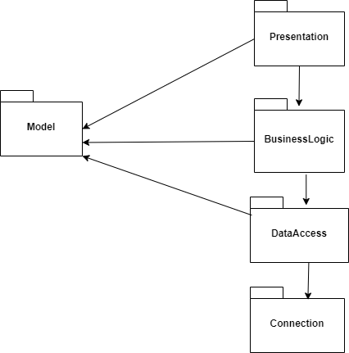
Figure 2: Package diagram

a) Model: contains the classes modelling the application
- Client
- Product
- Orders
b) DataAccess: contains the classes that implements the queries to modify the data in the database
- AbstractDAO
- ClientDAO
- ProductDAO
- OrdersDAO
c) BusinessLogic: contains the classes which make the connection between the Model and the DataAccess
- ClientBLL
- ProductBLL
- OrdersBLL
- validators
- EmailValidator
- StockValidator
d) Presentation: contains the classes which generate the interface
- ClientFrame
- ProductFrame
- OrderFrame
- ClientController
- ProductController
- OrderController
- View
- Controller
e) Connection: contain the classes which sets the connection to the database
- ConnectionFactory

Division into classes:
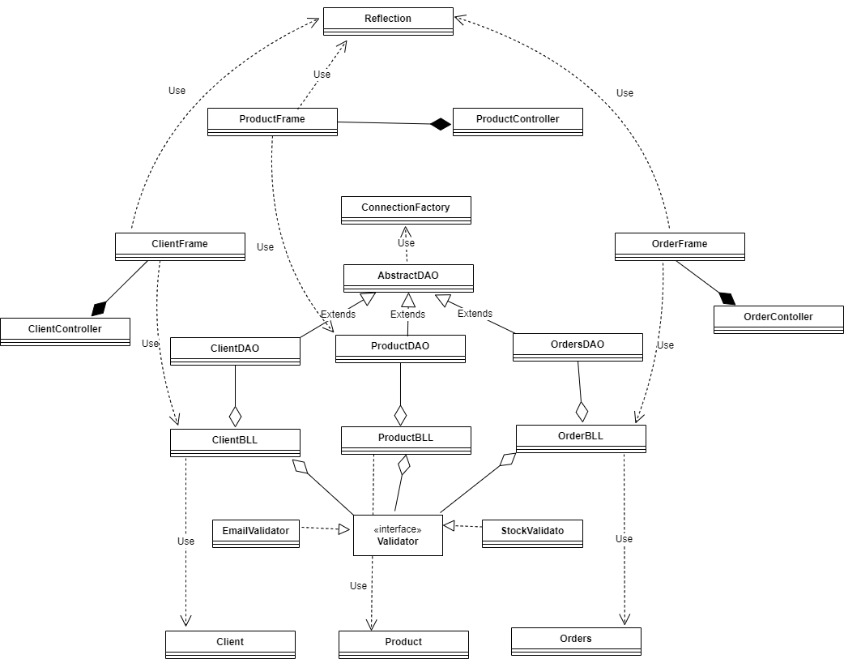

Figure 3: Class diagram

Data structures
Some data structures that I used are: ArrayList, List, etc. I used ArrayLists due to the fact that their size is not fixed, and I can add as many elements as I want in the list without worrying about the memory management.

Implementation
Client class
Attributes: private int id;
private String name;
private String address;
private String email;
Methods: Constructors + set and get for each attribute

Product class
Attributes: private int id;
private String name;
private double price;
private int stock;
Methods: Constructors + set and get for each attribute

Orders class
Attributes: private int id;
private int clientId;
private int productId;
private int quantity;
private double totalPrice;
Methods: Constructors + set and get for each attribute

ConnectionFactory
It is the class that establishes the connection between my code and the database from Postgres. It contains the necessary data in order to connect to a database which are: driver, URL of the database, username and password.
Attributes: private static final Logger LOGGER;
private static final String DRIVER;
private static final String DBURL;
private static final String USER;
private static final String PASS;
Methods: private Connection createConnection();
public static Connection getConnection();
public static void close(Connection connection);
public static void close(Statement statement);
public static void close(ResultSet resultSet);

AbstractDAO
This generic class implements the queries for finding, inserting, updating, deleting data from the table and the other classes will extend this class.
Attributes: protected static final Logger LOGGER;
private final Class<T> type;
Methods: public AbstractDAO(); obtain the class of the generic T
public String createSelectQuery(String field); returns a String consist of the exact query which will be executed to select a specific row based on that field
public T findByID(Integer id); creates a connection and returns the object of the needed class which is found by the given id
private String createSelectAllQuery(); this is the String that will be use in the query to select all the data from a table and be order in ascending order by id
public List<T> findAll(); returns a list will all the elements inserted in the database
private List<T> createObjects(ResultSet resultSet); returns a list of a specific type T of the model objects based on the resultSet
private String createInsertQuery(T t); returns a String of the query which would be executed in order to insert a new row in a table of type T
public int insert(T t); calles the function createInsertQuery for the preparedStatement and return the id
private String createDeleteQuery(String field); returns the String of the query for deleting a row in the table based on the field given as parameter
public void delete(Integer id); calls the function createDeleteQuery for the preparedStatement and make the connection to the database in order to execute the query
private String createUpdateQuery(T t); returns the String of the query meant to update a row of a specific type given by id
public T update(T t); this returns the data of type T updated by calling the function createUpdateQuery for prepareStatement and saving the changes in the database

ClientDAO class
This class extends the AbstractDAO class using the class Client. In this way the Client table from the database will have the fields of the class Client.

ProductDAO class
This class extends the AbstractDAO class using the class Product. In this way the Product table from the database will have the fields of the class Product.

OrdersDAO class
This class extends the AbstractDAO class using the class Orders. In this way the Orders table from the database will have the fields of the class Orders.

ClientBLL class
Attributes: private List<Validator<Client>> validator; creates a list of type Client of all the clients which are valid
private ClientDAO clientDAO; an attribute of type ClientDAO in order to call the functions from that class
Methods: publicClientBLL(); initializes the validators list and clientDAO
public Client findClientById(Integer id); returns the client which is found by calling the specific function in class ClientDAO, otherwise will print an error
public List<Client> findAllClients(); returns a list of all the clients in the database
public void insertClient(Client client); inserts a client in the database by calling the function from the ClientDAO but not before verifying the validity
public void deleteClient(Integer id); calls the function from the ClientDAO based on the given id
public void updateClient(Client client); updates a client in the database by calling the function from the ClientDAO but not before verifying the validity

ProductBLL
Attributes: private List<Validator<Product>> validators; creates a list of type Product of all the products which are valid
private ProductDAO productDAO; an attribute of type ProductDAO in order to call the functions from that class
Methods: public ProductBLL(); initializes the validators list and productDAO
public Product findProductById(Integer id); returns the client which is found by calling the specific function in class ProductDAO, otherwise will print an error
public List<Client> findAllProducts(); returns a list of all the products in the database
public void insertProduct(Product product); inserts a product in the database by calling the function from the ProductDAO but not before verifying the validity
public void deleteProduct(Integer id); calls the function from the ProductDAO based on the given id
public void updateProduct(Product product); updates a client in the database by calling the function from the ProductDAO but not before verifying the validity

OrdersBLL class
Attributes: private List<Validator<Orders>> validators; creates a list of type Orders of all the orders which are valid
private OrderDAO orderDAO; an attribute of type OrdersDAO in order to call the functions from that class
Methods: public OrdersBLL(); initializes the validators list and ordersDAO
public List<Orders> findAllOrders(); returns a list of all the orders in the database
public int insertOrder(Orders order); verifies the validation of the order and returns the id of that order

Validator class
This class is an interface which has a method called validate. The classes EmailValidator, StockValidator are implementing this method.

Reflection class
This class consists of a list of objects of a type and it will give the header of the table including the names of the fields of that objects.
Method: public JTable retriveProperties(List<T> objects); this method generates the header of a JTable and populates the table with the elements given from the list.

The classes in the package Presentation have the purpose to generate the interface and make the connection between the database, the code from the classes and the visual results.
Each field has its own Frame and Controller. The View class is the first frame that will open when the application is run and gives the user the opportunity to decide on which frame he wants to go. This class makes the connection between all the frames. The Controller class implements the class ActionListener which lets the user navigate to the next frame by clicking the labeled buttons.

Results
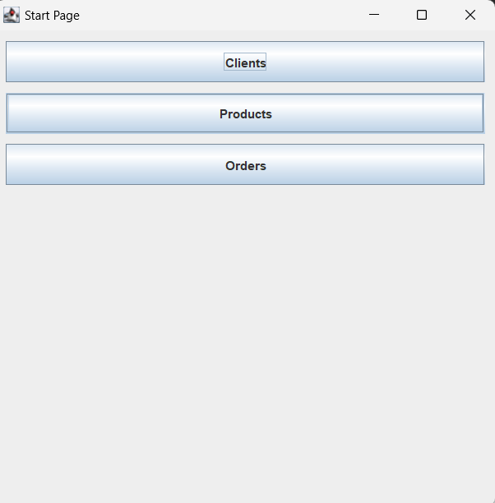
Figure 4: Start page
This image shows the Start page in which the user should select the frame he wants to go to and perform the operations.
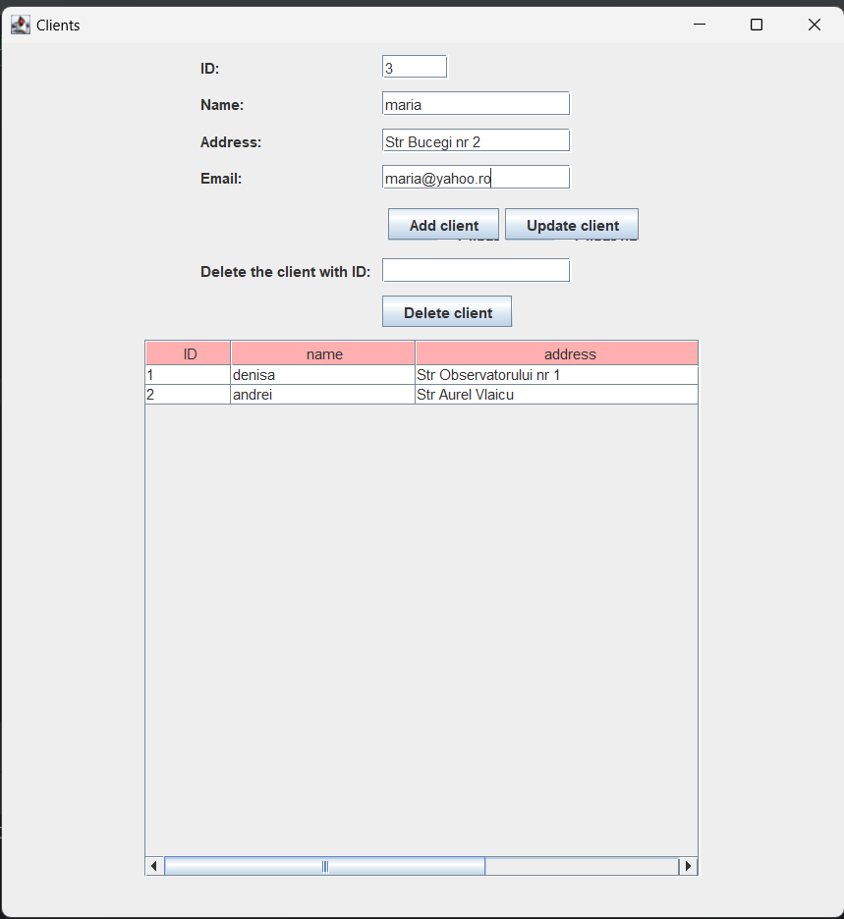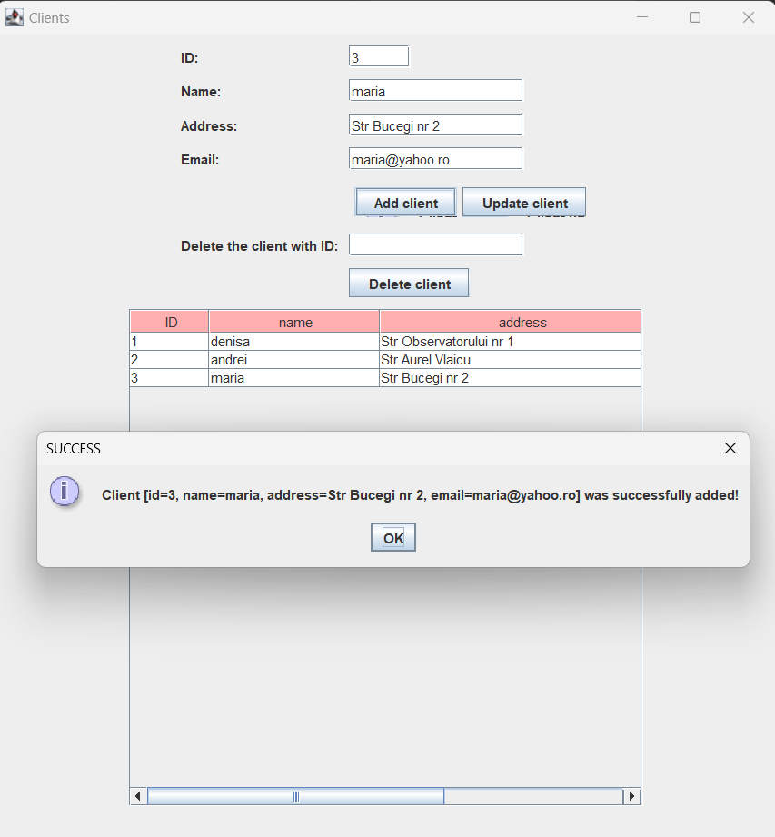

Figure 5: Add client
These images show the Add client functionality which is similar to Add product.
I just insert the data in the specific TextFields and the database will update.

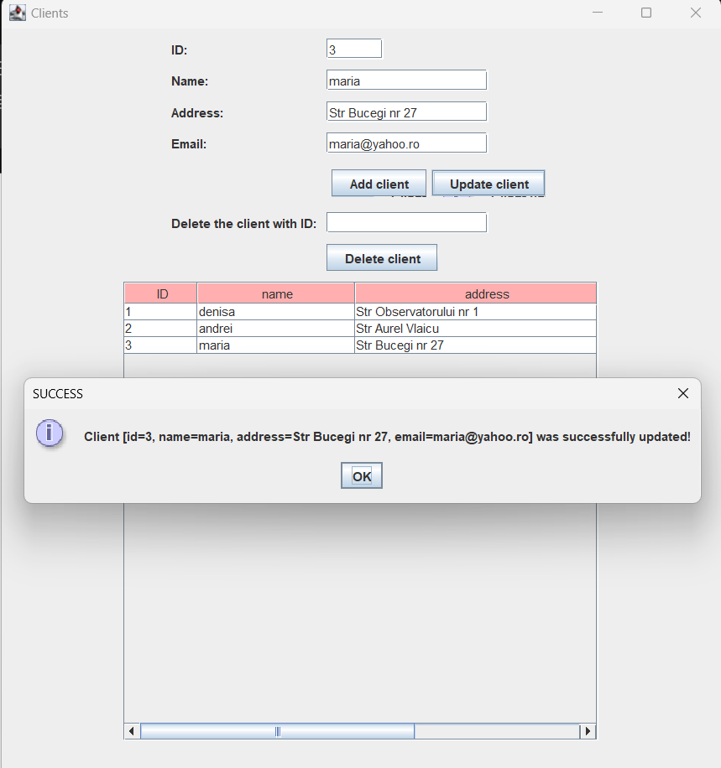

Figure 6: Update client
This image shows the functionality of Update client which is similar to Update product.
I just insert the new data for the client with id 3. If the id is not present in the database, the program will display an error message.

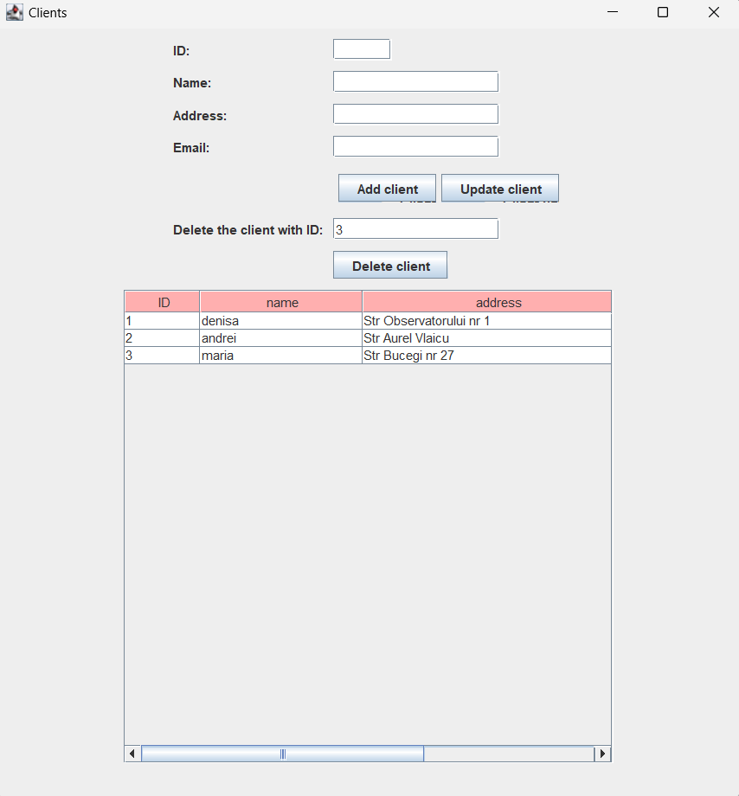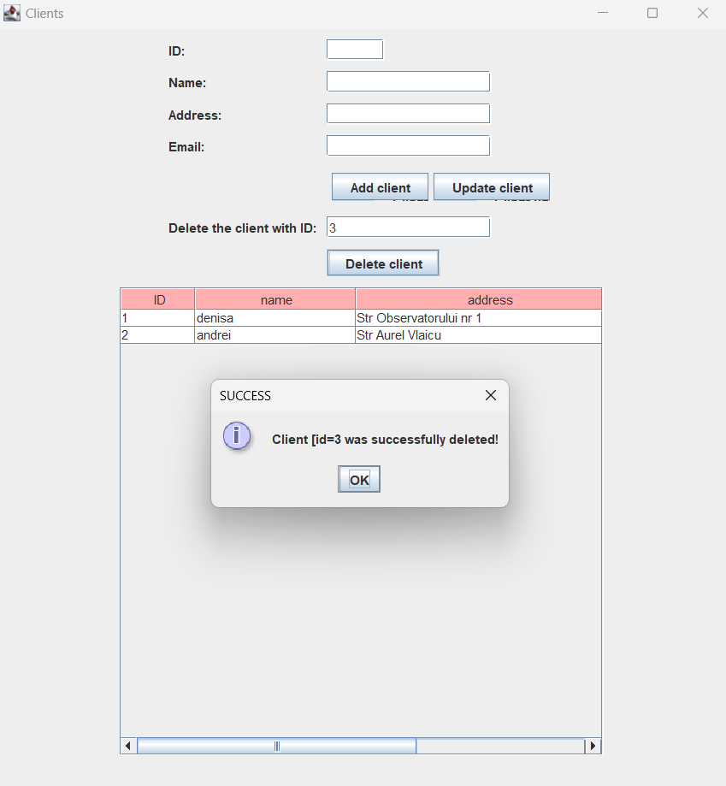

Figure 7: Delete client
This image shows the functionality of Delete client which is similar to Update product.
I just insert the id in the specific TextField and the client will be deleted from the database.

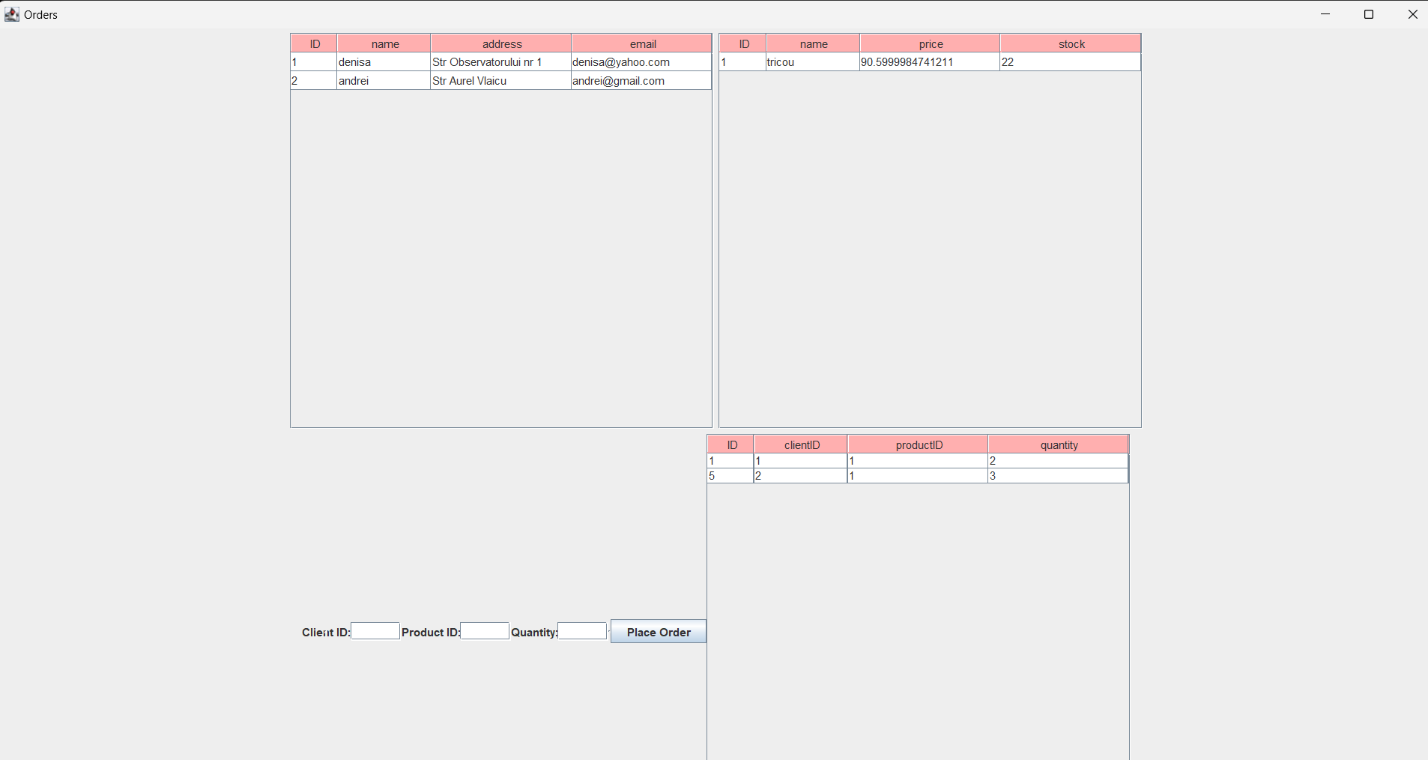

Figure 8: Orders frame
This image shows the Order frame consisting of the Client table and Product table, some textFields in which the user should insert the order he wants to make and the Orders table.
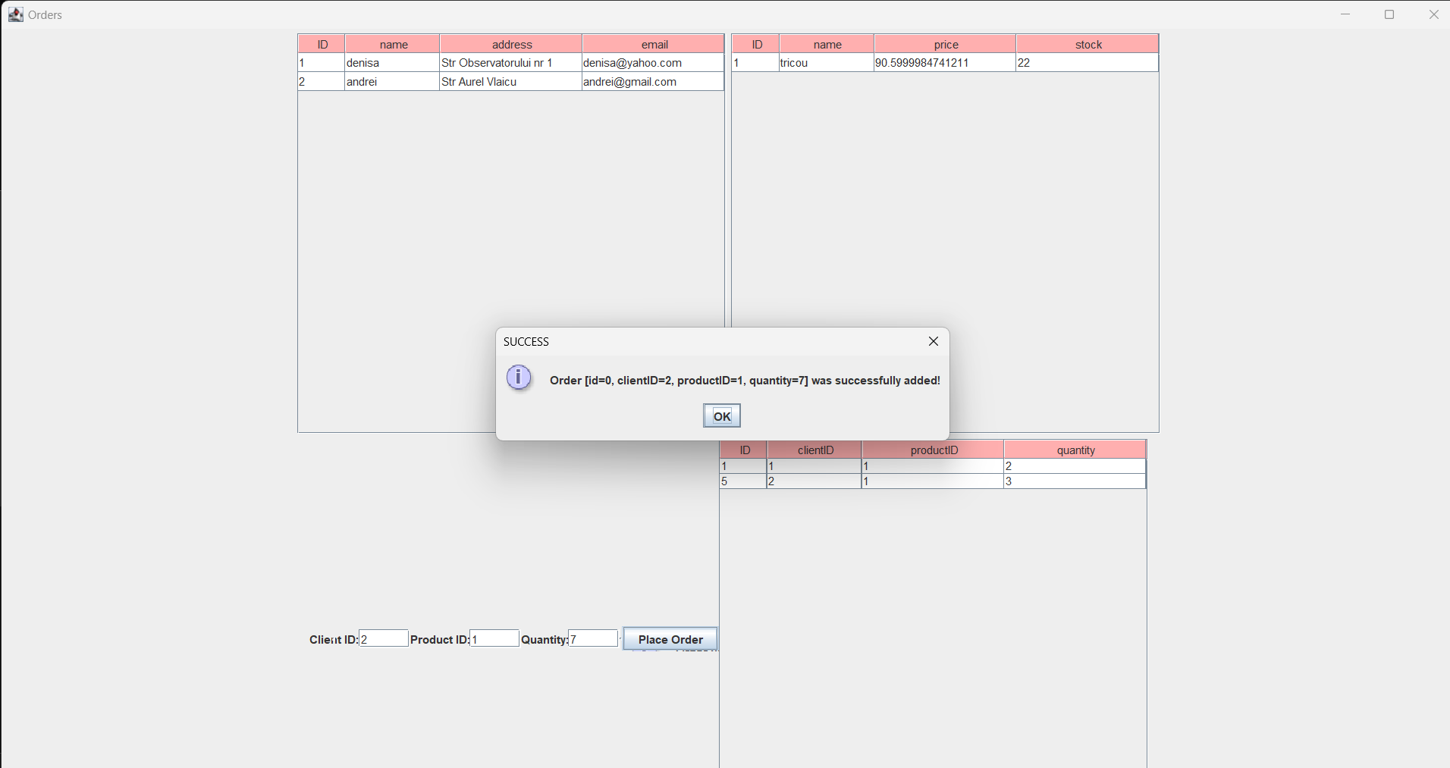

Figure 9: Insert order example
If I insert an order with clientId 1, productId 1 and quantity 7 I will get a message that the order has been successfully.
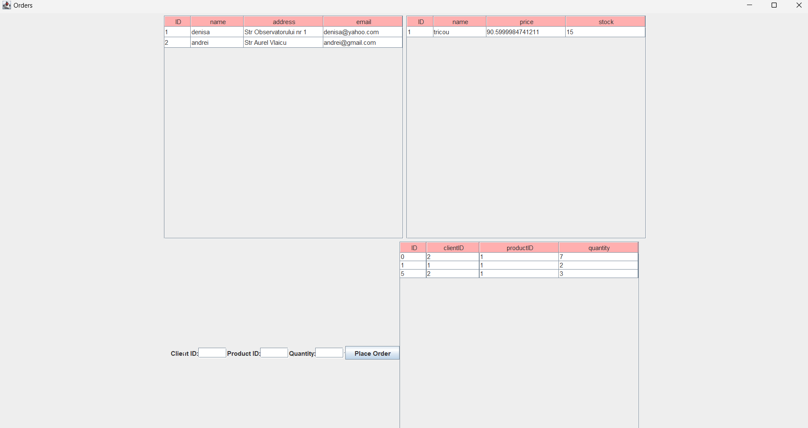

Figure 10: Inser order result
After I get back on the Orders frame, I can see that the order made earlier was inserted in the Orders table and as it can be visible the stock has been decremented.
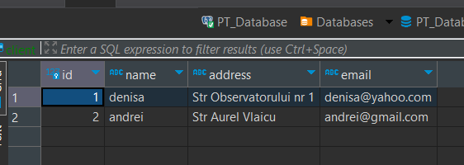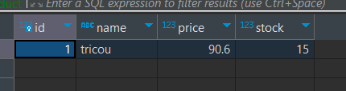
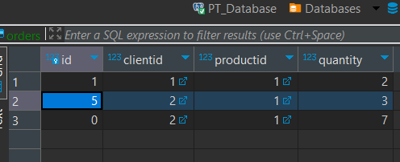

Figure 11: Database tables
In the previous tables it can be visible the data from the PostgresDatabase.
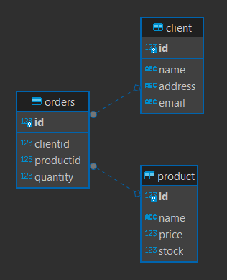

Figure 12: Database diagram
In this image it can be visible the ER Diagram from the Postgres and its dependencies.

Conclusions
What have I learned?
I have developed how to make an interface in Java Swing by writing the code, also I have practiced my skills on connecting a Postgres Database to Java and use it in order to work. I have also learned how to create a JavaDoc file, how to use reflection and generic classes.

Future improvements
I would work more on the interface or adjust the functionality of my application making possible the feature that a client can add multiple products at one run of the application.

Bibliography
https://dsrl.eu/courses/pt/
https://www.baeldung.com/javadoc

