<<author name redacted>>

CS5387

02/12/20

**TableSorter Test Plan**

**Purpose:**

A Junit test class was created to evaluate the correctness of the “TableSorter” class. The The purpose of the TableSorter class is to determine whether a given symmetric table (NxN) is sorted. The TableSorter class must also be able to sort any given symmetric table (NxN). All values must be sorted as defined in this section. The values of stored within the table are defined as any integer value (Negative and Positive). There is no limitation on the size of the table, as long as it is symmetric (rows == columns).

*Sorted is defined as all rows and columns are ordered in ascending order based on the integer value.*

**Test Requirements:**

This test is to be performed using eclipse IDE.

In order to accomplish this three (3) files are necessary to carry out the test procedure. The following files must be included in the project folder.

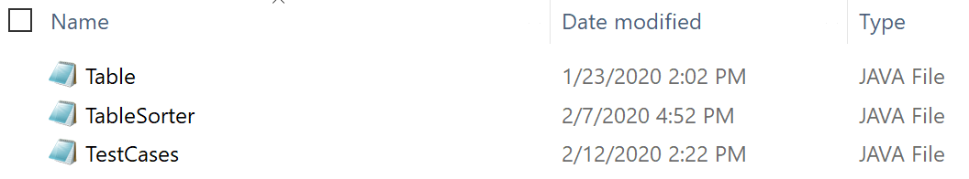

The TestCases.java file is provided as an attachment along with this file.

**Test Procedure:**

Once all files are available in the project folder, compile and execute the TestCases.class file.

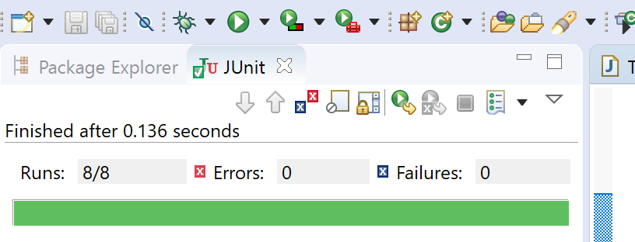

This will perform the tests denoted in the table below.

Table 1: Test IDs and Descriptions

| Test Group | Test ID | Test Description | Sub-Categories | Expected Result | Actual Result |
| --- | --- | --- | --- | --- | --- |
| (1)  isSorted() | 1-a | Random Numbers | 1. Random placement 2. Sorted 3. Symmetric 4. All zeroes | False  False  False  True |  |
| 1-b | Positive Numbers | 1. Random placement 2. Sorted 3. Symmetric 4. Repeating values | False  True  False  True |  |
| 1-c | Negative Numbers | 1. Random placement 2. Sorted 3. Symmetric 4. Repeating values | False  False  False  True |  |
| 1-d | Empty | 1. Empty table | True |  |
| (2)  Sortable() | 2-a | Random Numbers | 1. Random placement 2. Sorted 3. Symmetric 4. All zeroes | True  True  True  True |  |
| 2-b | Positive Numbers | 1. Random placement 2. Sorted 3. Symmetric 4. Repeating values | True  True  True  True |  |
| 2-c | Negative Numbers | 1. Random placement 2. Sorted 3. Symmetric 4. Repeating values | True  True  True  True |  |
| 2-d | Empty | 1. Empty table | False |  |

The tests are divided into two groups:

Group 1: Tests 1a – 1d

Group 2: Tests 2a – 2d

The test groups must be performed in that order, however, the tests within each group may be performed in any order.

In the event that any test in Group 1 is unsuccessful, the overall test will be concluded and Group 2 testing will be suspended until the problems are addressed.

**Test Criteria:**

All tests cases must yield a successful result in order for the overall test to be called successful.

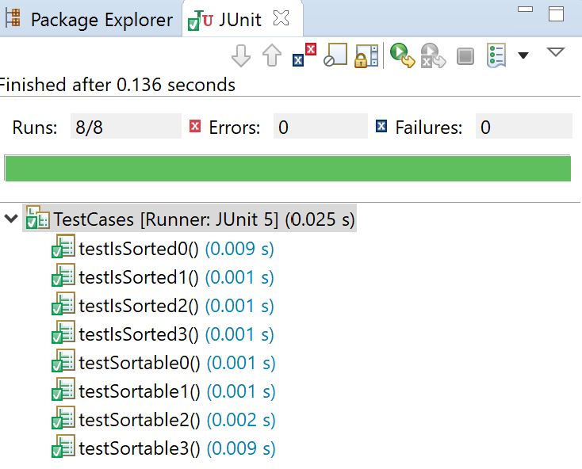

**Conclusion:**

This tests provides sufficient information to perform the tests necessary for the evaluation of TableSorter class, per the requirements identified in Programming Assignment 1. Further evaluations may be added to ensure all operational requirements are met.