## Test Sort

**Objective:** The objective of this test is to check inputs and outputs are correct without knowing how the system is structured.

**Notes:** Since this program does not require input from the user, the tester must manipulate the main function in order to carry out tasks. However, this does not mean that they will be manipulating the functionality of the program, just the calling of methods.

Before: Must have Table.java, TableSorter.java, and tableFile.txt file within the same directory. Have an Java IDE in order to run the program.

|  |  |  |
| --- | --- | --- |
| Current Status: Pending | | |
| STEP  1  2 | OPERATOR ACTION  In the main, on line 14 set the text file name to  Table tableInit = Table.*GetTable*("tableFile.txt");  Below this line insert,  System.*out*.println(*isSorted*(tableInit));  As shown in figure 1 in appendix.  Run the program.  In the main, below line 15 insert,  *sortable*(tableInit);  And on line 16 insert,  System.*out*.println(*isSorted*(tableInit));  As shown in figure 2 in the appendix.  Run the program | PURPOSE  Since the tableFile.txt is not sorted, we would like to test the isSorted function to see if it works.  To check sorting algorithm as well as isSorted Boolean. | | EXEPCTED RESULTS  It should print to console “FALSE”.  It should print to console  “FALSE”  “TRUE”. | COMMENTS  When table is not sorted.  When table is sorted. |
| Concluding Remarks: In this test suite, we test that the isSorted method indicated whether a table is sorted or not. At the same time we are testing that the sortable method is sorting the table appropriately by using the isSorted method. | | | | | |

Apendix

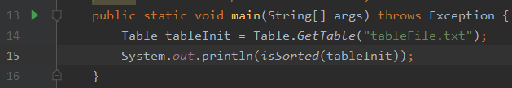

Figure

Figure