<<author name redacted>>

**TEST PLAN**

**Purpose**

The strategy used to test this project was to use integers including positive numbers, negative numbers and the number 0. These values are written on files, each file has a different size of values.

The tool used for this test plan we are using JUnit. The file that contains the test cases is named “TableSorter.java”. It contains test cases that proves the functionality of our program. In order to execute this test properly is recommended to use IntelliJ.

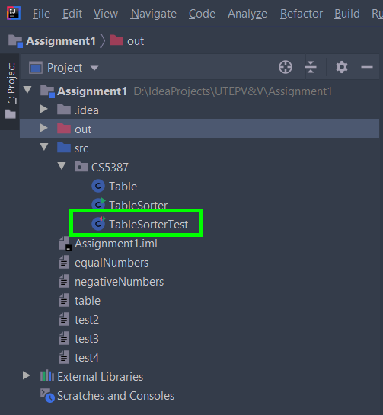

*Input:* Files containing numbers. In order to execute the tests in JUnit, files have to be provided. The project already contains the files to be tested. The files are located within the main directory, that is, “Assignment1” as shown in figure 1.

*List of files:*

* equalNumbers
* negativeNumbers
* table
* test2
* test3
* test4

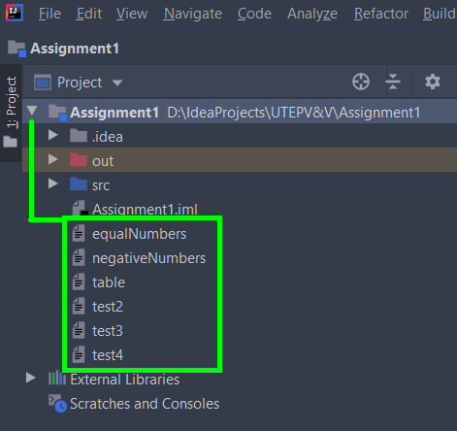 *figure 1.*

**Test Items**

|  |  |
| --- | --- |
| **Class** | **Module** |
| TableSorter | sortable |
| isSorted |

**Test Cases and individual execution**

* **Test Case 1 – *minimumTable ()***

This test is the simplest test 2 x 2 with positive numbers.

*Execution steps:*

1. Click on the green arrow  next to the method that will execute the test.

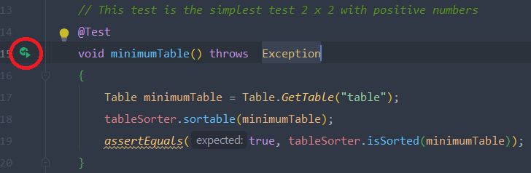

* **Test Case 2 – table12by12()**

Test negative numbers, 0 and positive numbers - 12 x 12.

*Execution steps:*

1. Click on the green arrow  next to the method that will execute the test.

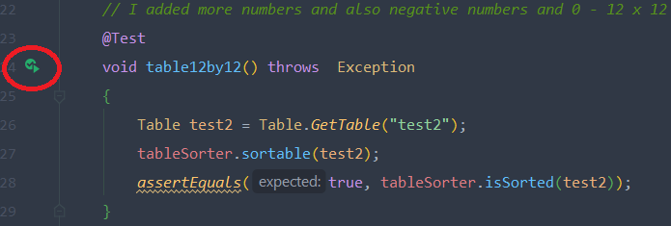

* **Test Case 3 – *table4by4()***

Test negative numbers, 0 and positive numbers - 4 x 4

*Execution steps:*

1. Click on the green arrow  next to the method that will execute the test.

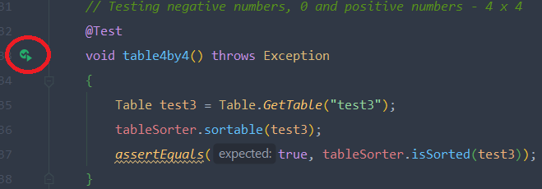

* **Test Case 4 – *table24by24()***

Test negative numbers, 0 and positive numbers - 24 x 24

*Execution steps:*

1. Click on the green arrow  next to the method that will execute the test.

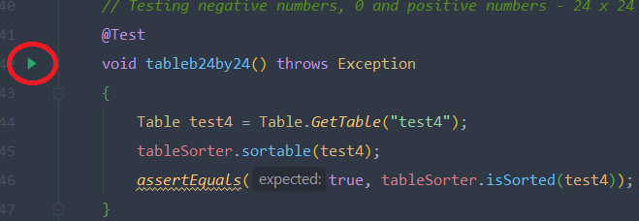

* **Test Case 5 – *equalNumbers()***

Test equal numbers, the file contains only ones as the number to be tested - 4 x 4

*Execution steps:*

1. Click on the green arrow  next to the method that will execute the test.

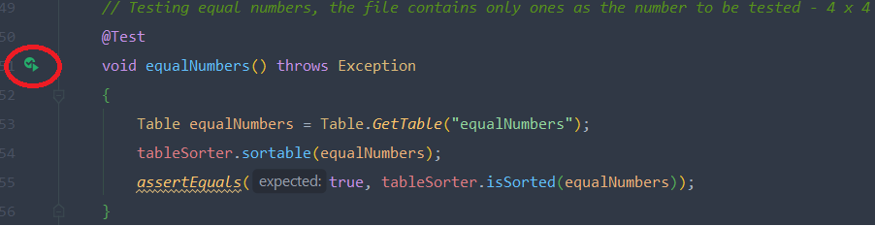

* **Test Case 6 – *negativeNumbers()***

Test with only negative numbers - 5x5

*Execution steps:*

1. Click on the green arrow  next to the method that will execute the test.

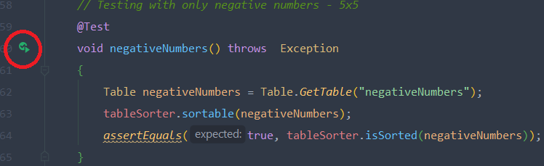

* **Test Case 7 – *notCallingSortable ()***

Test without calling the "sortable" method to test that isSorted returns false

*Execution steps:*

1. Click on the green arrow  next to the method that will execute the test.

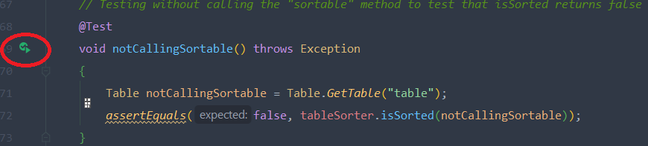

**Executing all tests at once**

We can execute all tests at once in two different ways.

1. Click on the green arrow  next to the class “TableSorter”.

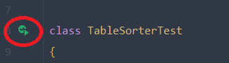

1. Right-click next to the “TableSorterTest” class and choose the option

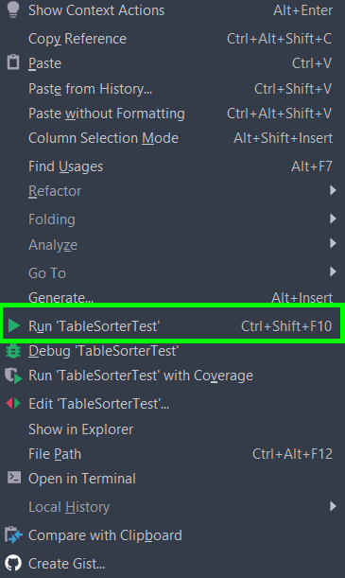

**Results**

The results are displayed at the bottom after the test(s) are executed. IntelliJ will indicate if the past or not by displaying a green arrow for a successful test or a X for an unsuccessful test.



List of testes executed

