Code: 1989

Test Plan: 2096

Test Results:

* Test 1 - Test valid input size when creating table. **Passed**

The test plan mentions that the test is expected to fail, because the input provided is not square.

*Output*:

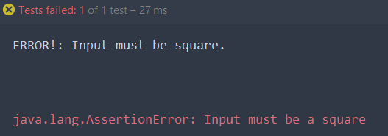

* Test 2 - Test square with positive integers only. **Passed**

The expected output mentioned in the test plan is not shown. However, the test passed.

Output:

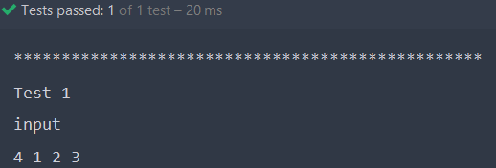

* Test 3 - Test square with negative integers only. **Passed**

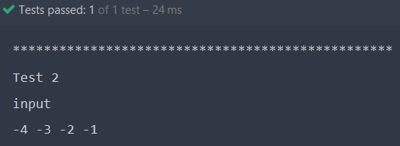

* Test 4 - Test 2 positive integers, one negative integer and a zero. **Passed**

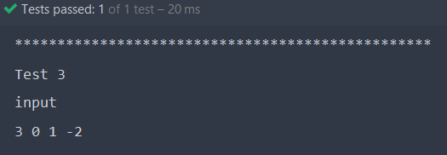

* Test 5 - Test to see if square is sorted. **Passed**

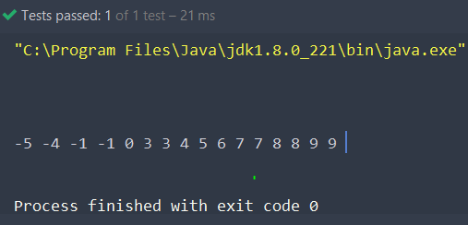

* Test 6 - Test to see if square is not sorted. **Passed**

