Test Plan: 2096

Test Plan review:

* In the “Expected Result” section the author mentions different possibilities depending if the tester changed the file test. The author should just state one possibility in the test case, and create another test case.
* In step 2, the author should have coded the test to classify a failure as a successful test rather than failing the test, which is misleading to the tester.

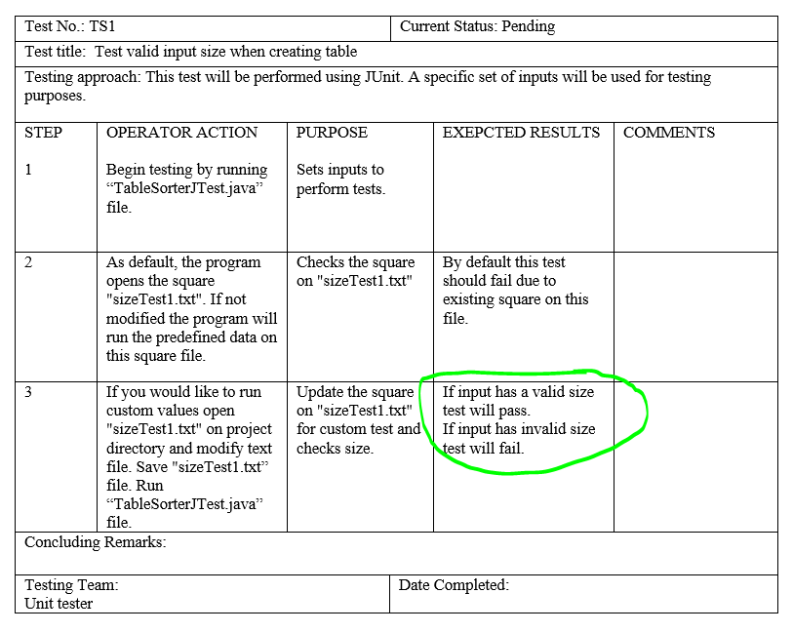

* The output that the author is expecting is not displayed.

