(2) does the test plan work as intended?

Yes, the test plan worked as intended because it revealed a problem in the package hierarchy. After making the necessary package fixes (placing the cs5387 package in the directory) and changing the top line from “package cs5387” to “import cs5387.\* “ I was able to compile the program.

Futhermore, the test revealed that the program crashes when it cannot find the file as follows:  .

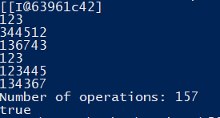Additionally, the test reveals that the output is not very helpful for a human brain as it provides the following table for:

1 2 3

34 45 12

13 67 43

When it should have given:

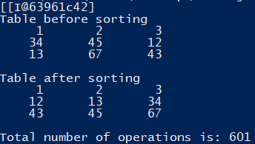.

The test did not provide equivalence classes of inputs to test however but still revealed problems which makes it a successful test plan.