Test Results Code-7146

The code passed all the tests from the 7971-test plan.

I organized the files in this manner according to the test plan and executed the TableSorterTest file using IntelliJ.

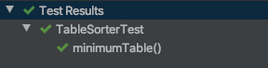

Above is the individual execution of the first test which passed.

Below are the results of all the tests executed at once.

The code behaved as intended. Its structure is easy to follow since it is clear the Table is separated into two parts and sorted in a separate method. Comments and method and variable naming aid in understanding of code.