Test Plan Review

Test Plan ID: 7840

Test Code ID: 8119

Plan:

The test plan calls for the tester to run a “TableTester” class, however, no such class is included. Folder contents are shown below. Therefore, no test was conducted using this test plan.

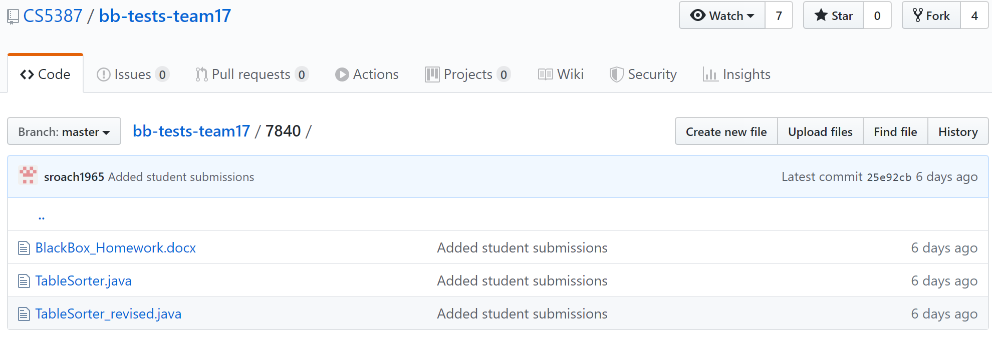

The test plan also calls for additional testing, with the use of text files (not included). Create the text files based on the provided instructions was also ineffective without the previously mentioned “TableTester” class. Attempts to input the text file data to either of the class files provided was unsuccessful, since no file reader function was coded into it. The test file did not provide any method or function to input the text file data.

Conclusion:

Therefore, attempts to conduct testing based on this test plan proved to be unsuccessful. The tools necessary to conduct any testing were not available.