Test Plan ID: 2096

Test Code ID: 8119

Test Results:

All test cases were successful based on the criteria specified in Test Plan ID 2096. Results are shown below.

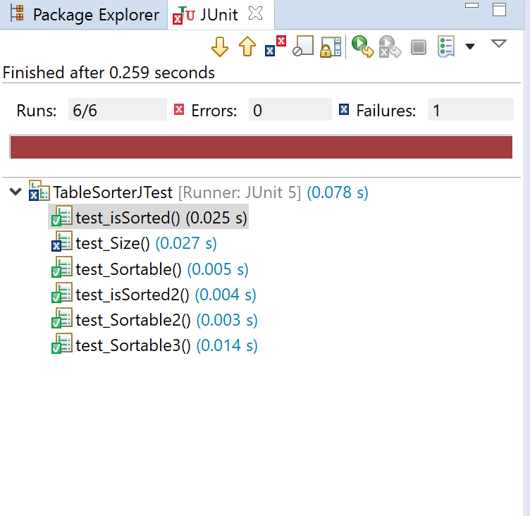

Note: The failed test case for “test_Size()” shown above is considered successful per the criteria expressed in the test plan. Based on the input file, the test should fail.

Conclusion:

Therefore, the test cases are deemed successful, for this test code ID.