1. Plan
   * Identify the purpose of the design and its audience
     + *The purpose of the kids’ website is to introduce astronomy and the planets to children of all genders who are in the ages from around 5 to 8. The child will have access to a mobile device, tablet, and/or laptop computer.*
   * Perform a [heuristic critique (Links to an external site.)](http://faculty.cascadia.edu/brianb/bit175/docs/heuristic.doc) on two comparable sites with comments.
     + *Word documents*
   * Create a mood board with interesting examples of images, fonts, shapes, colors, layouts, etc.
     + [*https://www.pinterest.com/drdraggoo/bit175-kids-site/*](https://www.pinterest.com/drdraggoo/bit175-kids-site/)
   * Create a simple navigation model for your design
2. Design
   * Sketch design ideas on paper for mobile, tablet and desktop versions
     + *See jpg’s*
   * Source, create, and compose **design assets** (images, graphics, fonts, icons, etc.) as needed for your design; document licensing for any graphic assets you use
     + *See PowerPoint*
   * Choose an appropriate color palette for the design

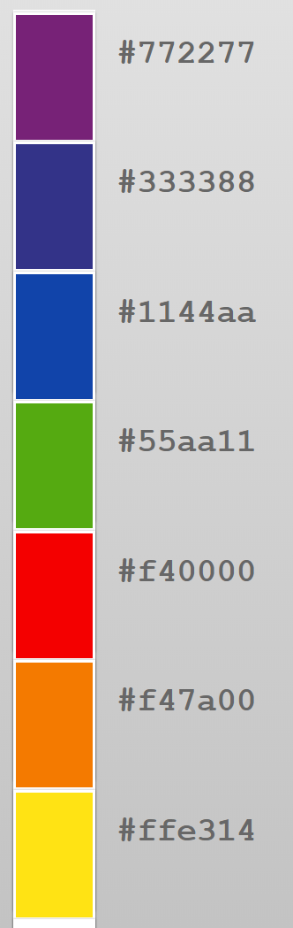

* + **Create style tile(s) for the design**
  + **Refine your layout with Containers and Modules**

1. Code
   * Create a valid, semantic HTML template for a main page and a secondary page
   * Compose your CSS for responsive layout and transitions in the browser
   * Code any interactive design Javascript to complete the template
   * Add **believable** **content** (fictional but representative of the design) for the main page and at least one subpage
2. Add Assignment to your Portfolio

Include a visual of the design in your portfolio along with details that include:

* + Style guide info: site purpose, audience, color palette, and design asset list (with licensing)
  + Design sketches
  + Links to the page templates (main page and subpage)
  + A short paragraph describing the focus/highlight of your work on the design and what you accomplished