AI-Driven Smart-City Traffic and Energy Optimization Using Multi-Agent Q-Learning and Regression-Based Energy Management
Margaret Gonzalez
Computer Science Graduate Program
Full Sail University
Winter Park, Florida, United States
mdgonzalez1@student.fullsail.edu

Abstract—This paper presents a discrete-event simulation of a smart city that jointly automates traffic signals and energy distribution. A 3 × 3 grid of signalized intersections and four energy zones were modeled in SimPy. Nine intersection agents share a tabular Q-learning policy that minimizes queued vehicles, and a gradient-boosting regression model forecasts zone loads to drive peak shaving, inter-zone solar sharing, and traffic-adaptive street lighting. Across five simulated days of about 49,000 vehicles each, the Q-learning agent cut average delay by 55.0 percent compared with fixed-time control and by 16.7 percent compared with a rule-based actuated controller, with no loss of throughput. The forecast-driven energy manager reduced energy wastage by 98.6 percent, peak grid demand by 8.9 percent, and energy cost by 12.7 percent. A Unity scene replays the simulated day in 3D, and fourteen automated tests verified the simulation logic.
Keywords—smart city, traffic signal control, reinforcement learning, Q-learning, energy management, load forecasting, discrete-event simulation

Introduction
Cities are adopting artificial intelligence to manage transportation and energy infrastructure, and a bibliometric study of the field identified intelligent transportation and artificial-intelligence-based energy efficiency as two of its five main research themes [1]. Both systems share a common problem: conventional control rules are designed offline for average conditions, while real demand changes by the minute. Fixed-time traffic signals cannot respond to queues that build during peak periods, and scheduled building and street-lighting systems consume energy whether or not it is needed.
Reinforcement learning (RL) addresses this gap by letting a controller learn a policy from interaction with its environment. Recent studies report that RL signal controllers reduce waiting time and queue length compared with fixed-time and actuated control [2]-[4], and RL is also used to schedule batteries, renewable generation, and building demand response in smart grids [9]-[11]. Most studies, however, examine traffic or energy in isolation. This project builds a single simulation in which both systems run on one clock, so that traffic activity can inform energy decisions such as street-lighting levels.
The objectives of the project were to: (a) build a simulated city with intersections, roads, and energy zones; (b) automate traffic lights with both rule-based logic and an RL agent; (c) model building power consumption and automate its distribution by time of day and usage; (d) train an RL agent and a regression model to minimize waiting time and energy wastage; (e) visualize city activity with animated charts and heatmaps; and (f) measure delay, throughput, and energy efficiency. Section II reviews related work, Section III describes the system design, Section IV explains the methodology, Section V presents results, and Sections VI and VII discuss limitations and conclusions.

Related Work

Reinforcement Learning for Traffic Signal Control
Cai and Wei [2] combined a dueling network, noisy exploration, prioritized replay, and double Q-learning in a controller that selects green durations at a single intersection. In the Simulation of Urban Mobility (SUMO) platform, their method reduced average waiting time by 42.59 percent compared with max-pressure control and by 60.9 percent compared with fixed-time control in one test scenario [2]. Mortazavi Azad and Ramazani [3] applied deep Q-learning to one and two connected intersections and reported a 34 percent reduction in average queue time against a static signal, plus a 24 percent reduction in heavy traffic when agents shared information [3]. Li et al. [4] trained proximal policy optimization agents with federated learning so that intersections share model parameters rather than raw traffic data; their agents converged 47.69 percent faster than single-agent training and reduced waiting time by an average of 27.34 percent [4].
Other work broadens the objective beyond delay. Zhang et al. [5] built a multi-objective controller that reduced traffic conflicts by more than 16 percent and carbon emissions by 4 percent while lowering waiting time by 18 percent compared with traditional adaptive control [5]. Shang et al. [6] studied the effect of deep RL signal control on emissions in urban road networks with cooperative vehicle-infrastructure systems, and Xu et al. [7] used graph attention networks to coordinate multiple intersections even when detector data are missing. Simpler tabular methods remain competitive: Vlasceanu et al. [8] found that a discretized Q-learning controller kept average waiting time between 2.57 s and 3.71 s across traffic densities, while a fuzzy-logic controller rose from 2.67 s to 11.02 s [8]. That result motivated the choice of a compact, explainable tabular agent in this project.

Artificial Intelligence for Smart-Grid and Building Energy
Vamvakas et al. [9] reviewed more than 80 highly cited studies from 2015 to 2023 that apply RL to renewable sources, building energy management, and electric-vehicle charging. Xu et al. [10] reviewed RL across smart-grid evolution and proposed a two-layer framework in which upper-level agents coordinate the grid every hour while lower-level agents adjust devices every 15 min. Han et al. [11] modeled grid-interactive buildings as a partially observable Markov decision process and showed that sequentially updated multi-agent deep RL reduced energy costs and improved load shaping compared with a multi-agent deep deterministic policy gradient baseline. This project adopts the same 15-min dispatch interval as [10] and treats each zone as a separately managed resource, as in [11].

System Design

City Environment
The city is a 3 × 3 grid of signalized intersections (I0-I8) connected by 300 m road links, as shown in Fig. 1. Column 1 is a north-south arterial and row 1 is an east-west arterial, so the center intersection I4 carries the heaviest cross traffic. Vehicles enter at 12 boundary points. Each intersection belongs to one of four energy zones: Residential, Commercial, Industrial, or Mixed-Use. Each zone contains buildings, rooftop solar photovoltaic (PV) panels, a battery, and street lights (Table I).
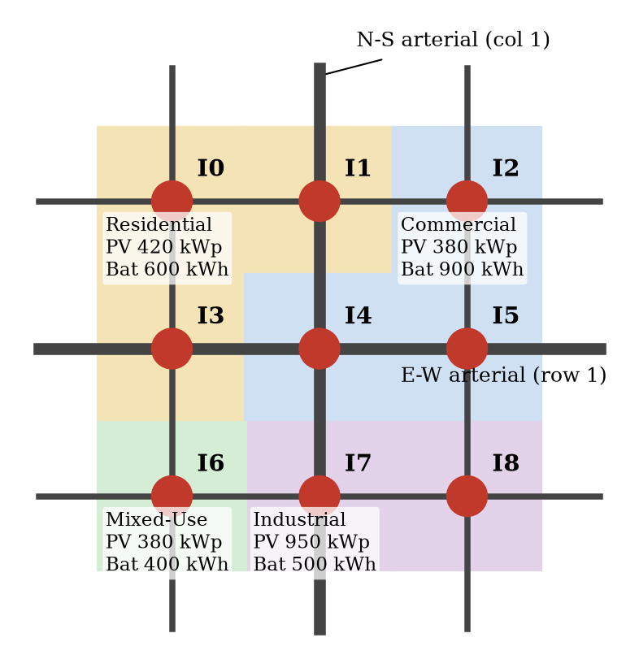
- City layout: nine intersections, two arterials, and four energy zones with solar and battery capacity.
- Simulation Parameters
Parameter | Value
Intersections / links | 9 / 300 m, free-flow 22 s
Saturation flow | 1,800 veh/h per approach (2 s headway)
Yellow + all-red interval | 4 s
Link storage (spillback) | Forty vehicles
Turning probability | 10 % left, 10 % right
Peak entry demand | 620 veh/h (N-S arterial)
Energy dispatch interval | 15 min
Total PV / battery capacity | 2,130 kWp / 2,400 kWh
Street lights | 270 × 0.15 kW LED
Tariff (USD/kWh) | 0.08 off-peak, 0.12 mid, 0.22 on-peak

Traffic Model
The traffic model is a discrete-event simulation built with SimPy. Each of the 12 entry points is a process that generates vehicles with a non-homogeneous Poisson arrival rate that follows a 24-hour demand curve with morning and evening peaks. Each intersection is a second process that, every 2 s, moves arriving vehicles from the upstream link into stop-line queues, asks its controller whether to change phase, and discharges one vehicle from each approach that has a green signal. Two phases are used: north-south green and east-west green. A vehicle cannot leave if the downstream link is full, which reproduces queue spillback between intersections. The delay of vehicle i is its travel time minus its free-flow time:
$d_{i}=(t_{i,exit}-t_{i,enter})-[(h_{i}-1)τ+\frac{τ}{2}]$ (1)
where h_{i} is the number of intersections the vehicle crossed and τ = 22 s is the free-flow link travel time. Throughput is the number of vehicles that complete their trips per hour.

Traffic-Signal Controllers
Three controllers were compared. The fixed-time controller gives each phase 30 s of green, which produces a 68 s cycle. The rule-based actuated controller enforces a 10 s minimum and a 60 s maximum green, ends the green when the served approaches are empty (gap-out), and otherwise switches when the red-direction queue exceeds the green-direction queue by more than three vehicles.
The RL controller uses tabular Q-learning [12]. Every 2 s after a 10 s minimum green, each agent observes a state s made of five discretized features: queue pressure (red queue minus green queue), green queue, vehicles approaching on green links, elapsed green time, and red queue. This creates 864 phase-symmetric states. The agent then chooses action a ∈ {keep, switch}. The reward is the negative mean number of queued vehicles at the intersection between decisions, which is proportional to total waiting time:
$r_{t}=-\frac{1}{10n}\sum_{k=1}^{n}{q_{k}}$ (2)
where q_{k} is the total queue at tick k and n is the number of ticks since the last decision. The Q-values are updated with the standard rule [12]:
$Q(s,a)←Q(s,a)+α[y-Q(s,a)]$ (3)
where y = r + γ max_{*a*′} Q(s′, a′) is the learning target, α is the learning rate, and the discount factor is γ = 0.9. All nine agents read and update one shared Q-table. This parameter sharing is a simple form of multi-agent learning: each agent acts on local information, but experience from every intersection improves the common policy. A 90 s maximum-green safety rule prevents the agent from starving a direction.

Energy Grid Model
Building load in zone z at time t is the product of the number of buildings, the average building demand, and a normalized hourly profile for the zone type, plus a cooling term that rises with outdoor temperature and 3 percent random noise. Solar output follows a daylight curve with random cloud cover. Street lights operate only in darkness. Every 15 min, a SimPy energy process reads the current traffic density of the intersections in each zone and dispatches energy so that supply equals demand:
$P^{grid}+P^{PV}+P^{dis}+P^{in}=L+P^{ch}+P^{out}+P^{curt}$ (4)
where L is the building and lighting load, P^{ch} and P^{dis} are battery charge and discharge, P^{in} and P^{out} are solar energy received from and sent to other zones, and P^{curt} is solar energy that is curtailed because it cannot be used or stored.

Energy Optimization
The baseline policy reflects common practice: street lights run at full power all night, each battery charges from local solar surplus and discharges whenever its zone has a deficit, and surplus that the battery cannot hold is curtailed. The artificial-intelligence-optimized policy adds four functions. First, a gradient-boosting regression model [13], implemented with scikit-learn [14], forecasts each zone's load for the next day from the hour, day of week, temperature, zone, traffic density, and the load at the same time on the previous day. Second, the forecast sets a peak-shaving threshold θ_{z}, the lowest grid level the battery can sustain, found by bisection so that:
$\sum_{t}{{\min{(F_{z,t}-S_{z,t}-θ_{z},P_{max})}}^{+}Δt}=0.9ηE_{z}$ (5)
where F is the forecast load, S is the expected solar output, P_{max} is battery power, E is battery capacity, η = 0.95 is battery efficiency, and [x]⁺ = max(0, x). The battery also discharges during on-peak prices and pre-charges at night only by the amount that tomorrow's forecast solar surplus will not supply. Third, surplus solar in one zone is shared with deficit zones at 97 percent feeder efficiency. Fourth, street lights dim in proportion to measured traffic density, with a 30 percent safety floor:
$λ_{z}=\min{\{1, 1.1[0.3+0.7\min{(1,\frac{ρ_{z}}{0.5})}]\}}$ (6)
where ρ_{z} is the number of vehicles near the zone's intersections divided by a busy-road reference level. Energy wastage is defined as curtailed solar energy plus lighting energy above the traffic-based need, and energy efficiency is one minus wastage divided by total energy supplied.

Unity 3D Simulation Environment
The city is also rendered as a 3D environment in Unity. Python remains the simulation and learning engine, and an export script reruns evaluation day 1 for each controller with event logging switched on. It records every vehicle's arrival at and departure from each stop line, every signal change, and every 15-min energy dispatch record. Logging does not change the random-number stream, so the replay reproduces the reported day exactly: average delays of 42.49 s, 22.96 s, and 19.24 s for the three controllers. Unity C# scripts build the road grid, zone tiles, buildings with rooftop solar panels, signal heads, street lights, and battery and grid-import bars from primitives. Each frame, every vehicle is placed according to its logged state: entering, queued at a stop line, crossing a link, or leaving the grid. Building color follows zone demand, panels turn pink when solar energy is curtailed, and lamp brightness follows the dimming rule in (6). A dashboard lets the user switch controllers and energy policies during playback, change the speed, view grid-import or queue heatmaps on the ground, and compare live delay and energy metrics.

Experimental Methodology
The Q-learning agent was trained for 240 episodes of 2 h of simulated traffic. Each episode started at a random hour and scaled demand by a random factor between 0.8 and 1.3 so that the agent experienced night, off-peak, and peak conditions. Exploration (ε) decreased linearly from 0.6 to 0.05, and the learning rate decreased from 0.3 to 0.05. The forecaster was trained on 14 days of synthetic metered data (5,376 samples) and tested on a held-out 7-day period (2,688 samples).
Each controller was then evaluated on five independent 24-hour days that used different random seeds. Exploration and learning were turned off during evaluation. Both energy policies were run side by side within the same simulations so that they faced identical building loads, weather, and traffic. A stress test repeated the traffic evaluation with 20 percent more demand on three new seeds. Results are reported as mean ± standard deviation across days.
To verify that the simulation behaves correctly, 14 automated tests were written with pytest. They check vehicle conservation (generated vehicles equal completed vehicles plus vehicles still in the network), the absence of conflicting green signals, a yellow interval before every green, the 30 s fixed-time green, non-negative delays, link-capacity limits, battery state-of-charge bounds, the energy balance in (4) at every interval, the lighting safety floor, forecaster accuracy, Q-value updates, that the trained agent outperforms fixed-time control, and that the Unity trace matches the simulated trips hop by hop. All 14 tests passed (Fig. 2).
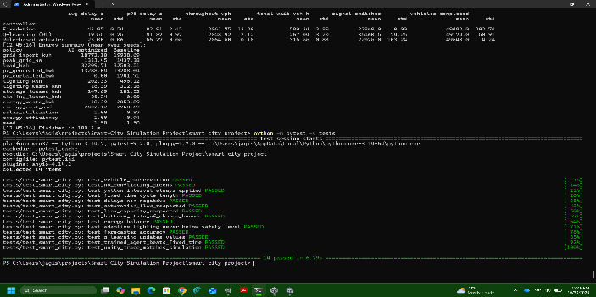
- Console output of the automated validation test suite (14 of 14 tests passed).

Results

Learning Behavior
Fig. 3 shows the training curve. The average wait fell from 24.1 s over the first 20 episodes to 19.0 s over the last 40 episodes, and the agent visited 295 of the 864 possible states. Episode-to-episode variation remains because each episode uses a different start hour and demand level. Inspection of the learned table showed that the agent keeps the green when queue pressure is negative and switches more often as pressure increases, which matches the logic a traffic engineer would expect.
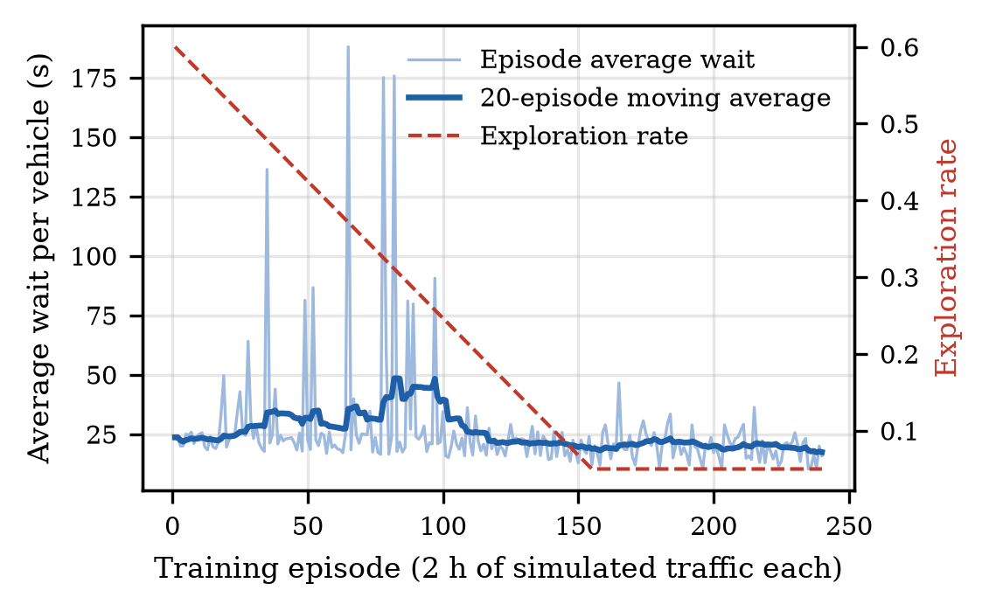
- Q-learning training curve with exploration rate.

Traffic Performance
Table II summarizes traffic results. The Q-learning agent achieved an average delay of 19.18 s, compared with 23.03 s for the rule-based controller and 42.63 s for fixed-time control. These are reductions of 55.0 percent and 16.7 percent. The 95th-percentile delay, which reflects the worst trips, fell by 48.7 percent and 25.8 percent. Total waiting time fell from 583 to 263 vehicle-hours per day. Throughput was nearly identical for all three controllers because the network operated below capacity, so every vehicle eventually completed its trip; the benefit of adaptive control therefore appears as shorter delay rather than higher throughput. The standard deviations are small, so the differences are consistent across days.
- Traffic Performance (Mean ± SD, 5 Days)
Metric | Fixed | Rule-based | Q-learning
Average delay (s) | 42.63 ± 0.36 | 23.03 ± 0.05 | 19.18 ± 0.18
95th-pct. delay (s) | 82.0 | 56.7 | 42.0
Throughput (veh/h) | 2052 | 2054 | 2054
Total wait (veh-h) | 583 | 315 | 263
Phase switches/day | 22,869 | 21,959 | 33,851
+20 % demand delay (s) | 73.7 | 25.3 | 22.3

Fig. 4 shows delay by hour. Fixed-time delay reaches about 50 s at the 08:00 and 17:00 peaks and stays near 35 s overnight, because vehicles wait for a fixed cycle even when the cross street is empty. Both adaptive controllers reduce night delay to about 9 s. The Q-learning agent holds its advantage through the day and is lowest during the midday and evening shoulders. The queue heatmaps in Fig. 5 show that fixed-time control produces long queues on the north-south arterial (I1, I4, I7) during both peaks, while the Q-learning agent spreads green time to clear them.
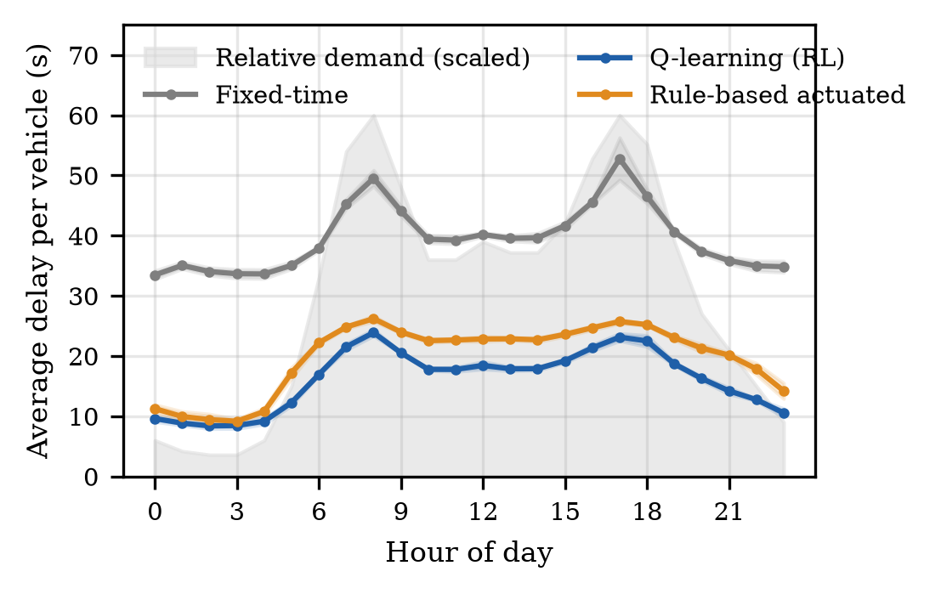
- Average delay by hour of day (shaded bands show ±1 standard deviation across five days).
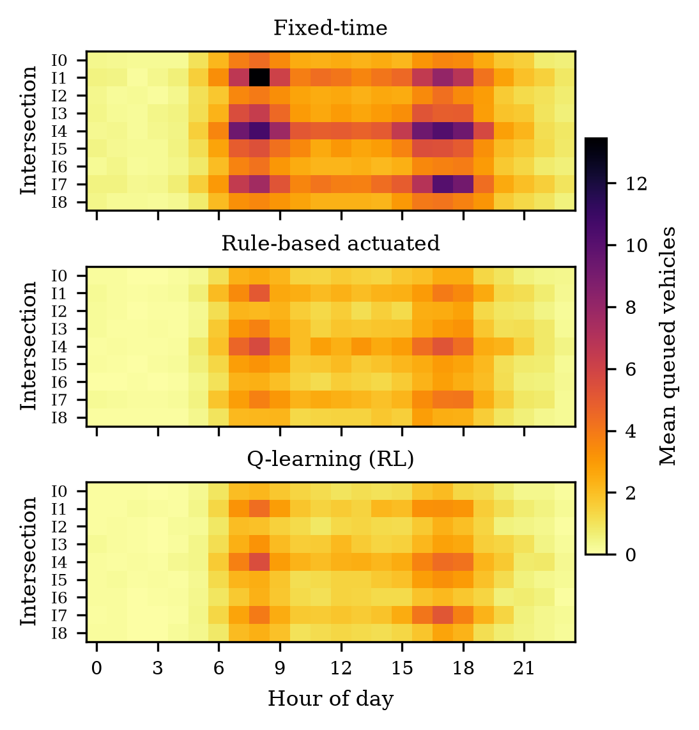
- Heatmaps of mean queued vehicles by intersection and hour for each controller.
The Q-learning agent switches phases about 1.5 times as often as the rule-based controller. Short, frequent greens clear small queues quickly at the cost of more yellow intervals. In the +20 percent stress test, the agent still achieved the lowest delay (22.3 s versus 25.3 s and 73.7 s), a 12.1 percent improvement over rule-based control, while fixed-time delay increased sharply as its arterial approaches neared saturation.

Energy Performance
The forecaster achieved a mean absolute error of 11.0 kW, a mean absolute percentage error of 3.8 percent, and a coefficient of determination of 0.996 on the held-out week (Fig. 6). Its error was 45 percent lower than a naive forecast that repeats the previous day's load.
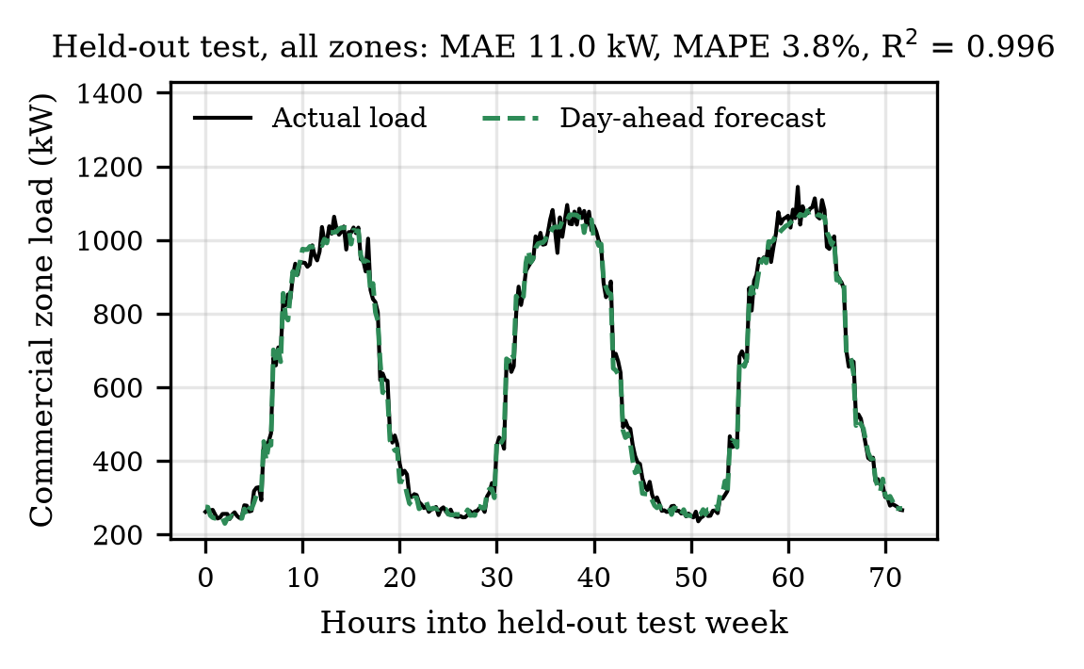
- Day-ahead load forecast compared with actual load for the Commercial zone over three test days.
Table III and Fig. 7 compare the two energy policies. The optimized policy stored or shared nearly all midday solar surplus, so solar utilization rose from 87.0 percent to 99.9 percent and curtailment fell from 1,721 kWh to 10 kWh per day. Holding battery energy for the evening lowered peak grid demand from 1,448 kW to 1,319 kW and moved purchases into cheaper hours, reducing daily cost by 12.7 percent.
- Energy Performance (Mean, 5 Days)
Metric | Baseline | AI-optimized | Change
Grid import (kWh/day) | 19,993 | 18,857 | −5.7 %
Peak grid demand (kW) | 1,448 | 1,319 | −8.9 %
Solar curtailed (kWh) | 1,721 | 10 | −99.4 %
Street lighting (kWh) | 496 | 203 | −59.1 %
Energy wastage (kWh) | 2,033 | 29 | −98.6 %
Wastage + lossesª (kWh) | 2,214 | 335 | −84.9 %
Energy cost (USD/day) | 2,769 | 2,417 | −12.7 %
Energy efficiency | 94.1 % | 99.9 % | —
- Conversion losses are battery and feeder losses; including them keeps the comparison conservative.

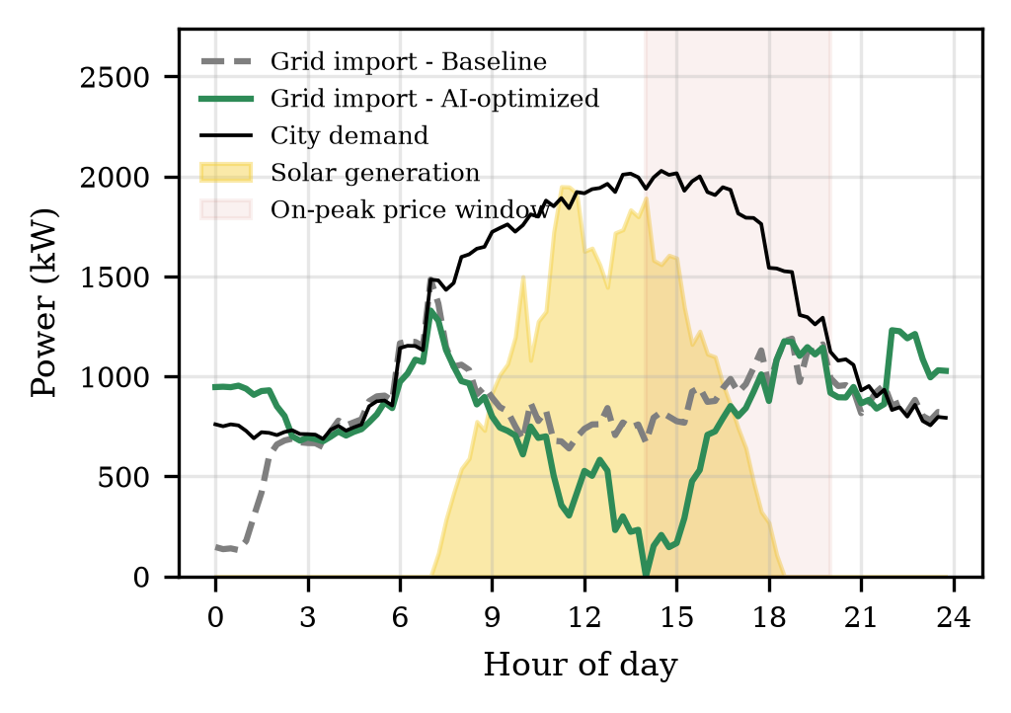
- City-wide demand, solar generation, and grid import under both energy policies for one simulated day.
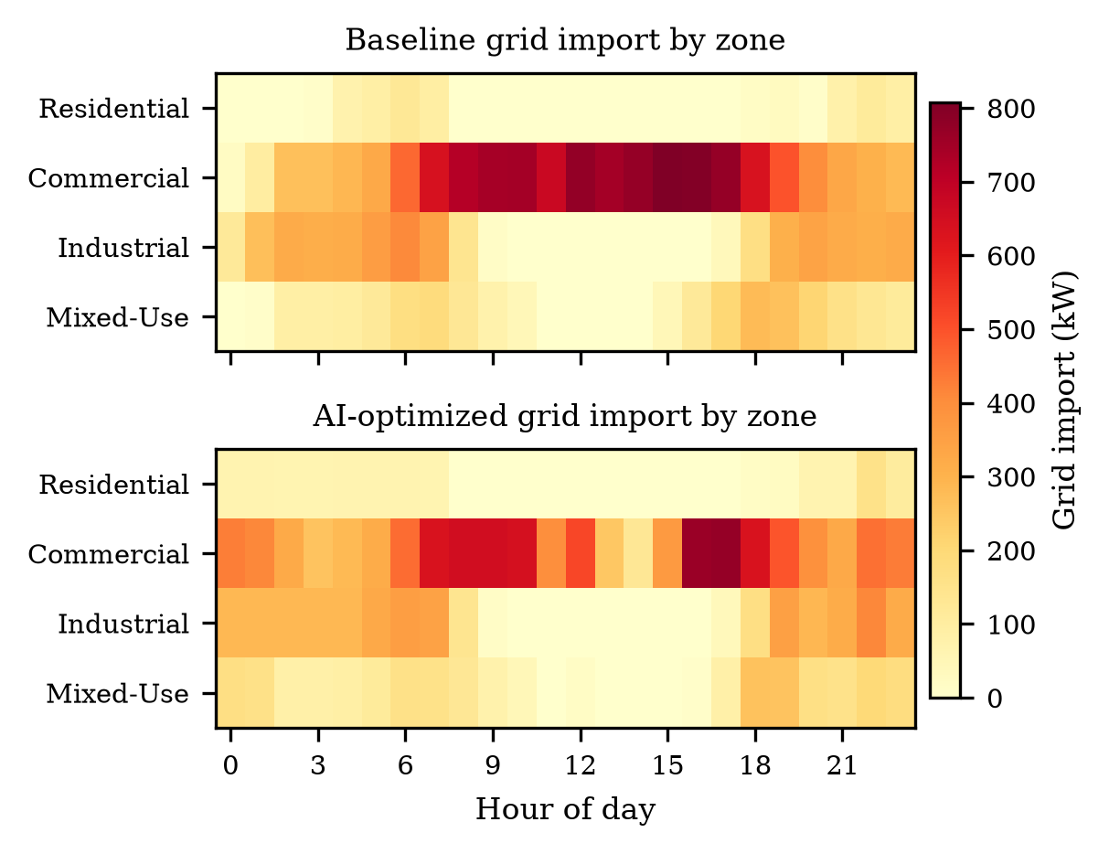
- Heatmaps of grid import by zone and hour for the baseline and optimized energy policies.
Fig. 8 shows where the savings occur. The Commercial zone dominates grid demand because its offices draw about 1,000 kW during business hours, while the Residential and Industrial zones produce surplus solar at midday. Under the optimized policy, that surplus flows to the Commercial zone instead of being curtailed. The optimized policy imports more energy between 22:00 and 06:00 because it pre-charges batteries at the off-peak price, which is the intended trade-off.

Traffic Density and Energy Use
Fig. 9 links the two subsystems. Vehicle counts peak at 08:00 and 17:00, while building demand peaks in the early afternoon, so traffic and electricity peaks do not coincide in this city. At night, traffic density is low, so the adaptive lighting rule dims street lights toward the 30 percent floor and cuts lighting energy by 59.1 percent. Fig. 10 shows a frame of the Python animation, which plays the full 24 hours with live queue bars, signal states, and zone grid import. Fig. 11 shows the same peak in the Unity environment, where switching from fixed-time to Q-learning control visibly shortens the red queues on the north-south arterial and switching to the optimized energy policy removes the pink curtailed rooftops at midday.
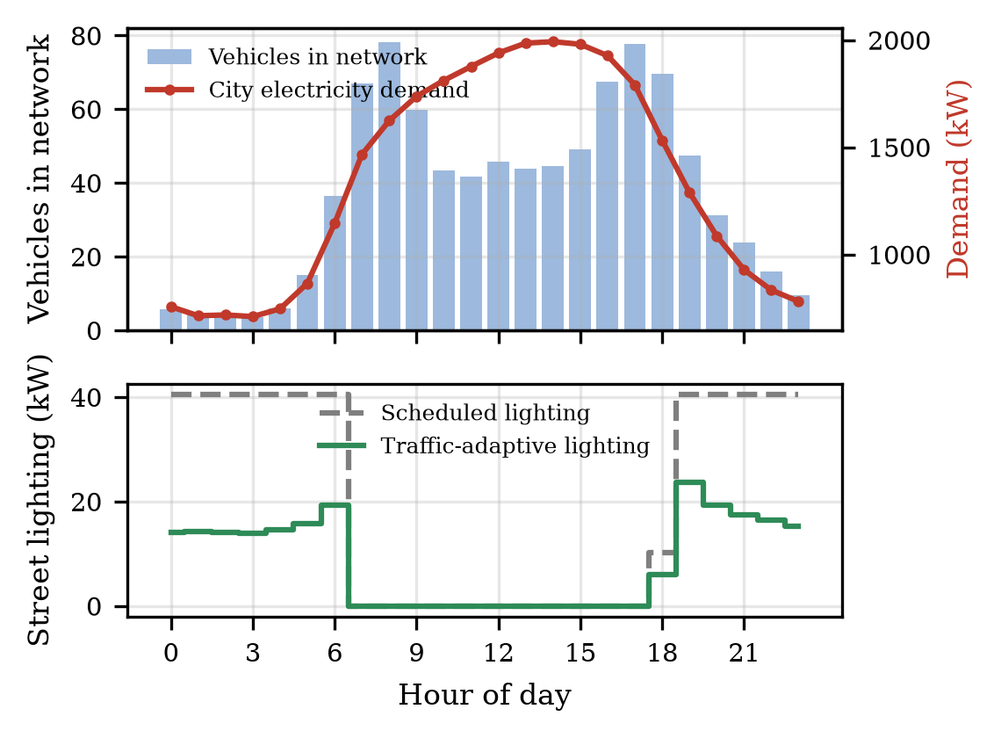
- Traffic density compared with city electricity demand (top) and street-lighting power under scheduled and traffic-adaptive control (bottom).
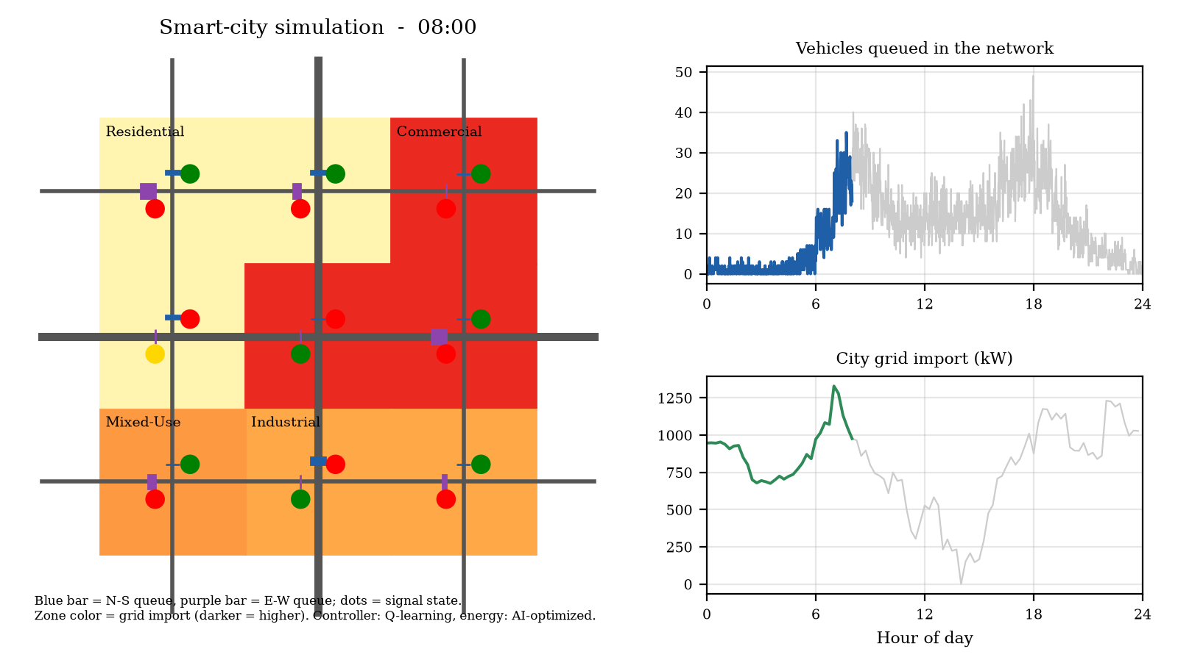
- Frame from the animated simulation at 08:00 showing queues, signal phases, and zone grid import.
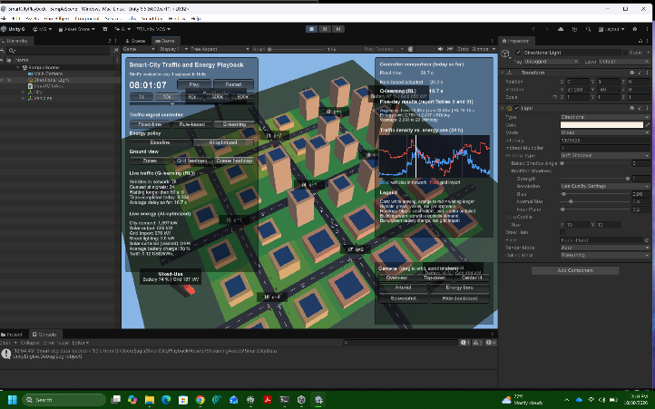
- Unity 3D playback of the Q-learning controller at 08:00 with the queue heatmap, signal states, rooftop solar, zone battery and grid bars, and the live dashboard.

Discussion
The results support the findings of [2]-[4] and [8]: a learning controller that responds to measured queues outperforms fixed-time control by a wide margin and also improves on a well-tuned rule-based controller. The gain over the rule-based controller is smaller than the gain over fixed-time control, which is expected because both adaptive controllers observe the same queues. The Q-learning agent's advantage comes from learning when to end a green early or extend it based on the combination of pressure, approaching vehicles, and elapsed time, rather than from a single fixed threshold. The energy results agree with the reviews in [9] and [10]: forecasting and storage scheduling deliver the largest savings when they shift renewable surplus to times of high demand.
The project has several limitations. First, the traffic model uses one lane per approach, two signal phases, and point-queue links instead of the car-following models used in SUMO [2]-[4]. Second, loads, weather, and traffic are synthetic, so the absolute values describe this simulated city rather than a real one. Third, the tabular agent observes only local information; graph-based or communicating agents such as those in [3] and [7] could coordinate green waves along the arterials. Fourth, the energy optimizer is a forecast-driven rule set rather than an RL agent, so it cannot learn new dispatch strategies. Future work will replace the tabular agent with a deep Q-network, add an RL battery agent similar to [11], calibrate demand with real detector and smart-meter data, and run the agent inside Unity in real time instead of replaying recorded traces.

Conclusion
This project built an integrated smart-city simulation in which nine Q-learning traffic agents and a forecast-driven energy manager share one discrete-event clock. The agents reduced average vehicle delay by 55.0 percent compared with fixed-time signals and by 16.7 percent compared with rule-based actuated control without reducing throughput, and they kept this advantage under 20 percent higher demand. The energy manager used a regression forecast to reduce wastage by 98.6 percent, peak demand by 8.9 percent, and cost by 12.7 percent. A Unity 3D environment replays the simulated day for inspection and demonstration. Automated tests, multi-day evaluation, and visual outputs confirm that the system works as designed.

AI Tool Usage Statement
In accordance with the course policy, AI-assisted development tools were used to help draft simulation code and figures. The author ran, tested, and validated all code, verified every reported number against the generated output files, and confirmed every reference against its published source.

References
- E. Karger, A. Rothweiler, T. Brée, and F. Ahlemann, “Building the smart city of tomorrow: A bibliometric analysis of artificial intelligence in urbanization,” Urban Sci., vol. 9, no. 4, Art. no. 132, Apr. 2025, doi: 10.3390/urbansci9040132.
- C. Cai and M. Wei, “Adaptive urban traffic signal control based on enhanced deep reinforcement learning,” Sci. Rep., vol. 14, Art. no. 14116, Jun. 2024, doi: 10.1038/s41598-024-64885-w.
- S. M. Mortazavi Azad and A. Ramazani, “Smart control of traffic lights based on traffic density in the multi-intersection network by using Q learning,” Discover Artif. Intell., vol. 3, Art. no. 39, Nov. 2023, doi: 10.1007/s44163-023-00087-z.
- M. Li, X. Pan, C. Liu, and Z. Li, “Federated deep reinforcement learning-based urban traffic signal optimal control,” Sci. Rep., vol. 15, Art. no. 11724, Apr. 2025, doi: 10.1038/s41598-025-91966-1.
- G. Zhang, F. Chang, J. Jin, F. Yang, and H. Huang, “Multi-objective deep reinforcement learning approach for adaptive traffic signal control system with concurrent optimization of safety, efficiency, and decarbonization at intersections,” Accid. Anal. Prev., vol. 199, Art. no. 107451, May 2024, doi: 10.1016/j.aap.2023.107451.
- W.-L. Shang et al., “The impact of deep reinforcement learning-based traffic signal control on emission reduction in urban road networks empowered by cooperative vehicle-infrastructure systems,” Appl. Energy, vol. 390, Art. no. 125884, Jul. 2025, doi: 10.1016/j.apenergy.2025.125884.
- D. Xu, Z. Yu, X. Liao, and H. Guo, “A graph deep reinforcement learning traffic signal control for multiple intersections considering missing data,” IEEE Trans. Veh. Technol., vol. 73, no. 12, pp. 18307-18319, Dec. 2024, doi: 10.1109/TVT.2024.3444475.
- I.-M. Vlasceanu et al., “Comparative evaluation of fuzzy logic and Q-learning for adaptive urban traffic signal control,” Electronics, vol. 14, no. 14, Art. no. 2759, Jul. 2025, doi: 10.3390/electronics14142759.
- D. Vamvakas, P. Michailidis, C. Korkas, and E. Kosmatopoulos, “Review and evaluation of reinforcement learning frameworks on smart grid applications,” Energies, vol. 16, no. 14, Art. no. 5326, Jul. 2023, doi: 10.3390/en16145326.
- N. Xu, Z. Tang, C. Si, J. Bian, and C. Mu, “A review of smart grid evolution and reinforcement learning: Applications, challenges and future directions,” Energies, vol. 18, no. 7, Art. no. 1837, Apr. 2025, doi: 10.3390/en18071837.
- Y. Han, J. Wu, H. Chen, F. Si, Z. Cao, and Q. Zhao, “Enhancing grid-interactive buildings demand response: Sequential update-based multiagent deep reinforcement learning approach,” IEEE Internet Things J., vol. 11, no. 14, pp. 24439-24451, Jul. 2024, doi: 10.1109/JIOT.2024.3357109.
- C. J. C. H. Watkins and P. Dayan, “Q-learning,” Mach. Learn., vol. 8, no. 3-4, pp. 279-292, May 1992, doi: 10.1007/BF00992698.
- J. H. Friedman, “Greedy function approximation: A gradient boosting machine,” Ann. Statist., vol. 29, no. 5, pp. 1189-1232, Oct. 2001, doi: 10.1214/aos/1013203451.
- F. Pedregosa et al., “Scikit-learn: Machine learning in Python,” J. Mach. Learn. Res., vol. 12, pp. 2825-2830, 2011. [Online]. Available: https://jmlr.org/papers/v12/pedregosa11a.html

