**Internet protocol version 6**

* It develop by “Internet Engineering task force” (IETF).
* It is 128-bit(32 hexa-decimal)ip address, which divide into 8 quarter and each quarter have 4 hexa-decimal value.
* Each and every portion seprated with “:” (semi-colmn)
* It supportIpsec (internet protocol security)
* NDP (neighbor discovery protocol) is available in IPV6. The NDP is based on ICMPv6 message that manage the interaction nodes on the same link. There are no arp for ipv6 and the role of arp is replaced by NDP.
* MLD (Multicast listener discovery) protocol use to manage multicast group membership.
* It represented into hexa-decimal format. (0-9 , a-f)

Like :->2001:ab01:cd02:ea04:ac05:cd06

* It use shortest expression for representing like

2001:ab01:0000:0000:0000:cd06 in this example 3 portion have zero , then we are represented it : 🡪 2001:ab01::cd06 (double semi-column)

* IPv6 prefixes:

Ipv6 prefixes represent a range or block of consecutive Ipv6 addresses. Just like routers use Ipv4 subnets in Ipv4 subnets in Ipv4 routing tables to represent ranges of consecutive addresses, routers use Ipv6 prefixes to represent ranges of consecutive IPv6 address as well.

IPv6 prefixes are often called IPv6 subnets, It use only classless network

For example :

2000:1234:5678:9abc:1234:5678:9abc:1111/64

In this example first 64 bit is its prefixes (Subnets), and we are purely known single hexa-decimal value is equal to 4 bit. So 64 bit = 16 hexa-decimal value.

Means In this example first 16 hexa-decimal value (first four quarter) is its prefixes.

As with IPv4 , when writting or typing a prefix, the bits past the end of the prefix length are all binary 0s. In the IPv6 address previously shown, the prefix in which the address resides would be

2000:1234:5678:9abc:0000:0000:0000:0000/64

Thats, ti abbreviated, would be

2000:1234:5678:9abc::/64

This prefix lenth is totally multiple with 16, In case prefix length is not multiple with 16, then its interface ID (host ID) part of the address is inside a quarter. Just like on this example we consider prefix length is /44. Than whole first 2 quarter is including in prefix, plus 3 hexa digits value is include of fouth quarter, as fallow:

2000:1234:5670::/44

**Note:** The /48 prefix assigned to a single company is called either a global routing prefix or a site prefix.

**Prefix Terminology:**

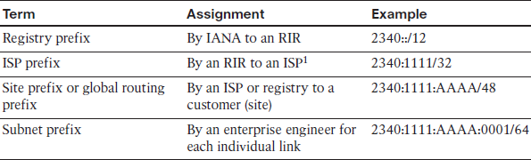

* Ipv6 special usable range:

1. ::/0 🡪 use for default routing
2. ::/128 🡪 Unspecified address like (0.0.0.0)
3. ::1/128 🡪 loopback address
4. 2000::/3🡪 global unicast address (public use)
5. Fc00::/7🡪 unique local address (private use)
6. Fe80::/10 🡪 link-local (mac base ipv6)
7. Fec0::/10 🡪 site-local (ipv4 base ipv6)
8. 2002::/32 🡪 6 to 4 tunneling
9. Ff00::/8 🡪 multicasting

Special multicast address:

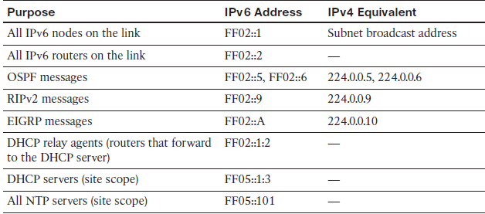

* Ipv6 address type:

1. Unicast: one to one communication
2. Multicast: one to many communications but particular group
3. Anycast: an address configured in multiple locations

(broadcast is not available, but every node ff02::1 used for broadcast similar functionally).

* Subnetting Global Unicast IPv6 addresses Inside an Enterprise

The original IPv4 Internet design called for each organization to be assigned a classful network number, with the Enterprise network subdividing the network into smaller address ranges by subnetting the classful network. This same concept of subnetting carries over from IPv4 to IPv6, with the Enterprise subnetting its assigned global unicast prefix into smaller prefixes.

1. The prefix assigned to the Enterprise by the ISP (the global routing prefix) acts like the prefix assigned for IPv4.
2. The Enterprise engineer extends the prefix length, borrowing host bits, to create a subnet part of the address with which to identityindividual subnets.
3. The remaining part of the addresses on the right, called either the interface ID or host part.

For example, below figure more detailed view of the Company1 Enterprise network.

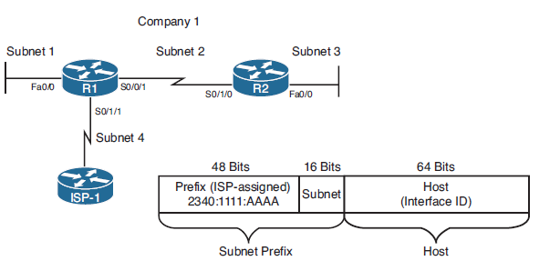

Address is :🡪 2340:1111:AAAA::/64

* Why Ipv6:

1. Larger address space
2. Simplified Header
3. End to end connectivity
4. Auto-configuration
5. Faster forwarding/routing
6. IP Sec
7. No broadcast
8. Any cast Support
9. Mobility
10. Enhanced priority Support
11. No need for NAT/PAT
12. Transition tools (ipv4 to ipv6 tools)

* Assigning IPv6 Global Unicast address on interface

Here we are discuses about how to IPv6 host known what is global unicast ipv6 address to use. It requires following IPv6 parameters:

1. IP address
2. IP subnet Mask (Prefix length)
3. Default Router IP address
4. DNS IP address (es)

Any IPv6 host know about all of these parameter by using following method:

1. Stateful DHCP
2. Stateless autoconfig (stateless DHCP)
3. Static configuration
4. Static config with EUI-64

**Stateful DHCP**

IPv6 host can use stateful DHCP to learn an IP address and corresponding prefix length and the DNS IP address (es). This process is generally same as IPv4 but here stateful DHCPv6 does not supply the default router configuration, instead relying on Neighbor Discovery Protocol b/w the client and local routers. It is track state information of DHCPv6 client.DHCPv6 client send multicast request for finding DHCPv6 server.

**Stateless autoconfig (stateless DHCP)**

Stateless autoconfiguration allow a host to automatically learn the key pieces of addressing information – Prefix, host and prefix lenght – Plus the default router IP address and DNS IP addresses. Stateless DHCP function:

1. IPv6 Neighbor Discovery protocol, particularly the router solicitation and router advertisement messages, to learn the prefix , prefix lengh and default router.
2. Some math to derive the interface ID portion of the IPv6 address, using a format called EUI-64 (extended User interface -64).
3. Stateless DHCP to learn the DNS IPv6 address.

**Note:** It does not track any DHCP client information.

**Learning the prefix/length and Default router with NDP Router advertisements**

The IPv6 Neighbor Discovery Protocol (NDP) has many functions. One function allows

IPv6 hosts to multicast a message that asks all routers on the link to announce two key

pieces of information: the IPv6 addresses of routers willing to act as a default gateway

and all known IPv6 prefixes on the link. This process uses ICMPv6 messages called a

Router Solicitation (RS) and a Router Advertisement (RA).

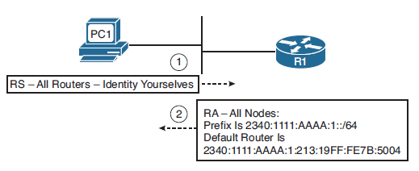

IPv6 host does not use broadcast address for sending RS and RA message. They use multicast address RS message send on FF02::2 and RA message use FF02::1.

**Calculating the Interface ID Using EUI-64**

The second half (64bit) of IPv6 unicast address is called *host part or interface ID*. IPv6 this part automatically create derived from the host’s MAC address. Because MAC address is globally unique and Interface ID should also be globally unique.

MAC address is 48-bit (6-byte) it expands to 64-bit value. To do so IPv6 fill in 16-bit into the middle of MAC address.

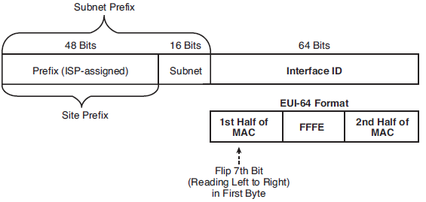

* **Configuration of IPv6 on CISCO router**

1. IPv6 unicast-routing:

The global configuraton mode command which enable the routing of unicast IPv6 traffic.

1. IPv6 cef:

The global configuration mode command that enables CISCO express forwarding for IPv6

1. IPv6 flowset:

The global configuration mode command that configures flow-label marketing in 1280-byte or larger packet sent from the router.

1. IPv6 address <address/lengh>

Static configuration of the entire IPv6 unicast address.

1. IPv6 address <Prefix/length> eui64

Static configuration of the first 64 address: the router derives the last 64 bit with EUI64

1. IPv6 address autoconfig

Router uses stateless autoconfig to find an address.

1. IPv6 address dhcp

Router uses stateful DHCP to find an address.

1. IPv6 enable

Enables IPv6 on the interface, but results in only a link-local address.

1. IPv6 address <address> link-local

Manually create link-local address

1. Ipv6 address <address/length>anycast

Designates that the unicast address is an anycast address.

* **IPv6 Routing Protocol:**

1. RIPng (Next generation) , RFC 2080
2. OSPFv3 , RFC 5340
3. EIGRP for IPv6 , proprietary
4. MP-BGP4, Multiprotocol BGP4 , RFC 4760

**Static Routing (IPv6)**

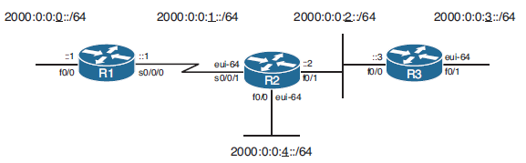

Step:

Provide IP address as per figure, but base on EUI-64 (only R2’s f0/0 and R3’s f0/1)

Enable IPv6 routing of interface.

“Ipv6 unicast-routing

Ipv6 route <destination ipv6>/<prefix><exit interface ipv6>/prefix