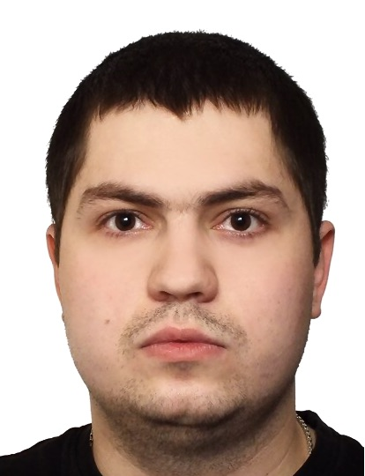

|  |  |  |  |
| --- | --- | --- | --- |
| <https://bit.ly/itagrad> | | Alexei Denisov  Junior QA Engineer  Phone: +38 063 375 59 80  Email: [denisovUAlexei@gmail.com](mailto:denisovUAlexei@gmail.com);  Telegram: +38 063 375 59 80  LinkedIn:  <https://www.linkedin.com/in/alexei-denisov> | |
| Summary of Qualifications | I am a beginner QA Engineer. I would like to find a team that will provide me with future career growth opportunities and access to some interesting projects. | | |
|  | | | |
| Skills | Programming Languages/Technologies   * HTML/CSS   RDBMS   * MySQL   Methodologies   * Agile: Scrum, Kanban   Operating Systems   * Microsoft Windows XP/ 2003 Server/ Vista * MacOS Big Sur (11.2.1) | | Testing Tools   * Atlassian JIRA * TestLink * Mantis * Confluence * Postman * JMeter * Git Desktop |
|  |  | | |
| Experience / IT related educational practice |  | | |
|  | **ROZETKA webstore** | | |
| Project Description: | The Ukrainian online webstore and marketplace that enables users to purchase various products. Users access service through the website interface | | |
| Customer: | SoftServe | | |
| Involvement Duration: | 2 months | | |
| Project Role: | Trainee QA Engineer | | |
| Responsibilities: | * Test plan creation; * Checklist creation; * Test case creation; * Test case execution; * Bug report creation; * Description requirements as User Stories; * Test scenarios preparation using test design techniques; * API testing; * Performance testing. | | |
| Project Team Size: | 6 team members | | |
| Tools & Technologies: | HTML5, Atlassian JIRA, Postman, JMeter. | | |
| Languages | English – Pre-intermediate | | |
|  | | |
|  |  | | |
| Education | **Specialist degree**  National Technical University of Ukraine “Kharkiv Polytechnic Institute”;  Department of Management and Marketing Intellectual Property  2006-2012 | | |
|

|  |  |  |
| --- | --- | --- |
| Additional education (courses, trainings, certifications) | Course in the SoftServe Academy  Quality Assurance Engineer: Manual QA;  Course in the QATestLab  Quality Assurance Engineer: QA Core. | |
|  | | |
| Hobbies | In my free time I enjoy reading books, play football and mobile game (CoD). |  |