**Assessment Cover Page**

|  |  |
| --- | --- |
| *Student Full Name* | Denisse Guadarrama Tinoco |
| *Student Number* | 2024154 |
| *Module Title* | Machine Learning for Data Analysis |
| *Assessment Title* | CA1 |
| *Assessment Due Date* | 21th April 2024 |
| *Date of Submission* | 21th April 2024 |

**Declaration**

By submitting this assessment, I confirm that I have read the CCT policy on academic misconduct and understand the implications of submitting work that is not my own or does not appropriately reference material taken from a third party or other source.

I declare it to be my own work and that all material from third parties has been appropriately referenced.

I further confirm that this work has not previously been submitted for assessment by myself or someone else in CCT College Dublin or any other higher education institution.

Contents

Introduction: iii

Objective: iii

Problem Definition: iii

Data Source: iv

Execution: iv

References iv

# Introduction:

Predicting the price of a home could be very useful for anyone who is looking to buy or sell one.

With Machine Learning we can forecast very complex things having a reliable database, but for this Project we used a "simple" database to find more everyday answers such as: "how much will my house with 2 bathrooms, 3 bedrooms and that is in a rural area cost?" Being able to predict the price of a house makes what we have seen easier to understand.

In this project 3 different models will be used with a split of 20%, 25% and 30%:

* Random Forest Regression:

Random Forest algorithm combines ensemble learning methods with the decision tree framework to create multiple randomly drawn decision trees from the data, averaging the results to output a new result that often leads to strong predictions/classifications.

It is commonly used in companies to predict prices of products or services in the future. It's an extremely accurate model thanks to its ‘wisdom of the crowds’ approach, it is easy to use and scales well.

* Linear Regression:

When you know the relationship between the independent and dependent variable have a linear relationship. It is a great tool to analyse the relationships among the variables but it isn’t recommended for most practical applications because it over-simplifies real-world problems by assuming a linear relationship among the variables.

It is important before trying to fit a linear model to the observed dataset, one should assess whether or not there is a relationship between the variables. Of course, this doesn't mean that one variable causes the other, but there should be some visible correlation between them.

* K-Neighbors Regressor:

It is one of the simplest models in machine learning. In fact, to some extent, there is no model, because for the prediction of a new observation, it will use the entirety of the training dataset to find the “nearest neighbors” according to the average distance of the target variable values of these neighbors.

# Objective:

Predict the price of a house depending on 5 variables, finding the best model with the best split:

1. House Size
2. Number of bathrooms
3. Number of bedrooms
4. Type of Neighborhood
5. Year of construction

# Problem Definition:

Let's suppose we are a new real estate agency in X place, and we are starting to sell our first houses, but we have no idea how to sell it, however there is a database with the values of the houses sold, with this information I could find a price that according to the conditions of the house you could sell. Therefore, the main problem is to find a model that best predicts the price of a house.

# Data Source:

The URL database was taken: [Housing Price Prediction Data (kaggle.com)](https://www.kaggle.com/datasets/muhammadbinimran/housing-price-prediction-data)

# Execution:

This is the visualization of 4 rows of our data set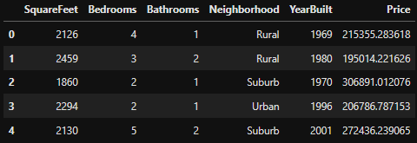

Contains 50,000 observations and 6 features.

In the following image we can see more information about our variables: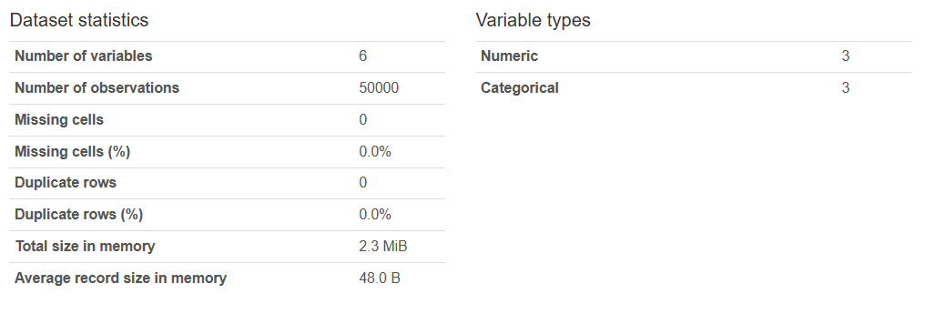

No missing data or duplicate rows.

In the following graph you can see the relationship between the squareFeet and price, the price increases as the size of the square increases.

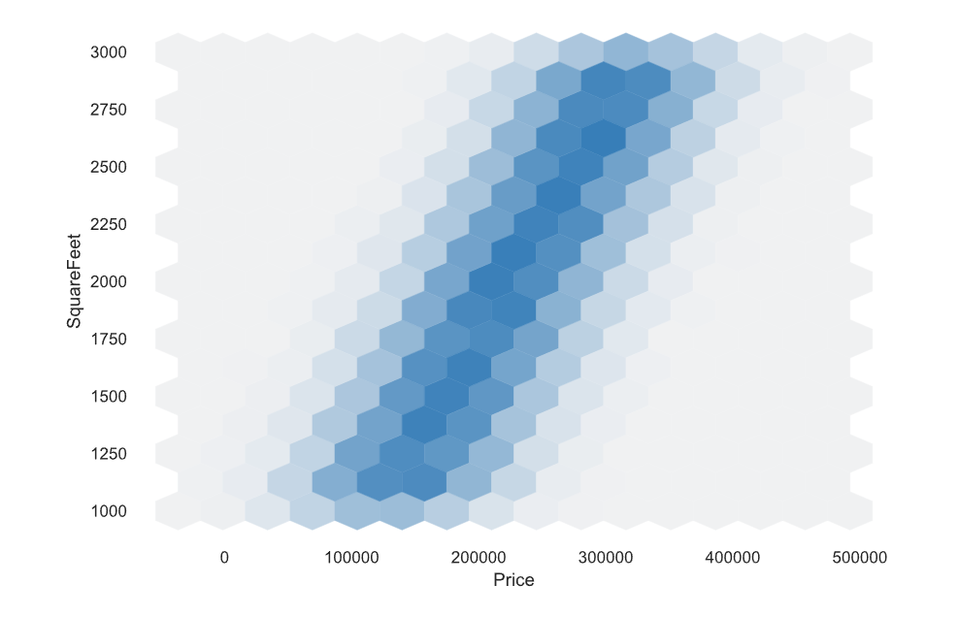

With the help of the correlation matrix we can see that only in price and square feet there is a better correlation as it is close to 1, this means that they have a linear relationship:

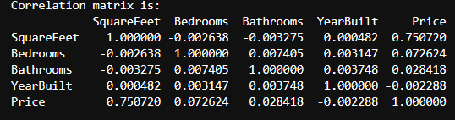

# References