**Wireframe Documentation**

**Flight Price Prediction**

|  |  |
| --- | --- |
| **Written by** | **Denistan B** |
| **Documented Version** | **1.0** |
| **Last Revised Date** | **13 December 2024** |

**Overview:**

The interface consists of two main sections:

1. **Input Section** – Users provide data through input fields such as flight duration, airline, source, destination, date of travel, and promotions.
2. **Visualization and Output Section** – Displays the predicted flight fare and two visualizations related to Flight Duration vs Predicted Fare and Airline vs Average Fare.

**1. Input Section:**

**Position:**

* The input fields (such as Flight Duration, Airline, Source, Destination, etc.) are positioned at the top of the screen, arranged in a column layout for better organization.
* They are grouped together for easy readability and to encourage users to input their details in an intuitive manner.

**Behavior:**

* The fields are interactive, allowing the user to select or input values for each field.
  + **Flight Duration**: A numeric input with a range slider to allow the user to choose the length of the flight.
  + **Airline**: A dropdown menu where users can select their preferred airline.
  + **Source** and **Destination**: Dropdown menus to select the departure and arrival locations.
  + **Date of Travel**: A date picker to specify the travel date.
  + **Promotion**: A radio button or dropdown input to indicate if any special promotions or discounts apply to the flight.
* The **"Predict Fare"** button activates the fare prediction process.

**Purpose:**

* The input section allows users to provide the necessary data points (e.g., flight details, source, destination, promotions) that will be used to generate an accurate fare prediction.

**Workflow:**

1. The user selects or inputs data into all fields (flight duration, source, destination, promotions, etc.).
2. Once all fields are filled, the user presses the **"Predict Fare"** button.
3. The system processes the input, feeds it into the trained machine learning model, and returns the predicted flight fare.
4. The predicted flight fare is displayed below the input fields, allowing users to easily see the fare estimate.

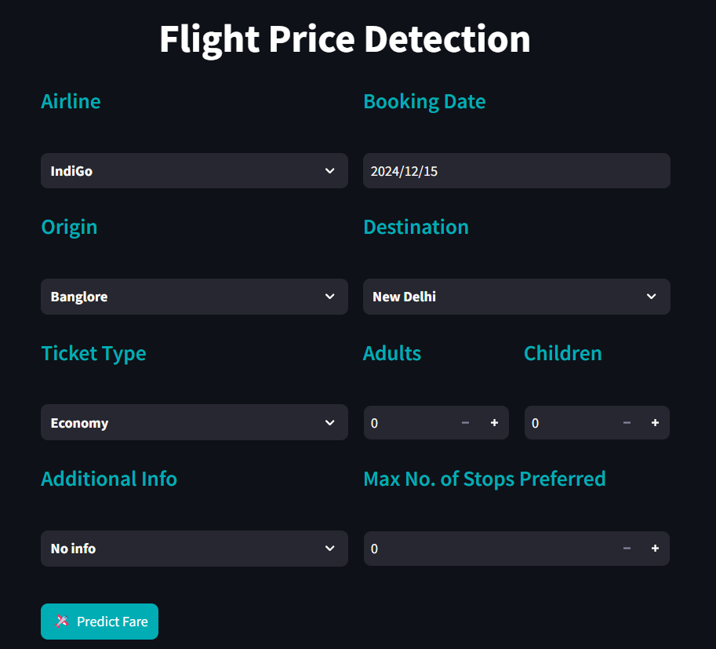

**2. Visualization and Output Section:**

**Position:**

* The Visualization and Output Section is positioned below the user input fields, ensuring a clean and organized layout.
* This section is directly above any footer or additional content, allowing the user to easily access and interpret the results.
* The visualizations are displayed in a vertical layout:
  1. **Flight Duration vs Predicted Fare**: A graph that shows the relationship between flight duration and predicted fare for each trip.
  2. **Airline vs Average Fare**: A graph that illustrates how different airlines' fares compare, offering insights into airline-based pricing patterns.
* This layout ensures there’s adequate space for both visualizations, preventing overcrowding and making the results easy to interpret.

**Behavior:**

* **Real-Time Dynamic Updates**: The visualizations will update in real time as the user enters their input data, reflecting how the model processes the values and predicts the fare.
* **Update Upon Prediction**: Once the user clicks the **"Predict Fare"** button, the system will execute the prediction algorithm and refresh both graphs with the latest data.
* **Interactive Legends**: Each graph includes a legend to denote different categories, like the airline or flight duration. Users can toggle or adjust these legends to gain deeper insights into how different input variables affect the predictions.
* **Responsive Design**: The visualizations are designed to be responsive, adjusting to different screen sizes (desktop, tablet, mobile). This ensures a consistent user experience across devices.

**Purpose:**

* **Data-Driven Insights**: The visualizations provide users with insights into the factors influencing flight fares.
  + **Flight Duration vs Predicted Fare**: This graph helps users understand if longer flights tend to have higher fares. It provides an intuitive view of how flight duration correlates with predicted ticket prices.
  + **Airline vs Average Fare**: This chart displays fare patterns across different airlines, helping users make informed decisions about which airlines might offer better pricing based on historical data.
* **User Engagement**: By visualizing complex relationships in an interactive format, users can easily identify trends and gain a better understanding of the factors influencing flight prices. This encourages deeper interaction with the tool, improving their decision-making process.

**Workflow:**

1. **User Input**: The user enters relevant data such as Flight Duration, Airline, Source, Destination, and other travel-related details.
2. **Prediction Trigger**: Upon pressing the **"Predict Fare"** button, the system processes the user input and generates a flight fare prediction.
3. **Visualization Generation**: After receiving the prediction, the system generates the two visualizations:
   * **Flight Duration vs Predicted Fare**: Displays how the length of the flight relates to the predicted fare.
   * **Airline vs Average Fare**: Shows the fare comparison across airlines to assist users in selecting the best option based on price.
4. **Visualization Update**: When the user adjusts the input fields and presses **"Predict Fare"** again, the visualizations are automatically updated to reflect the new input data, providing real-time insights and offering the user a dynamic experience.

