­





**Week 9 - Report**

**Group M2-CB01-G5**

**Made by:**

Nikoleta Dimitrova

Alek Zanev

Yoana Ivanova

Deniz Hadjiosmanov

Toni Dimitrov

Viktor Velizarov

Week 9: 11/04/2022 - 17/04/2022

2 meetings – 12/04/2022 (start 18:30 – end 20:00)

17/04/2022 (start 15:00 – end 17:00)

# Our online planning tool <https://trello.com/b/XHeuHBJj/work-planning>

# Performed and completed activities

* Made the report for the Data Point 1 submission – whole group
* Prepared the presentation for the showroom – whole group
* Presented our progress at the current point – whole group
* Changed the logo and the font in the prototype with the ones that Maaike liked – Nikoleta Dimitrova
* Sent our progress so far to Maaike – Deniz Hadjiosmanov
* Analyzed the tests from Week 8 and made a summary – Deniz Hadjiosmanov with the help of the whole group

# Discussions

* How should we organize our report for the submission in Week 9?
* How should we divide the slides of the presentation between the group members?
* How to approach the test analyses?
* How to implement the changes in the high-fidelity prototype in order to achieve best results?

# Work showroom

* 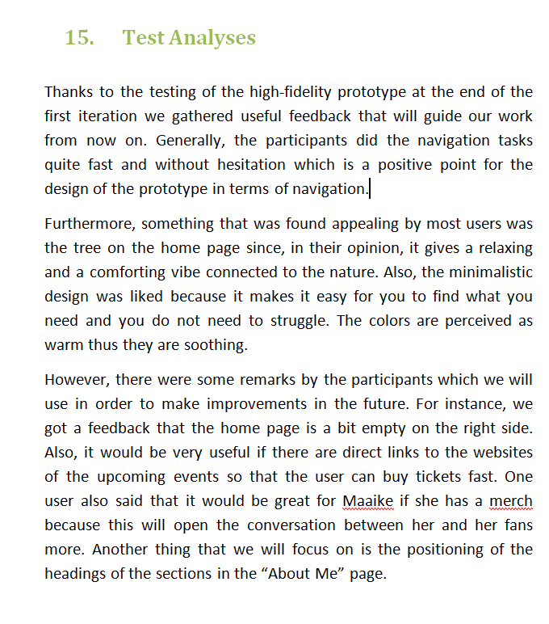Test analyses
* Changed the font and the logo

