­





**Week 11 - Report**

**Group M2-CB01-G5**

**Made by:**

Nikoleta Dimitrova

Alek Zanev

Yoana Ivanova

Deniz Hadjiosmanov

Toni Dimitrov

Viktor Velizarov

Week 11: 25/04/2022 - 01/05/2022

2 meetings – 28/04/2022 (start 17:00 – end 17:30)

01/05/2022 (start 10:30 – end 12:30)

# Our online planning tool <https://trello.com/b/XHeuHBJj/work-planning>

# Performed and completed activities

* Started coding the other pages (besides the Home page) – whole group
* Completed half of the About Me page – Toni Dimitrov & Deniz Hadjiosmanov
* Fixing the background color of the Home page and other coding edits there – Nikoleta Dimitrova
* Edits on the responsive function of the Home page – Viktor Velizarov & Alek Zanev

# Discussions

* What coding standard & rules we should follow?
* How should we make the gramophone on the Listen Now page responsive.

# Work showroom

* 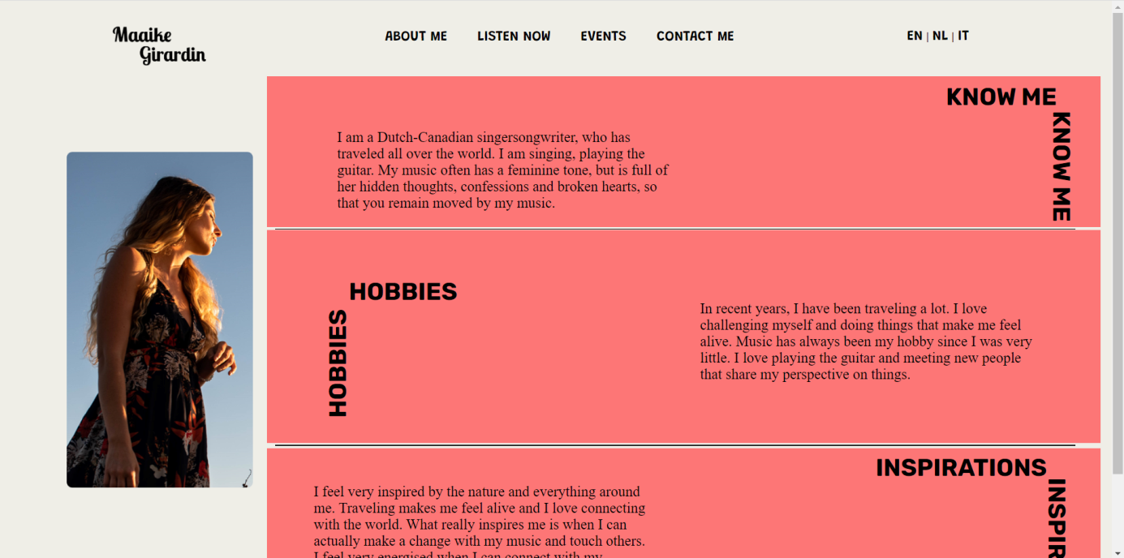Coded half of the About Me page

*The fields are marked in red in order to serve as a guide for the developers.*