­





**Week 12 - Report**

**Group M2-CB01-G5**

**Made by:**

Nikoleta Dimitrova

Alek Zanev

Yoana Ivanova

Deniz Hadjiosmanov

Toni Dimitrov

Viktor Velizarov

Week 12: 09/05/2022 - 15/05/2022

2 meetings – 10/05/2022 (start 9:00 – end 10:00)

14/05/2022 (start 14:30 – end 16:00)

# Our online planning tool <https://trello.com/b/XHeuHBJj/work-planning>

# Performed and completed activities

* Finished the About Me page – Toni Dimitrov and Deniz Hadjiosmanov
* Redesigned the high-fidelity prototype (based on user feedback) – Nikoleta Dimitrova & Yoana Ivanova
* Coded the Home page and the Contact Me page – Nikoleta Dimitrova

# Discussions

* How should we structure the new design?
* What colours should we use for it?
* How to keep the nature vibe?

# Work showroom

* 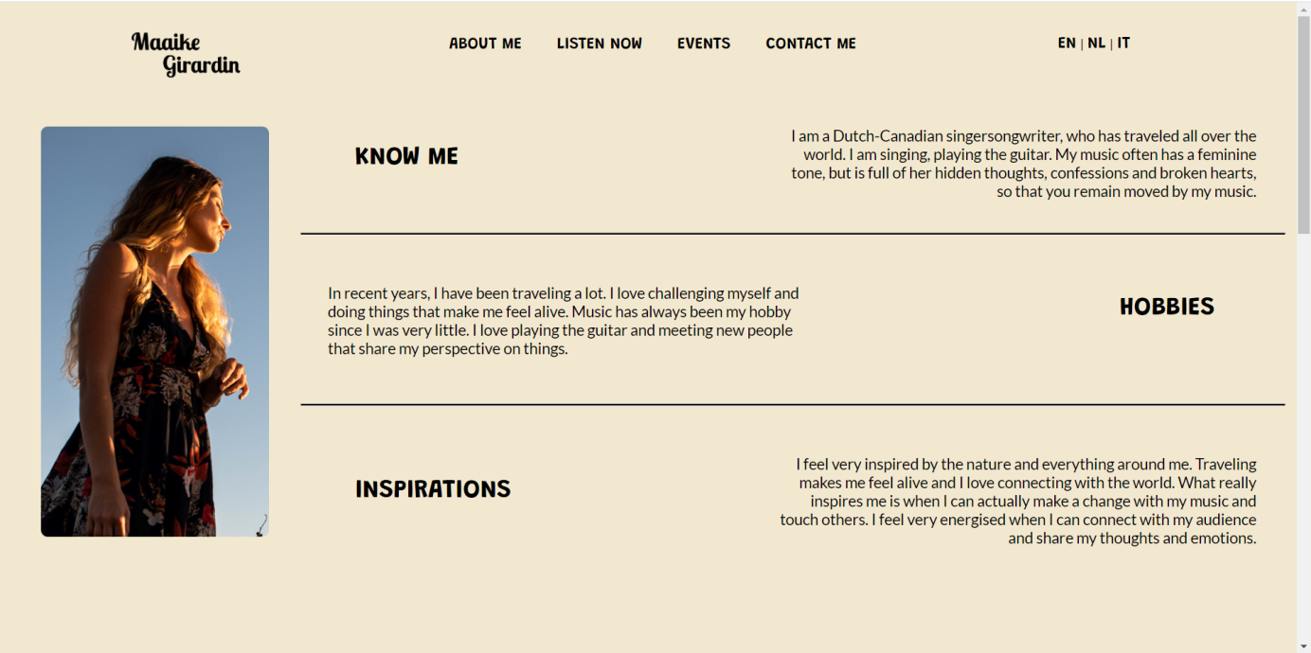Finished the About Me page

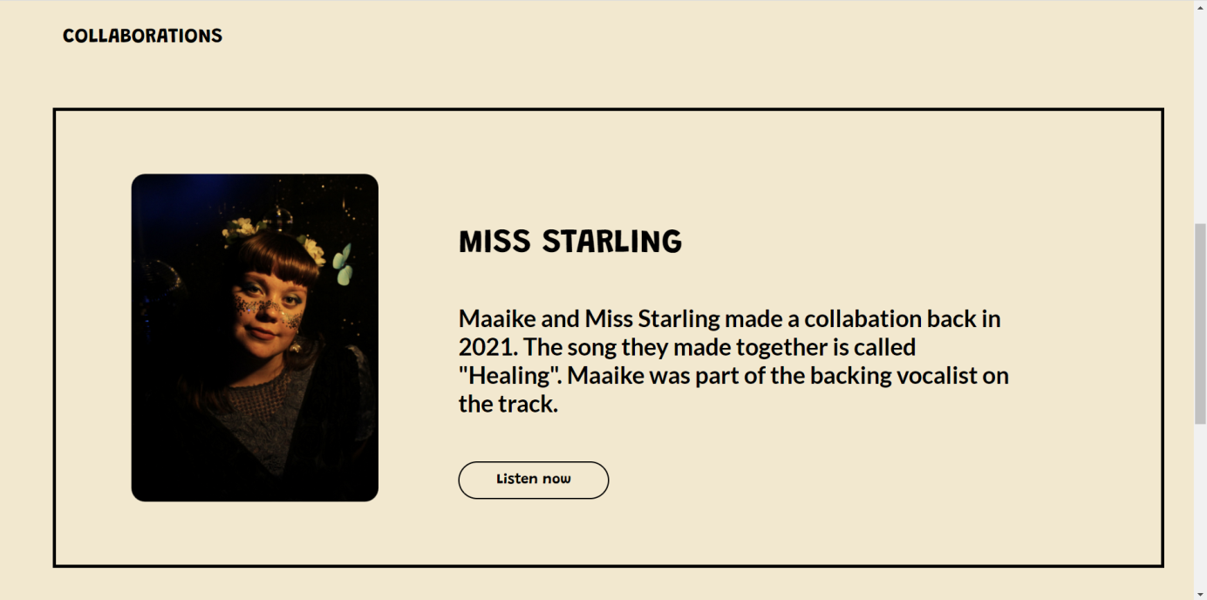

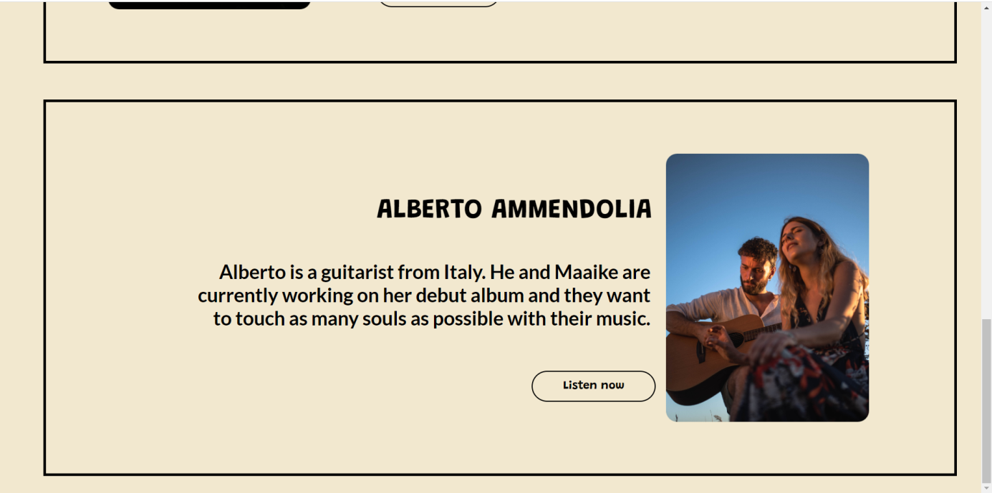

* Made the new design

