­





**Week 14 - Report**

**Group M2-CB01-G5**

**Made by:**

Nikoleta Dimitrova

Alek Zanev

Yoana Ivanova

Deniz Hadjiosmanov

Toni Dimitrov

Viktor Velizarov

Week 14: 23/05/2022 - 29/05/2022

2 meetings – 25/05/2022 (start 10:00 – end 11:00)

29/05/2022 (start 16:00 – end 17:00)

# Our online planning tool <https://trello.com/b/XHeuHBJj/work-planning>

# Performed and completed activities

* Made the gramophone for the Listen Now page – Yoana Ivanova
* Made the Listen Now page – Nikoleta Dimitrova and Yoana Ivanova
* Translated the website in Dutch and Italian – Deniz Hadjiosmanov
* Improved the Future Appearances and the Past Events sections – Nikoleta Dimitrova
* Fixed the colours of the tree on the Contact Me page – Yoana Ivanova
* Added a scroll-to-top button – Nikoleta Dimitrova
* Made the website responsive – Alek Zanev & Viktor Velizarov

# Discussions

* How should we restructure the report for our work so that it is as easy-to-read as possible?
* How to approach the work for making the website responsive?
* Discussing important details regarding the gramophone
* How to make the Past Events and the Future Appearances sections more visually appealing?

# Work showroom

* Made the gramophone on the Listen Now page and added a scroll-to-top button

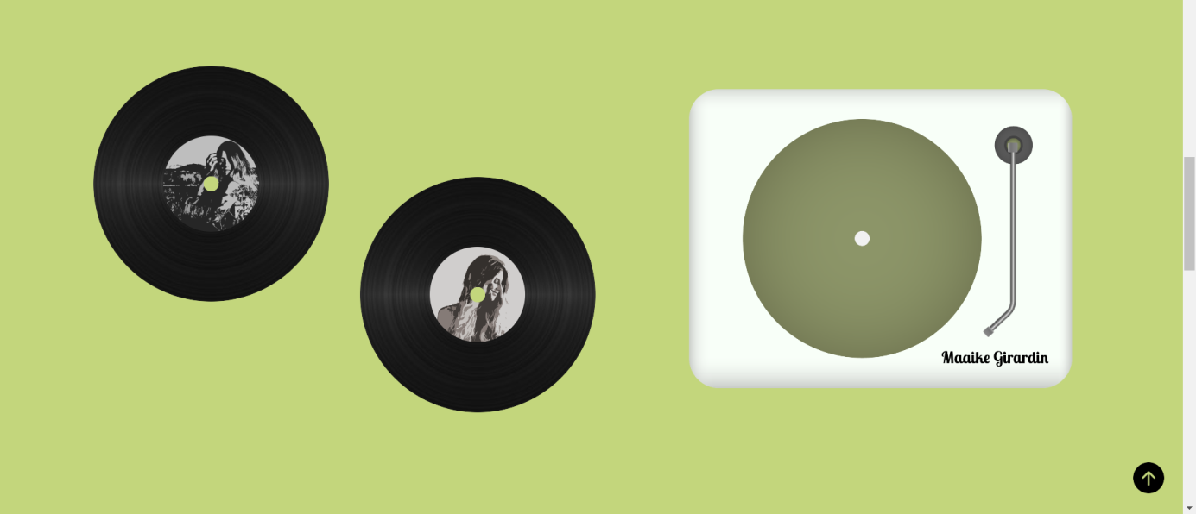

* 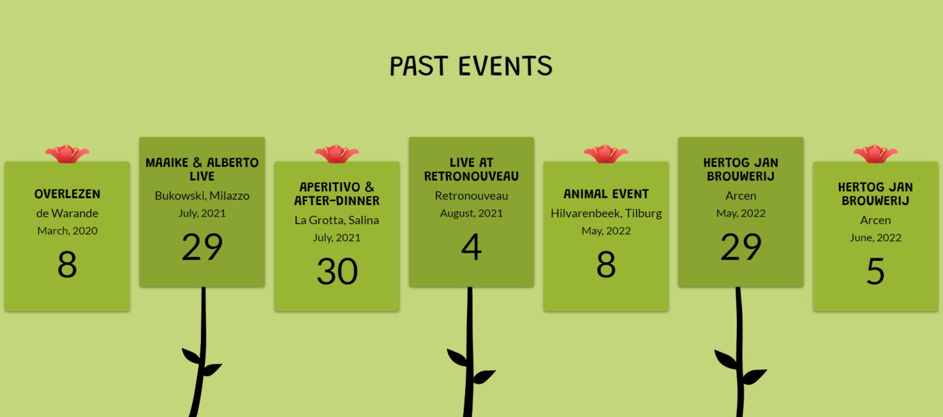Improved the Future Appearances and the Past Events sections

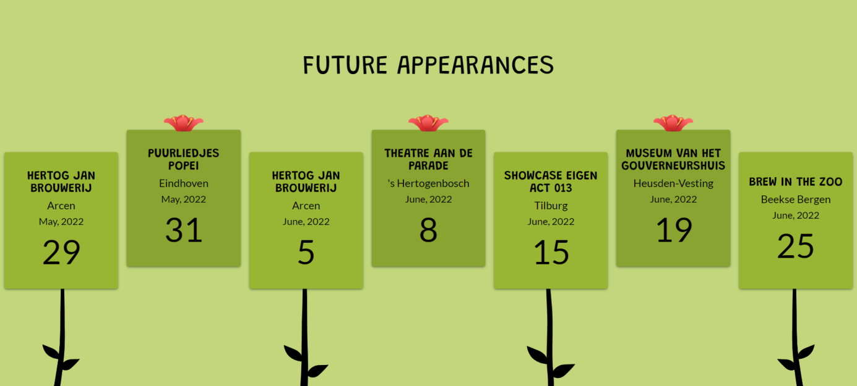

* 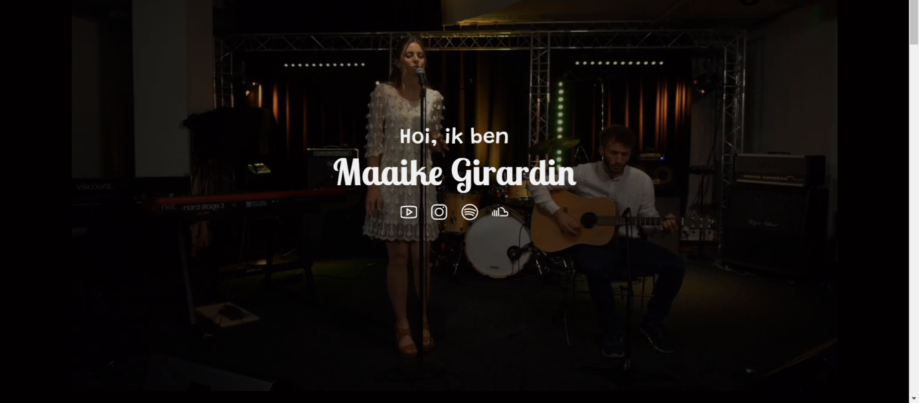Translated the website in Dutch and Italian

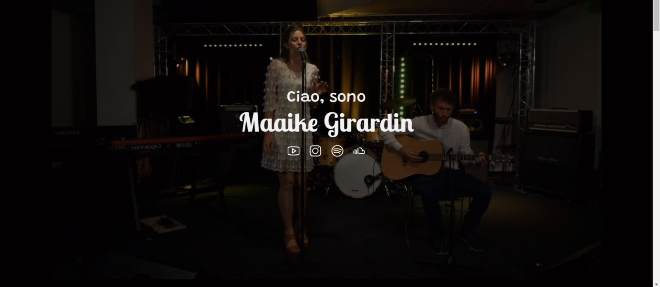

* 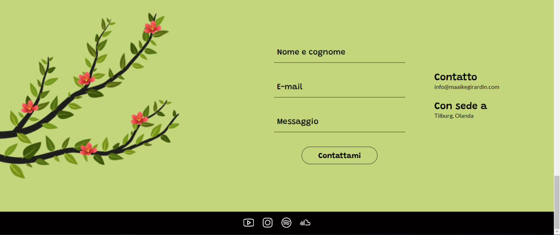Fixed the colours of the tree on the Contact Me page