



**Week 4 - Report**

**Group M2-CB01-G5**

**Made by:**

Nikoleta Dimitrova

Alek Zanev

Yoana Ivanova

Deniz Hadjiosmanov

Toni Dimitrov

Viktor Velizarov

Week 4: 07/03/2022 - 13/03/2022

2 meetings – 06/03/2022 (start 10:30 – end 11:10)

12/03/2022 (start 13:30 – end 15:00)

# Our online planning tool <https://trello.com/b/XHeuHBJj/work-planning>

# Preformed and completed activities

* Add “Scope of the project”, “Deliverables”, “Setbacks and mitigations” to the project plan – Nikoleta Dimitrova (discussions – whole group)
* Code the “Contact Us” page of our group website – Toni Dimitrov
* Interview (for music in general, preferences, introduced to Maaike’s music and first impression of it) – Yoana Ivanova
* Sketches before the wireframe – Nikoleta Dimitrova, Yoana Ivanova
* Start working on the low-fidelity wireframe in Adobe – Yoana Ivanova, Nikoleta Dimitrova, Deniz Hadjiosmanov
* Go through the results we got from the survey once again – whole group
* Downloaded colour palettes what might come in handy for the project
* Ideas about Maaike’s logo (still in progress)

# Discussions

* What things can we have in the “Home page” of Maaike’s website to make it more interactive?
* How many pages should Maaike’s website have?
* Will we include the covers she made on the website?
* How many social medias does Maaike use?
* How active is she on them?
* Will it take us a lot of time to make the animations?
* What things can we ask her in the personal survey that we are going to make in the future for the branding part? (In progress)
* Discussion about minimalistic design

# Work showroom

* 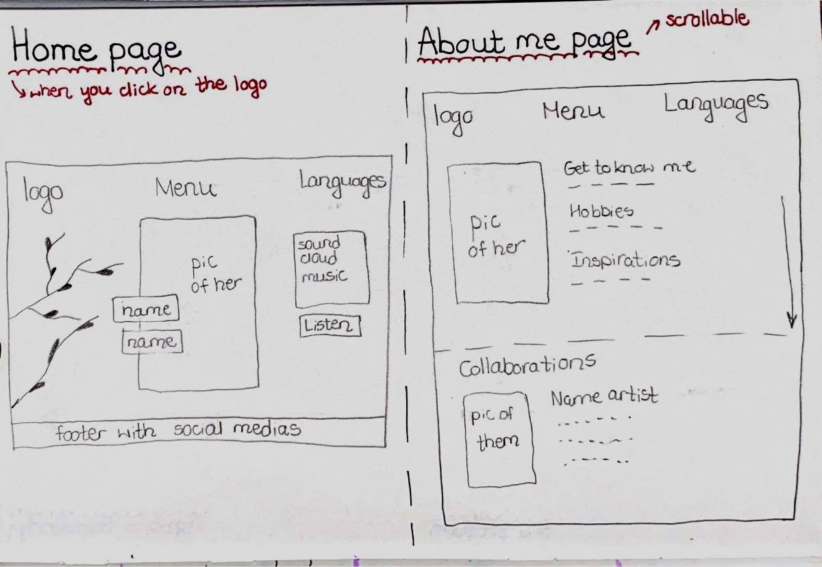Sketches

Картина, която съдържа текст, табло

Описанието е генерирано автоматично

* 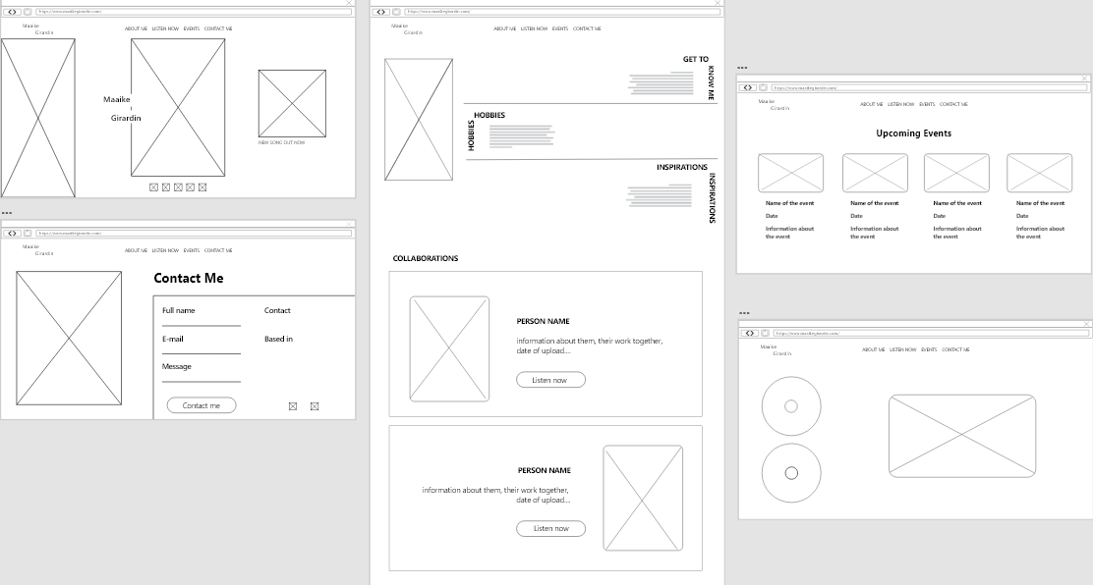Wireframe (low-fidelity)