



**Week 5 - Report**

**Group M2-CB01-G5**

**Made by:**

Nikoleta Dimitrova

Alek Zanev

Yoana Ivanova

Deniz Hadjiosmanov

Toni Dimitrov

Viktor Velizarov

Week 5: 14/03/2022 - 20/03/2022

2 meetings – 16/03/2022 (start 10:00 – end 11:00)

20/03/2022 (start 11:00 – end 13:00)

# Our online planning tool <https://trello.com/b/XHeuHBJj/work-planning>

# Performed and completed activities

* Code the “Project” page of the group website – Alek Zanev, Nikoleta Dimitrova
* Decided on the colour palette we are going to use for Maaike’s website – whole group with the help of the client
* 4 more interviews (for music in general, preferences, introduced to Maaike’s music and first impression of it) – Toni Dimitrov, Deniz Hadjiosmanov, Alek Zanev, Nikoleta Dimitrova
* Done with the wireframe in AdobeXD – Nikoleta Dimitrova, Yoana Ivanova
* Started with the high-fidelity prototype – Yoana Ivanova, Nikoleta Dimitrova, Toni Dimitrov
* Update in the project plan (added a Gantt chart) – Deniz Hadjiosmanov, Toni Dimitrov
* Meeting with the client to show her our work and ask for feedback – whole group
* Modification in the “Contact us” page of the group website

# Discussions

* Questions to ask in the interviews.
* What things should we change in the wireframe?
* The answers from the survey and the interviews.
* How can we add JSON in Maaike’s website to make it easier to maintain? (In progress)
* The purpose of the personas we created
* About Maaike’s brand

# Work showroom

* “Contact us” and “Project” page

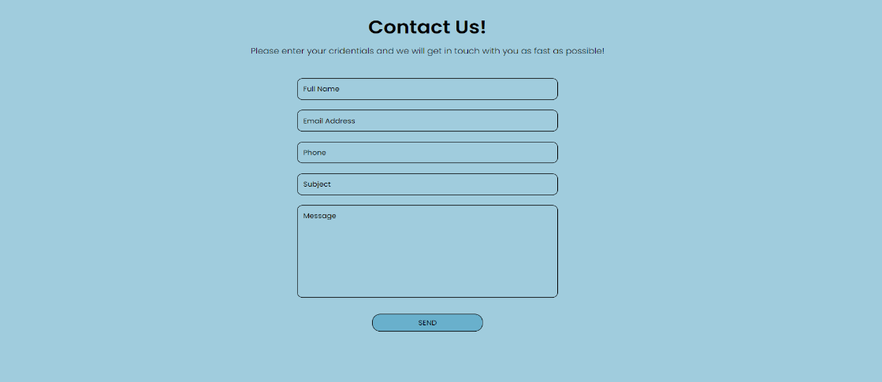

Картина, която съдържа текст, лице, жена, момиче

Описанието е генерирано автоматично

* 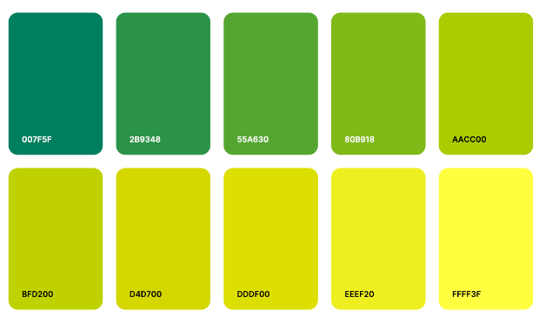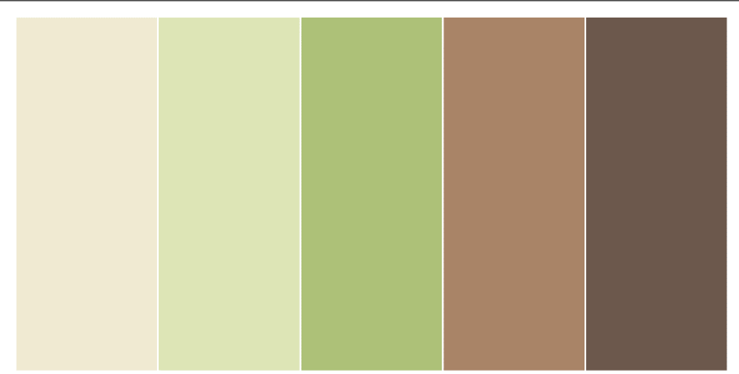Colour palette choice
* Interview links

<https://youtu.be/iHIQc0RvorY> - First Interview (Yoana)

<https://youtu.be/tSA1xrGMeas> - Second Interview (Toni)

<https://youtu.be/q0bKcpJQlPs> - Third Interview (Deniz)

<https://youtu.be/4X_Yk61870g> - Fourth Interview (Deniz)

<https://youtu.be/fObs6J1XgOM> - Fifth Interview (Nikoleta)

* 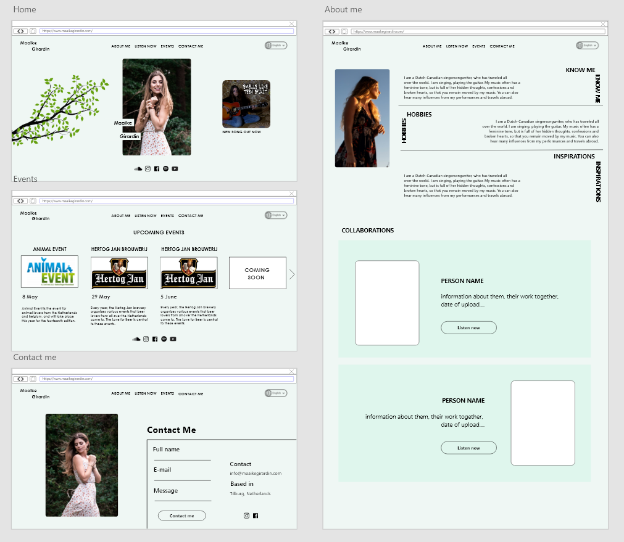High-fidelity prototype