­





**Week 7 - Report**

**Group M2-CB01-G5**

**Made by:**

Nikoleta Dimitrova

Alek Zanev

Yoana Ivanova

Deniz Hadjiosmanov

Toni Dimitrov

Viktor Velizarov

Week 7: 28/03/2022 - 03/04/2022

2 meetings – 30/03/2022 (start 10:00 – end 10:40)

03/04/2022 (start 11:00 – end 12:30)

# Our online planning tool <https://trello.com/b/XHeuHBJj/work-planning>

# Performed and completed activities

* Started coding the home page – whole group
* Chose the font for the navigation bar and logo – whole group with the help of Maaike
* Made the layout of the whole page – Yoana Ivanova, Nikoleta Dimitrova
* Initial version of the interactive tree – Yoana Ivanova
* Done with the final version of Maaike’s logo in Illustrator – Nikoleta Dimitrova, Deniz Hadjiosmanov
* Started with the translate option (still in progress) – Deniz Hadjiosmanov, Nikoleta Dimitrova, Toni Dimitrov

# Discussions

* How can we make the translate option work?
* How big should the tree be and what colours should it have?
* What font would suit Maaike’s brand?
* What nature elements can we use in Maaike’s website?
* Minimalistic design discussion with the whole group.
* Do we need backend for the tree and the translate option?
* Coding rules to follow.
* The feedback we got from Maaike.
* Still no Spotify account...what can we add in the home page as a song then?
* Searching for free API’s that we can use for the translate option.

# Work showroom

* 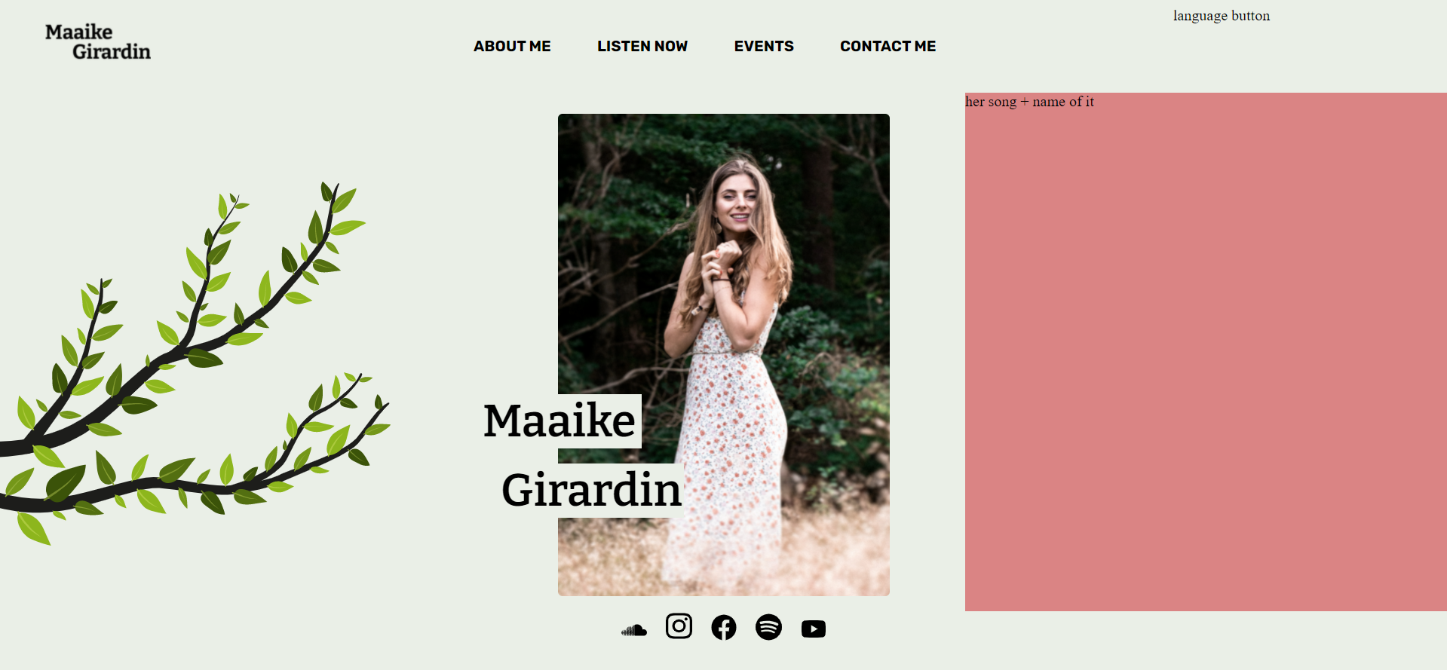The home page so far
* Maaike’s logo (Font used - Bitter)

