­

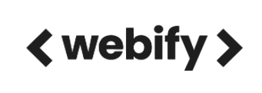



**Week 8 - Report**

**Group M2-CB01-G5**

**Made by:**

Nikoleta Dimitrova

Alek Zanev

Yoana Ivanova

Deniz Hadjiosmanov

Toni Dimitrov

Viktor Velizarov

Week 8: 04/04/2022 - 10/04/2022

2 meetings – 05/04/2022 (start 10:00 – end 11:00)

07/04/2022 (start 19:00 – end 20:30)

# Our online planning tool <https://trello.com/b/XHeuHBJj/work-planning>

# Performed and completed activities

* Made the “Listen Now” page in the high-fidelity prototype – Yoana Ivanova
* Made the clickable sidebar in the “Events” page of the high-fidelity prototype – Deniz Hadjiosmanov
* Made the message that appears after clicking the “Contact Me” button in the “Contact Me” page of the high-fidelity prototype – Nikoleta Dimitrova, Deniz Hadjiosmanov
* Making the Home page of the website responsive – Alek Zanev, Viktor Velizarov
* Conducting tests with the high-fidelity prototype – whole group
* Font choice – Nikoleta Dimitrova, Toni Dimitrov
* Making the translate option in the high-fidelity prototype – Nikoleta Dimitrova

# Discussions

* How should we make the high-fidelity prototype as interactive as possible?
* What should happen after clicking the “Contact Me” button in the “Contact Me” page?
* Discussing what fonts should we use.
* Are there better ways to make the translation of the website?
* Thinking about what content we need to include in our presentation.
* How should we organize our report for the submission in Week 9?

# Work showroom

* 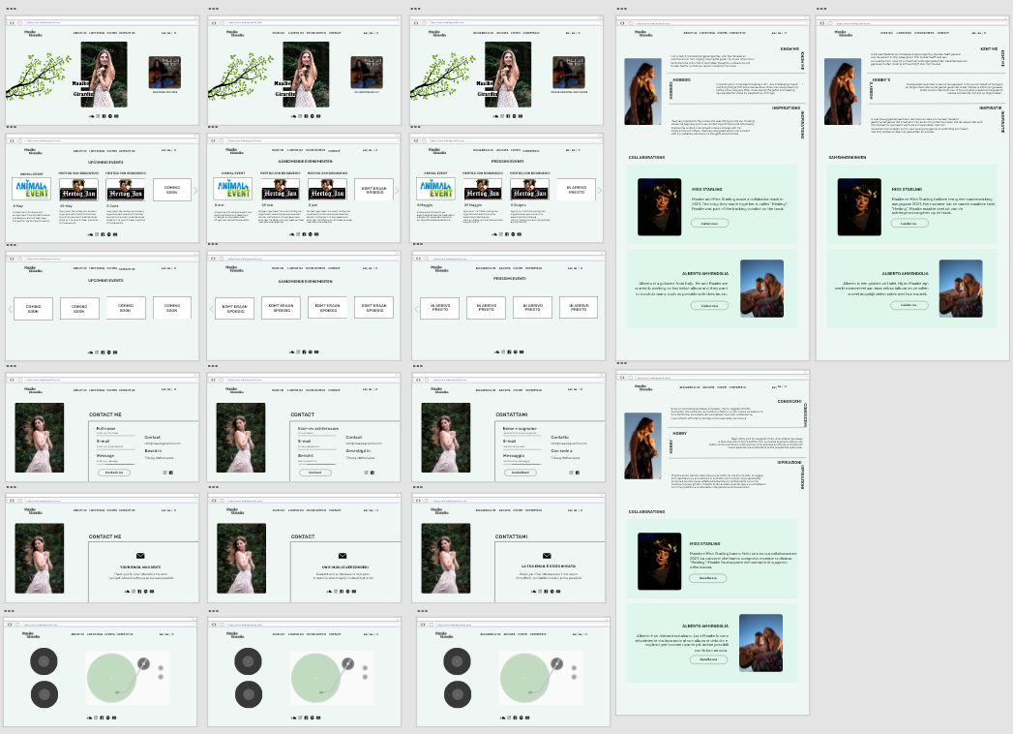Our high-fidelity prototype
* Testing our high-fidelity prototype

<https://youtu.be/iIJehcf4sAQ> - Deniz's First Testing

<https://youtu.be/blgGLMrjEOo> - Deniz's Second Testing

<https://youtu.be/xkc_uQ7lIYM> - Toni's Testing

<https://youtu.be/JyD4Hhn5sUA> - Nikoleta's Testing

<https://youtu.be/UbzfkfW7rVU> - Yoana’s Testing