Kanat Özgen 30973

Deniz Yavuzgil 30957

Özgür Kıyak 31051

**LexDelegate**

Our project is an app that provides an opportunity for lawyers to find and get help from other lawyers in other cities when they have cases in the courthouses of other, far away cities where they cannot go. This app will be useful and beneficial for many lawyers as this is a common problem for them. Lawyers who need help from other lawyers in other cities will create a job in the app with an explanation stating the money they offer for this job, and they’ll choose the best one among the lawyers who applied for the job instead of trying to find and convince a lawyer in another city. On top of that, young lawyers who live in small cities that do not have their own clients can have an alternative income via other lawyers with the help of this app.

When signing up to our app, users will choose the city or cities where they can go to the courthouse. Also, a lawyer will choose the cities where they need help with while creating a job that will be added to the open jobs. Therefore, when a lawyer searches for the open jobs, they will only see the necessary ones in cities where they are available. When a lawyer applies for a job, the job application will be added to this lawyer’s job applications and the list of job applications of the lawyer who created the job. If the lawyer who created the job accepts the job application, the job will be added to the “applications I accepted” section of this lawyer and it will be added to the “jobs that I am accepted for” section of the lawyer who applied, also the job will be removed from open jobs. If the lawyer who created the job rejects the job application, it will be removed from the list of job applications of this lawyer and it will be removed from job applications of the lawyer who applied.

The most important current state-of-the-art example is the official app of Union of Turkish Bar Associations called as “Avukatlar Arası Mesleki Dayanışma Projesi”, it is the safest one since the Union has an opportunity to verify that the app is only used by lawyers by checking the Bar that the lawyer registered, name, surname, and Bar ID of the lawyer. There is also a website of the Union to check this information. The official app of the Union allows the users to search all user lawyers in a city, since this can cause a misuse of the personal information, we will not include this opportunity in our app. In our app, the users will only see the information of lawyers who created jobs and only the lawyer who created the job will see the information of the users who applied for this job. There are also other similar apps which are not official, one of them is called “Avutap”. The drawback of this one is that they do not control the bar ID so we could sign up with a non-existent bar ID.

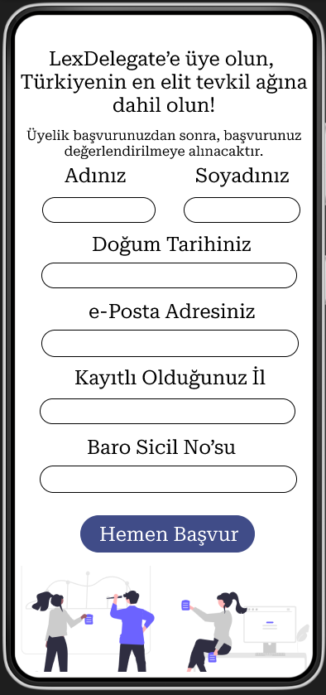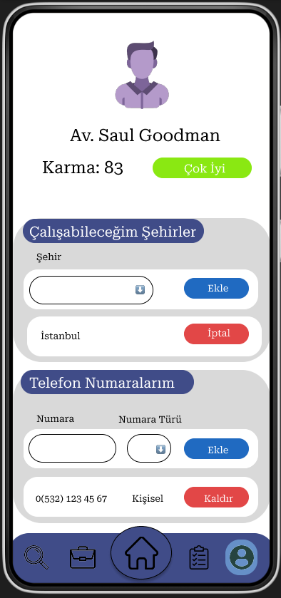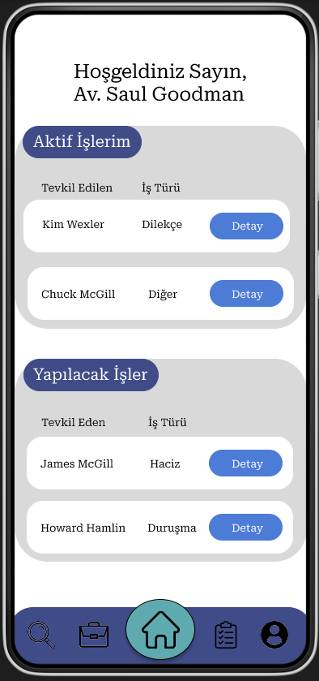We plan on having 19 API end0points in our project and our app has around 15 different screens. The design mockups and API endpoint explanations are down below.

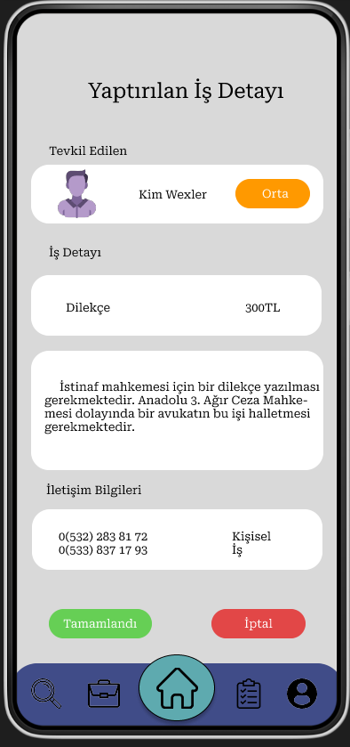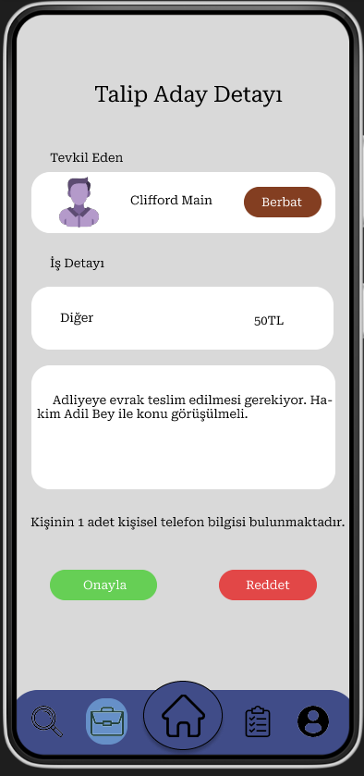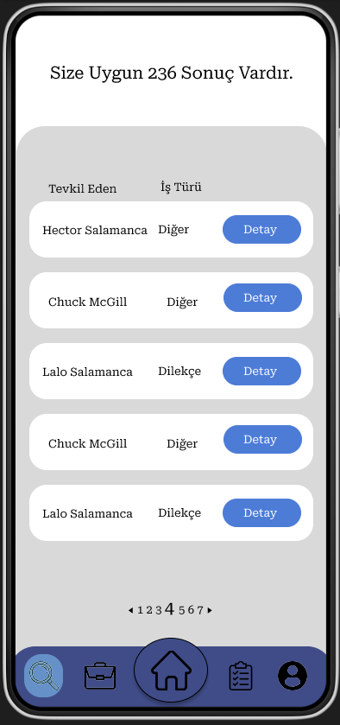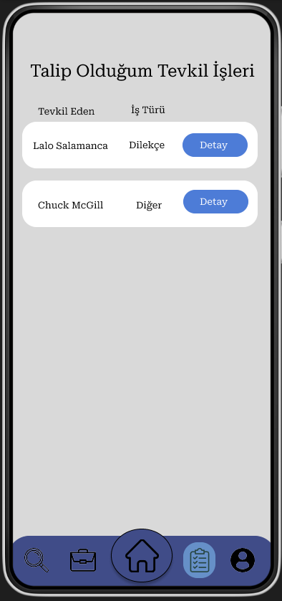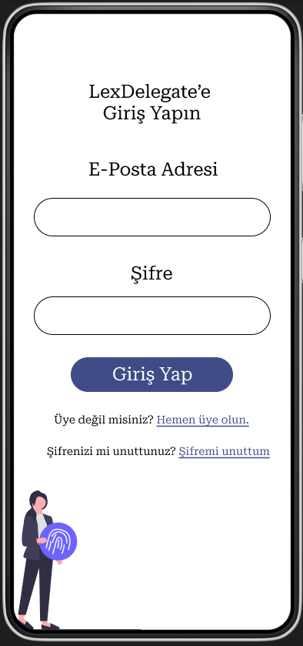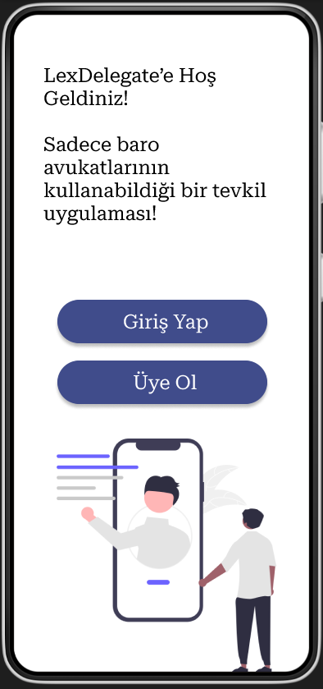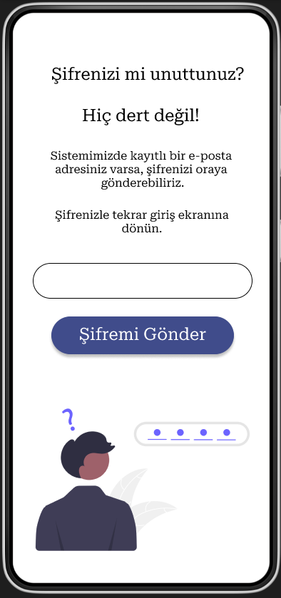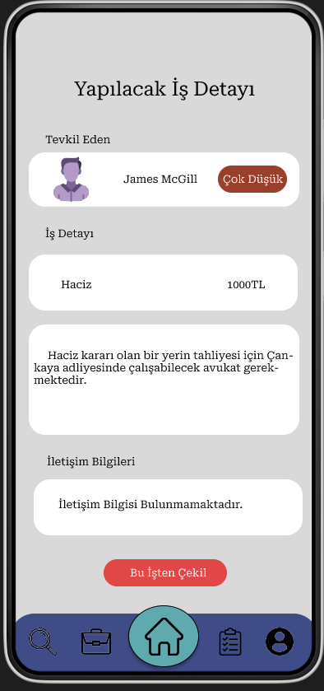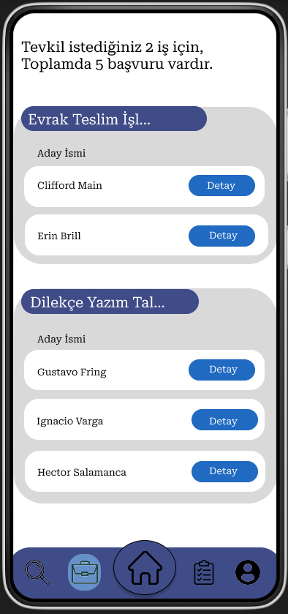

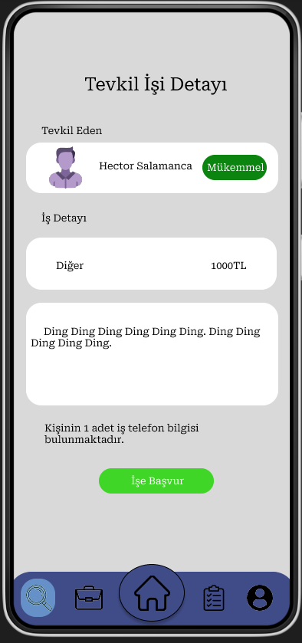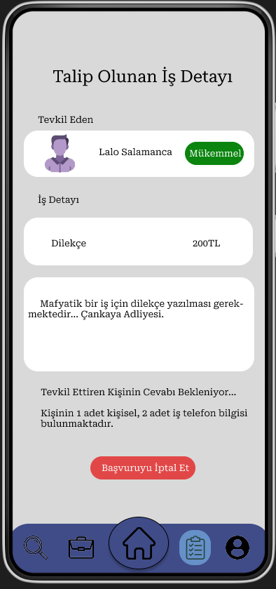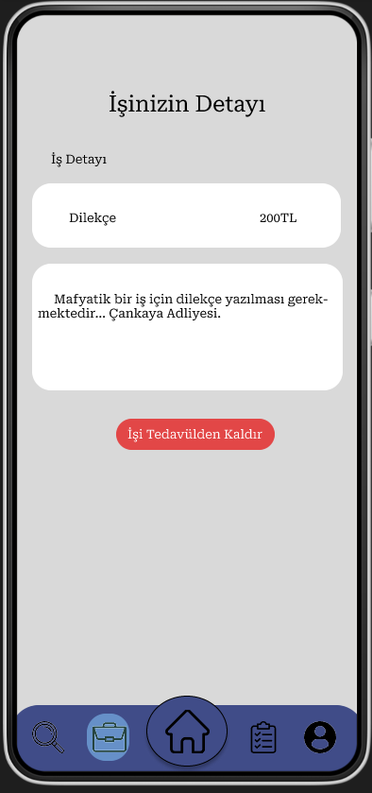

**Tentative documentation of our API:**

POST /api/userSignUp

POST /api/userSignIn

POST /api/forgottenPassword

GET /api/availableJobs/[userID]

GET /api/userInfo/[userID]

GET /api/addCity/[userID]/[cityID]

POST /api/addPhone/[userID]

GET /api/applyJob/[userID]/[jobID]

GET /api/myPostedJobs/[userID]

GET /api/myPendingJobs/[userID]

GET /api/myTakenJobs/[userID]

GET /api/acceptApplicant/[userID]/[jobID]

DELETE /api/removePostedJob/[userID]/[jobID]

DELETE api/removePendingJob/[userID]/[jobID]

DELETE /api/removeTakenJob/[userID]/[jobID]

DELETE /api/removeApplicant/[userID]/[jobID]

DELETE /api/removePhone/[userID]/[phoneID]

DELETE /api/removeCity/[userID]/[cityID]

DELETE /api/finishJob/[jobID]