**ORTA DOĞU TEKNİK ÜNİVERSİTESİ**

**MIDDLE EAST TECHNICAL UNIVERSITY**

**EE568 Selected Topics on Electrical**

**Project-2: Motor Winding Design & Analysis**

**Deniz Alp Yılmaz**

**Student ID: 1879766**

**May 2022**

Contents

INTRODUCTION 3

INTEGRAL-SLOT WINDING DESIGN 3

Fractional-Slot Winding Design 7

2D FEA Modelling 11

# INTRODUCTION

Winding design is one of the most important parameters that effects the performance of the electric machines. The scope of this project is to make an integral-slot winding and fractional-slot winding design by using analytical methods and making a numerical analysis by using some FEA tools.

# INTEGRAL-SLOT WINDING DESIGN

In this part, a 6-pole, 72 slot (Q), 3-phase (m) machine with double-layer winding configuration is assumed. As a first step, winding diagram for the full-pitched and 11/12 short-pitched winding designs are represented in the Table 1.

Table 1. Winding diagram for the full-pitched and 11/12 short-pitched winding designs



Secondly, the distribution factor, pitch factor and the winding factor for the fundamental component and the 3rd and the 5th harmonics calculated for the full-pitched and 11/12 short-pitched winding designs. Relations with all middle steps are represented below and the results are shown as tables.

Pole pair (p) is calculated by the equation below.

$$p=\frac{Number of Poles}{2}=\frac{6}{2}=3$$

Slot per phase per pole (q) is found by the relation below.

$$q=\frac{Q}{Number of Poles ×m}=\frac{72}{6×3}=4$$

Coil pitch is calculated by the equation below.

$$Coil Pitch=\frac{Q}{Number of Poles}=\frac{72}{6}=12$$

Slot angle (αu) is calculated as an electrical degree by relation below.

$$α_{u}=\frac{360×p}{Q}=\frac{360×3}{72}=15°$$

Coil pitch (λ) is calculated as an electrical degree by equation below.

$$λ=\frac{360×Coil Pitch×p}{Q}=\frac{360×12×3}{72}=180°$$

Distribution factor kdn is calculated by the relation below.

$$k_{dn}=\frac{sin⁡(\frac{q×n×α_{u}}{2})}{q×sin⁡(\frac{n×α_{u}}{2})}$$

It should be noted that n means the number of harmonic and while calculating the fundamental, the value of n is taken as 1. Pitch factor kpn is calculated by using the equation below.

$$k_{pn}=sin(\frac{n×λ}{2})$$

Similar to the calculation of kdn, n means the number of harmonic and while calculating the fundamental, the value of n is taken as 1. Finally, winding factor kwn is calculated by relation below.

$$k_{wn}=k_{pn}×k_{dn}$$

The results of calculations that summarized above are represented in Table 2 for the full-pitched winding and in Table 3 for 11/12 short-pitched winding designs.

Table 2. Full-pitched winding design calculations



Table 3. 11/12 short-pitched winding design calculations



From the represented results in the tables above, p, q, coil pitch and slot angle values does not change by the variation in pitch design. Also, distribution factors are the same. However, by the change in λ, pitch factors have different values, and it directly effects the winding factor for both fundamental and the 3rd and the 5th harmonics. For the full pitch, it could be seen that the pitch factors are equal to 1 absolutely as expected. When we compared the winding factors, the full pitch design has higher values which leads to the higher induced voltage and power outputs.

# Fractional-Slot Winding Design

In this part, a 3-phase permanent-magnet synchronous machine are analyzed with a fractional-slot winding. Respecting the constraints mentioned in the project description, a pole number 22 and slot number 24 are chosen at the first step. Some performed calculation by using the relations in INTEGRAL-SLOT WINDING DESIGN part and winding diagram are represented in Table 4 and Table 5 respectively.

Table 4. Calculations of needed parameters for fractional-slot winding design 1



Table 5. Winding diagram of the fractional-slot winding design 1



After that, the induced voltage angles are calculated for all slots for both fundamental and the 3rd and the 5th harmonics with respect to the related slot angle values. Since the A phases are chosen for the induced voltage calculations, related slot numbers are painted with the yellow color. Calculated values are represented in Table 6, Table 7, Table 8 for fundamental and the 3rd and the 5th harmonics respectively.

Table 6. Induced voltage angles for fundamental



Table 7. Induced voltage angles for 3rd harmonic



Table 8. Induced voltage angles for 5th harmonic



The vectoral summation of the A phasors are calculated geometrically and represented in Figure 1, Figure 2 and Figure 3 for fundamental and the 3rd and the 5th harmonics respectively. In the figures, phasors are shown with the blue colour, the middle sums are shown in red and the total sums in yellow. The value of the one phase is named as x and other are represented parametrically.

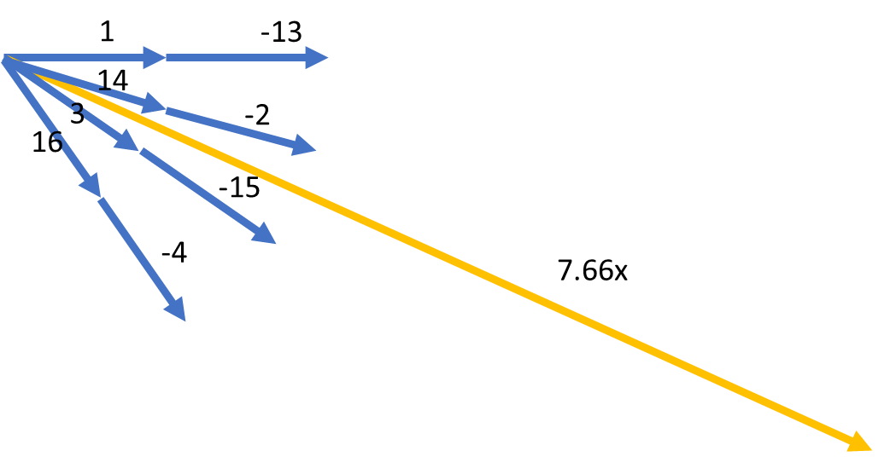

Figure 1. Phasor diagram for fundamental of fractional-slot winding design 1

kw1 is calculated by the ratio of the geometric sum and sum of the absolute values of the phasors. Therefore, kw1 is equal to 0.9577 for the selected design.

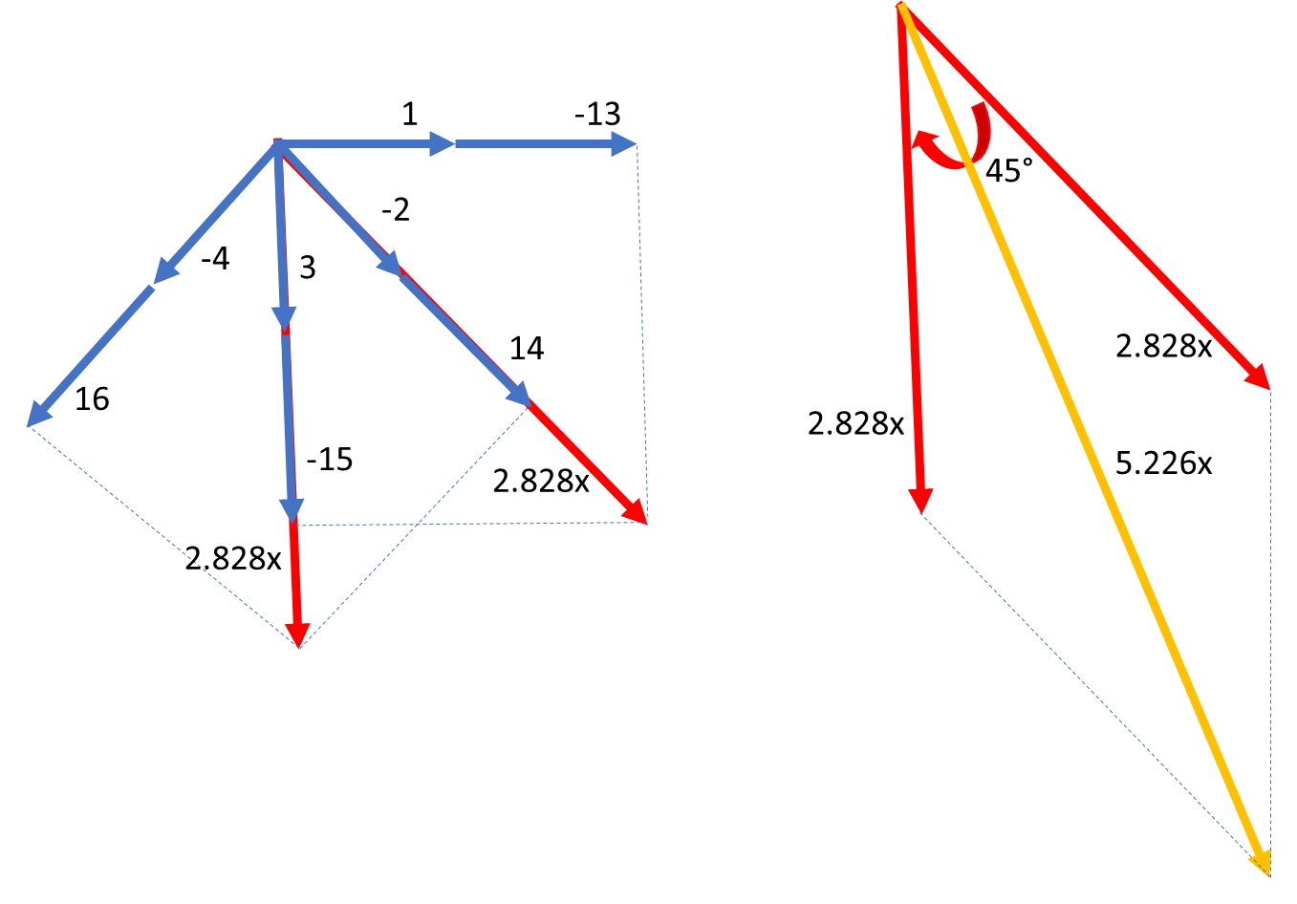

Figure 2. Phasor diagram for 3rd harmonic of fractional-slot winding design 1

kw3 is calculated by the ratio of the geometric sum and sum of the absolute values of the phasors. Therefore, kw3 is equal to 0.653 for the selected design.

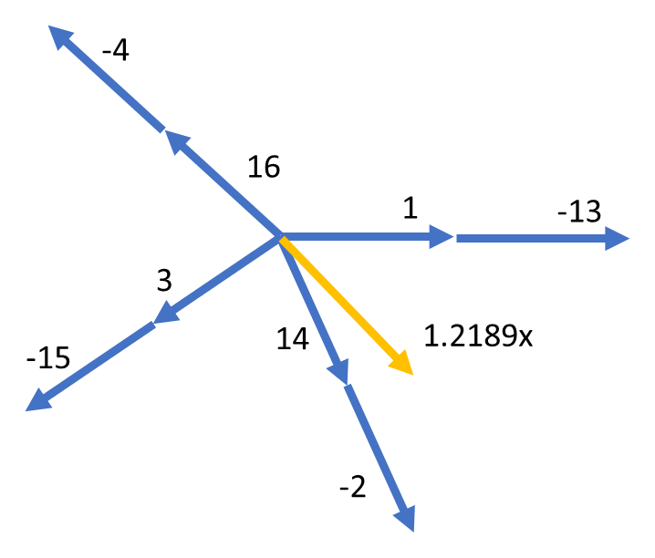

Figure 3. Phasor diagram for 5th harmonic of fractional-slot winding design 1

kw5 is calculated by the ratio of the geometric sum and sum of the absolute values of the phasors. Therefore, kw5 is equal to 0.1523 for the selected design.

# 2D FEA Modelling

2D FEA modelling of the fractional-slot winding design 1 is performed by using one of the most common FEA tools which is called ANSYS MAXWELL. Results of the FEA analyses are presented below figures.

