**ORTA DOĞU TEKNİK ÜNİVERSİTESİ**

**MIDDLE EAST TECHNICAL UNIVERSITY**

**EE568 Selected Topics on Electrical**

**Project-3: Final Project**

**Deniz Alp Yılmaz**

**Student ID: 1879766**

**July 2022**

Contents

INTRODUCTION & LITERATURE REVIEW 3

ANALYTICAL CALCULATION & SIZING 6

FEA MODELLING 12

COMPARISON & DISCUSSION 16

REFERENCES 18

# INTRODUCTION & LITERATURE REVIEW

Beginning from the industrial revolution, the increase in carbon pollution results in catastrophic events such as global warming, change in seasonal patterns, rise in sea levels, etc. To be able to have a more sustainable future, renewable and low-carbon energy production are much more vital today. Hydroelectric energy production is one of the most common renewable energy methods in the world. According to the International Energy Agency data, hydropower supplies 16% of the electricity demand of humankind and it is in the third place after natural gas and coal in terms of the amount of produced energy. Moreover, it is the second largest low-carbon electricity source [1]. The share of the low-carbon electricity generation by different technologies in 2020 is shown in Figure 1.

Figure 1: Electricity Production of Low-Carbon Generation Technologies, Adapted from [1]

In terms of the share of the hydropower capacities of different countries, 24% of the 950 GW of total installed capacity was in China in 2011 and it was followed by Brazil and US with 9% and 8% of the global hydroelectric production respectively [2]. Turkey is providing 1.84% of the installed hydroelectric capacity in the world and according to 2015 data, hydropower is the biggest electricity source in the country. The share of different electricity production methods for Turkey is presented in Figure 2.

Figure 2. Comparison of Different Electricity Production Methods for Turkey, Adapted from [3]

Although there are smaller size applications of hydro generators [4] [5], they are mostly used in hydroelectric plants. Hydroelectric plants convert hydraulic energy to electricity by using turbines and generators. Plants could be dam type or river type. In dam-type plants, the water is collected into a dam and released through a penstock. First, the head of the dam water is converted into kinetic energy, it turns the turbine, and the angular momentum and torque of the turbine turn the shaft of the generator which is connected to the turbine shaft with a coupling. The main components of a hydroelectric plant are shown in Figure 3.

Figure 3. Main Components of a Hydroelectric Plant [6]

In the design of a hydrogenator, there are various challenges due to the working conditions of the plant that should be disposed of carefully. One of these challenges that should be overcome is high vibration on the rotor shaft due to the unbalanced rotation of the turbine. These unbalances appear because of the deformations on the turbine. The not only but the major cause of turbine defects is cavitation which occurs because of the formation of vapor bubbles in the liquid, starting to evaporate when the hydrodynamic pressure of the liquid drops below the vapor pressure at constant ambient temperature. Two-phase flow is formed as a result of the mixing of substances with different densities such as water and water vapor. Since the density of the mentioned two-phase flow is low, the velocity of the water vapor bubbles is lower than that of the liquid water, and the flow regime is disrupted, resulting in a noisy and highly turbulent flow. In this highly turbulent flow, the bubbles hitting the turbine blades are suddenly exposed to high pressure and disappear by collapsing into themselves, which is called cavitation. Cavitation, which is undesirable in turbines, is more likely to occur near the fast-moving blades of turbines or in the outlet region. Although the formation of steam bubbles in cavitation is not a major problem, the collapse of these bubbles produces pressure waves of high frequency that damage the machine. In particular, the collapse of the bubbles near the turbine surface causes higher damage and causes abrasions called cavitation erosion on the surface of the turbine blades. The areas exposed to cavitation erosion first become bright, then small cavities are formed, and the wing surface takes on a spongy appearance as a result of these cavities deepening and the loss of material from turbine blades causes high vibration [7] [8]. Because of these high vibrations, the air gap should be designed larger compared to other generators that are used in different applications.

In hydroelectric systems, salient pole synchronous generators are commonly used. In the scope of this project, a salient pole hydrogenerator will be designed by using the determined constraints in the project description. The main concern is achieving an acceptable efficiency and energy output, considering the working conditions in the hydroelectric plants.

# ANALYTICAL CALCULATION & SIZING

In this part of the project, analytical calculations are performed by using the given information in project description to determine the generators characteristics and size of the main components. Formulations and calculation steps are presented below with order that was followed in the arithmetic computations in Excel (related Excel file can be found in Github). Given information and estimated values are presented with a green color and needed explanations *if exist) are given in the footnotes.

[1]

[2]

[3]

[4] *A/m*

[5] *A/m*

[6]

In addition to the above calculations, chosen materials from RMXPRT Library for the stator, rotor and poles are presented in Table 1.

Table 1. Selected Materials for Designed Generator

# FEA MODELLING

In this chapter of the project, the designed generator is analyzed by using a commercial FEA tool ANSYS Maxwell. Some of the results of the analytical calculations (stator dimensions, pole geometry, slot height and thicknesses, frequency, rated speed, etc.) were defined by using RMXPRT module in Maxwell and RMXPRT model was imported into the Maxwell 2-D model as transient FEA input data. The results of the FEA analyses are represented in this section and related results are discussed and compared with the analytical calculations in the next section.

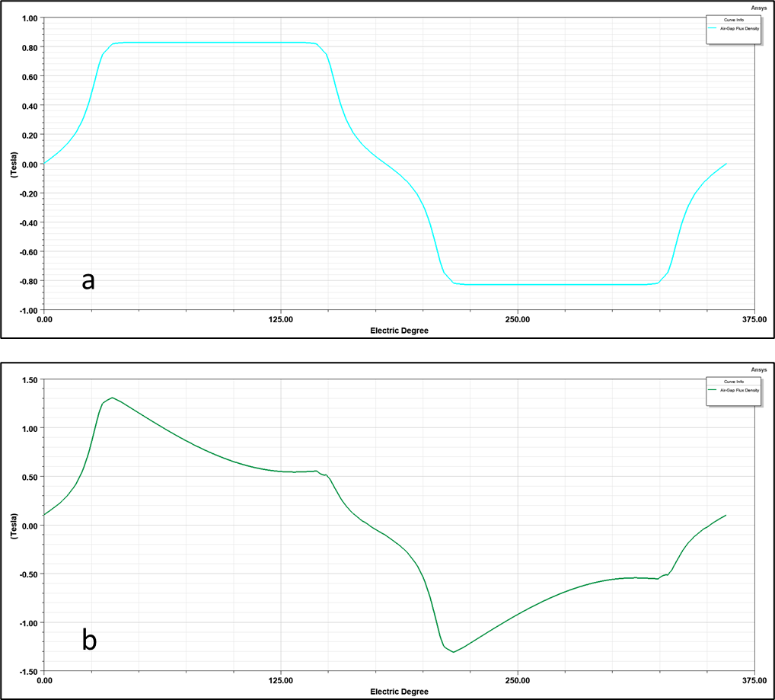

Figure 4. Air Gap Flux Density at a) No Load, b) Full Load

Figure 5. Cogging Torque

Figure 6. Induced Voltages for Phase A (red), Phase B (green) and Phase C (blue)

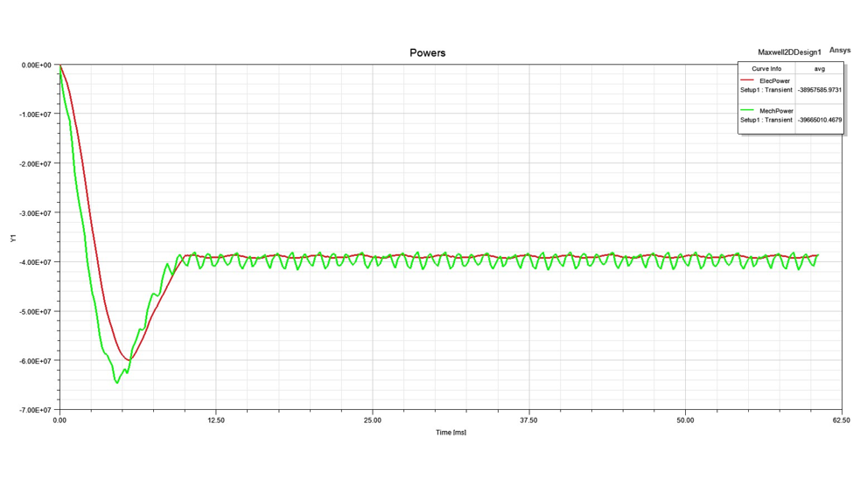

Figure 7. Electrical Power (red) and Mechanical Power (green)

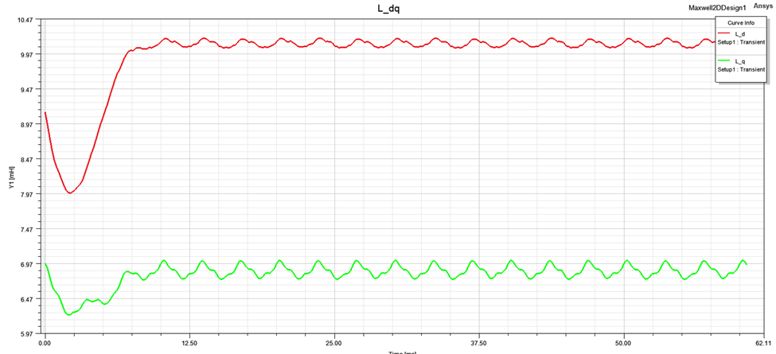

Figure 8. Direct Axis Inductance (red) and Quadrature Axis Inductance (Green)

Figure 9. Direct Axis Current (red) and Quadrature Axis Current (Green)

Figure 10. Analyzed Fraction of the Designed Machine

# COMPARISON & DISCUSSION

Above sections, analytical calculations and FEA results for the designed generator are explained. In addition to these calculations, also an analysis using RMXPRT software is performed. The comparison of important data taken as a result of these different methods will be compared in this section. Before comparisons, firstly, some important parameters about the size of the generator are presented in Table 1.

Table 2. Sizing Dimensions of the Generator

Losses that occur in stator and rotor cores and coppers are presented in Table 2.

Table 3. Loss Values with Their Locations

The performance parameters taken from RMXPRT results are presented in Table 4.

Table 4. Performance Parameters

As a starting point, comparing the induced voltage value found in analytical calculations (7967 V) is very close to the FEA results presented in Figure 6 for all 3 phases. Although the designed machine with 288 slots in the stator has various advantages such as high efficiency and smaller losses, it has a high cogging torque as could be seen in Figure 5. That amount of cogging torque may cause a large amount of undesired vibrations in the generator and results in many problems in the mechanical performance of machine such as high loads on the supports and fatigue load on the generator components which may shorten the service life of the machine. Also, the power outputs are similar in analytical calculations, and FEA represented results in Figure 7 (44 MW and 40 MW respectively). When it comes to the inductance and current values in direct and quadrature directions represented in Figure 8 and Figure 9 respectively, a significant difference between the two components could be observed as expected in salient pole synchronous machines. Power factor was an input in analytical calculations (with a value of 0.9). From Table 4, it could be seen that the calculated power factor (with a value of 0.88) as a result of RMXPRT calculations is very close to the considered one.

To conclude, designed generator has acceptable dimensions for a hydrogenerator and capable of satisfy the desired power outputs. Also, analytical calculations and FEA results are consistent in majority, however, some improvements could be performed to match them more precisely as a future work. Lastly, the large cogging torque should be mentioned as the biggest defect of the design.

# REFERENCES

[1] International Energy Agency (IEA). 2021. Hydropower Special Market Report Analysis and forecast to 2030. Paris, France.

[2] International Energy Agency (IEA). 2012. Key World Energy Statistics. Paris, France.

[3] Gökdemir M., Kömürcü M., Evcimen. T.U., Türkiye’de Hidroelektrik Enerji ve HES Uygulamalarına Genel Bakış, IMO Su Yapıları Kurulu

[4] M. O. A. Aqel, A. Issa, E. Qasem and W. El-Khatib. (2018) Hydroelectric Generation from Water Pipelines of Buildings. 2018 International Conference on Promising Electronic Technologies (ICPET), pp. 63-68.

[5] Ma, T., et al. (2018). Development of inline hydroelectric generation system from municipal water pipelines. Energy 144, 535–548.

[6] Khalil, I.U., et al. (2020). Solver-Based Mixed Integer Linear Programming (MILP) Based Novel Approach for Hydroelectric Power Generation Optimization. IEEE Access.

[7] Kumar, P., Saini, R. P. (2010). Study of cavitation in hydro turbines-a review. Renewable Sustainable Energy Reviews, 14:374–83.

[8] Li, D.Y., Song, Y.C., Lin, S., Wang, H.J., Qin, Y.L., Wei, X.Z. (2021). Effect mechanism of cavitation on the hump characteristic of a pump-turbine. Renewable Energy, 167, pp. 369-383.

[9] Pyrhonen, J., Jokinen, T., & Hrabovcova, V. (2008). Design of rotating electrical machines. Chichester, West Sussex, United Kingdom: Wiley.

1. A general assumption due to grid conditions
2. General assumption
3. From Pyrhonen [9], Table 6.1
4. From Pyrhonen, Table 6.2
5. From Pyrhonen, Table 6.2
6. Recalculated to apply the effect of rounding on