DOKUZ EYLUL UNIVERSITY
ENGINEERING FACULTY
DEPARTMENT OF COMPUTER ENGINEERING

CME1252 PROJECT BASED LEARNING – II
FINAL REPORT
PROJECT – I I

Number Maze

by
2019510040 Rana Gül
2019510128 Deniz Küçükkara
2018510122 Tutku Ekin Bayrı

Lecturers
Prof. Dr. Recep Alp Kut
phD Özge Kart

IZMIR
20.05.2021

CHAPTER ONE
PROGRESS DESCRIPTION
Purpose of this project is to create a maze game that is played with numbers. The player eats the numbers that are lower than his/her’s and adds them into a backpack. The player has 2 backpacks. Player can swap eaten numbers in the backpack by pressing Q and W buttons. By getting a number in the same backpack level the player gets his/her number increased and gets score based on eaten numbers value. The game ends if a number bigger than player’s eats the player. We started the project in 26.04.2021 and finished it in 17.05.2021. To complete this project we researched about enigma library and path finding algorithms.

CHAPTER TWO
TASK SUMMARY

Completed Tasks
Rana Gül: Number class has been created.The Maze has been read from the file. The screen has been printed on the screen with the help of Enigma. After that, maze colouring has been done. Numbers in the mazes have been printed on the screen with the input queue. They have been coloured on the screen with the help of Number Class's colour attribute. The score has been calculated and printed on the screen.
The pathfinding algorithm was written using depth-first searching. The path found has been printed on the screen. A new path is created every second according to the user's location. Red numbers were moved according to this path. The game main arrays have been changed to 23,55, created as 23,110. All code has been rearranged according to the new 23,55 array. To improve the Depth-first search algorithm, a better path was found by analogy with the stack queue structure.
The start screen has been added to the game. This screen has been decorated with different shapes for the user. It has been put into a general loop to be able to play the game again. Menu for the user has been added. the Exit option has been added to this menu. Two options were created in the game as normal and hard mode. Two different music has been added for the user to enjoy. A separate class was opened for this music.
A poster was prepared for the final evaluation. Presentation and report were prepared. Tests and controls were carried out.

Deniz Küçükkara: First of all, the movements of our number of players have been adjusted. Arrays are used to do this and all the other movements. Necessary checks are then made to make sure that our player number cannot go through walls or eat. For this, I add the walls on the arrays. Then, static numbers are made randomly placed in the maze, and then the places where these numbers would be placed randomly are checked. This control is to ensure that static numbers did not show up inside the walls. Then, random move command is written for the numbers (4,5,6). Then, eating status controls are checked. If the number of players is greater, the number of enemies defeated is transferred to the backpack. Otherwise, the game is over and the game over text is added. Required end of code debug and improvements have been made. The scores in the game have been saved in a file and sorted by size. The scores are listed on the screen at the end of the game. Finally, the presentation was made.

Tutku Ekin Bayrı: Created backpack class and its properties. Made backpack’s insertion operations and swapping elements between backpacks. Made when left backpack is full the top element is deleted and new element is added. Also made deleting elements from backpack when two elements are matched, adding of score and increasing the player’s number.
Created time class for time related operations such as adding new elements to board, printing seconds, the player’s number turning from 1 to 2 when 4 seconds are passed and board pieces moving when a certain time has passed.
Created coordinate class to use in path finding algorithm. Created a path finding algorithm for numbers that move using path finding.
Fixed numbers moving multiple times in the movement section.

Incomplete Tasks: Reasons and Explanations
There is no incomplete tasks. All tasks requested from the project team in the project file have been completed.

Additional Improvements to the Project
Rana Gül: The window size and font size have been changed to make the game easier to read. The circular queue class was used for the input queue because it takes up too much memory.
After writing the path-finding algorithm, the stack structure was compared to the queue structure to make the paths smoother. In this way, shorter paths were found. Red numbers were able to reach the user without doing it back and forth.
For the game to be effective for the user, the login screen has been added and decorated. This screen is decorated with various shapes and slogans and it is colored.
The game is looped so that the game can be played again and the user can exit whenever they want. the Menu has been added. The menu was decorated with different patterns and colors.
Normal and Hard modes have been added to the game. In this way, different games were offered to the user. In hard mode, more red and yellow numbers are provided to the user.
Different musics have been added to the game to attract user attention. The progress of the game and game over music was preferred differently.

Deniz Küçükkara: At the beginning of the game, a nickname is taken from the user. The username and score are saved in the file which, includes all scores and names. When the game is over, all scores are listed by size.

Tutku Ekin Bayrı: Made pathfinding more accurate when trying to find a way to the target.

CHAPTER THREE
EXPLANATION of algorıthms

Screenshots
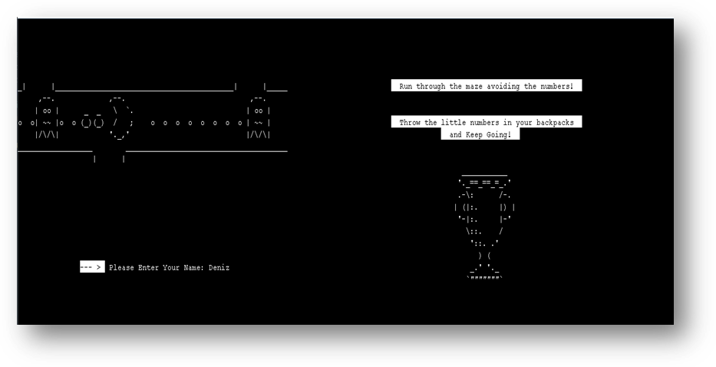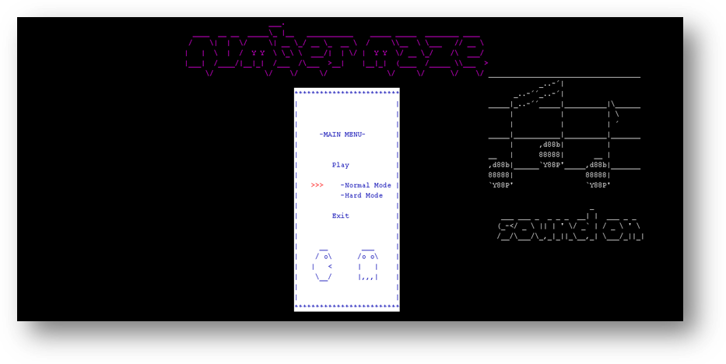

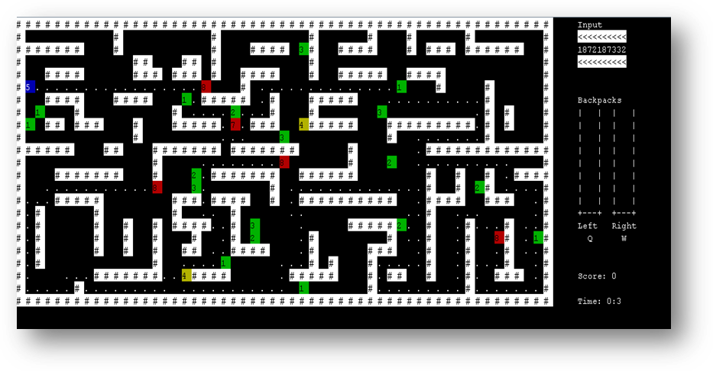

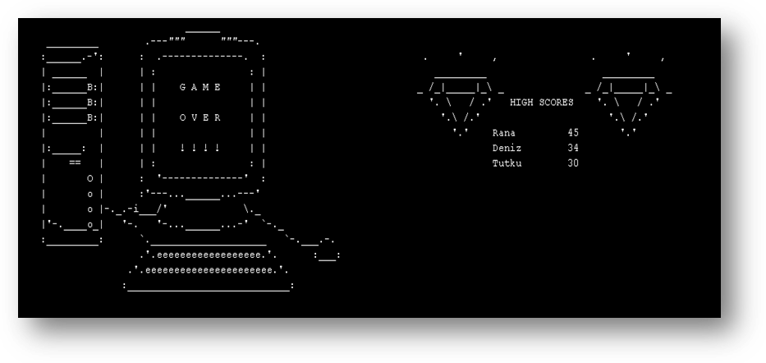
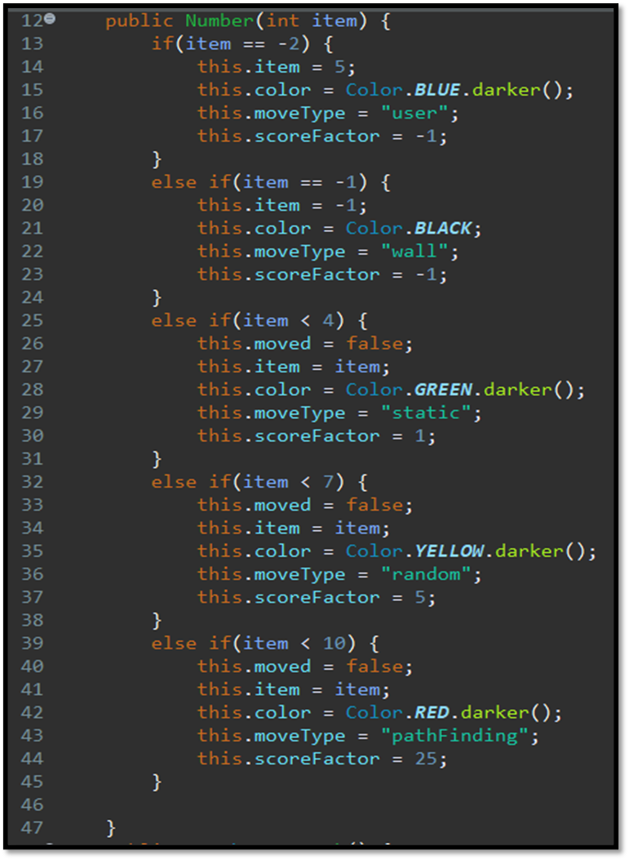
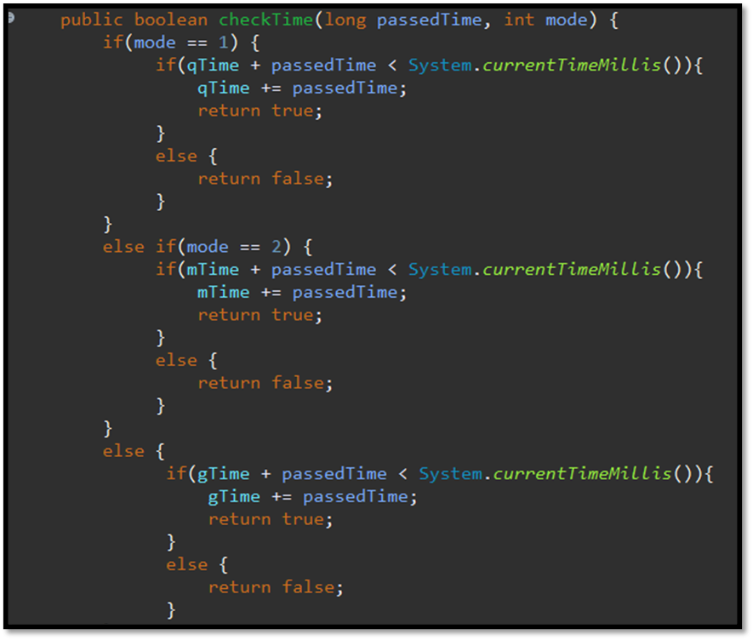
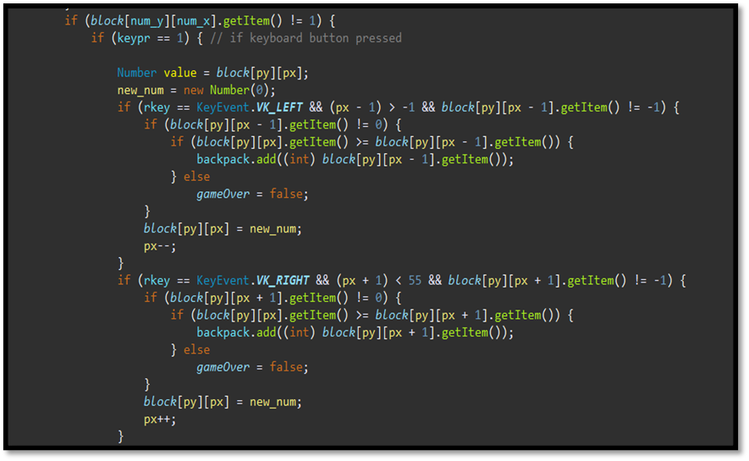

Functions
- //GAME CLASS
- public void pathFinding(int red_y, int red_x)
- public boolean ctrl(int add1, int add2, int red_x, int red_y, Coordinate currentCrdnte, Stack path,Coordinate[][] board)
- public boolean move(int i, int j, int add1, int add2, Backpack backpack, Number new_num)
- public void createInputQ(CircularQueue inputQueue)
- public void clearScreen()
- public void printGameArea2(String name, int score, int type) throws IOException
- public void Writer()
- public boolean printMenu(Boolean game) throws InterruptedException, FileNotFoundException
- //BACKPACK CLASS
- public void printBackpack(enigma.console.Console cn)
- public int swapElement(int rkey, int keypr,enigma.console.Console cn)
- public int compare(enigma.console.Console cn)
- public void add(int a)
- //MUSIC CLASS
- public void playMusic(String path)
- public void playMusic(String path)

Algorithms and Solution Strategies
Rana Gül: By creating the Number Class, information can be easily retrieved while printing the table or moving the numbers. The values, action types, score factors and colours of the numbers have been created as attributes. Arrays used are created in this type. Colour attributes are also defined for each object in order to be able to use it while printing on the screen.File inputs have been assigned to the array in the generated Number type.
The circular queue class was used for the input queue, which produces 25 numbers. This class has allowed the use of queue by saving little space in memory. Input queue has been created according to the generation probability given from the numbers. A number has been brought to the maze every 5 seconds.
The score has been calculated according to the score factor of the numbers. The number of users has been increased in every number of collets. When the user was 9, it was made to return to 1 and stay still for 4 seconds. At the end of 4 seconds, if the user is still 1, it is increased to 2.
Path finding algorithm: Coordinate class was created. Attributes are defined in it. X, Y, and previous coordinate have been kept in this class. By creating an array in the coordinate class, each point is assigned at the beginning of the function. While this assignment was made, each point was marked as untested. A variable was created holding the Current coordinate and given the values ​​of the user location. Looking at the location of the user and path-finding number, a direction was determined. (for example, at the bottom left, it was pushed to the stack in the following order upper-right-lower-left) Thanks to this direction, finding the path is made easier. The numbers around the current coordinate have been thrown to the stack. Each number got its previous coordinate value before being cast to the stack. And the stack was reversed. It has been pushed in reverse and this value becomes the current coordinate. The stack was then reverted and this loop continued until it reaches number or the stack is empty. If the path-finding number was reached during this loop, a break was made from the loop and the flag was true. By entering the next control, points were placed in previous coordinates, starting from current coordinate. A separate public array was created to print dots on the screen and markup was made over it.
Music has been added for the user to enjoy the game. A music class was created for this. This class contructor got a music path parameter. It played the music in this path. In addition to this class, the music stop function has been written. The music that will play during the game has been added to the outer loop when the game starts. When game over, this music was stopped and other music was added in its place. In this way, a musical feast that rotates with the game loop was created.
The game was originally written by creating an array of 23-100 and this has been changed to 23-55. The code was then adapted to this array. In addition, the screen has been edited for easier viewing, the console dimensions and font size have been increased. Normal and hard mode has been made to offer different options to the user in the game. For normal mode, an input queue was created with 5% red and 20% yellow probabilities. An input queue was created with 10% red and 25% yellow probabilities for hard mode. Thanks to this, different games emerged.
The Start screen has been added to provide game visuals and these various visuals are decorated with slogans and colors. Menu has been added. The menu was decorated with various images and colors. Normal, hard mode and exit options were created in the menu. Looped so that the game can be played again. In this way, unlimited game rights were offered to the user.

Deniz Küçükkara: While creating the array of the game, the walls are given a value of (-1), our player number (-2), and spaces are given (0). After that, a random number came to the map every 5 seconds. A loop is set up so that the incoming number does not hit the walls, so they appear in a random place where there is no wall.
A random direction is chosen individually for each (4,5,6) on the map for random movement control. In doing so, a random number from four is chosen, and each number is given a direction. If there is a situation where the number cannot go, a direction has been created again.
Then, two checks are made in 2 different places for the enemy eating situation and the number of players, and if the number of players is greater than the number of enemies they encountered, the number is beaten and thrown into the bag. Otherwise, the game is over and the game end screen appears.

Tutku Ekin Bayrı : In backpack whenever player gets a new number that number is added to first backpack stack using push. By reading if the key W or Q is pressed the top element in backpacks are moved between the backpacks. While comparing the backpacks first the backpack with more elements is trimmed and their elements are put into a holder stack. This way the same levels can be checked until both backpacks are empty. All the levels are checked by peeking and popping. If there are same numbers in a level, they are popped and returned in the function to see how much score will be added. Once both stacks are empty holder stacks are emptied into backpacks so that backpacks are restored.
For time System.currentTimeMillis() method is used to checked how much time has passed. The time class accepts a passedTime parameter and checks if that many milliseconds have passed.
Coordinate class holds the x and y locations and also holds what type of piece is in that location. 0 is for empty spaces -1 is for walls -2 is for player’s number and other numbers are non-player numbers. Coordinate class also holds a coordinate object called prev. This makes it so by using this prev a path can be created by going from the final location to where prev no more exists.
In pathfinding the number move according to player’s location. If the player is bottom right the number tries to go bottom right. If it cannot go that way, then number tries other ways. The number also pushes each way it could have gone but did not into a stack. If the number gets stuck, then it goes to the location on top of the stack. By doing this and finding the final location prev is used to create a path.

CHAPTER FOUR
PROBLEMS ENCOUNTERED
Rana Gül: Creating the array created for the maze in char type made it difficult to get the information. For this, a Number class with different attributes was created.
The input queue was causing the game to pause because it takes up a lot of memory. The circular queue class was used to avoid this problem.
While writing path finding, problems occured because the x and y coordinates were taken incorrectly. Later, it was very difficult to print the points in the game cycle. The points were marked and although they were deleted later, the path could not find. For this, a separate array had to be created. The problem is solved this way.
The Depth search algorithm found a very long way and the red numbers looped back and forth. For this, the stack structure has been compared to the queue structure.
As the numbers were small, they were difficult to follow on the screen. For this, the screen and texts were enlarged.
Array was opened 23-110 with spaces and this was forcing the path algorithm. For this, by making 23-55, spaces were used only when printing on the screen.

Deniz Küçükkara: Since I had never used Enigma before, I wasn't quite sure how it worked. At first, I had some difficulties moving our number and printing it, but then I was able to figure out what works and what.
Another problem I encountered was the control of randomly moving numbers. Loop was looking for all random numbers one by one, but sometimes the player number would also fall into this loop and move randomly. This problem disappeared when we defined our number in the Number class and made an if accordingly

Tutku Ekin Bayrı: Creating the pathfinding algorithm was thought provoking and different ideas were coming to mind. This resulted in creating multiple pathfinding algorithms to find a good solution until an announcement was made for pathfinding.
Also while trying to setup enigma I had several issues which could only be fixed by completely removing eclipse even removing any leftovers and even then I could only setup 1 project that utilizes enigma.
Another problem I encountered was numbers were moving twice or more because of the loop moving through the board and the number was moving before the loop moves causing the number to move multiple times. This was fixed using checks in the loop.

CHAPTER FIVE
conclusıon
In this project we learned how to make a maze game, how to use enigma library and how to implement path finding algorithms in 2d game designs. We learned how sharing the work makes a project much easier to complete and how teamwork makes everything more efficient.

REFERENCES
- https://www.java.com/
- https://www.stackoverflow.com/
- https://www.tutorialspoint.com/java/java_files_io.htm
- https://github.com/mikepound/enigma

AppendIx A
Poster/Web page of the Project
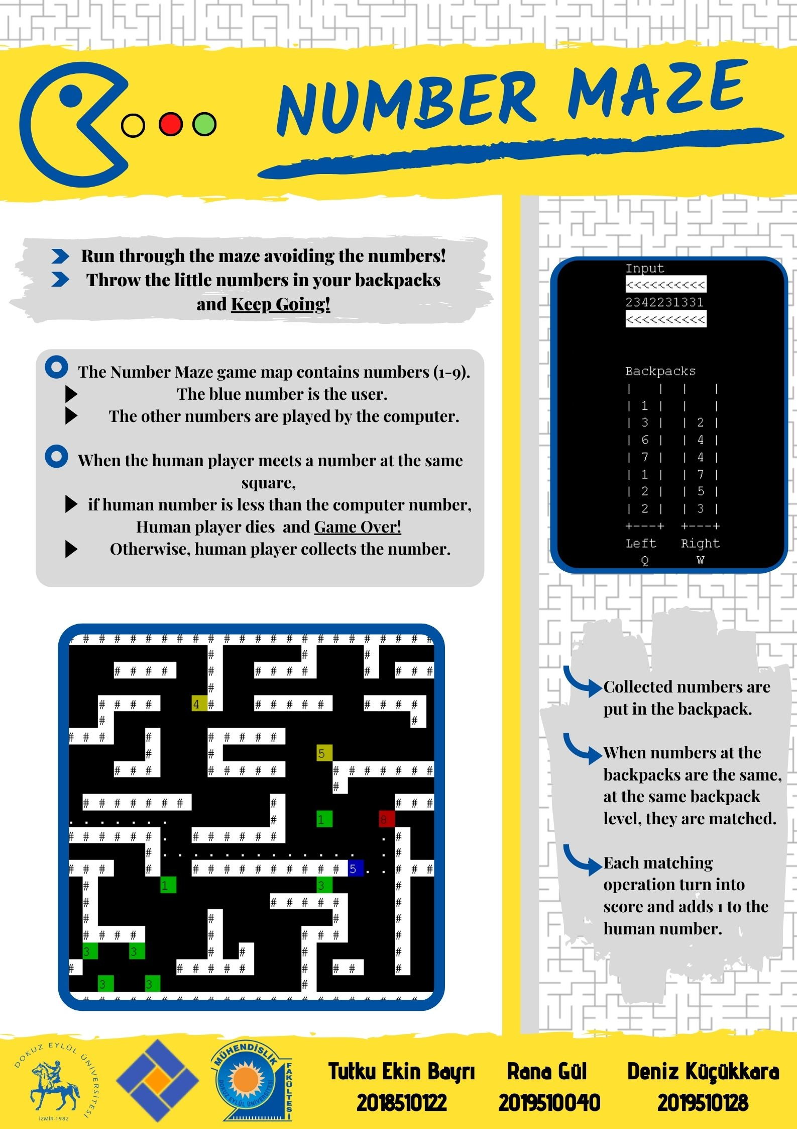
AppendIx B
Code of the Project

import java.io.BufferedReader;
import java.io.File;
import java.io.FileReader;
import java.util.Scanner;

import java.awt.Color;
import java.io.File;
import java.io.FileReader;
import java.util.Scanner;

import enigma.console.TextAttributes;
import enigma.core.Enigma;

public class GameTest {

public static void main(String[] args) throws Exception {
Game game = new Game();
}
}
import enigma.core.Enigma;
import enigma.event.TextMouseEvent;
import enigma.event.TextMouseListener;
import java.awt.event.KeyEvent;
import java.awt.event.KeyListener;
import java.io.File;
import java.io.FileNotFoundException;
import java.io.FileWriter;
import java.io.IOException;
import java.util.Iterator;
import java.util.Random;
import java.util.Scanner;

import enigma.console.TextAttributes;
import java.awt.Color;

public class Game {
public enigma.console.Console cn = Enigma.getConsole("--- Number Maze ---", 160, 30, 15);
public TextMouseListener tmlis;
public KeyListener klis;
public TextAttributes reset = new TextAttributes(Color.WHITE);
public TextAttributes attr = new TextAttributes(Color.BLACK, Color.WHITE);
public Object[][] gameArea = new Object[23][55];

public static Number[][] block = new Number[23][55];
public static boolean gameOver = true;
public int num_x, num_y;
public int score = 0;
public int turn;
public Backpack backpack = new Backpack();
public int[][] dotsblock = new int[23][55];
public int gameMode;
// ------ Standard variables for mouse and keyboard ------
public int mousepr; // mouse pressed?
public int mousex, mousey; // mouse text coords.
public int keypr; // key pressed?
public int rkey; // key (for press/release)
// ----------------------------------------------------

public void clearScreen() {
cn.getTextWindow().setCursorPosition(0, -1);
for (int i = 0; i < cn.getTextWindow().getColumns(); i++) {
for (int j = 0; j < cn.getTextWindow().getRows(); j++) {
System.out.print(" ");
}
}
}

public boolean printMenu(Boolean game) throws InterruptedException, FileNotFoundException {
TextAttributes reset = new TextAttributes(Color.WHITE);
TextAttributes attr2 = new TextAttributes(Color.MAGENTA);
clearScreen();

File r = new File("menu.txt");
Scanner sc2 = new Scanner(r, "UTF-8");
int im = 0;
while (sc2.hasNextLine()) {
cn.getTextWindow().setCursorPosition(40, im);
if (im >= 6){
cn.getTextWindow().setCursorPosition(66, im);
attr2 = new TextAttributes(Color.BLUE.darker(),Color.WHITE);
}
cn.setTextAttributes(attr2);
String line = sc2.nextLine();
System.out.println(line);
im++;
}
File r2 = new File("soundOn.txt");
Scanner sc3 = new Scanner(r2, "UTF-8");
int em = 3;
while (sc3.hasNextLine()) {
cn.getTextWindow().setCursorPosition(112, em);
attr2 = new TextAttributes(Color.WHITE);
cn.setTextAttributes(attr2);
String line = sc3.nextLine();
System.out.println(line);
em++;
}
cn.setTextAttributes(reset);
attr2 = new TextAttributes(Color.RED,Color.WHITE);
game = true;
cn.getTextWindow().setCursorPosition(70, 16); int n = 16;
cn.getTextWindow().output(">>>", attr2);
while (true) {
if (keypr == 1) {
if (rkey == KeyEvent.VK_UP && (n == 17)) {
cn.getTextWindow().setCursorPosition(70, 17);
cn.getTextWindow().output(" ", attr2);
cn.getTextWindow().setCursorPosition(70, 16); n =16;
cn.getTextWindow().output(">>> ", attr2);
game = true; gameMode=5;
}
if (rkey == KeyEvent.VK_UP && (n == 19)) {
cn.getTextWindow().setCursorPosition(70, 19);
cn.getTextWindow().output(" ", attr2);
cn.getTextWindow().setCursorPosition(70, 17); n =17;
cn.getTextWindow().output(">>> ", attr2);
game = true; gameMode=10;
}
else if (rkey == KeyEvent.VK_DOWN && (n == 16)) {
cn.getTextWindow().setCursorPosition(70, 16);
cn.getTextWindow().output(" ", attr2);
cn.getTextWindow().setCursorPosition(70, 17); n = 17;
cn.getTextWindow().output(">>> ", attr2);
game = true ; gameMode=10;
}
else if (rkey == KeyEvent.VK_DOWN && (n == 17)) {
cn.getTextWindow().setCursorPosition(70, 17);
cn.getTextWindow().output(" ", attr2);
cn.getTextWindow().setCursorPosition(70, 19); n =19;
cn.getTextWindow().output(">>> ", attr2);
game = false;
}else if (rkey == KeyEvent.VK_ENTER)
break;
keypr = 0;
}
Thread.sleep(20);
}
clearScreen();
return game;
}

public void printStart() throws FileNotFoundException {

cn.getTextWindow().setCursorPosition(0, 5);
File f = new File("ascii_pacman.txt");
Scanner sc = new Scanner(f, "UTF-8");
while (sc.hasNextLine()) {
String line = sc.nextLine();

System.out.println(line);
}
int x = 12;
File f2 = new File("ascii_trophy.txt");
Scanner sc2 = new Scanner(f2, "UTF-8");
while (sc2.hasNextLine()) {
String line = sc2.nextLine();
cn.getTextWindow().setCursorPosition(99, x);
System.out.println(line);
x++;
}
TextAttributes items_color = new TextAttributes(Color.BLACK, Color.WHITE);
cn.getTextWindow().setCursorPosition(90, 5);
cn.setTextAttributes(items_color);
System.out.println(" Run through the maze avoiding the numbers! ");
cn.getTextWindow().setCursorPosition(90, 8);
System.out.println(" Throw the little numbers in your backpacks ");
cn.getTextWindow().setCursorPosition(102, 9);
System.out.println(" and Keep Going! ");
cn.setTextAttributes(reset);
}

public void printGameArea() {
cn.getTextWindow().setCursorPosition(0, 0);
for (int i = 0; i < gameArea.length; i++) {
for (int j = 0; j < gameArea[i].length; j++) {

if (String.valueOf(gameArea[i][j]).equals("#")) {
cn.setTextAttributes(attr);
Number new_num = new Number(-1);
block[i][j] = new_num;
dotsblock[i][j] = 0;
} else {
cn.setTextAttributes(reset);
Number new_num = new Number(0);
block[i][j] = new_num;
dotsblock[i][j] = 0;
}
System.out.print(gameArea[i][j] + " ");
}
System.out.println();
}
}

public void printInputQ(CircularQueue inputQueue) { // its new for display numbers
int cx = 115;
int cy = 0;
cn.setTextAttributes(reset);
cn.getTextWindow().setCursorPosition(cx, cy);
System.out.println("Input");
cn.setTextAttributes(attr);
cn.getTextWindow().setCursorPosition(cx, cy + 1);
System.out.println("<<<<<<<<<<");

for (int i = 0; i < 25; i++) {
cn.setTextAttributes(reset);
cn.getTextWindow().setCursorPosition(cx + i, cy + 2);
if (i < 10)
System.out.print(inputQueue.peek());
inputQueue.enqueue(inputQueue.dequeue());
}

cn.setTextAttributes(attr);
cn.getTextWindow().setCursorPosition(cx, cy + 3);
System.out.println("<<<<<<<<<<");
cn.setTextAttributes(reset);
}

public void Writer() {
for (int i = 0; i < block.length; i++) {
int a = i, b = 0;
for (int j = 0; j < block[i].length; j++) {
if (block[i][j].getMoveType().equals("user")) {
cn.getTextWindow().setCursorPosition(b, a);
TextAttributes items_color = new TextAttributes(Color.WHITE, block[i][j].getColor());
cn.setTextAttributes(items_color);

System.out.print((char) (block[i][j].getItem() + '0') + " ");
cn.setTextAttributes(reset);

} else if (block[i][j].getItem() > 0 && block[i][j].getItem() < 10) {

cn.getTextWindow().setCursorPosition(b, a);
TextAttributes items_color = new TextAttributes(Color.BLACK, block[i][j].getColor());
cn.setTextAttributes(items_color);

System.out.print((char) (block[i][j].getItem() + '0') + " ");
cn.setTextAttributes(reset);

} else if (dotsblock[i][j] == 1) {
cn.getTextWindow().setCursorPosition(b, a);
TextAttributes items_color = new TextAttributes(Color.WHITE);
cn.setTextAttributes(items_color);

System.out.print((char) ('.') + " ");
cn.setTextAttributes(reset);
} else if ((block[i][j].getItem() == -1)) {
cn.getTextWindow().setCursorPosition(b, a);
TextAttributes items_color = new TextAttributes(block[i][j].getColor(), Color.WHITE);
cn.setTextAttributes(items_color);

System.out.print("# ");
cn.setTextAttributes(reset);
} else if (block[i][j].getItem() == 0) {
cn.getTextWindow().setCursorPosition(b, a);
System.out.print(" ");

} else {
cn.getTextWindow().setCursorPosition(b, a);
TextAttributes items_color = new TextAttributes(Color.BLACK, block[i][j].getColor());
cn.setTextAttributes(items_color);

System.out.print((char) (block[i][j].getItem() + '0') + " ");
cn.setTextAttributes(reset);
}
b = b + 2;
}
}
}

public void printGameArea2(String name, int score, int type) throws IOException {
String[] names = new String[999];
int[] scores = new int[999];
int var_while = 0;
clearScreen();

cn.getTextWindow().setCursorPosition(0, 0);
File f = new File("ascii_computer.txt");
Scanner sc = new Scanner(f, "UTF-8");
while (sc.hasNextLine()) {
String line = sc.nextLine();

System.out.println(line);
}
sc.close();
File f2 = new File("diamond.txt");
Scanner sc2 = new Scanner(f2, "UTF-8");
int im = 2;
while (sc2.hasNextLine()) {
cn.getTextWindow().setCursorPosition(68, im);
String line = sc2.nextLine();
System.out.println(line);
cn.getTextWindow().setCursorPosition(97, im);
System.out.println(line);
im++;
}
sc2.close();
File fff = new File("scoretable.txt");
if (type == 1) {
if(name.equals("")) name = "Default";
FileWriter fw = new FileWriter(fff, true);
fw.write(name + " " + score + "\n");
fw.close();
}
File ff = new File("scoretable.txt");
Scanner scc = new Scanner(ff, "UTF-8");
while (scc.hasNextLine()) {
String line = scc.nextLine();
String[] namescore = line.split(" ");
names[var_while] = namescore[0];
scores[var_while] = Integer.parseInt(namescore[1]);
var_while++;
}
scc.close();
for (int i = 0; i < scores.length; i++) {
for (int j = 0; j < scores.length; j++) {
if (scores[i] > scores[j]) {
int temp = scores[i];
scores[i] = scores[j];
scores[j] = temp;
String temp_two = names[i];
names[i] = names[j];
names[j] = temp_two;
}
}
}
cn.getTextWindow().setCursorPosition(82, 5);
System.out.println(" HIGH SCORES");
for (int i = 0; i < scores.length; i++) {
if (names[i] != null) {
cn.getTextWindow().setCursorPosition(82, 7 + i);
System.out.print(names[i] + "");
cn.getTextWindow().setCursorPosition(95, 7 + i);
System.out.println(scores[i] + "");
}
}
}

public void createInputQ(CircularQueue inputQueue) { // creating input queue, its adding 25 random numbers to queue.
Random rnd = new Random();
for (int i = 0; i < 25; i++) {
int rnd_num = rnd.nextInt(100) + 1;
if (rnd_num <= gameMode) {
rnd_num = rnd.nextInt(3) + 7;
} else if (rnd_num <= (gameMode+15)) {
rnd_num = rnd.nextInt(3) + 4;
} else if (rnd_num <= 100) {
rnd_num = rnd.nextInt(3) + 1;
}
inputQueue.enqueue(rnd_num);
}
int cntr = 0;
while (cntr != 25) { //Send 25 numbers to maze at the start of the game.
Number num = new Number((int) inputQueue.peek());
inputQueue.enqueue(inputQueue.dequeue());
int rand_int1 = rnd.nextInt(23); // find a location
int rand_int2 = rnd.nextInt(55);
if (block[rand_int1][rand_int2].getItem() == 0) {
block[rand_int1][rand_int2] = num;
cntr++;
}
}
}

public boolean move(int i, int j, int add1, int add2, Backpack backpack, Number new_num) {
//The function that can perform the movements of all numbers.
if (block[i + add1][j + add2].getMoveType().equals("user")) {
if (block[i][j].getItem() > block[i + add1][j + add2].getItem()) {
gameOver = false;
return true;
} else if (block[i][j].getItem() <= block[i + add1][j + add2].getItem()) {
backpack.add((int) block[i][j].getItem());
block[i][j] = new_num;
return false;
}
} else {
block[i + add1][j + add2] = block[i][j];
new_num = new Number(0);
block[i][j] = new_num;
return false;
}
return false;
}

public void calculateScore(Number num) {
if (num.getItem() != -3 && num.getItem() != -4) {
score += num.getScoreFactor() * num.getItem(); //the formula for score
if (num.getItem() != 0 && block[num_y][num_x].getItem() != 9) {
block[num_y][num_x].setItem(block[num_y][num_x].getItem() + 1);
} else if (num.getItem() != 0) {
block[num_y][num_x].setItem(1);
}
cn.getTextWindow().setCursorPosition(115, 20);
System.out.println("Score: " + score);
}
}

public void pathFinding(int red_y, int red_x) {
Stack path = new Stack(500); //stack for path finding
Coordinate[][] board = new Coordinate[23][55]; //coordinate array for numbers's coordinates

for (int a = 0; a < board.length; a++) {
for (int b = 0; b < board[a].length; b++) {
board[a][b] = new Coordinate(b, a, -1, -1); // set the coordinates
block[a][b].setTried(false); // set the tried false
}
}
Coordinate currentCrdnte = new Coordinate(num_x, num_y, -1, -1);
//current coordinate initially has the user location. Then, in each step,
//the position of the number is sent to the current coordinate, allowing it to do path finding.
boolean flag = false;
//The flag becomes true when the user finds the path finding number.
int type = 0;
//These types change the order of assigning numbers to the stack, making it easier to find paths.
if (red_x <= currentCrdnte.getX() && red_y >= currentCrdnte.getY())
type = 1;
else if (red_x > currentCrdnte.getX() && red_y > currentCrdnte.getY())
type = 2;
else if (red_x < currentCrdnte.getX() && red_y < currentCrdnte.getY())
type = 3;

while (true) {

if (currentCrdnte.getX() == red_x && currentCrdnte.getY() == red_y)
break;
if (type == 1) { // sol alt
flag = ctrl((-1), 0, red_x, red_y, currentCrdnte, path, board);if (flag)break; // upper
flag = ctrl(0, 1, red_x, red_y, currentCrdnte, path, board);if (flag)break; // right
flag = ctrl(1, 0, red_x, red_y, currentCrdnte, path, board);if (flag)break; // lower
flag = ctrl(0, (-1), red_x, red_y, currentCrdnte, path, board);if (flag)break; // left
} else if (type == 2) { // sag alt
flag = ctrl((-1), 0, red_x, red_y, currentCrdnte, path, board);if (flag)break; // upper
flag = ctrl(0, (-1), red_x, red_y, currentCrdnte, path, board);if (flag)break; // left
flag = ctrl(1, 0, red_x, red_y, currentCrdnte, path, board);if (flag)break; // lower
flag = ctrl(0, 1, red_x, red_y, currentCrdnte, path, board);if (flag)break; // right
} else if (type == 3) { // sol ust
flag = ctrl(1, 0, red_x, red_y, currentCrdnte, path, board);if (flag)break; // lower
flag = ctrl(0, 1, red_x, red_y, currentCrdnte, path, board);if (flag)break; // right
flag = ctrl((-1), 0, red_x, red_y, currentCrdnte, path, board);if (flag)break; // upper
flag = ctrl(0, (-1), red_x, red_y, currentCrdnte, path, board);if (flag)break; // left
} else {
flag = ctrl(1, 0, red_x, red_y, currentCrdnte, path, board);if (flag)break; // lower
flag = ctrl(0, (-1), red_x, red_y, currentCrdnte, path, board);if (flag)break; // left
flag = ctrl((-1), 0, red_x, red_y, currentCrdnte, path, board);if (flag)break; // upper
flag = ctrl(0, 1, red_x, red_y, currentCrdnte, path, board);if (flag)break; // right
}
//The value is pushed by reversing the stack.
// In this way, the queue algorithm is imitated and easier to find paths.
if (!path.isEmpty()) {
Stack temp = new Stack(500);
while(!path.isEmpty()) {
temp.push(path.pop());
}
currentCrdnte = (Coordinate) temp.pop();
while(!temp.isEmpty()) {
path.push(temp.pop());
}
}
else
break;
}
if (flag) {//if there is a path

block[red_y][red_x].setMoved(true); //for the red number to move once in a loop
int index_y = board[red_y][red_x].getPrevY();
int index_x = board[red_y][red_x].getPrevX();
int temp3 = index_y;
int temp4 = index_x;
Number new_num = new Number(-2);// user

if (index_y > -1 && index_x > -1) {

if (block[index_y][index_x].getMoveType().equals("user")) {
//if there is a number picking

if (block[red_y][red_x].getItem() > block[index_y][index_x].getItem()) {
gameOver = false;
} else if (block[red_y][red_x].getItem() <= block[index_y][index_x].getItem()) {
backpack.add((int) block[red_y][red_x].getItem());
block[red_y][red_x] = new_num;
}

} else {
//With the help of an independent array, points are printed on the screen
// by taking their previous coordinates.
while (!(board[index_y][index_x].getPrevY() == num_y
&& board[index_y][index_x].getPrevX() == num_x)) {
int temp = index_x;
int temp2 = index_y;

index_y = board[temp2][temp].getPrevY();
index_x = board[temp2][temp].getPrevX();
dotsblock[index_y][index_x] = 1;

if (index_y < 0 || index_x < 0)
break;
}

block[temp3][temp4] = block[red_y][red_x];
new_num = new Number(0);
block[red_y][red_x] = new_num;
Writer();
}
}
}
}

public boolean ctrl(int add1, int add2, int red_x, int red_y, Coordinate currentCrdnte, Stack path,
Coordinate[][] board) {

if (currentCrdnte.getY() + add1 < 23 && currentCrdnte.getX() + add2 < 55) {

if (block[currentCrdnte.getY() + add1][currentCrdnte.getX() + add2].getItem() == 0
&& block[currentCrdnte.getY() + add1][currentCrdnte.getX() + add2].isTried() != true) {

//setting for previous coordinates
board[currentCrdnte.getY() + add1][currentCrdnte.getX() + add2].setPrevX(currentCrdnte.getX());
board[currentCrdnte.getY() + add1][currentCrdnte.getX() + add2].setPrevY(currentCrdnte.getY());

// to push the numbers around the current coordinate
path.push(board[currentCrdnte.getY() + add1][currentCrdnte.getX() + add2]);
block[currentCrdnte.getY() + add1][currentCrdnte.getX() + add2].setTried(true);

return false;
} else if (currentCrdnte.getY() + add1 == red_y && currentCrdnte.getX() + add2 == red_x) {
//If the number on the path find is reached

board[red_y][red_x].setPrevX(currentCrdnte.getX());
board[red_y][red_x].setPrevY(currentCrdnte.getY());
return true;
}
}
return false;
}

public void deleteDots() {
//deleting path dots
for (int i = 0; i < block.length; i++) {
for (int j = 0; j < block[i].length; j++) {
if (dotsblock[i][j] == 1) {
dotsblock[i][j] = 0;
}
}
}
}

Game() throws Exception { // --- Contructor
// ------ Standard code for mouse and keyboard ------ Do not change
tmlis = new TextMouseListener() {
public void mouseClicked(TextMouseEvent arg0) {
}

public void mousePressed(TextMouseEvent arg0) {
if (mousepr == 0) {
mousepr = 1;
mousex = arg0.getX();
mousey = arg0.getY();
}
}

public void mouseReleased(TextMouseEvent arg0) {
}
};
cn.getTextWindow().addTextMouseListener(tmlis);
klis = new KeyListener() {
public void keyTyped(KeyEvent e) {
}

public void keyPressed(KeyEvent e) {
if (keypr == 0) {
keypr = 1;
rkey = e.getKeyCode();
}
}

public void keyReleased(KeyEvent e) {
}
};
cn.getTextWindow().addKeyListener(klis);
//////////////////////////////
Random rand = new Random();
boolean game = true;
String username = "user";

// FILE OPERATIONS
File f = new File("maze.txt");
Scanner sc = new Scanner(f, "UTF-8");
int row = 0;
while (sc.hasNextLine()) {
String line = sc.nextLine();
for (int i = 0; i < 55; i++) {
gameArea[row][i] = line.charAt(i);
}
row++;
}
Music music = new Music();

while (game) {
music.playMusic("pac-man.wav");
CircularQueue inputQueue = new CircularQueue(25);// Input queue(numbers) (25)
int numbersCounter = 25;
block = new Number[23][55];
gameOver = true;
num_x = 0;
num_y = 0;
score = 0;
turn = 0;
backpack = new Backpack();
dotsblock = new int[23][55];

game = printMenu(game);
if (!game)
break;
Scanner sc1 = new Scanner(System.in);
printStart();

TextAttributes items_color = new TextAttributes(Color.BLACK, Color.WHITE);
cn.setTextAttributes(items_color);
cn.getTextWindow().setCursorPosition(15, 20);
System.out.print("--- > ");
cn.setTextAttributes(reset);
System.out.print(" Please Enter Your Name: ");
username = sc1.nextLine();
clearScreen();

Time time = new Time();
printGameArea();
// Selecting number for input Queue
createInputQ(inputQueue);
printInputQ(inputQueue);

int rnd_x = 0;
int rnd_y = 0;
while (!(block[rnd_y][rnd_x].getItem() >= 0)) {
rnd_x = rand.nextInt(55);
rnd_y = rand.nextInt(23);
}
int px = rnd_x;
int py = rnd_y;
num_x = px;
num_y = py;

Number new_num = new Number(-2);// user
block[py][px] = new_num;//

while (true) {

Number deneme = new Number(0);
deneme.setItem(0);
calculateScore(deneme);
time.printTime(cn);

// an item is inserted into the maze every 5 seconds.
if (time.checkTime(5000, 1)) {
Number num = new Number((int) inputQueue.peek());
inputQueue.enqueue(inputQueue.dequeue());
numbersCounter++;
printInputQ(inputQueue);
boolean inserter = true;
while (inserter) {// find a location
int rand_int1 = rand.nextInt(23);
int rand_int2 = rand.nextInt(55);
if (block[rand_int1][rand_int2].getItem() == 0) {
block[rand_int1][rand_int2] = num;
inserter = false;
}
}
}
if (time.checkTime(4000, 3) && block[num_y][num_x].getItem() == 1) {
block[num_y][num_x].setItem(2);
Writer();
}
if (time.checkTime(300, 2)) {
turn = backpack.swapElement(rkey, keypr, cn);
Number turnnum = new Number(turn);
calculateScore(turnnum);
backpack.printBackpack(cn);
deleteDots();
for (int i = 0; i < block.length; i++) { // RANDOM MOVEMENT FOR 4 5 6
for (int j = 0; j < block[i].length; j++) {
if ((block[i][j].getMoveType().equals("random"))) {
boolean stop = true;
while (stop) {
int rand_int1 = rand.nextInt(4) + 1;
if (rand_int1 == 1 && j - 1 > -1) {// left
if ((block[i][j - 1].getItem() == 0
|| block[i][j - 1].getMoveType().equals("user")
|| block[i][j - 1].getItem() == -4) && !block[i][j - 1].isMoved()) {
if (move(i, j, 0, -1, backpack, new_num))
break;

stop = false;
}
} else if (rand_int1 == 2 && j + 1 < 55) {// right
if ((block[i][j + 1].getItem() == 0
|| block[i][j + 1].getMoveType().equals("user")
|| block[i][j + 1].getItem() == -4) && !block[i][j + 1].isMoved()) {
if (move(i, j, 0, 1, backpack, new_num))
break;

stop = false;
}
} else if (rand_int1 == 3 && i - 1 > -1) {// up
if ((block[i - 1][j].getItem() == 0
|| block[i - 1][j].getMoveType().equals("user")
|| block[i - 1][j].getItem() == -4) && !block[i - 1][j].isMoved()) {
if (move(i, j, -1, 0, backpack, new_num))
break;

stop = false;
}
} else if (rand_int1 == 4 && i + 1 < 23) {// down
if ((block[i + 1][j].getItem() == 0
|| block[i + 1][j].getMoveType().equals("user")
|| block[i + 1][j].getItem() == -4) && !block[i + 1][j].isMoved()) {
if (move(i, j, 1, 0, backpack, new_num))
break;

stop = false;
}
}
}
}
if ((block[i][j].getMoveType().equals("pathFinding") && !block[i][j].isMoved())) {
pathFinding(i, j);
block[i][j].setMoved(true);

} else
continue;
}

}
for (int k = 0; k < 23; k++) {
for (int k2 = 0; k2 < 55; k2++) {
block[k][k2].setMoved(false);
}
}
if (block[num_y][num_x].getItem() != 1) {
if (keypr == 1) { // if keyboard button pressed

Number value = block[py][px];
new_num = new Number(0);
if (rkey == KeyEvent.VK_LEFT && (px - 1) > -1 && block[py][px - 1].getItem() != -1) {
if (block[py][px - 1].getItem() != 0) {
if (block[py][px].getItem() >= block[py][px - 1].getItem()) {
backpack.add((int) block[py][px - 1].getItem());
} else
gameOver = false;
}
block[py][px] = new_num;
px--;
}
if (rkey == KeyEvent.VK_RIGHT && (px + 1) < 55 && block[py][px + 1].getItem() != -1) {
if (block[py][px + 1].getItem() != 0) {
if (block[py][px].getItem() >= block[py][px + 1].getItem()) {
backpack.add((int) block[py][px + 1].getItem());
} else
gameOver = false;
}
block[py][px] = new_num;
px++;
}
if (rkey == KeyEvent.VK_UP && (py - 1) > -1 && block[py - 1][px].getItem() != -1) {
if (block[py - 1][px].getItem() != 0) {
if (block[py][px].getItem() >= block[py - 1][px].getItem()) {
backpack.add((int) block[py - 1][px].getItem());
} else
gameOver = false;
}
block[py][px] = new_num;
py--;
}
if (rkey == KeyEvent.VK_DOWN && (py + 1) < 23 && block[py + 1][px].getItem() != -1) {
if (block[py + 1][px].getItem() != 0) {
if (block[py][px].getItem() >= block[py + 1][px].getItem()) {
backpack.add((int) block[py + 1][px].getItem());
} else
gameOver = false;
}
block[py][px] = new_num;
py++;
}
char rckey = (char) rkey;
// left right up down
if (rckey == '%' || rckey == '\'' || rckey == '&' || rckey == '(') {
block[py][px] = value;
num_y = py;
num_x = px;
}
keypr = 0; // last action
}
}
Writer();
if (gameOver == false) {
break;
}
}
Thread.sleep(20);
}
music.stop();
music.playMusic("game-over.wav");
printGameArea2(username, score, 1);
Thread.sleep(6000);
music.stop();
}
music.stop();
printGameArea2(username, score, 2);
}
}
import java.awt.event.KeyEvent;

public class Backpack {
//backpacks 1 and 2 are created as stacks
public Stack backpack1;
public Stack backpack2;
Backpack(){
backpack1 = new Stack(8);
backpack2 = new Stack(8);
}
//Prints the backpacks and updates them when elements are added or moved.
public void printBackpack(enigma.console.Console cn){
int cx = 115;
int cy = 7;
cn.getTextWindow().setCursorPosition(cx,cy - 1);
System.out.println("Backpacks");
for(int i = 0; i < 4; i++) {
cn.getTextWindow().setCursorPosition(cx,cy);
for(int j = 0; j < 8; j++) {
System.out.println("|");
cy++;
cn.getTextWindow().setCursorPosition(cx,cy);
}
System.out.println("+");
if(i == 1) {
cx += 3;
}
else {
cx += 4;
}
cy = 7;
}
Stack dummy = new Stack(8);
int size = backpack1.size();
while(!backpack1.isEmpty()) {
cn.getTextWindow().setCursorPosition(117,cy + 8 - size);
Object object = backpack1.pop();
System.out.println(object);
dummy.push(object);
cy++;
}
while(!dummy.isEmpty()) {
backpack1.push(dummy.pop());
}
cy = 7;
size = backpack2.size();
while(!backpack2.isEmpty()) {
cn.getTextWindow().setCursorPosition(124,cy + 8 - size);
Object object = backpack2.pop();
System.out.println(object);
dummy.push(object);
cy++;
}
while(!dummy.isEmpty()) {
backpack2.push(dummy.pop());
}
cx = 116;
cy = 15;
for(int i = 0; i < 6; i++) {
cn.getTextWindow().setCursorPosition(cx,cy);
System.out.println("-");
if(i == 2) {
cx += 5;
}
else {
cx++;
}
}
cn.getTextWindow().setCursorPosition(115,16);
System.out.println("Left Right");
cn.getTextWindow().setCursorPosition(117,17);
System.out.println("Q W");
}
//Swaps the elements between backpacks.
//Checks if it is okay to swap before doing so.
public int swapElement(int rkey, int keypr,enigma.console.Console cn) {
if(keypr==1) { // if keyboard button pressed
if(rkey==KeyEvent.VK_Q && !backpack1.isFull() && !backpack2.isEmpty()) {
cn.getTextWindow().setCursorPosition(124,15 - backpack2.size());
System.out.println(" ");
backpack1.push(backpack2.pop());
}
else if(rkey == KeyEvent.VK_W && !backpack2.isFull() && !backpack1.isEmpty()) {
cn.getTextWindow().setCursorPosition(117,15 - backpack1.size());
System.out.println(" ");
backpack2.push(backpack1.pop());
}

return compare(cn);
}
else return -3;
}
//Compares if there are two same elements in the same backpack levels
//Uses dummy stacks to empty the stacks and checks the stacks.
public int compare(enigma.console.Console cn) {
Stack holder1 = new Stack(8);
Stack holder2 = new Stack(8);
int size1 = backpack1.size();
int size2 = backpack2.size();
int turn = -3;
if(size1 < size2) {
for(int i = 0; i < size2 - size1; i++) {
holder2.push(backpack2.pop());
}
}
else {
for(int i = 0; i < size1 - size2; i++) {
holder1.push(backpack1.pop());
}
}
while(!backpack1.isEmpty()) {
if((int) backpack1.peek() == (int) backpack2.peek()) {
cn.getTextWindow().setCursorPosition(117,15 - size1);
System.out.println(" ");
cn.getTextWindow().setCursorPosition(124,15 - size2);
System.out.println(" ");
backpack2.pop();
turn = (int) backpack1.pop();

}
else {
holder1.push(backpack1.pop());
holder2.push(backpack2.pop());

}
}

while(!holder1.isEmpty()) {
backpack1.push(holder1.pop());
}
while(!holder2.isEmpty()) {
backpack2.push(holder2.pop());
}
return turn;
}
//Adds a new element to the left backpack.
//If the backpack is full deletes the top element and inserts.
public void add(int a) {
if(backpack1.isFull()) {
backpack1.pop();
}
backpack1.push(a);
}
}

//Coordinate class
public class Coordinate {
//Coordinate class holds x,y and prev variables.
//X and Y corresponds to x and y in the board and prev refers to the coordinate previous to this coordinate.
private int x;
private int y;
private int prev_x;
private int prev_y;
Coordinate prev;
int type;
public Coordinate(int x, int y,int per_x,int per_y) {
this.x = x;
this.y = y;
this.prev_x = per_x;
this.prev_y = per_y;
}

//Getters and setters.
public Coordinate getPrev() {
return prev;
}
public void setPrev(Coordinate prev) {
this.prev = prev;
}
public Coordinate(int x , int y) {
this.x = x;
this.y = y;
}
public int getX() {
return x;
}
public void setX(int x) {
this.x = x;
}
public int getY() {
return y;
}
public void setY(int y) {
this.y = y;
}
public int getPrevX() {
return prev_x;
}
public void setPrevX(int prev_x) {
this.prev_x = prev_x;
}
public int getPrevY() {
return prev_y;
}
public void setPrevY(int prev_y) {
this.prev_y = prev_y;
}

}
import javax.sound.sampled.AudioInputStream;
import javax.sound.sampled.AudioSystem;
import javax.sound.sampled.Clip;
import java.io.File;
public class Music {
AudioInputStream audioInput;
Clip clip;
public void playMusic(String path) {
try {
File music = new File(path);
if (music.exists()) {
audioInput = AudioSystem.getAudioInputStream(music);
clip = AudioSystem.getClip();
clip.open(audioInput);
clip.start();
}
} catch (Exception ex) {
ex.printStackTrace();
}
}
public void stop(){
clip.close();
}
}
import java.awt.Color;
//Number class holds the attributes of numbers.
public class Number {
//These are attributes of numbers.
private int item;
private String moveType;
private Color color;
private int scoreFactor;
private boolean tried;
private boolean moved;
private Stack stack;

public Number(int item) {
//Numbers' attributes are given according to their item.
//The users number and its attributes are created according to item.
if(item == -2) {
this.item = 5;
this.color = Color.BLUE.darker();
this.moveType = "user";
this.scoreFactor = -1;
}
//Walls.
else if(item == -1) {
this.item = -1;
this.color = Color.BLACK;
this.moveType = "wall";
this.scoreFactor = -1;
}
//Static screen numbers.
else if(item < 4) {
this.moved = false;
this.item = item;
this.color = Color.GREEN.darker();
this.moveType = "static";
this.scoreFactor = 1;
}
//Random movement numbers.
else if(item < 7) {
this.moved = false;
this.item = item;
this.color = Color.YELLOW.darker();
this.moveType = "random";
this.scoreFactor = 5;
}
//Pathfinding numbers.
else if(item < 10) {
this.moved = false;
this.item = item;
this.color = Color.RED.darker();
this.moveType = "pathFinding";
this.scoreFactor = 25;
}

}
//Getters setters and other methods.
public Stack getStack() {
return stack;
}
public Object popFromStack() {
return stack.pop();
}
public void addToStack(Object object) {
stack.push(object);
}
public boolean isMoved() {
return moved;
}

public void setMoved(boolean moved) {
this.moved = moved;
}

public boolean isTried() {
return tried;
}

public void setTried(boolean tried) {
this.tried = tried;
}

public void display() {
System.out.println(item);
}
public int getItem() {
return item;
}

public void setItem(int item) {
this.item = item;
}
public String getMoveType() {
return moveType;
}

public void setMoveType(String moveType) {
this.moveType = moveType;
}

public Color getColor() {
return color;
}

public void setColor(Color color) {
this.color = color;
}

public int getScoreFactor() {
return scoreFactor;
}

public void setScoreFactor(int scoreFactor) {
this.scoreFactor = scoreFactor;
}
}
public class Time {
//Number values to check each time.
public long time;
public long qTime;
public long mTime;
public long gTime;
public int seconds;
public int minutes;
Time(){
//Gets the current time when time class is created.
time = System.currentTimeMillis();
qTime = System.currentTimeMillis();
mTime = System.currentTimeMillis();
gTime = System.currentTimeMillis();;
seconds = 0;
minutes = 0;
}
//Prints the game time in the screen.
public void printTime(enigma.console.Console cn){
cn.getTextWindow().setCursorPosition(115,22);
if(seconds % 60 == 0 && seconds != 0) {
minutes++;
seconds = 0;
}
System.out.print("Time: " + minutes + ":" + seconds);

if(time + 1000 < System.currentTimeMillis()) {
time+=1000;
seconds++;
}

}
//Checks if enough time has passed so that an action can be done.
//Mode declares which time variable is checked.
public boolean checkTime(long passedTime, int mode) {
if(mode == 1) {
if(qTime + passedTime < System.currentTimeMillis()){
qTime += passedTime;
return true;
}
else {
return false;
}
}
else if(mode == 2) {
if(mTime + passedTime < System.currentTimeMillis()){
mTime += passedTime;
return true;
}
else {
return false;
}
}

else {
if(gTime + passedTime < System.currentTimeMillis()){
gTime += passedTime;
return true;
}
else {
return false;
}
}

}
}
public class CircularQueue {
private int rear, front;
private Object[] elements;

public CircularQueue(int capacity){
elements = new Object[capacity];
rear = -1;
front = 0;
}
public void enqueue(Object data) {
if(isFull()) {
System.out.println("Queue is full");
}
else {
rear = (rear + 1) % elements.length;
elements[rear] = data;
}
}
public Object dequeue() {
if(isEmpty()) {
System.out.println("Queue is empty");
return null;
}
else {
Object retData = elements[front];
elements[front] = null;
front = (front + 1) % elements.length;
return retData;
}
}
public Object peek() {
if(isEmpty()) {
System.out.println("Queue is empty");
return null;
}
else{
return elements[front];
}
}
public boolean isEmpty() {
return elements[front] == null;
}
public boolean isFull() {
return (front == (rear + 1) % elements.length &&
elements[front] != null &&
elements[rear] != null);
}
public int size() {
if (elements[front] == null) {
return 0;
}
else {
if(rear >= front)
return rear - front + 1;
else
return elements.length - (front - rear) + 1;
}
}
}

public class Stack {
private Object[] elements;
private int top;

public Stack(int capacity) {
elements = new Object[capacity];
top = -1;
}
public void push(Object data) {
if(isFull()) {
System.out.println("Stack is overflow");
}
else {
top++;
elements[top] = data;
}
}
public Object pop() {
if(isEmpty()) {
System.out.println("Stack is empty");
return null;
}
else {
Object temp = elements[top];
top--;
return temp;
}
}
public Object peek() {
if(isEmpty()) {
System.out.println("Stack is empty");
return null;
}
else {
return elements[top];
}
}
public boolean isEmpty() {
return (top == -1);
}
public boolean isFull() {
return (top + 1 == elements.length);
}
public int size() {
return top+1;
}
}

