DOKUZ EYLUL UNIVERSITY
ENGINEERING FACULTY
DEPARTMENT OF COMPUTER ENGINEERING

CME1252 PROJECT BASED LEARNING – II
FINAL REPORT
PROJECT – I

SHAPER

by
Mehmet Tunahan Kanpolat 2016510127
Muhammet Ali Yeşilöz 2019510085
Deniz Küçükkara 2019510128

Lecturers
Assistant Professor ÖZLEM AKTAŞ
Research Assistant GÖKSU TÜYSÜZOĞLU

IZMIR
21.10.2014

CHAPTER ONE
PROGRESS DESCRIPTION
The aim of the project was to create car rented company that works correctly. We started the week it was given to the project, but we didn't progress too much. In the first week, we mainly did research and decided on what course to follow. We started the project in the second week and made serious progress. We had finished the project fully at the end of the 4th week. We worked in accordance with the recommended schedule. Apart from that, it was in our own researches, we all made researches on our own departments and reflected this on the code.

CHAPTER TWO
TASK SUMMARY

Completed Tasks
Mehmet Tunahan Kanpolat
We initially decided what the classes and their fields were and created the classes. We wrote the Constructor, Getters, and Setters methods that should be in the classes. These classes are; office, employee, car, customer, time, date and other must-have. We created the command class to run commands. Commands written in the command class; Office, employee, car, customer addition and listing, office and employee deletion. The commands needed by the command class was made from the input class where the main method is written so that they can be taken from the user or from the file. After checking the incoming car requests, we made the contracts. We then gave the user statistics about these contracts. While doing these, we solved all the problems that the user may encounter.

Muhammet Ali Yeşilöz
At first we created the required classes and assigned the variables to be included. Then we added the getter setter commands. We created commands such as add, list and delete. To run the program, an input has been requested from the user or a direct txt file has been requested. According to the incoming command, the processes were assigned . Revenues, office statistics, system suggestions and nextday commands created

Deniz Küçükkara
We've all done the project individually and combined the best parts of it. I focused more on getting information from the user. Mainly I did the text file reading process and running the commands written by the user. For example, when the user typed "listOffice", I redirected accordingly. Finally, I used the "try-catch" command to prevent the program from crashing when the wrong input was entered, and I printed special error messages in some places. Last two week I did nextday command which includes Office profits, Incomes, Expenses .Finally I did the “Three Day Recommendation” part.

Incomplete Tasks: Reasons and Explanations
There are no incomplete tasks on the project.

Additional Improvements to the Project
Mehmet Tunahan Kanpolat
After providing all the desired features in our project, we made additional improvements to be user friendly.
Muhammet Ali Yeşilöz
Minor improvements have been made for the user to use comfortably.
Deniz Küçükkara
We made an output visually as elegant as possible. We made clear and specific error messages.

CHAPTER THREE
EXPLANATION of algorıthms

Functions

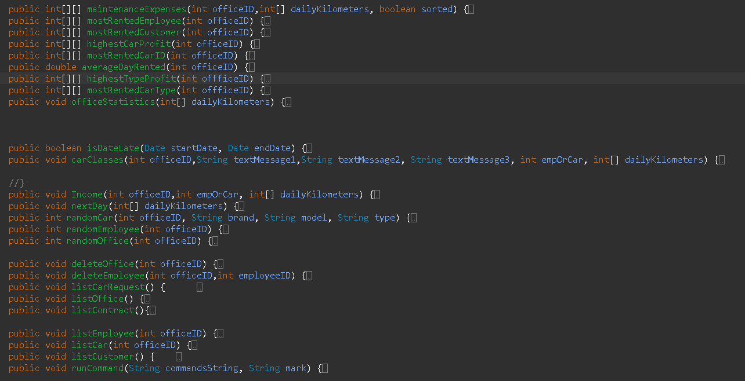

Algorithms and Solution Strategies
Mehmet Tunahan Kanpolat
The program first runs the data it receives by reading the commands from the user or file, on an object from the command class. After the command is split, it works according to what is written in the first element. Running commands are added to arrays within the command class. When the program runs the nextday command, the day ends. Then the statistics for the day are displayed. For 10-day statistics from these statistics, contracts are deleted when 10 days pass from the end date of the contracts. Since deleted contracts cannot be processed, functions written do not print them on the screen.

Muhammet Ali Yeşilöz
The program starts with the input received from the user. The input received from the user is applied according to the commands. The necessary classes are processed and the operations are performed and the necessary output or commands are fulfilled.

Deniz Küçükkara
First, I wrote the necessary codes to get input from the user. It was more troublesome to get input than the previous language we used. Later, we divided this command according to ";" and analyzed it piece by piece. If the first part is "load;" If it contains, we have read the file, if it does not, we have done other operations. Afterward, thanks to the command class, which is another class that contains the commands of the classes, we processed this input and gave a correct output. Last two week we added lots of function because of the “10 day statistics and nextday commands”. Thanks to these functions, the code got a lot shorter.

CHAPTER FOUR
PROBLEMS ENCOUNTERED
Mehmet Tunahan Kanpolat
When we started the project, we tried to create its own arrays within each class. Later, we learned that this was a very wrong thing and changed the project. In this part, we encountered many minor problems, but we solved them all in one way or another. We had a lot of problems in the 10-day statistics part. Some of these problems were; Some systemic errors when deleting contracts that need to be deleted after the end date, functions that use the deleted contracts. We solved these problems with expressions like ! = null.

Muhammet Ali Yeşilöz
First, we made a certain progress in the project. Later, we learned that we made the mistake of using a structure we established in the same class again. We worked on this error and fixed it. We solved these problems with phrases like! = null.
Deniz Küçükkara
We used Scanner while receiving input from the user and learned that we had to close the scanner, but when we tried to close, there were problems with the code(crash or loop). After that we learned Buffered Reader and things got easier. The part I encountered the most problems individually was to output the "nextday" part. The place to print out the quantities of Income and Expenses was quite challenging. I wrote a function that finds the values ​​for them, but this time the random kilometers also crashed. I solved the problem by calculating the random kilometer somewhere other than nextday.

CHAPTER FIVE
conclusıon
The program works properly in all conditions. We able to use necessary class. We managed to solve problems that we faced and improved ourselves in coding. We had a successful project period.

REFERENCES
https://docs.oracle.com/javase/tutorial/
https://www.udemy.com/course/sifirdan-ileri-seviyeye-komple-ja
https://www.javatpoint.com/how-to-get-input-from-user-in-java
https://www.tutorialspoint.com/java/java_files_io.htm


AppendIx A
Poster/Web page of the Project
AppendIx B
Code of the Project

