DOKUZ EYLUL UNIVERSITY
ENGINEERING FACULTY
DEPARTMENT OF COMPUTER ENGINEERING

CME1251 PROJECT BASED LEARNING – I
FINAL REPORT
PROJECT – II

BINARY SUDOKU

by
Deniz KÜÇÜKKARA
Berke SÖZER

Lecturers
Elife ÖZTÜRK
Mehmet Hilal ÖZCANHAN

IZMIR
28.12.2020

CHAPTER ONE
PROGRESS DESCRIPTION
Move the pieces with arrow keys in your keyboard and place them to the board.Try to fill the columns,rows or blocks to get points.If you fill 2 rows/columns/blocks you get 2x points from that move.Goal of the game is getting most points without causing game to end.That means you have to pay attention the spaces.

CHAPTER TWO
TASK SUMMARY

Completed Tasks
Berke Sözer
Converting the binary number into the decimal number, determining.Calculating score, determining end of the game and testing/debugging.

Deniz Küçükkara
I prepared an 18 * 18 array for chart. I prepared random arrays of "X" s. After that I randomly assigned 1 and 2 to these resulting pieces. I have adjusted the cursor movements and the trails it leaves behind . I set up a "do while" loop to keep random tracks coming. I inserted the random pieces with the enter key and at the same time transferred these placed pieces to the arrays in the chart. For the continuity of the game, each time "enter" is pressed, the whole game goes into a "do while" loop.

Incomplete Tasks: Reasons and Explanations
We completed every task.

Additional Improvements to the Project
Berke Sözer
Animated effect for 2x combo

Deniz Küçükkara
Player can see the current piece at the cursor.
Colorised and animated texts,
If the piece is not placable in that current position, game gives a warning.

CHAPTER THREE
EXPLANATION of algorıthms

Screensots

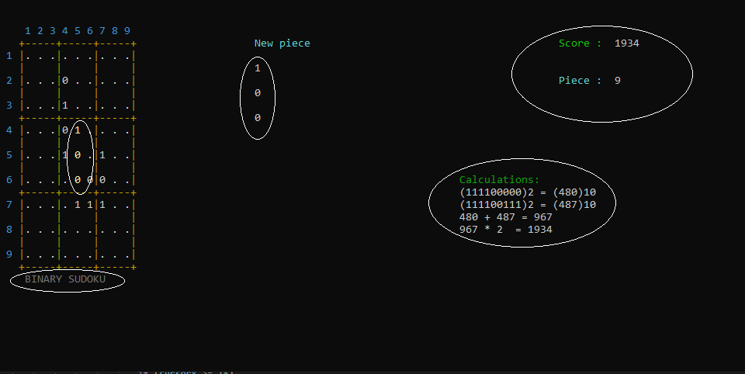

Algorithms and Solution Strategies
Berke Sözer : Displaying the game board was simple. While converting the game board to 2 dimensional array, I used SetCursorPosition in a for loop and defined the elements of the array.

Deniz Küçükkara
In this flowchart I did array chart. All these loops for creating dot array which includes dots.

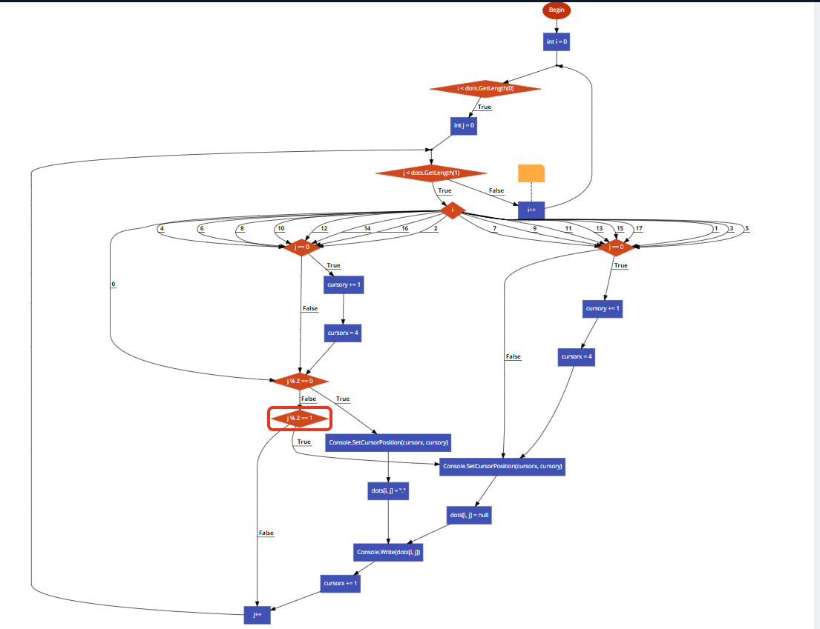

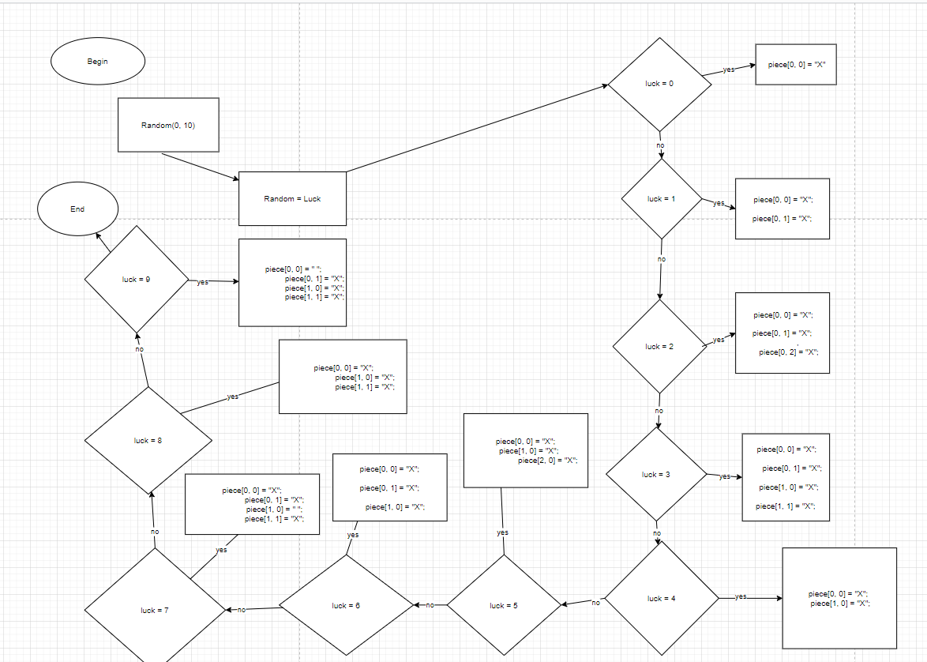

In this second flowchart I created random pieces and throw it “piece” array

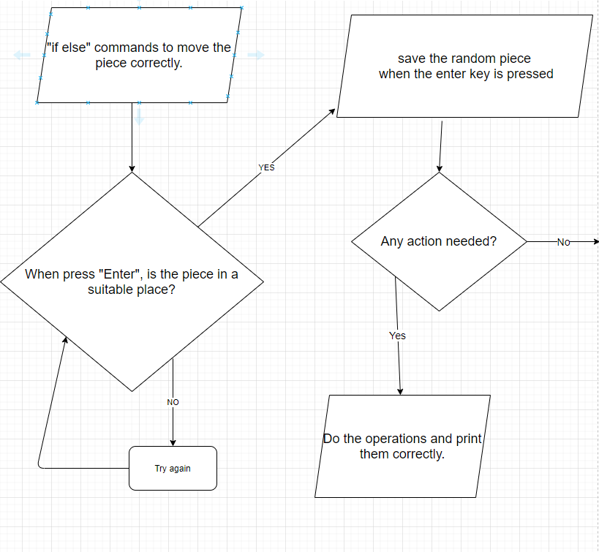
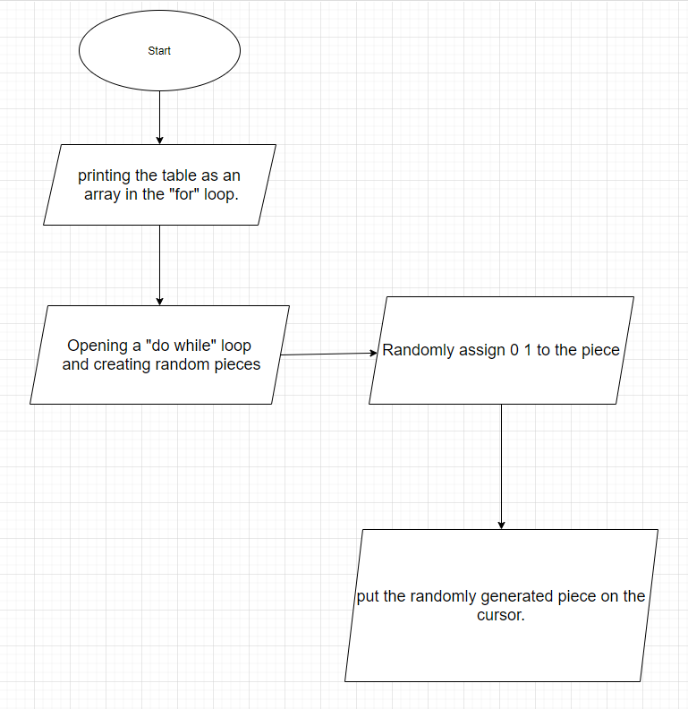
Deniz Küçükkara

This is the summary of all the code

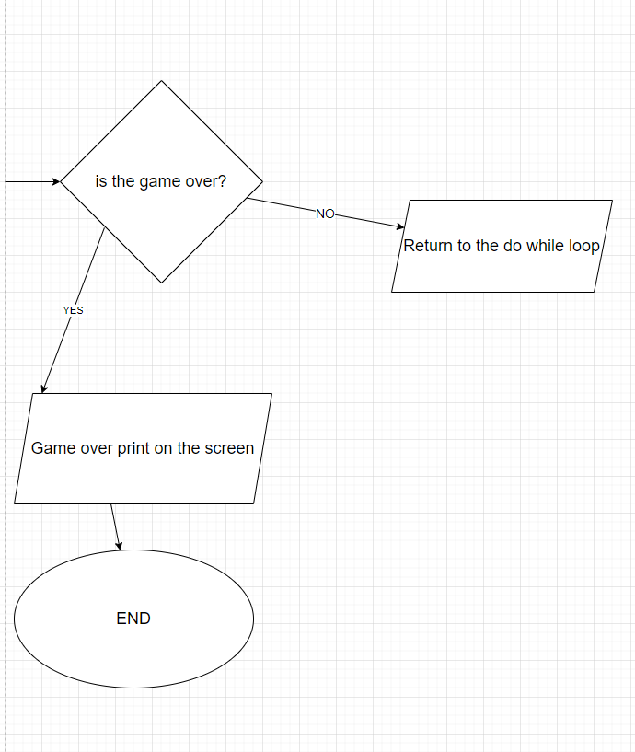

CHAPTER FOUR
PROBLEMS ENCOUNTERED

Berke Sözer
If player gets a 2x combo, points were not displaying correct. I had trouble calculating the processes

Deniz Küçükkara
The cursor was erasing as it passed over the arrays and the table, and the more difficult part is it was erasing the numbers in the table. But I took care of them by assigning conditions. The random piece format was sliding and it was very difficult to throw the arrays in the painting and when I made the array to 2d, this problem disappeared. While assigning random numbers to pieces, it was difficult to assign random numbers to the things I mentioned as X. Instead, I'd have random numbers chosen from 1 to 10 and linked them to arrays. In addition, I did coloring and the colors could be deleted as the piece passes over it.For this, I made a section that constantly updates the color in do while.

CHAPTER FIVE
conclusıon
- In conclusion we really learned a lot of new things about C# and improved our problem solution skills while doing this project.
- We learned to really be a team in order to finish it because we stayed 2 people while doing the project.
- We finished the game in an error-free and pleasing way for the users. Additionally, while doing this we tried to write the code in the best way.

REFERENCES
- https://docs.microsoft.com/tr tr/dotnet/api/system.windows.forms.cursor.position?view=net-5.0

- https://online.deu.edu.tr/access/content/group/2409265d-e167-412f-af76-34abcaeb081f/Ders%20İçerikleri/Books/Book1-Illustrated%20CSharp.pdf (Book :Illustrated C# Sharp 2010 by Daniel M. Solis)

AppendIx A
Poster/Web page of the Project
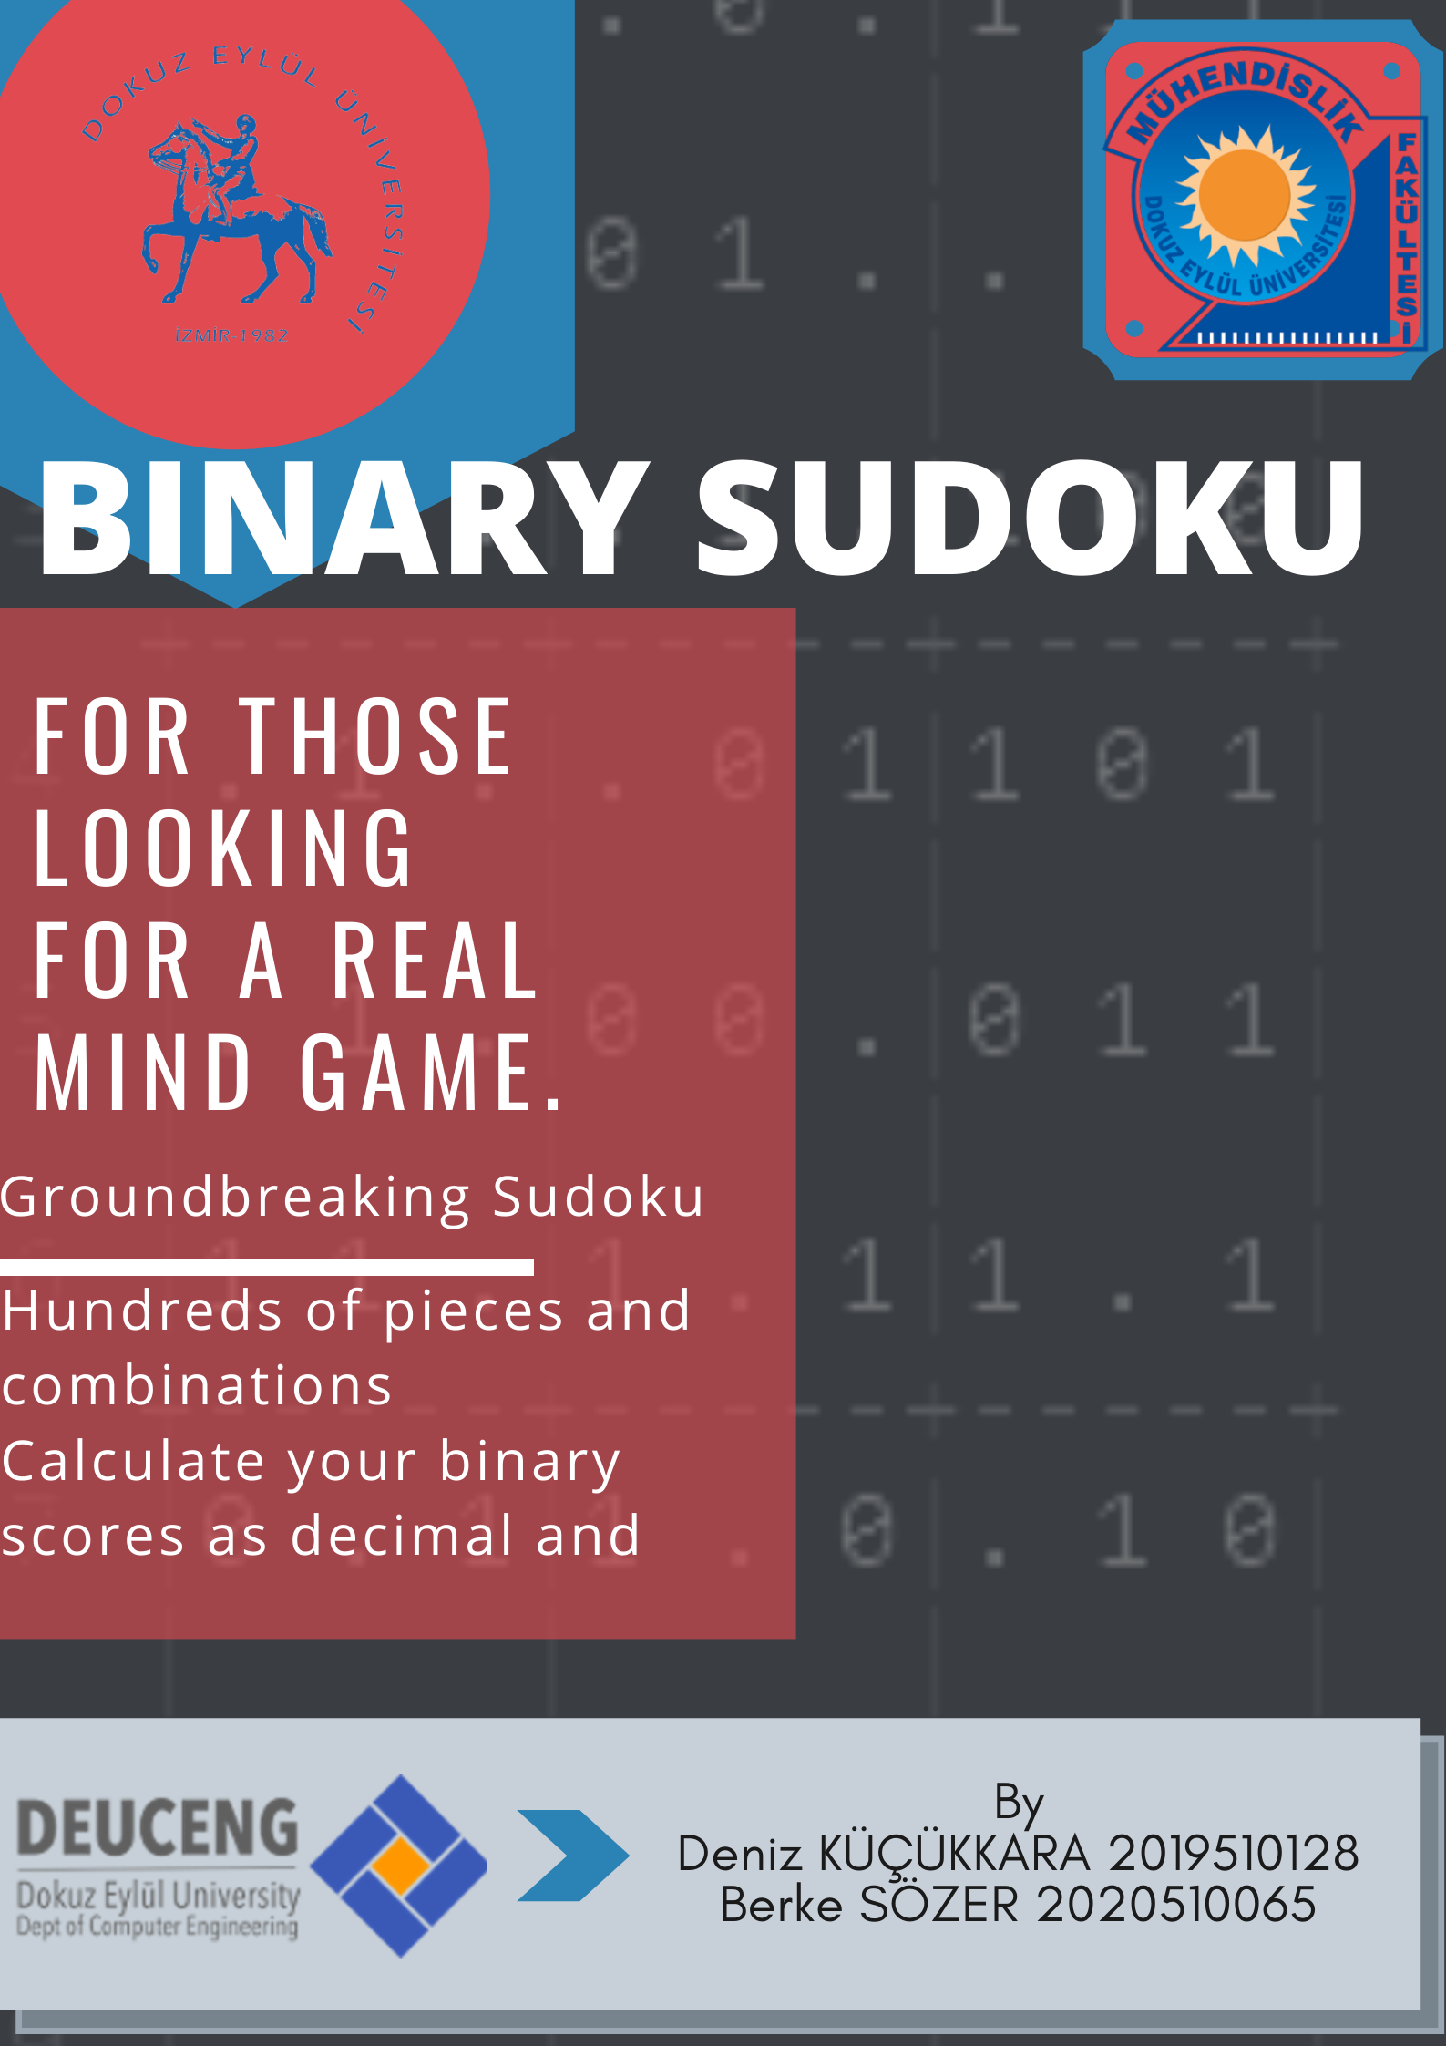
AppendIx B
Code of the Project

do// If the user tries to enter numbers in spaces by mistake, the program does not crash thanks to this command.
{

enter_flag = true;//This bool exists for the continuity of the game
while (enter_flag == true)
{

if (Console.KeyAvailable)
{
bool X_check = true, Y_Check = true;
for (int i = 9; i <= 15; i += 6)//Prevents the color change while piece is moving.
{
for (int j = 4; j <= 20; j++)
{
Console.SetCursorPosition(i, j);
Console.ForegroundColor = ConsoleColor.DarkYellow;
Console.Write(dots[j - 4, i - 4]);

Console.ResetColor();
}
}
for (int i = 4; i <= 20; i++)
{
for (int j = 9; j <= 15; j += 6)
{
Console.SetCursorPosition(i, j);
Console.ForegroundColor = ConsoleColor.DarkYellow;
Console.Write(dots[j - 4, i - 4]);

Console.ResetColor();
}
}

ck = Console.ReadKey(true);

if (ck.Key == ConsoleKey.RightArrow && cursorx < 20)//Fix for the pieces do not erase the screen as they pass
{

Console.SetCursorPosition(cursorx, cursory);//Row 1
Console.Write(dots[cursory - 4, cursorx - 4]);

if ((luck == 1 || luck == 2 || luck == 3 || luck == 6 || luck == 7 || luck == 9 ))
{
Console.SetCursorPosition(cursorx + 2, cursory);//Row 2
Console.Write(dots[cursory - 4, cursorx - 2]);
if (cursorx >= 18)
X_check = false;
}

if (luck == 2)
{
Console.SetCursorPosition(cursorx + 4, cursory);//Row 3
Console.Write(dots[cursory - 4, cursorx]);
if (cursorx >= 16)
X_check = false;
}

if (luck == 3 || luck == 4 || luck == 5 || luck == 6 || luck == 9 || luck ==8)
{
Console.SetCursorPosition(cursorx, cursory + 2);//Column 2 Row 1
Console.Write(dots[cursory - 2, cursorx - 4]);

}

if (luck == 3 || luck == 7 || luck == 8 || luck == 9 )
{
Console.SetCursorPosition(cursorx + 2, cursory + 2);//Column 2 Row 2
Console.Write(dots[cursory - 2, cursorx - 2]);
if (cursorx >= 18)
X_check = false;
}

if (luck == 5)
{
Console.SetCursorPosition(cursorx, cursory + 4);//Column 3 Row 1
Console.Write(dots[cursory, cursorx - 4]);
}

if (X_check == true)
cursorx++;
}

if (ck.Key == ConsoleKey.LeftArrow && cursorx > 4)
{

Console.SetCursorPosition(cursorx, cursory);//Row 1
Console.Write(dots[cursory - 4, cursorx - 4]);

if ((luck == 1 || luck == 2 || luck == 3 || luck == 6 || luck == 9 ||luck == 7 ))
{
Console.SetCursorPosition(cursorx + 2, cursory);//Row 2
Console.Write(dots[cursory - 4, cursorx - 2]);

}

if (luck == 2)
{
Console.SetCursorPosition(cursorx + 4, cursory);//Row 3
Console.Write(dots[cursory - 4, cursorx]);
}

if (luck == 3 || luck == 4 || luck == 5 || luck == 6 || luck == 9 || luck ==8)
{
Console.SetCursorPosition(cursorx, cursory + 2);//Column 2 Row 1
Console.Write(dots[cursory - 2, cursorx - 4]);
}

if (luck == 3 || luck == 7 || luck == 8 || luck == 9 )
{
Console.SetCursorPosition(cursorx + 2, cursory + 2);//Column 2 Row 2
Console.Write(dots[cursory - 2, cursorx - 2]);
}

if (luck == 5)
{
Console.SetCursorPosition(cursorx, cursory + 4);//Column 3 Row 1
Console.Write(dots[cursory, cursorx - 4]);
}

cursorx--;
}

if (ck.Key == ConsoleKey.UpArrow && cursory > 4)
{

Console.SetCursorPosition(cursorx, cursory);//Row 1
Console.Write(dots[cursory - 4, cursorx - 4]);

if ((luck == 1 || luck == 2 || luck == 3 || luck == 6 || luck == 9||luck == 7 ))
{
Console.SetCursorPosition(cursorx + 2, cursory);//Row 2
Console.Write(dots[cursory - 4, cursorx - 2]);
//if (cursorx >= 20)
// cursorx--;
}

if (luck == 2)
{
Console.SetCursorPosition(cursorx + 4, cursory);//Column 3
Console.Write(dots[cursory - 4, cursorx]);
}

if (luck == 3 || luck == 4 || luck == 5 || luck == 6 || luck == 9 ||luck==8)
{
Console.SetCursorPosition(cursorx, cursory + 2);//Column 2 Row 1
Console.Write(dots[cursory - 2, cursorx - 4]);
}

if (luck == 3 || luck == 7 || luck == 8 || luck == 9 )
{
Console.SetCursorPosition(cursorx + 2, cursory + 2);//Column 2 Row 2
Console.Write(dots[cursory - 2, cursorx - 2]);
if (cursory >= 20)
Y_Check = false;
}

if (luck == 5)
{
Console.SetCursorPosition(cursorx, cursory + 4);//Column 3 Row 1
Console.Write(dots[cursory, cursorx - 4]);
}

if (X_check == true&& Y_Check==true)
cursory--;
}

if (ck.Key == ConsoleKey.DownArrow && cursory < 20)
{

Console.SetCursorPosition(cursorx, cursory);//Row 1
Console.Write(dots[cursory - 4, cursorx - 4]);

if ((luck == 1 || luck == 2 || luck == 3 || luck == 6 || luck ==7|| luck == 9 ))
{
Console.SetCursorPosition(cursorx + 2, cursory);//Row 2
Console.Write(dots[cursory - 4, cursorx - 2]);
if (cursorx >= 20)
cursorx--;
}

if (luck == 2)
{
Console.SetCursorPosition(cursorx + 4, cursory);//Row 3
Console.Write(dots[cursory - 4, cursorx]);
}

if (luck == 3 || luck == 4 || luck == 5 || luck == 6 || luck == 9 || luck==8)
{
Console.SetCursorPosition(cursorx, cursory + 2);//Column 2 Row 1
Console.Write(dots[cursory - 2, cursorx - 4]);
if (cursory >= 18)
Y_Check = false;
}

if (luck == 3 || luck == 7 || luck == 8 || luck == 9 )
{
Console.SetCursorPosition(cursorx + 2, cursory + 2);//Column 2 Row 2
Console.Write(dots[cursory - 2, cursorx - 2]);
if (cursory >= 18)
Y_Check = false;
}

if (luck == 5)
{
Console.SetCursorPosition(cursorx, cursory + 4);//Column 3 Row 1
Console.Write(dots[cursory, cursorx - 4]);
if (cursory >= 16)
Y_Check = false;
}

if (Y_Check == true && X_check==true)
cursory++;
}

Console.ForegroundColor = ConsoleColor.Yellow;//This part is for displaying the random piece at the cursor.

if (luck != 9)
{
Console.SetCursorPosition(cursorx, cursory);
Console.Write(piece[0, 0]);
}

Console.SetCursorPosition(cursorx + 2, cursory);
Console.Write(piece[0, 1]);
Console.SetCursorPosition(cursorx + 4, cursory);
Console.Write(piece[0, 2]);
if (luck != 7)
{
Console.SetCursorPosition(cursorx, cursory + 2);
Console.Write(piece[1, 0]);
}

Console.SetCursorPosition(cursorx + 2, cursory + 2);
Console.Write(piece[1, 1]);
Console.SetCursorPosition(cursorx + 4, cursory + 2);
Console.Write(piece[1, 2]);
Console.SetCursorPosition(cursorx, cursory + 4);
Console.Write(piece[2, 0]);
Console.SetCursorPosition(cursorx + 2, cursory + 4);
Console.Write(piece[2, 1]);
Console.SetCursorPosition(cursorx + 4, cursory + 4);
Console.Write(piece[2, 2]);
Console.ResetColor();

if (ck.Key == ConsoleKey.Enter)
{
check_pieceplace = true;
if (!(cursory % 2 == 0 && cursorx % 2 == 0))//Gives a warning when cursor is in a wrong place.
{
check_pieceplace = false;
Console.SetCursorPosition(4, 22);
Console.ForegroundColor = ConsoleColor.DarkRed;
Console.Write("Wrong Place ");
Console.ResetColor();
}

if (check_pieceplace == true)//If the cursor is in a placeable position it writes "Binary Sudoku"
{
Console.SetCursorPosition(4, 22);
Console.ForegroundColor = ConsoleColor.DarkGray;
Console.Write("BINARY SUDOKU");
Console.ResetColor();
switch (luck)//Here we place the pieces in the table.
{
case 0:
if (dots[(cursory - 4), cursorx - 4] == ".")//Checks the cursor position if piece is placeable or not.
{
dots[cursory - 4, cursorx - 4] = piece[0, 0];
enter_flag = false;//This is for game continuity.
}
else
{
check_pieceplace = false;//This part is for not to generate new piece.
Console.SetCursorPosition(4, 22);
Console.ForegroundColor = ConsoleColor.DarkRed;
Console.Write("Wrong Place! "); // Wrong place warning
Console.ResetColor();
break;
}

break;

case 1:
if (cursorx == 20)
{
Console.SetCursorPosition(4, 22);
Console.ForegroundColor = ConsoleColor.DarkRed;
Console.Write("Wrong Place! ");
Console.ResetColor();
check_pieceplace = false;
Console.SetCursorPosition(4, 22);
Console.ForegroundColor = ConsoleColor.DarkRed;
Console.Write("Wrong Place! "); // Wrong place warning
Console.ResetColor();
break;
}
if (dots[cursory - 4, cursorx - 4] == "." && dots[cursory - 4, cursorx - 2] == ".")
{

dots[cursory - 4, cursorx - 4] = piece[0, 0];
cursorx += 2;
dots[cursory - 4, cursorx - 4] = piece[0, 1];
enter_flag = false;
}
else
{
check_pieceplace = false;
Console.SetCursorPosition(4, 22);
Console.ForegroundColor = ConsoleColor.DarkRed;
Console.Write("Wrong Place! "); // Wrong place warning
Console.ResetColor();
break;
}

break;
case 2:
if (cursorx == 20 || cursorx == 18)
{
Console.SetCursorPosition(4, 22);
Console.ForegroundColor = ConsoleColor.DarkRed;
Console.Write("Wrong Place! "); // Wrong place warning
Console.ResetColor();
check_pieceplace = false;
break;
}
if (dots[cursory - 4, cursorx - 4] == "." && dots[(cursory - 4), cursorx - 2] == "." && dots[cursory - 4, cursorx] == ".")
{
dots[cursory - 4, cursorx - 4] = piece[0, 0];
cursorx += 2;
dots[cursory - 4, cursorx - 4] = piece[0, 1];
cursorx += 2;
dots[cursory - 4, cursorx - 4] = piece[0, 2];
enter_flag = false;
}
else
{
check_pieceplace = false;
Console.SetCursorPosition(4, 22);
Console.ForegroundColor = ConsoleColor.DarkRed;
Console.Write("Wrong Place! "); // Wrong place warning
Console.ResetColor();
break;
}

break;
case 3:
if (cursorx == 20 || cursory == 20)
{
Console.SetCursorPosition(4, 22);
Console.ForegroundColor = ConsoleColor.DarkRed;
Console.Write("Wrong Place! "); // Wrong place warning
Console.ResetColor();
check_pieceplace = false;
break;
}
if (dots[cursory - 4, cursorx - 4] == "." && dots[cursory - 4, cursorx - 2] == "." &&
dots[cursory - 2, cursorx - 4] == "." && dots[cursory - 2, cursorx - 2] == ".")
{
dots[cursory - 4, cursorx - 4] = piece[0, 0];
cursorx += 2;
dots[cursory - 4, cursorx - 4] = piece[0, 1];
cursory += 2;
dots[cursory - 4, cursorx - 4] = piece[1, 1];
cursorx -= 2;
dots[cursory - 4, cursorx - 4] = piece[1, 0];
enter_flag = false;
}
else
{
check_pieceplace = false;
Console.SetCursorPosition(4, 22);
Console.ForegroundColor = ConsoleColor.DarkRed;
Console.Write("Wrong Place! "); // Wrong place warning
Console.ResetColor();
break;
}

break;
case 4:
if (cursory == 20)
{
Console.SetCursorPosition(4, 22);
Console.ForegroundColor = ConsoleColor.DarkRed;
Console.Write("Wrong Place! "); // Wrong place warning
Console.ResetColor();
check_pieceplace = false;
break;
}
if (dots[cursory - 4, cursorx - 4] == "." && dots[cursory - 2, cursorx - 4] == ".")
{
dots[cursory - 4, cursorx - 4] = piece[0, 0];
cursory += 2;
dots[cursory - 4, cursorx - 4] = piece[1, 0];
enter_flag = false;
}
else
{
check_pieceplace = false;
Console.SetCursorPosition(4, 22);
Console.ForegroundColor = ConsoleColor.DarkRed;
Console.Write("Wrong Place! "); // Wrong place warning
Console.ResetColor();
break;
}

break;
case 5:
if (cursory == 20 || cursory == 18)
{
check_pieceplace = false;
Console.SetCursorPosition(4, 22);
Console.ForegroundColor = ConsoleColor.DarkRed;
Console.Write("Wrong Place! "); // Wrong place warning
Console.ResetColor();
break;
}
if (dots[cursory - 4, cursorx - 4] == "." && dots[cursory - 2, cursorx - 4] == "." && dots[cursory, cursorx - 4] == ".")
{
dots[cursory - 4, cursorx - 4] = piece[0, 0];
cursory += 2;
dots[cursory - 4, cursorx - 4] = piece[1, 0];
cursory += 2;
dots[cursory - 4, cursorx - 4] = piece[2, 0];
enter_flag = false;
}
else
{
check_pieceplace = false;
Console.SetCursorPosition(4, 22);
Console.ForegroundColor = ConsoleColor.DarkRed;
Console.Write("Wrong Place! "); // Wrong place warning
Console.ResetColor();
break;
}
break;
case 6:
if (cursorx == 20 || cursory == 20)
{
check_pieceplace = false;
Console.SetCursorPosition(4, 22);
Console.ForegroundColor = ConsoleColor.DarkRed;
Console.Write("Wrong Place! "); // Wrong place warning
Console.ResetColor();
break;
}
if (dots[cursory - 4, cursorx - 4] == "." && dots[(cursory - 4), cursorx - 2] == "." &&
dots[cursory - 2, cursorx - 4] == ".")
{
dots[cursory - 4, cursorx - 4] = piece[0, 0];
cursory += 2;
dots[cursory - 4, cursorx - 4] = piece[1, 0];
cursory -= 2;
cursorx += 2;
dots[cursory - 4, cursorx - 4] = piece[0, 1];
enter_flag = false;
}
else
{
check_pieceplace = false;
Console.SetCursorPosition(4, 22);
Console.ForegroundColor = ConsoleColor.DarkRed;
Console.Write("Wrong Place! "); // Wrong place warning
Console.ResetColor();
break;
}
break;
case 7:
if (cursorx == 20 || cursory == 20)
{
check_pieceplace = false;
Console.SetCursorPosition(4, 22);
Console.ForegroundColor = ConsoleColor.DarkRed;
Console.Write("Wrong Place! "); // Wrong place warning
Console.ResetColor();
break;
}
if (dots[cursory - 4, cursorx - 4] == "." && dots[(cursory - 4), cursorx - 2] == "." &&
dots[cursory - 2, cursorx - 2] == ".")
{
dots[cursory - 4, cursorx - 4] = piece[0, 0];
cursorx += 2;
dots[cursory - 4, cursorx - 4] = piece[0, 1];
cursory += 2;
dots[cursory - 4, cursorx - 4] = piece[1, 1];
enter_flag = false;

}
else
{
check_pieceplace = false;
Console.SetCursorPosition(4, 22);
Console.ForegroundColor = ConsoleColor.DarkRed;
Console.Write("Wrong Place! "); // Wrong place warning
Console.ResetColor();
break;
}
break;
case 8:
if (cursory == 20 || cursorx == 20)
{
Console.SetCursorPosition(4, 22);
Console.ForegroundColor = ConsoleColor.DarkRed;
Console.Write("Wrong Place! "); // Wrong place warning
Console.ResetColor();
check_pieceplace = false;
break;
}
if (dots[cursory - 4, cursorx - 4] == "." && dots[cursory - 2, cursorx - 4] == "." && dots[cursory - 2, cursorx - 2] == ".")
{
dots[cursory - 4, cursorx - 4] = piece[0, 0];
cursory += 2;
dots[cursory - 4, cursorx - 4] = piece[1, 0];
cursorx += 2;
dots[cursory - 4, cursorx - 4] = piece[1, 1];
enter_flag = false;
}
else
{
check_pieceplace = false;
Console.SetCursorPosition(4, 22);
Console.ForegroundColor = ConsoleColor.DarkRed;
Console.Write("Wrong Place! "); // Wrong place warning
Console.ResetColor();
break;
}
break;
case 9:
if (cursory == 20 || cursorx == 20)
{
Console.SetCursorPosition(4, 22);
Console.ForegroundColor = ConsoleColor.DarkRed;
Console.Write("Wrong Place! "); // Wrong place warning
Console.ResetColor();
check_pieceplace = false;
break;
}
if (dots[(cursory - 4), cursorx - 2] == "." && dots[cursory - 2, cursorx - 4] == "." && dots[cursory - 2, cursorx - 2] == ".")
{
cursorx += 2;
dots[cursory - 4, cursorx - 4] = piece[0, 1];
cursory += 2;
dots[cursory - 4, cursorx - 4] = piece[1, 1];
cursorx -= 2;
dots[cursory - 4, cursorx - 4] = piece[1, 0];
enter_flag = false;
}
else
{
check_pieceplace = false;
Console.SetCursorPosition(4, 22);
Console.ForegroundColor = ConsoleColor.DarkRed;
Console.Write("Wrong Place! "); // Wrong place warning
Console.ResetColor();
break;
}
break;

