**CS202**

|  |
| --- |
| **Title: Sorting and Algorithm Efficiency**  **Author: Deniz Semih Özal**  **ID: 21802414**  **Assignment: 1** |

**Description: Comparing Empirical and Theoretical Results of Different Sorting Algorithms**

**Question 1**

**Selection Sort:**

Inital Array: 6 1 5 3 7 2 8 4

1th pass:

swap 4 , 8

6 1 5 3 7 2 4 |8

2th pass:

swap 4 , 7

6 1 5 3 4 2 |7 8

3th pass:

swap 2 , 6

2 1 5 3 4 |6 7 8

4th pass:

swap 4 , 5

2 1 4 3 |5 6 7 8

5th pass:

swap 3 , 4

2 1 3 |4 5 6 7 8

6th pass:

swap 3 , 3

2 1 |3 4 5 6 7 8

7th pass:

swap 1 , 2

1 |2 3 4 5 6 7 8

Key Comparisons: 28

Data Moves: 21

**Insertion Sort:**

Inital Array: 6 1 5 3 7 2 8 4

1th pass: 1 |6 5 3 7 2 8 4

2th pass: 1 5| 6 3 7 2 8 4

3th pass: 1 3 5| 6 7 2 8 4

4th pass: 1 3 5 6| 7 2 8 4

5th pass: 1 2 3 5 6 |7 8 4

6th pass: 1 2 3 5 6 7| 8 4

7th pass: 1 2 3 4 5 6 7| 8

Key Comparisons: 19

Data Moves: 26

**Bubble Sort:**

Inital Array: 6 1 5 3 7 2 8 4

1th pass:

swap 6 , 1

1 6 5 3 7 2 8 4

swap 6 , 5

1 5 6 3 7 2 8 4

swap 6 , 3

1 5 3 6 7 2 8 4

swap 7 , 2

1 5 3 6 2 7 8 4

swap 8 , 4

1 5 3 6 2 7 4 8

2th pass:

swap 5 , 3

1 3 5 6 2 7 4 8

swap 6 , 2

1 3 5 2 6 7 4 8

swap 7 , 4

1 3 5 2 6 4 7 8

3th pass:

swap 5 , 2

1 3 2 5 6 4 7 8

swap 6 , 4

1 3 2 5 4 6 7 8

4th pass:

swap 3 , 2

1 2 3 5 4 6 7 8

swap 5 , 4

1 2 3 4 5 6 7 8

5th pass:

1 2 3 4 5 6 7 8

**Merge Sort:**

Inital Array: 6 1 5 3 7 2 8 4

MergeSort called

First portion

6 1 5 3

Second portion

7 2 8 4

MergeSort called

First portion

6 1

Second portion

5 3

MergeSort called

First portion

6

Second portion

1

6

6 1

Merge called

First portion

1

Second portion

6

1 6

MergeSort called

First portion

5

Second portion

3

1 6 5

1 6 5 3

Merge called

First portion

3

Second portion

5

1 6 3 5

Merge called

First portion

1 3

Second portion

5 6

1 3 5 6

MergeSort called

First portion

7 2

Second portion

8 4

MergeSort called

First portion

7

Second portion

2

1 3 5 6 7

1 3 5 6 7 2

Merge called

First portion

2

Second portion

7

1 3 5 6 2 7

MergeSort called

First portion

8

Second portion

4

1 3 5 6 2 7 8

1 3 5 6 2 7 8 4

Merge called

First portion

4

Second portion

8

1 3 5 6 2 7 4 8

Merge called

First portion

2 4

Second portion

7 8

1 3 5 6 2 4 7 8

Merge called

First portion

1 2 3 4

Second portion

5 6 7 8

1 2 3 4 5 6 7 8

Key Comparisons: 16

Data Moves: 48

**Quick Sort:**

Inital Array: 6 1 5 3 7 2 8 4

Partition 1

6 as pivot

Checking if 1 < 6 (pivot)

Checking if 5 < 6 (pivot)

Checking if 3 < 6 (pivot)

Checking if 7 < 6 (pivot)

Checking if 2 < 6 (pivot)

Swap (2,7)

6 1 5 3 2 7 8 4

Checking if 8 < 6 (pivot)

Checking if 4 < 6 (ivot)

6 1 5 3 2 4 8 7

Swap (6,4)

4 1 5 3 2 6 8 7

4 as pivot

Checking if 1 < 4

Checking if 5 < 4

Checking if 3 < 4

Swap (3,5)

4 1 3 5 2 6 8 7

Checking if 2 < 4

Swap (2,5)

4 1 3 2 5 6 8 7

Swap (2,4)

2 1 3 4 5 6 8 7

Partition 3

2 as pivot

Checking if 1 < 2

Checking if 3 < 2

Swap (1,2)

1 2 3 4 5 6 8 7

Selecting 8 as pivot

Checking if 7 < 8

Swap (7,8)

1 2 3 4 5 6 7 8

**Question 2**

**Output in Dijkstra**

Sorting on Random Arrays

--------------------------------------------------

Analysis of Insertion Sort

Array Size Time Elapsed countComp countMove

5000 39.7417 6235702 6240701

10000 160.708 25103015 25113014

15000 357.831 56068725 56083724

20000 638.308 100093616 100113615

25000 991.085 155658723 155683722

30000 1423.08 223610730 223640729

35000 1954.83 307218965 307253964

40000 2543.71 399797892 399837891

--------------------------------------------------

Analysis of Merge Sort

Array Size Time Elapsed countComp countMove

5000 1.81195 55259 123616

10000 3.76633 120454 267232

15000 6.01854 189263 417232

20000 8.15281 260876 574464

25000 10.37 334116 734464

30000 12.6657 408650 894464

35000 14.5552 484406 1058928

40000 16.8962 561938 1228928

--------------------------------------------------

Analysis of Quick Sort

Array Size Time Elapsed countComp countMove

5000 1.19592 66414 119349

10000 2.61497 154480 249224

15000 4.00936 236334 390377

20000 5.59431 347663 565425

25000 6.94984 424185 650555

30000 8.88886 536588 944008

35000 10.3557 632630 1027266

40000 11.7163 716116 1157486

--------------------------------------------------

--------------------------------------------------

Sorting on Ascending Arrays

--------------------------------------------------

Analysis of Insertion Sort

Array Size Time Elapsed countComp countMove

5000 81.0274 12502499 6240701

10000 319.801 50004999 50014998

15000 721.981 112507499 112522498

20000 1275.25 200009999 200029998

25000 1999.04 312512499 312537498

30000 2864.22 450014999 450044998

35000 3903.32 612517499 612552498

40000 5112.17 800019999 800059998

--------------------------------------------------

Analysis of Merge Sort

Array Size Time Elapsed countComp countMove

5000 1.1795 29804 123616

10000 2.44087 64608 267232

15000 3.89338 102252 417232

20000 5.30756 139216 574464

25000 6.71511 178756 734464

30000 8.12256 219504 894464

35000 9.3512 260100 1058928

40000 10.8148 298432 1228928

--------------------------------------------------

Analysis of Quick Sort

Array Size Time Elapsed countComp countMove

5000 107.12 12497500 18769996

10000 426.053 49995000 75039996

15000 961.115 112492500 168809996

20000 1703.88 199990000 300079996

25000 2670.63 312487500 468849996

--------------------------------------------------

--------------------------------------------------

Sorting on Descending Arrays

--------------------------------------------------

Analysis of Insertion Sort

Array Size Time Elapsed countComp countMove

5000 0.049233 4999 6240701

10000 0.096304 9999 19998

15000 0.146081 14999 29998

20000 0.193313 19999 39998

25000 0.239998 24999 49998

30000 0.291311 29999 59998

35000 0.335511 34999 69998

40000 0.388189 39999 79998

--------------------------------------------------

Analysis of Merge Sort

Array Size Time Elapsed countComp countMove

5000 1.18923 32004 123616

10000 2.4523 69008 267232

15000 3.90375 106364 417232

20000 5.33883 148016 574464

25000 6.74078 188476 734464

30000 8.16517 227728 894464

35000 9.38636 269364 1058928

40000 10.8665 316032 1228928

--------------------------------------------------

Analysis of Quick Sort

Array Size Time Elapsed countComp countMove

5000 52.9152 12497500 19996

10000 211.594 49995000 39996

15000 475.346 112492500 59996

20000 850.368 199990000 79996

25000 1320.85 312487500 99996

**ScreenShot from Dijkstra**

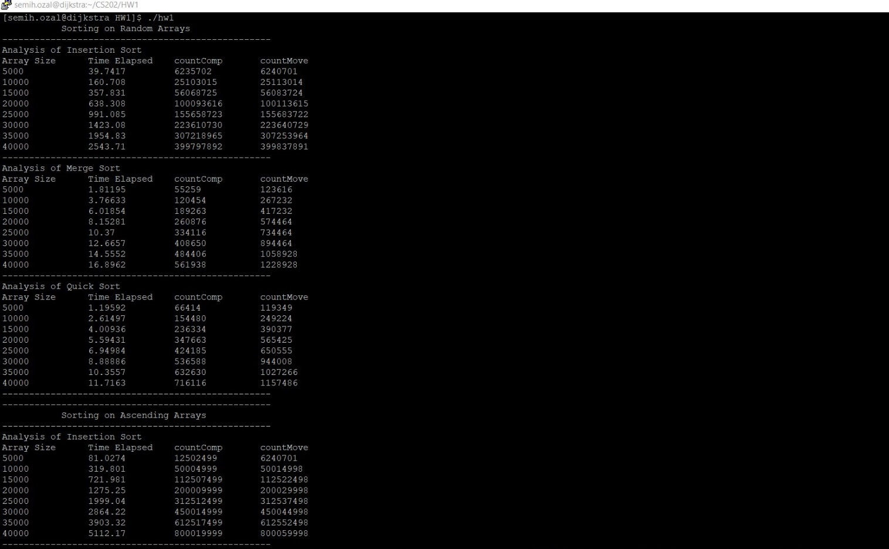

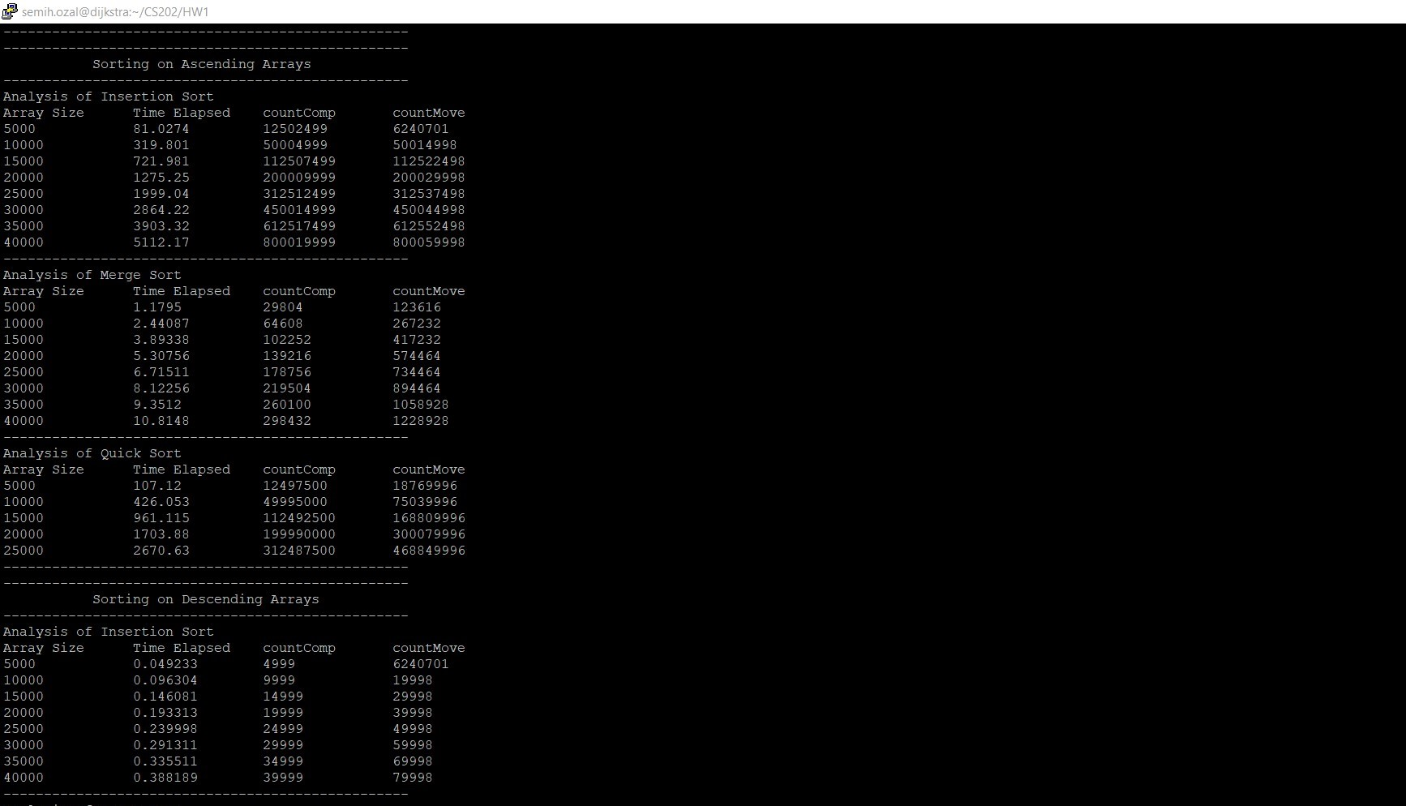

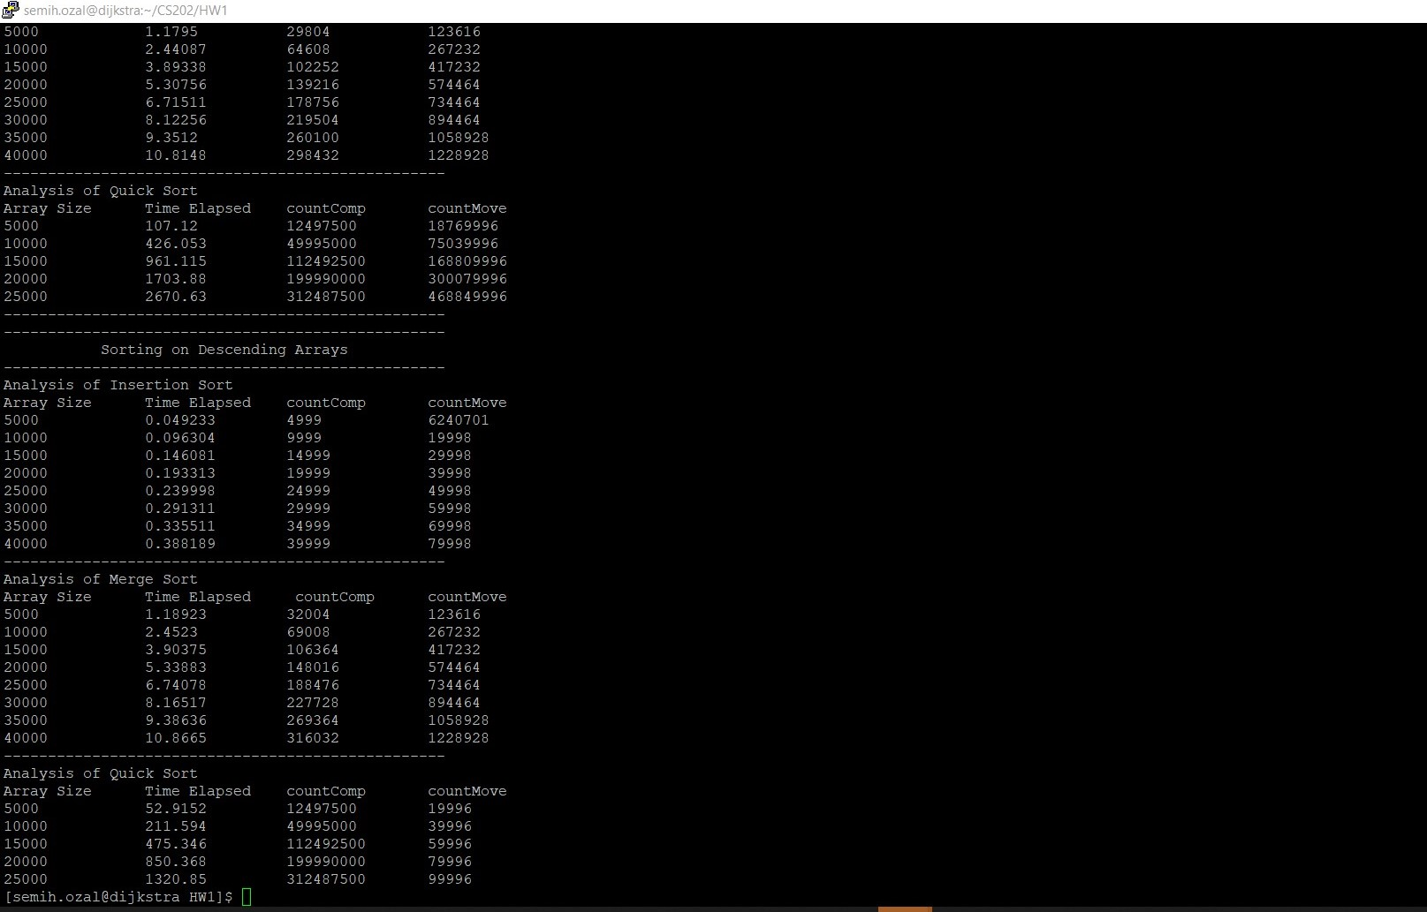

**Question3**

A) Elapsed Time vs Array Size Graph on Insertion Sort

B) Elapsed Time vs Array Size Graph on Merge Sort

C) Elapsed Time vs Array Size Graph on Quick Sort

**Analysis:**

**Insertion Sort Analysis:**

As it can be seen from the first graph, the greatest elapsed time belongs to ascending sorted array and if we compare our empirical results to the thereotical one it is quite reasonable. According to the theoretical result, ascending order is the worst-case since our insertion sort is implemented in a descending way and its time complexity is O(n^2). Whereas the best case is when the array is already descending sorted and its time complexity is O(n). Also as we expected the random sorted array gives an averages-case result and its time complexity again O(n^2). Therefore, I can argue that thereotical and empirical results match each other. The reason of why ascending order is the worst case is that is in reverse order, also the number of moves and the number of key comparisons are both in O(n^2) manner.

**Merge Sort Analysis:**

As it can be seen from the second graph, all elapsed times are quite close to each other and if we compare out empirical results to the theoretical one it is quite reasonable. In Merge Sort algorithm, both worst case and average cases are in O(nlogn) manner so there are very minor differences between ascending, descending, and random sorted arrays. Merge Sort is a quite efficient algorithm if it is compared with insertion, selection or bubble sort. However, by the principle of memory-time tradeoff, this algorithm requires an extra array whose size equals to the size of the original. Therefore, for many large sizes this algorithm could produce a problem and may give an error.

**Quick Sort Analysis:**

As it can be seen from the third graph, the greatest elapsed times belongs to ascending sorted array and if we compare our empirical results to the theoretical one it is quite reasonable. According to the theoretical result, quicksort is slow when the array is already sorted and if we choose element as the pivot. Similarly, we choose first element as a pivot and descending array is the worst case our implementation works in a descending manner. Therefore, for the sorted arrays the complexity is O(n^2) and both ascending and desceding sorted arrays work in this time complexity. On the other hand random sorted array takes quite minor time compared to sorted arrays and its time complexity is O(nlogn). Furthermore, when I try to compile after the size exceeding 25000, the compiler gives a stack overflow error for both ascending and descending sorted arrays. By my observation, I can argue that quick sort is a quite efficient algorithm if the array is not sorted, because if it is sorted compilers can’t calculate excessively recursive and swap operations.

**Note:** I have added std=c++11 when I try to compile my file because chrono functions works only in this compiler version.