The Power of the Ellipse: The Structural and Aerodynamic Genius of the Spitfire
The Spitfire. There is a striking, almost biological elegance to this bird that defies its grim purpose as a weapon of war. When we move past the superficiality of its looks, we can admire what the Spitfire meant for the UK and Europe during the WW2. The Spitfire was the mechanical prerequisite for the VE, and its engineering traits directly dictated the strategic timeline of the Western Front, which for Allies shifted from a posture of desperate survival in 1940 to total continental dominance by 1945.
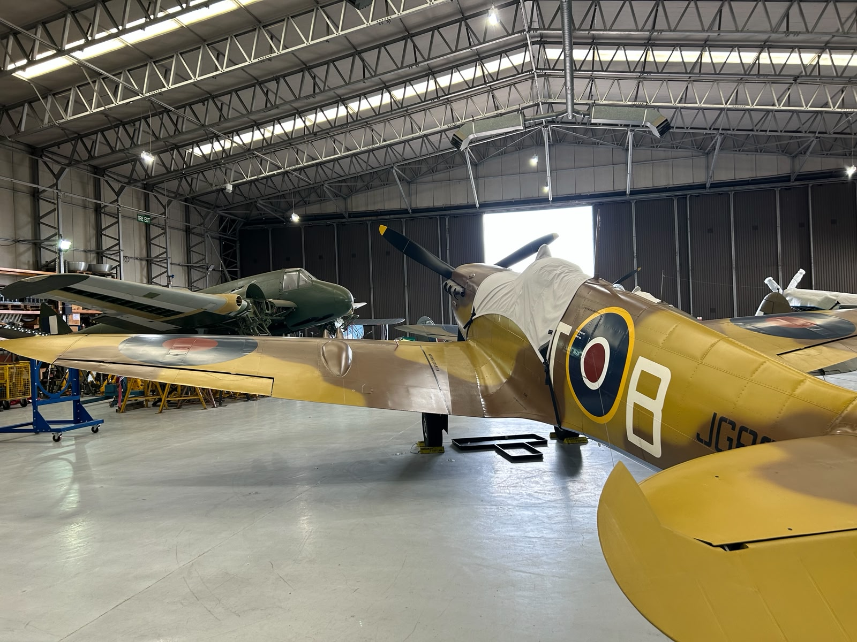
Foto caption: Supermarine Spitfire Vc (Trop) (JG89I) in Imperial War Museum Duxford.
While the Spitfire is often credited by the public with single-handedly winning the Battle of Britain, its actual battlefield role was highly specialized. The RAF operated on a deliberate tactical doctrine that divided the labor between the Spitfire and the older, more numerous Hawker Hurricane. The Hawker Hurricane was the RAF’s true workhorse, accounting for roughly 58% of downed enemy aircraft during the WW2. It was main tasked with intercepting heavy Luftwaffe bombers, relied on its ruggedness, stability as a gun platform, and overwhelming numerical superiority. In contrast, the Supermarine Spitfire was deployed to hunt Luftwaffe escort fighters like the Messerschmitt Bf 109, utilizing its speed, high-altitude capabilities, and matching agility. The Spitfire would claim about 42% of the kills during the war, keep the Luftwaffe fighters at bay, and give the nation an icon of victory.
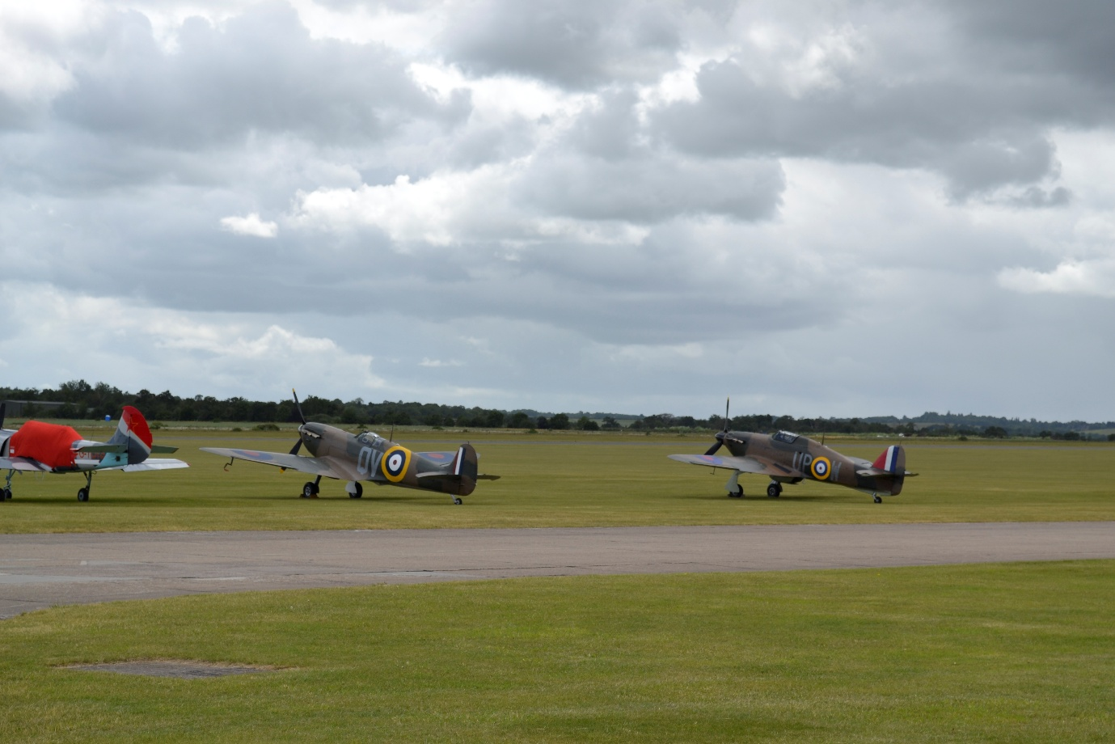
Photo caption: Supermarine Spitfire MK.Ia N3200 and Hawker Hurricane 1 ‘ R4118 G-HUPW side by side on the hills of East Anglia, Duxford.
This early success turned the aircraft into a massive psychological asset. Across the channel, the aircraft cultivated what became known as ‘Spitfire Snobbery’ among the Luftwaffe. Downed German pilots routinely claimed they were bested by a Spitfire, even when shot down by a Hurricane, because it was considered far less embarrassing to fall to the RAF's premier fighter.

(It is a gif, incorporate). Gun camera footage of spitfire shooting down a Messerschmitt Bf 109.
---- -----
Back to war strategy. Before a single Allied boot could hit the sand in France, the War Ministry needed to know where the German Panzer divisions were situated, which concrete pens housed the U-boats, and where the devastating new V-weapons were being assembled. Bombers would be slow, and standard fighters lacked the fuel capacity for the round trip.
The solution was a radical mutation of Reginald Mitchell’s masterpiece: the Photo-Reconnaissance (PR) Spitfire. Engineers essentially stripped the Spitfire of its claws, removing the heavy machine guns, protective armor plating, and radios. Every ounce of saved weight was traded for high-powered cameras and an extra 100 gallons of aviation fuel. Finally, the airframe was painted in a ghostly, low-visibility shade known as ‘PR Blue.’ 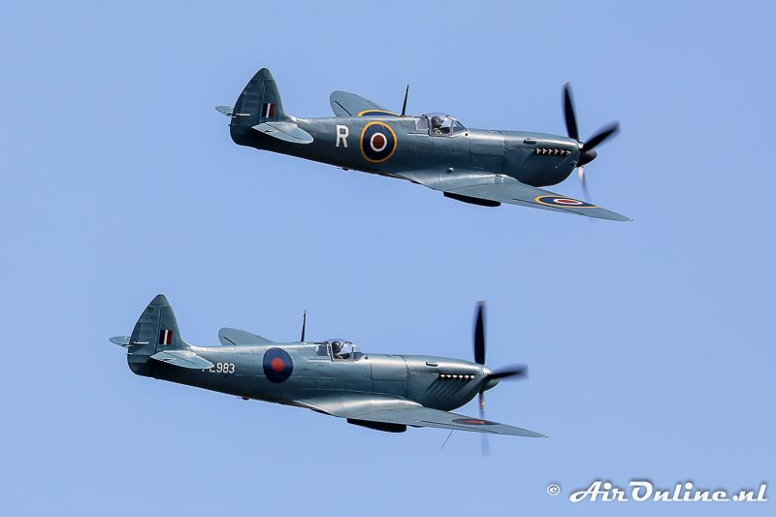
G-MKXI / PL965 / R en G-PRXI / PL983 / L Supermarine Spitfire PR Mk.XI. Source: https://www.aironline.nl/weblog/2018/09/27/ultra-zeldzaam-twee-blauwe-spitfires-pr-mk-xi-in-formatie/
These heavily modified, unarmed Spitfires were sent to fight a lonely, freezing war in the stratosphere. Climbing past 40,000 feet, where the air was lethally thin and temperatures plummeted to -65°C, the aircraft leaned entirely on the extreme aerodynamic efficiency of its elliptical wings and its Merlin 70 engine. Up there, it was untouchable, flying higher and faster than German interceptors could effectively climb or anti-aircraft guns could track.
Flown by solitary pilots operating in total radio silence, these blue ghosts became the ultimate intelligence tool. They brought back miles of film that mapped the concrete labyrinth of the Atlantic Wall, exposed the secret V-2 rocket facilities at Peenemünde, and guided heavy bomber streams over the Ruhr.
------------------------
By the time Operation Overlord launched in June 1944, the nature of the air war over Europe had fundamentally changed. The high-altitude dogfights were largely over, and the new mission was tactical ground support. The Allies needed an aircraft that could fly low and fast to destroy German trains, convoys, and troop concentrations in the hedgerows of Normandy and the forests of the Ardennes.
To achieve this, engineers committed what can only be considered an aerodynamic heresy: they chopped the beautiful elliptical tips right off the wings. These ‘clipped-wing’ variants sacrificed high-altitude performance for an explosive increase in roll rate. At low altitudes, where surviving ground fire and navigating terrain required violent, split-second maneuvers, a clipped-wing Spitfire could snap into a turn much faster than a standard model. Paired with engines tuned for maximum manifold pressure near sea level, these Spitfires paralyzed the German Wehrmacht's logistics. Field Marshal Erwin Rommel famously complained that German forces in France couldn't move a single truck in daylight without it being strafed by roaming packs of Allied fighters.
-------------------------------------------
When the prototype flew in 1936, its aerodynamic and structural sophistication instantly obsoleted fabric-covered biplanes. Its legendary performance rested on three engineering pillars.
First, it integrated the Rolls-Royce Merlin, a liquid-cooled, 27-liter V12. Its highly efficient centrifugal supercharger maximized volumetric efficiency, delivering unprecedented climb rates and scaling beyond 2,000 horsepower in later two-stage, intercooled variants.
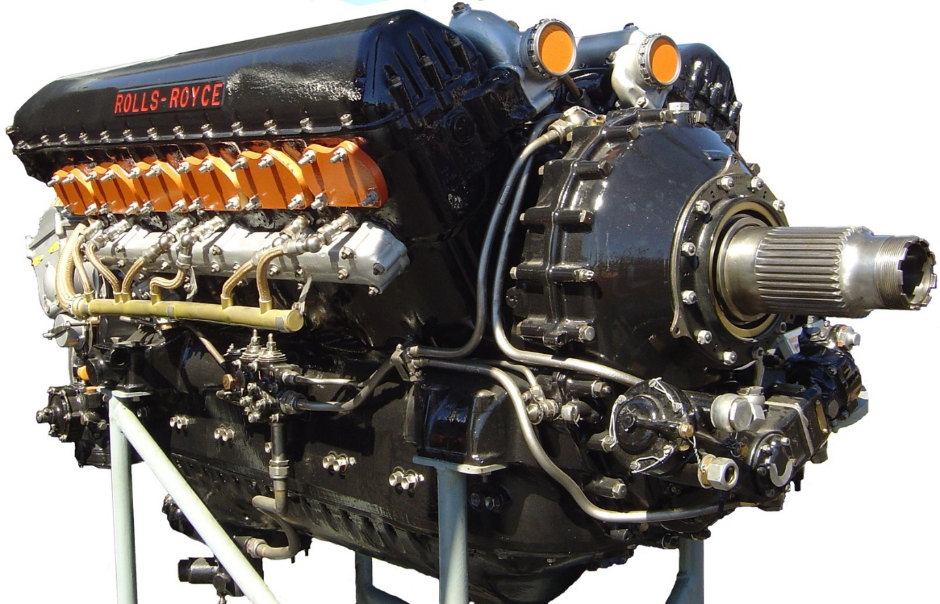
Photo caption: I mean, look at this thing.
Second, it utilized flush-riveted, duralumin semi-monocoque construction. Instead of relying on a heavy internal truss, the stressed-skin architecture distributed aerodynamic loads directly across the exterior shell. This minimized weight while yielding immense torsional rigidity for extreme high-G maneuvering.
Finally, refined control surface kinematics achieved ideal aerodynamic harmony. By balancing hinge moments, engineers were able to reduce pilot stick forces and incorporated geometric washout near the wingtips. This prevented sudden stall-spins, creating a stable, forgiving gun platform at the absolute edge of the flight envelope. More on that later.
The true secret to the Spitfire's speed, maneuverability, and high-altitude superiority was its most recognizable visual feature.
--------------------------------
Form Follows Function: The Elliptical Wing
The Air Ministry's specifications for what would become the Spitfire were driven by a shift in interception mathematics and logistics. Tactical planners calculated that closing speeds between modern monoplanes would restrict a pilot’s firing window to merely two seconds. This meant that the Ministry demanded an unprecedented concentration of firepower from eight wing-mounted .303-inch Browning machine guns, each capable of firing 1,000 rounds per minute per gun. Crucially, the specification mandated that these weapons be housed entirely outside the propeller arc. This would in theory eliminate the need for heavy and complex synchronization gear, but it did require a wing structure possessing enough internal volume to accommodate the gun breeches and ammunition boxes without introducing excessive aerodynamic drag.
"I don't give a damn whether it's elliptical or not so long as it covers the guns!" - R.J. Mitchell, on the Spitfire's design.
Beyond the raw firepower, the operational requirements demanded a leap in aerodynamic efficiency and pilot survivability. The aircraft was required to intercept fast, high-altitude bombers, dictating an enclosed cockpit with a built-in oxygen delivery system to sustain the pilot in the lethally thin air above 20,000 feet. To minimize parasitic drag and maximize the thrust from the Rolls-Royce PV-12 liquid-cooled engine, the Ministry stipulated a fully retractable undercarriage. The engineering directive was clear: a high-speed, fast-climbing interceptor where every structural and aerodynamic decision was subordinated to maximizing the destructive output of that critical two-second engagement window.
To accommodate this, the Chief Designer R.J. Mitchell needed a wing thin enough to minimize drag at high speeds, but wide (or deep) enough at the root to house a retractable undercarriage and all that weaponry. A standard straight-tapered wing would run out of internal space too quickly. So, he approved the formulation and proposal of the famous elliptical wing by his chief aerodynamicist Beverley Shenstone that aimed to hit all birds with one stone.
As wings generate lift, they also create drag (trailing vortices). An elliptical shape is theoretically the most perfect aerodynamic form for distributing lift evenly from the root to the tip, resulting in the lowest possible induced drag. When an aircraft generates lift, high-pressure air from beneath the wing seeks the lower-pressure area above it, curling around the wingtips. This creates trailing vortices. These vortices induce a downward velocity to the airflow over the wing, known as downwash ($w$).
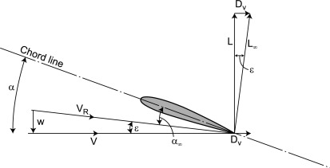
Image description: “ The lift L₀ perpendicular to the effective angle can be resolved into lift L perpendicular to the incident flow V₀ and drag D_{i} parallel to V₀. D_{i} is termed the induced drag of the section and is a result of the finite span of the aerofoil. The aerofoil can also now be considered one of infinite span but acting at an effective angle of attack (α–ε).” (Do this apa 2022, Marine Rudders, Hydrofoils and Control Surfaces (Second Edition) 3.4.2.1 Induced drag.

Downwash tilts the effective relative wind downward, which tilts the total aerodynamic lift vector slightly backward. This rearward component of the lift vector is induced drag (D). It is the inescapable aerodynamic cost of generating lift. 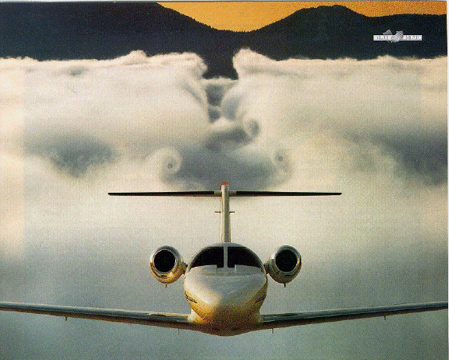Image caption: Here, the downwash from Cessna Citation that has just flown above a cloud deck can be seen wing has pushed a trough into the cloud deck can be seen, with the swirling flow rom the tip.
According to Prandtl's Lifting-Line Theory (insert apa reference her), a wing generates lift by creating a bound vortex with circulation $Γ\left(y\right)$ across the span. For an untwisted wing (no aerodynamic washout) with an elliptical planform, the circulation distribution naturally forms a perfect ellipse:
$$Γ\left(y\right)=Γ_{0}\sqrt{1-{\left(\frac{2y}{b}\right)}^{2}}$$
Where $Γ_{0}$ is the maximum circulation at the root. Because lift $L\left(y\right)$ is directly proportional to circulation via the Kutta-Joukowski theorem ($L=ρV_{∞}Γ$), the lift distribution across the wing is also perfectly elliptical.
The clever part of the elliptical lift distribution is what it does to this downwash. The downwash induced at any point $y_{0}$ along the span is calculated by integrating the effect of the trailing vortices:
$$w\left(y_{0}\right)=\frac{1}{4π}\int_{-b/2}^{b/2}{\frac{dΓ/dy}{y-y_{0}}}dy$$
When the elliptical circulation equation $Γ\left(y\right)$ is integrated into this integral, the result becomes:
$$w=\frac{Γ_{0}}{2b}=\text{constant}$$
Hence defining aerodynamic feature of the elliptical wing: the downwash velocity is perfectly constant across the entire wingspan.
Because the downwash $w$ is constant, the induced angle of attack ($α_{i}$) (the angle by which the local airflow is tilted downward) is also constant across the span:
$$α_{i}=\frac{w}{V_{∞}}=\text{constant}$$
Mathematically, the induced drag coefficient $C_{D_{i}}$ for any wing is given by:
$$C_{D_{i}}=\frac{C_{L}^{2}}{π.eA.R}$$

- $C_{L}$ is the total lift coefficient.
- $AR$ is the Aspect Ratio ($b^{2}/S$).
- $e$ is the Oswald efficiency number (or span efficiency factor).
For a purely elliptical lift distribution, $e=1$. This is the mathematical maximum. For any other wing shape (rectangular, swept, or standard tapered), $e<1$, which increases the denominator and therefore increases the induced drag.
By designing a wing with a pure elliptical planform (shape from above), Supermarine's aerodynamicist Beverley Shenstone ensured that the wing naturally produced this ideal elliptical lift distribution without requiring complex aerodynamic twist (washout) or varying airfoil sections across the span. Insert *[small footnote at the side of article: Also a nuance has to be made. The most optimal is an elliptical lift distribution, but an elliptical planform doesn't necessarily result in a perfect elliptical distribution. And there are other ways to approach an elliptical lift distribution without having an elliptical wing.]

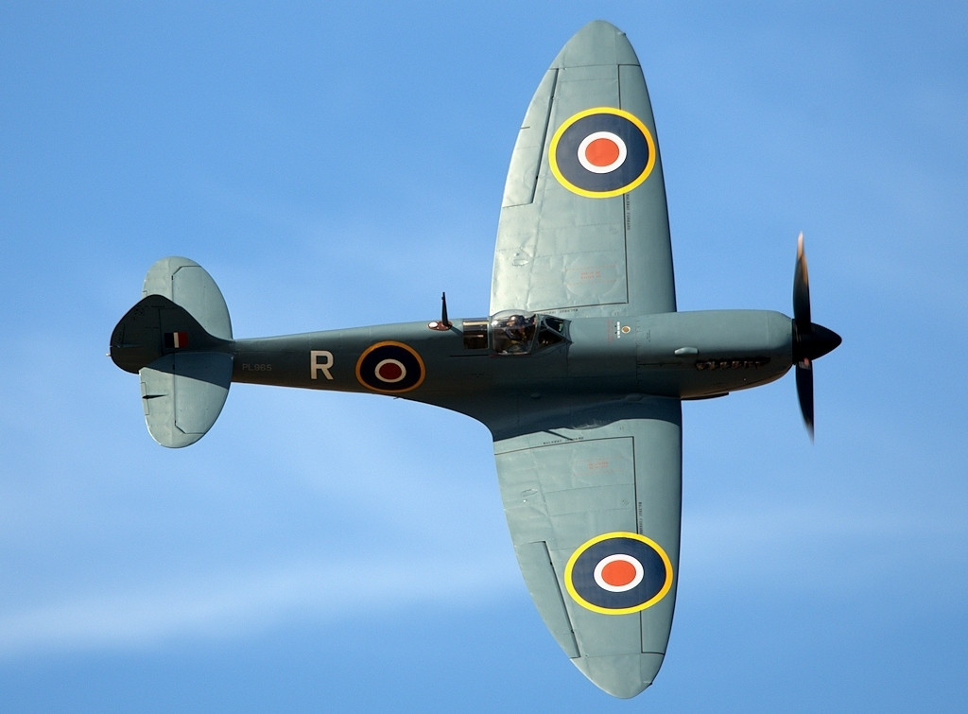
Foto caption: The elliptical form of the wings of a Spitfire can be clearly seen here.
In reality to accommodate the wing-root fairings and the pointed spinner, the true planform was constructed from two separate ellipses: one defining the leading edge and a different one defining the trailing edge. Furthermore, true elliptical wings have horrific stall characteristics, as in the entire wing would stall at once without warning. Despite these physical compromises, aerodynamic calculations show the Spitfire's Oswald efficiency number was approximately $e=0.98$ to $0.99$. It was as close to mathematical perfection as a mass-produced wartime machine could get.
-------------
However, the mathematical perfection of the pure elliptical wing is also linked to a fatal aerodynamic flaw: because it is so perfectly efficient, the entire wing would stall at the exact same moment. As mentioned earlier, if the pilot pulled the stick back too hard, a pure elliptical wing would instantly lose all lift without warning. Worse, the airflow would separate over the ailerons at the outer edges of the wings simultaneously. Without ailerons, the pilot cannot control the aircraft's roll, and the massive torque its engine would immediately torque the fighter into a violent, and often unrecoverable spin. To prevent this, the Supermarine engineers used a technique called geometric washout.
When an aircraft pulls its nose up to climb or maneuver tightly, the angle of attack (AoA) increases. If the AoA gets too high, the smooth airflow separates from the upper surface of the wing. This is a stall, the wing stops generating lift and instead generates massive drag.
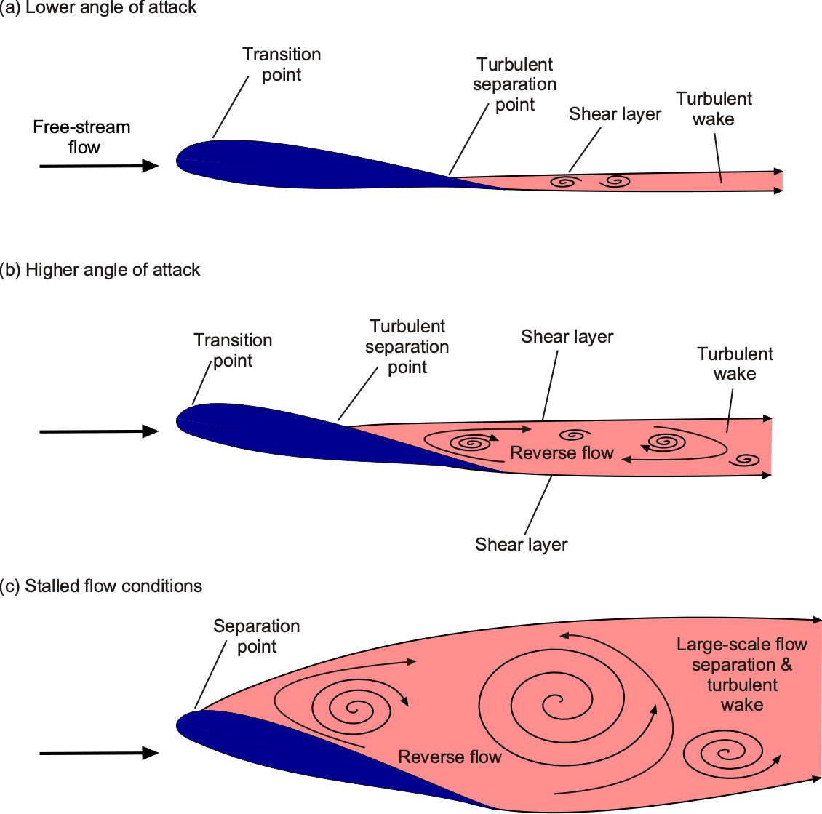
Image caption: The airflow around a wing in lower, higher AoA, and in stalled flow conditions.
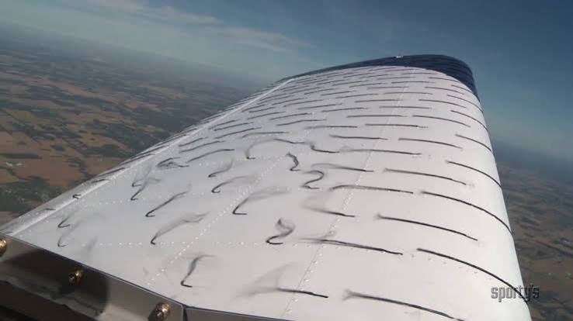
Here, the disturbed airflow above the wing can be seen in a high AoA. Source: global air.
If a wing stalls at the tip first (or simultaneously across the whole span), two things would happen. First is the loss of aileron control. The ailerons are located out at the wingtips. If the tips stall, the turbulent air renders the ailerons useless, meaning the pilot cannot roll the aircraft or keep the wings level. The second is a spin. A wingtip stall is rarely perfectly symmetrical. One tip usually stalls a fraction of a second before the other, causing that wing to drop sharply. This asymmetric lift easily throws the aircraft into a aerodynamic spin that is hard to recover from.
Geometric washout was designed to prevent this. Because the wing root is twisted to a higher angle of attack than the tip, the root always stalls first. When the root stalls, the pilot feels a buffeting vibration warning them of the impending stall, but more importantly, the wingtips are still flying at a lower angle of attack. The airflow over the ailerons remains smooth, which allowed the pilot to maintain roll control and push the nose down to recover. To fix this, Chief Designer R.J. Mitchell had to incorporate 2.5 degrees of geometric washout into the Spitfire's wing design. The root was set at an angle of incidence of +2 degrees, and the wing was twisted along its spar so the tip sat at -0.5 degrees.
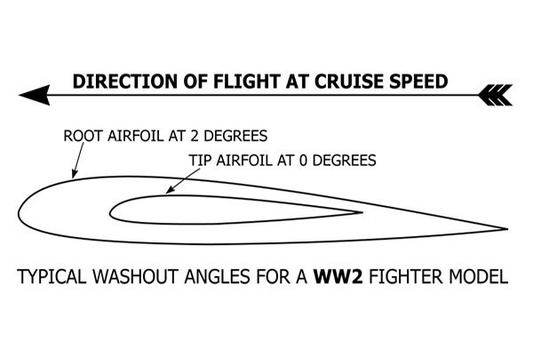
Image caption: Simple visualisation of washout. Source: Model Aviation

Another trick up to sleeve to make the elliptical wing work, is a mathematical manipulation of the wing's thickness-to-chord ratio. Beverley Shenstone specified a highly aggressive, thin aerodynamic profile, roughly 13 percent at the root tapering down to just over 9 percent at the tip, to minimize parasitic drag. However, the sweeping elliptical planform meant that the actual chord length (the physical distance from the leading edge to the trailing edge) was exceptionally broad near the fuselage. This chord length near the root provided the absolute physical depth required to accommodate the internal components without expanding the wing's drag-inducing vertical profile. The heavy struts and pivot mechanisms of the retractable undercarriage were anchored at the very deepest part of the wing root. To maximize internal volume, the gear was engineered to retract outwards, sweeping up into shallower wells positioned further down the span. This outward-retracting geometry kept the bulky hydraulics and load-bearing joints confined to the thickest, strongest section of the duralumin structure.
Fitting the eight Browning machine guns alongside their heavy ammunition boxes required a different spatial compromise. Because the elliptical wing aggressively tapered in both thickness and chord toward the tips, the weapons could not be clustered in a single bay. Supermarine engineers solved this by staggering the guns in a tiered arrangement along the spar. The breeches and feed mechanisms were mounted upright closer to the root where the wing remained relatively deep, and were then cleverly canted or laid on their sides progressively further outboard as the internal volume shrank. This staggered configuration allowed the aircraft to carry massive firepower entirely outside the propeller arc without disrupting the wing's aerodynamic envelope or compromising its primary load-bearing spar.
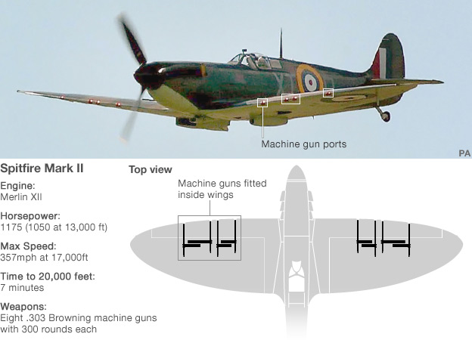
Foto caption: The machine gun arrangement of the Spitfore. Source: Mission 4 Today.
----------------------------------------
The Manufacturing
While the elliptical wing was an aerodynamic masterstroke, it was also a production nightmare. Mass-producing weapons of war usually demands straight lines and right angles. The Spitfire’s wing, however, featured complex, double-curvature surfaces. To build it, Supermarine engineers had to invent new fabrication methods. The main structural spar of the wing was constructed from square-section tubes that telescoped inside one another. This allowed the spar to progressively thin out toward the wingtip, maintaining structural integrity while shedding weight. The aircraft was skinned in 'Alclad', a duralumin alloy core coated in pure aluminum to prevent corrosion. To maintain the pristine aerodynamic boundary layer, the forward sections of the wings were flush-riveted. Workers had to countersink thousands of rivets perfectly flush with the metal skin, a time-consuming process that vastly reduced parasitic drag.
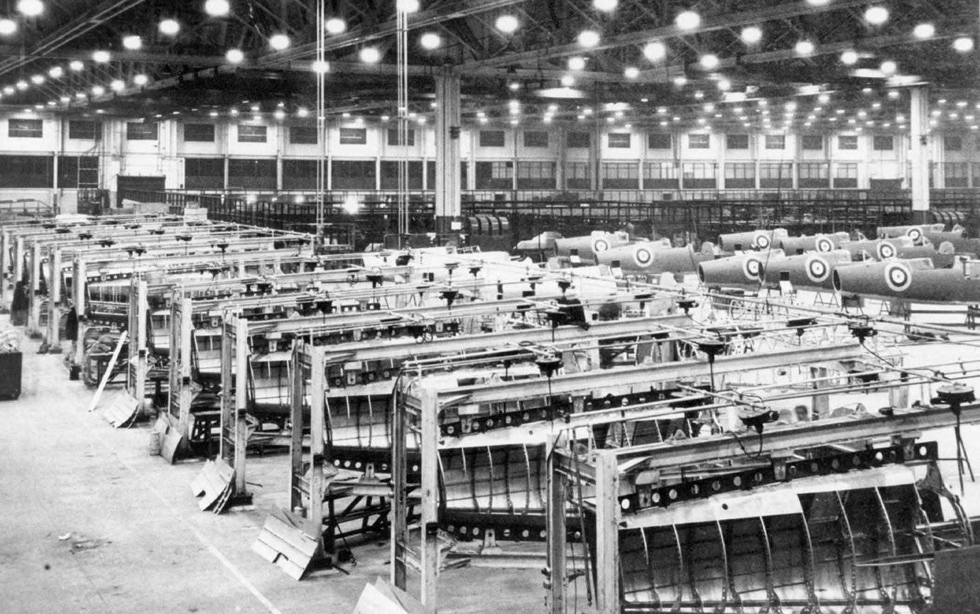
Photo caption: A Spitfire assembly line.
This complexity meant that in the dark days of 1940, Spitfires took roughly twice as long to build as Hurricanes. However, the Spitfire's aerodynamic edge proved entirely worth the effort, ensuring it remained highly competitive and in continuous development right into the jet age.
-------
The Disadvantages
The most severe combat penalty of the Spitfire's wing was its lack of torsional stiffness at high speeds. To maintain low aerodynamic drag, the elliptical wing was designed exceptionally thin. However, placing the ailerons far outboard on a thin, flexible structure created a phenomenon known as aeroelastic twist. At speeds above 300 mph, deflecting an aileron downward creates a localized increase in lift at the trailing edge. Because the wing lacked adequate torsional rigidity, this upward force on the rear of the wing actually twisted the entire leading edge downward. This twisting decreased the wing's overall angle of attack, canceling out the rolling moment the pilot was trying to initiate. In early Spitfire marks, this resulted in up to a 65% loss in aileron effectiveness at 400 mph. In extreme dive scenarios, this could even lead to aileron reversal, where applying right stick would actually cause the aircraft to roll left.
The physical force required to actuate the control surfaces at high speeds was significantly higher in the Spitfire than in the Bf 109. According to 1940 Ministry of Supply handling tests, rolling the Spitfire into a 45-degree bank at 400 mph required about 60 lbs of lateral stick force, compared to 40 lbs for the Bf 109.
This discrepancy was caused by two main factors. The Spitfire utilized a control circuit that suffered from mechanical stretch under high aerodynamic loads, giving the stick a less "solid" feel than the rigid control linkages of the Bf 109. Furthermore, The Spitfire’s stick required a wide lateral travel of +/- 8 inches, compared to the Bf 109's tight +/- 4 inches. Furthermore, the cramped, narrow cockpit of the Bf 109 actually worked to the German pilot's advantage at high speeds. By bracing their arm against the side of the cockpit, Bf 109 pilots could leverage their shoulder and back muscles more effectively to force the stick sideways, whereas the Spitfire pilot's arm was left floating, making it physically exhausting to initiate a high-speed roll.
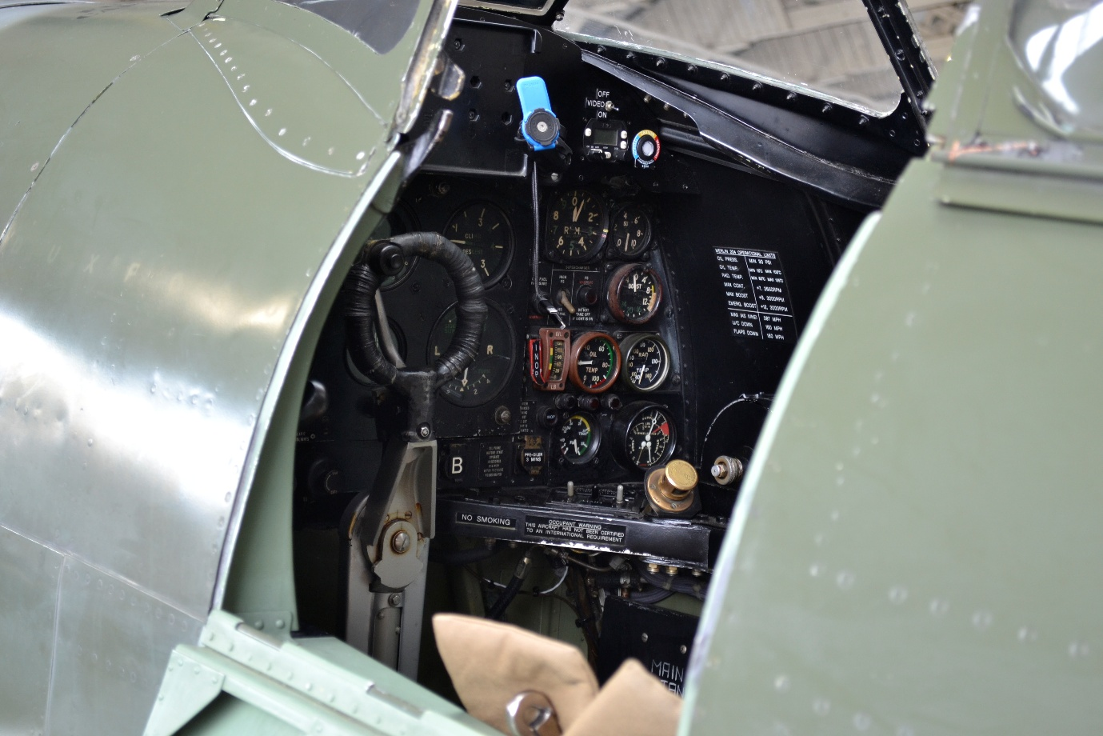
Photo caption: The cockpit of the Spitfire.
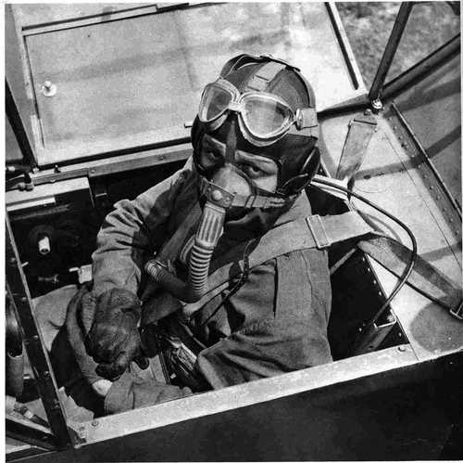
Foto caption: The narrow cockpit of the Bf 109 allowed Fliegeren to brace their arm for more effective stick deflection.

Advantages
Despite the disadvantages, the combination of the elliptical planform and geometric washout also gave the Spitfire some advantages dogfights.
In a dogfight, the aircraft that can turn tighter and sustain that turn without bleeding off too much airspeed will eventually get its guns on the enemy. The elliptical wing's primary math trick (minimizing induced drag) paid off. When an aircraft banks to turn, it has to generate much more lift than in level flight to pull the G-forces required. More lift equals more induced drag. Because the Spitfire's elliptical wing had the lowest possible induced drag penalty ($e≈1$), it bled less energy (airspeed) in a sustained, high-G turn than the Bf 109's straight-tapered wing. A Spitfire could lock into a tight, sustained turn that a 109 simply couldn't follow without slowing down, or stalling.

Dogfights are often fought right on the edge of an aerodynamic stall, pulling as hard as the wings will allow to turn inside the enemy. The 2.5 degrees of geometric washout meant the Spitfire pilot had a built-in physical warning system.
When the pilot pulled the stick back hard, the wing root would stall first, sending a shuddering vibration through the airframe and control stick. The pilot knew they were at the absolute limit of the aircraft's turning capability, but because the wingtips (and ailerons) were still flying, they wouldn't instantly snap into a deadly spin. They could ‘ ride the shudder,’ holding the plane right on the edge of maximum performance. Most modern aircraft that deploy fly-by-wire systems today, and thus have no direct mechanical linkage to control surfaces, incorporate a stick shaker to rapidly and noisily vibrate the stick to warn the flight crew that an imminent aerodynamic stall has been detected. This can be considered a mechanical simulation of stick shutter by electrified and digitized flight systems.
Ultimately, the Supermarine Spitfire stands as a masterclass in the intersection of uncompromising aerodynamics and pragmatism. It was by no means a flawless machine, as its double-curvature skin made it a production nightmare in 1940, and its aeroelastic limitations demanded exhausting physical effort from pilots. Yet, R.J. Mitchell and Beverley Shenstone were able to create an airframe whose underlying geometry was so fundamentally sound that it could evolve alongside the shifting tactical realities of the Second World War. Beyond the wartime snobbery and the enduring mythos, the Spitfire remains precisely what its math dictated - an absolute triumph of functional engineering.

