Lab 3: DenseNet Classification + Siamese Networks
Tasks:
- Build DenseNet CNN for Fashion-MNIST classification (>90% accuracy)
- Implement Siamese network for similar image search
- Visualize embeddings with t-SNE

Setup
import torch
import torch.nn as nn
import torch.nn.functional as F
import torch.optim as optim
from torch.utils.data import DataLoader, Dataset
import torchvision
import torchvision.transforms as transforms
import numpy as np
import matplotlib.pyplot as plt
import seaborn as sns
from sklearn.manifold import TSNE
from sklearn.metrics import confusion_matrix, classification_report
from sklearn.decomposition import PCA
from tqdm.auto import tqdm
import random
device = torch.device("cuda" if torch.cuda.is_available() else "cpu")
print(f"Using device: {device}")
torch.manual_seed(42)
np.random.seed(42)
random.seed(42)
Using device: cpu

Part 1: Data Preparation
transform_train = transforms.Compose(
[
transforms.RandomRotation(10),
transforms.RandomAffine(degrees=0, translate=(0.1, 0.1)),
transforms.ToTensor(),
transforms.Normalize((0.5,), (0.5,)),
]
)
transform_test = transforms.Compose(
[transforms.ToTensor(), transforms.Normalize((0.5,), (0.5,))]
)
train_dataset = torchvision.datasets.FashionMNIST(
root="./data", train=True, download=True, transform=transform_train
)
test_dataset = torchvision.datasets.FashionMNIST(
root="./data", train=False, download=True, transform=transform_test
)
train_size = int(0.9 * len(train_dataset))
val_size = len(train_dataset) - train_size
train_dataset, val_dataset = torch.utils.data.random_split(
train_dataset, [train_size, val_size]
)
train_loader = DataLoader(train_dataset, batch_size=128, shuffle=True, num_workers=0)
val_loader = DataLoader(val_dataset, batch_size=128, shuffle=False, num_workers=0)
test_loader = DataLoader(test_dataset, batch_size=128, shuffle=False, num_workers=0)
class_names = [
"T-shirt/top",
"Trouser",
"Pullover",
"Dress",
"Coat",
"Sandal",
"Shirt",
"Sneaker",
"Bag",
"Ankle boot",
]
print(
f"Train: {len(train_dataset)}, Val: {len(val_dataset)}, Test: {len(test_dataset)}"
)
Train: 54000, Val: 6000, Test: 10000

Part 2: DenseNet Architecture
class DenseLayer(nn.Module):
def __init__(self, in_channels, growth_rate, dropout=0.2):
super().__init__()
self.bn1 = nn.BatchNorm2d(in_channels)
self.conv1 = nn.Conv2d(in_channels, 4 * growth_rate, kernel_size=1, bias=False)
self.bn2 = nn.BatchNorm2d(4 * growth_rate)
self.conv2 = nn.Conv2d(
4 * growth_rate, growth_rate, kernel_size=3, padding=1, bias=False
)
self.dropout = nn.Dropout(dropout)
def forward(self, x):
out = self.conv1(F.relu(self.bn1(x)))
out = self.conv2(F.relu(self.bn2(out)))
out = self.dropout(out)
return torch.cat([x, out], 1)
class DenseBlock(nn.Module):
def __init__(self, in_channels, growth_rate, num_layers, dropout=0.2):
super().__init__()
self.layers = nn.ModuleList(
[
DenseLayer(in_channels + i * growth_rate, growth_rate, dropout)
for i in range(num_layers)
]
)
def forward(self, x):
for layer in self.layers:
x = layer(x)
return x
class TransitionLayer(nn.Module):
def __init__(self, in_channels, out_channels):
super().__init__()
self.bn = nn.BatchNorm2d(in_channels)
self.conv = nn.Conv2d(in_channels, out_channels, kernel_size=1, bias=False)
self.pool = nn.AvgPool2d(2, stride=2)
def forward(self, x):
return self.pool(self.conv(F.relu(self.bn(x))))
class DenseNet(nn.Module):
def __init__(
self,
growth_rate=12,
block_config=(6, 12, 8),
num_classes=10,
dropout=0.2,
compression=0.5,
):
super().__init__()
self.features = nn.Sequential()
num_channels = 2 * growth_rate
self.features.add_module(
"conv0", nn.Conv2d(1, num_channels, kernel_size=3, padding=1, bias=False)
)
self.features.add_module("bn0", nn.BatchNorm2d(num_channels))
self.features.add_module("relu0", nn.ReLU(inplace=True))
for i, num_layers in enumerate(block_config):
block = DenseBlock(num_channels, growth_rate, num_layers, dropout)
self.features.add_module(f"denseblock{i + 1}", block)
num_channels += num_layers * growth_rate
if i != len(block_config) - 1:
trans = TransitionLayer(num_channels, int(num_channels * compression))
self.features.add_module(f"transition{i + 1}", trans)
num_channels = int(num_channels * compression)
self.features.add_module("bn_final", nn.BatchNorm2d(num_channels))
self.features.add_module("relu_final", nn.ReLU(inplace=True))
self.features.add_module("avgpool", nn.AdaptiveAvgPool2d((1, 1)))
self.classifier = nn.Linear(num_channels, num_classes)
self.num_features = num_channels
self._initialize_weights()
def _initialize_weights(self):
for m in self.modules():
if isinstance(m, nn.Conv2d):
nn.init.kaiming_normal_(m.weight)
elif isinstance(m, nn.BatchNorm2d):
nn.init.constant_(m.weight, 1)
nn.init.constant_(m.bias, 0)
elif isinstance(m, nn.Linear):
nn.init.constant_(m.bias, 0)
def forward(self, x):
features = self.features(x)
out = features.view(features.size(0), -1)
out = self.classifier(out)
return out
def get_features(self, x):
features = self.features(x)
return features.view(features.size(0), -1)
model = DenseNet().to(device)
print(f"Model parameters: {sum(p.numel() for p in model.parameters()):,}")
Model parameters: 303,274

Part 3: Training DenseNet
def train_epoch(model, loader, criterion, optimizer, device):
model.train()
total_loss, correct, total = 0, 0, 0
for images, labels in tqdm(loader, desc="Training", leave=False):
images, labels = images.to(device), labels.to(device)
optimizer.zero_grad()
outputs = model(images)
loss = criterion(outputs, labels)
loss.backward()
optimizer.step()
total_loss += loss.item() * images.size(0)
_, predicted = outputs.max(1)
total += labels.size(0)
correct += predicted.eq(labels).sum().item()
return total_loss / total, 100.0 * correct / total
def validate(model, loader, criterion, device):
model.eval()
total_loss, correct, total = 0, 0, 0
with torch.no_grad():
for images, labels in tqdm(loader, desc="Validation", leave=False):
images, labels = images.to(device), labels.to(device)
outputs = model(images)
loss = criterion(outputs, labels)
total_loss += loss.item() * images.size(0)
_, predicted = outputs.max(1)
total += labels.size(0)
correct += predicted.eq(labels).sum().item()
return total_loss / total, 100.0 * correct / total
criterion = nn.CrossEntropyLoss()
optimizer = optim.Adam(model.parameters(), lr=0.0001, weight_decay=1e-4)
scheduler = optim.lr_scheduler.ReduceLROnPlateau(
optimizer, mode="max", factor=0.5, patience=3
)
num_epochs = 15
best_val_acc = 0
history = {"train_loss": [], "train_acc": [], "val_loss": [], "val_acc": []}
for epoch in range(num_epochs):
train_loss, train_acc = train_epoch(
model, train_loader, criterion, optimizer, device
)
val_loss, val_acc = validate(model, val_loader, criterion, device)
history["train_loss"].append(train_loss)
history["train_acc"].append(train_acc)
history["val_loss"].append(val_loss)
history["val_acc"].append(val_acc)
print(
f"Epoch {epoch + 1}/{num_epochs} - "
f"Train Loss: {train_loss:.4f}, Train Acc: {train_acc:.2f}% - "
f"Val Loss: {val_loss:.4f}, Val Acc: {val_acc:.2f}%"
)
scheduler.step(val_acc)
if val_acc > best_val_acc:
best_val_acc = val_acc
torch.save(model.state_dict(), "best_densenet.pth")
print(f" → Saved best model (Val Acc: {val_acc:.2f}%)")
print(f"\nBest validation accuracy: {best_val_acc:.2f}%")
Training: 0%| | 0/422 [00:00<?, ?it/s]
Validation: 0%| | 0/47 [00:00<?, ?it/s]
Epoch 1/15 - Train Loss: 1.4242, Train Acc: 57.10% - Val Loss: 0.9107, Val Acc: 68.82%
→ Saved best model (Val Acc: 68.82%)
→ Saved best model (Val Acc: 68.82%)
Training: 0%| | 0/422 [00:00<?, ?it/s]
Validation: 0%| | 0/47 [00:00<?, ?it/s]
Epoch 2/15 - Train Loss: 0.7366, Train Acc: 75.68% - Val Loss: 0.6909, Val Acc: 74.35%
→ Saved best model (Val Acc: 74.35%)
Training: 0%| | 0/422 [00:00<?, ?it/s]
Validation: 0%| | 0/47 [00:00<?, ?it/s]
Epoch 3/15 - Train Loss: 0.5836, Train Acc: 79.20% - Val Loss: 0.6681, Val Acc: 74.72%
→ Saved best model (Val Acc: 74.72%)
Training: 0%| | 0/422 [00:00<?, ?it/s]
Validation: 0%| | 0/47 [00:00<?, ?it/s]
Epoch 4/15 - Train Loss: 0.5099, Train Acc: 81.58% - Val Loss: 0.5063, Val Acc: 81.55%
→ Saved best model (Val Acc: 81.55%)
Training: 0%| | 0/422 [00:00<?, ?it/s]
Validation: 0%| | 0/47 [00:00<?, ?it/s]
Epoch 5/15 - Train Loss: 0.4700, Train Acc: 82.87% - Val Loss: 0.5096, Val Acc: 81.28%
Training: 0%| | 0/422 [00:00<?, ?it/s]
Validation: 0%| | 0/47 [00:00<?, ?it/s]
Epoch 6/15 - Train Loss: 0.4409, Train Acc: 83.84% - Val Loss: 0.4605, Val Acc: 83.93%
→ Saved best model (Val Acc: 83.93%)
Training: 0%| | 0/422 [00:00<?, ?it/s]
Validation: 0%| | 0/47 [00:00<?, ?it/s]
Epoch 7/15 - Train Loss: 0.4182, Train Acc: 84.79% - Val Loss: 0.4527, Val Acc: 83.37%
Training: 0%| | 0/422 [00:00<?, ?it/s]
Validation: 0%| | 0/47 [00:00<?, ?it/s]
Epoch 8/15 - Train Loss: 0.3981, Train Acc: 85.64% - Val Loss: 0.4400, Val Acc: 83.68%
Training: 0%| | 0/422 [00:00<?, ?it/s]
Validation: 0%| | 0/47 [00:00<?, ?it/s]
Epoch 9/15 - Train Loss: 0.3831, Train Acc: 85.95% - Val Loss: 0.4159, Val Acc: 84.95%
→ Saved best model (Val Acc: 84.95%)
Training: 0%| | 0/422 [00:00<?, ?it/s]
Validation: 0%| | 0/47 [00:00<?, ?it/s]
Epoch 10/15 - Train Loss: 0.3718, Train Acc: 86.35% - Val Loss: 0.4361, Val Acc: 83.95%
Training: 0%| | 0/422 [00:00<?, ?it/s]
Validation: 0%| | 0/47 [00:00<?, ?it/s]
Epoch 11/15 - Train Loss: 0.3611, Train Acc: 86.88% - Val Loss: 0.4026, Val Acc: 85.67%
→ Saved best model (Val Acc: 85.67%)
Training: 0%| | 0/422 [00:00<?, ?it/s]
Validation: 0%| | 0/47 [00:00<?, ?it/s]
Epoch 12/15 - Train Loss: 0.3509, Train Acc: 87.15% - Val Loss: 0.3687, Val Acc: 86.10%
→ Saved best model (Val Acc: 86.10%)
Training: 0%| | 0/422 [00:00<?, ?it/s]
Validation: 0%| | 0/47 [00:00<?, ?it/s]
Epoch 13/15 - Train Loss: 0.3422, Train Acc: 87.47% - Val Loss: 0.3840, Val Acc: 86.12%
→ Saved best model (Val Acc: 86.12%)
Training: 0%| | 0/422 [00:00<?, ?it/s]
Validation: 0%| | 0/47 [00:00<?, ?it/s]
Epoch 14/15 - Train Loss: 0.3338, Train Acc: 87.66% - Val Loss: 0.3456, Val Acc: 87.35%
→ Saved best model (Val Acc: 87.35%)
Training: 0%| | 0/422 [00:00<?, ?it/s]
Validation: 0%| | 0/47 [00:00<?, ?it/s]
Epoch 15/15 - Train Loss: 0.3280, Train Acc: 88.00% - Val Loss: 0.3591, Val Acc: 86.87%
Best validation accuracy: 87.35%
fig, (ax1, ax2) = plt.subplots(1, 2, figsize=(14, 5))
ax1.plot(history["train_loss"], label="Train Loss")
ax1.plot(history["val_loss"], label="Val Loss")
ax1.set_xlabel("Epoch")
ax1.set_ylabel("Loss")
ax1.set_title("Training and Validation Loss")
ax1.legend()
ax1.grid(True, alpha=0.3)
ax2.plot(history["train_acc"], label="Train Acc")
ax2.plot(history["val_acc"], label="Val Acc")
ax2.set_xlabel("Epoch")
ax2.set_ylabel("Accuracy (%)")
ax2.set_title("Training and Validation Accuracy")
ax2.legend()
ax2.grid(True, alpha=0.3)
plt.tight_layout()
plt.show()
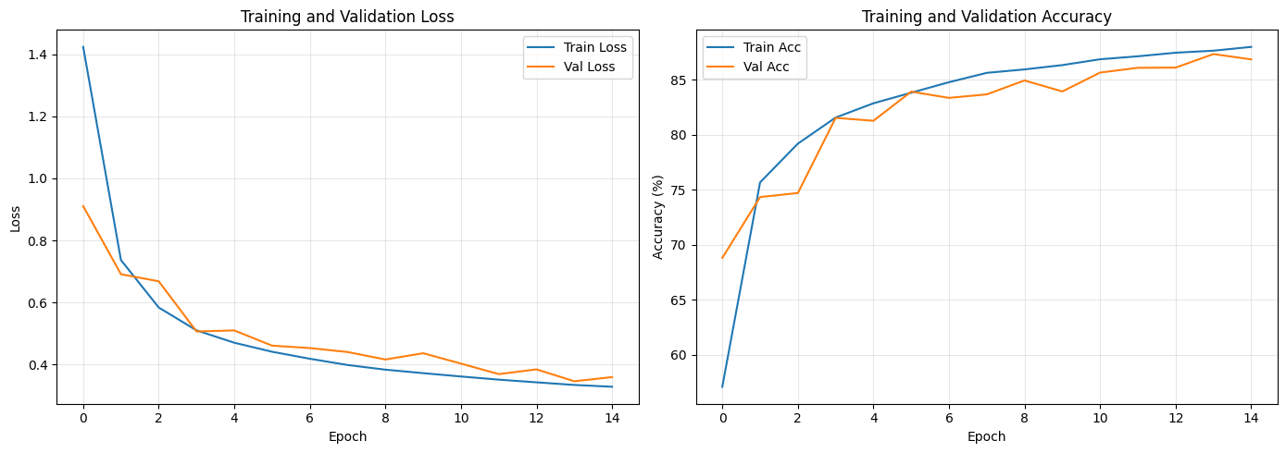

Part 4: Evaluate DenseNet
model.load_state_dict(torch.load("best_densenet.pth"))
test_loss, test_acc = validate(model, test_loader, criterion, device)
print(f"Test Accuracy: {test_acc:.2f}%")
Validation: 0%| | 0/79 [00:00<?, ?it/s]
Test Accuracy: 88.14%
model.eval()
all_preds, all_labels = [], []
with torch.no_grad():
for images, labels in test_loader:
images = images.to(device)
outputs = model(images)
_, predicted = outputs.max(1)
all_preds.extend(predicted.cpu().numpy())
all_labels.extend(labels.numpy())
cm = confusion_matrix(all_labels, all_preds)
plt.figure(figsize=(10, 8))
sns.heatmap(
cm,
annot=True,
fmt="d",
cmap="Blues",
xticklabels=class_names,
yticklabels=class_names,
)
plt.title("Confusion Matrix")
plt.ylabel("True Label")
plt.xlabel("Predicted Label")
plt.xticks(rotation=45, ha="right")
plt.yticks(rotation=0)
plt.tight_layout()
plt.show()
print("\nClassification Report:\n")
print(classification_report(all_labels, all_preds, target_names=class_names))
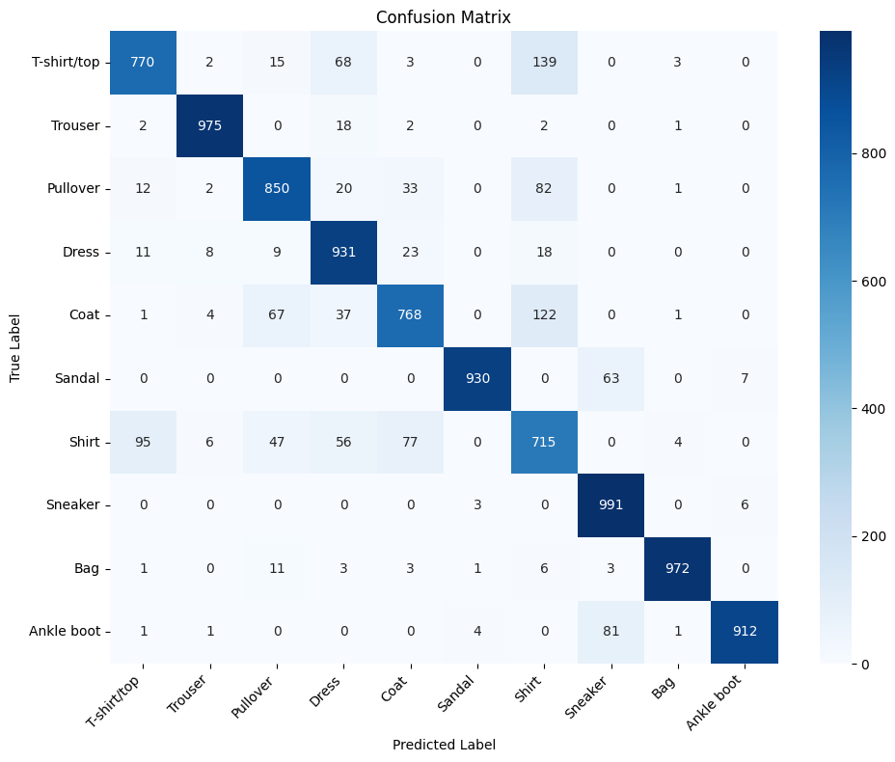
Classification Report:
precision recall f1-score support
T-shirt/top 0.86 0.77 0.81 1000
Trouser 0.98 0.97 0.98 1000
Pullover 0.85 0.85 0.85 1000
Dress 0.82 0.93 0.87 1000
Coat 0.84 0.77 0.80 1000
Sandal 0.99 0.93 0.96 1000
Shirt 0.66 0.71 0.69 1000
Sneaker 0.87 0.99 0.93 1000
Bag 0.99 0.97 0.98 1000
Ankle boot 0.99 0.91 0.95 1000
accuracy 0.88 10000
macro avg 0.89 0.88 0.88 10000
weighted avg 0.89 0.88 0.88 10000

Part 5: Siamese Network
class SiameseNetwork(nn.Module):
def __init__(self, backbone, embedding_dim=128):
super().__init__()
self.backbone = backbone
self.embedding = nn.Sequential(
nn.Linear(backbone.num_features, embedding_dim),
nn.ReLU(),
nn.Linear(embedding_dim, embedding_dim),
)
def forward(self, x):
features = self.backbone.get_features(x)
embeddings = self.embedding(features)
return F.normalize(embeddings, p=2, dim=1)
siamese_model = SiameseNetwork(model, embedding_dim=128).to(device)
for param in siamese_model.backbone.parameters():
param.requires_grad = False
print(
f"Trainable parameters: {sum(p.numel() for p in siamese_model.parameters() if p.requires_grad):,}"
)
Trainable parameters: 41,216
class TripletDataset(Dataset):
def __init__(self, dataset):
self.dataset = dataset
self.labels = np.array([label for _, label in dataset])
self.label_to_indices = {
label: np.where(self.labels == label)[0] for label in np.unique(self.labels)
}
def __len__(self):
return len(self.dataset)
def __getitem__(self, idx):
anchor_img, anchor_label = self.dataset[idx]
positive_idx = idx
while positive_idx == idx:
positive_idx = np.random.choice(self.label_to_indices[anchor_label])
positive_img, _ = self.dataset[positive_idx]
negative_label = np.random.choice(
[l for l in self.label_to_indices.keys() if l != anchor_label]
)
negative_idx = np.random.choice(self.label_to_indices[negative_label])
negative_img, _ = self.dataset[negative_idx]
return anchor_img, positive_img, negative_img
triplet_train = TripletDataset(train_dataset)
triplet_loader = DataLoader(triplet_train, batch_size=128, shuffle=True, num_workers=0)
print(f"Triplet dataset size: {len(triplet_train)}")
Triplet dataset size: 54000
class TripletLoss(nn.Module):
def __init__(self, margin=0.5):
super().__init__()
self.margin = margin
def forward(self, anchor, positive, negative):
pos_dist = F.pairwise_distance(anchor, positive, p=2)
neg_dist = F.pairwise_distance(anchor, negative, p=2)
loss = F.relu(pos_dist - neg_dist + self.margin)
return loss.mean()
triplet_criterion = TripletLoss(margin=0.5)
triplet_optimizer = optim.Adam(siamese_model.embedding.parameters(), lr=0.001)
triplet_scheduler = optim.lr_scheduler.StepLR(triplet_optimizer, step_size=5, gamma=0.5)
num_triplet_epochs = 15
triplet_history = []
for epoch in range(num_triplet_epochs):
siamese_model.train()
total_loss = 0
for anchor, positive, negative in tqdm(
triplet_loader, desc=f"Epoch {epoch + 1}/{num_triplet_epochs}"
):
anchor = anchor.to(device)
positive = positive.to(device)
negative = negative.to(device)
triplet_optimizer.zero_grad()
anchor_emb = siamese_model(anchor)
positive_emb = siamese_model(positive)
negative_emb = siamese_model(negative)
loss = triplet_criterion(anchor_emb, positive_emb, negative_emb)
loss.backward()
triplet_optimizer.step()
total_loss += loss.item()
avg_loss = total_loss / len(triplet_loader)
triplet_history.append(avg_loss)
print(f"Epoch {epoch + 1}/{num_triplet_epochs} - Loss: {avg_loss:.4f}")
triplet_scheduler.step()
torch.save(siamese_model.state_dict(), "siamese_model.pth")
print("\nSiamese model saved!")
Epoch 1/15: 0%| | 0/422 [00:00<?, ?it/s]
Epoch 1/15 - Loss: 0.0491
Epoch 2/15: 0%| | 0/422 [00:00<?, ?it/s]
Epoch 2/15 - Loss: 0.0457
Epoch 3/15: 0%| | 0/422 [00:00<?, ?it/s]
Epoch 3/15 - Loss: 0.0455
Epoch 4/15: 0%| | 0/422 [00:00<?, ?it/s]
Epoch 4/15 - Loss: 0.0444
Epoch 5/15: 0%| | 0/422 [00:00<?, ?it/s]
Epoch 5/15 - Loss: 0.0437
Epoch 6/15: 0%| | 0/422 [00:00<?, ?it/s]
Epoch 6/15 - Loss: 0.0435
Epoch 7/15: 0%| | 0/422 [00:00<?, ?it/s]
Epoch 7/15 - Loss: 0.0435
Epoch 8/15: 0%| | 0/422 [00:00<?, ?it/s]
Epoch 8/15 - Loss: 0.0431
Epoch 9/15: 0%| | 0/422 [00:00<?, ?it/s]
Epoch 9/15 - Loss: 0.0421
Epoch 10/15: 0%| | 0/422 [00:00<?, ?it/s]
Epoch 10/15 - Loss: 0.0425
Epoch 11/15: 0%| | 0/422 [00:00<?, ?it/s]
Epoch 11/15 - Loss: 0.0428
Epoch 12/15: 0%| | 0/422 [00:00<?, ?it/s]
Epoch 12/15 - Loss: 0.0428
Epoch 13/15: 0%| | 0/422 [00:00<?, ?it/s]
Epoch 13/15 - Loss: 0.0426
Epoch 14/15: 0%| | 0/422 [00:00<?, ?it/s]
Epoch 14/15 - Loss: 0.0418
Epoch 15/15: 0%| | 0/422 [00:00<?, ?it/s]
Epoch 15/15 - Loss: 0.0419
Siamese model saved!
plt.figure(figsize=(10, 5))
plt.plot(triplet_history)
plt.xlabel("Epoch")
plt.ylabel("Triplet Loss")
plt.title("Siamese Network Training")
plt.grid(True, alpha=0.3)
plt.show()
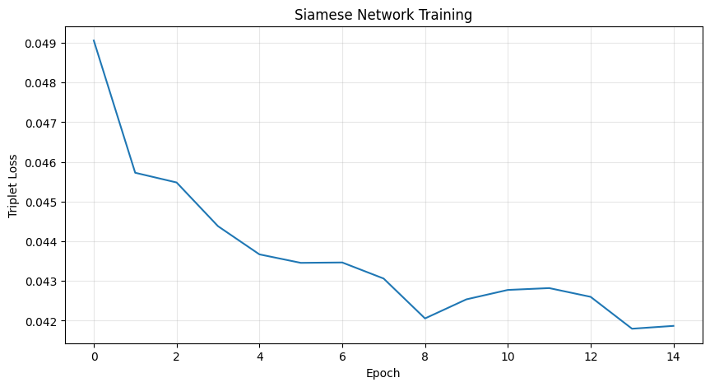

Part 6: Generate Embeddings
siamese_model.load_state_dict(torch.load("siamese_model.pth"))
siamese_model.eval()
test_embeddings = []
test_labels = []
test_images = []
with torch.no_grad():
for images, labels in tqdm(test_loader, desc="Generating embeddings"):
images = images.to(device)
embeddings = siamese_model(images)
test_embeddings.append(embeddings.cpu().numpy())
test_labels.extend(labels.numpy())
test_images.append(images.cpu())
test_embeddings = np.vstack(test_embeddings)
test_labels = np.array(test_labels)
test_images = torch.cat(test_images)
print(f"Embeddings shape: {test_embeddings.shape}")
print(f"Labels shape: {test_labels.shape}")
Generating embeddings: 0%| | 0/79 [00:00<?, ?it/s]
Embeddings shape: (10000, 128)
Labels shape: (10000,)

Part 7: Similar Image Search
def find_similar_images(query_idx, embeddings, top_k=5):
query_embedding = embeddings[query_idx]
distances = np.linalg.norm(embeddings - query_embedding, axis=1)
similar_indices = np.argsort(distances)[1 : top_k + 1]
return similar_indices, distances[similar_indices]
def visualize_similar_images(query_idx, similar_indices, images, labels, class_names):
fig, axes = plt.subplots(1, len(similar_indices) + 1, figsize=(15, 3))
query_img = images[query_idx].squeeze().numpy()
axes[0].imshow(query_img, cmap="gray")
axes[0].set_title(f"Query\n{class_names[labels[query_idx]]}", fontweight="bold")
axes[0].axis("off")
axes[0].add_patch(
plt.Rectangle(
(0, 0),
query_img.shape[1] - 1,
query_img.shape[0] - 1,
fill=False,
edgecolor="red",
linewidth=3,
)
)
for i, idx in enumerate(similar_indices):
img = images[idx].squeeze().numpy()
axes[i + 1].imshow(img, cmap="gray")
axes[i + 1].set_title(f"Similar {i + 1}\n{class_names[labels[idx]]}")
axes[i + 1].axis("off")
plt.tight_layout()
plt.show()
for _ in range(3):
query_idx = np.random.randint(0, len(test_embeddings))
similar_indices, distances = find_similar_images(
query_idx, test_embeddings, top_k=5
)
print(f"Query: {class_names[test_labels[query_idx]]} | Distances: {distances}")
visualize_similar_images(
query_idx, similar_indices, test_images, test_labels, class_names
)
Query: Coat | Distances: [0.01145475 0.01774825 0.02120035 0.02315172 0.02537438]
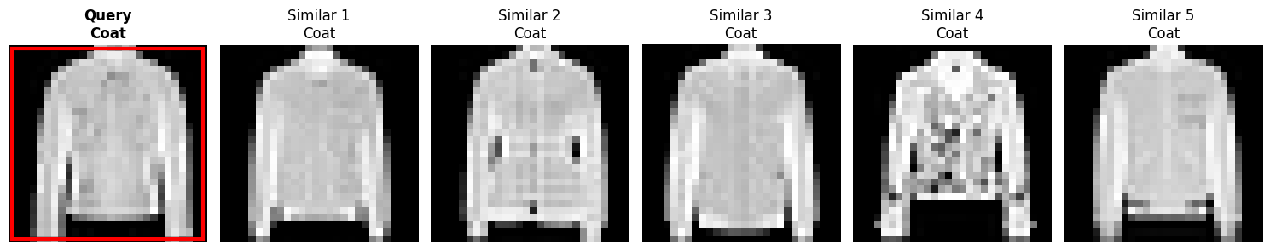
Query: Sneaker | Distances: [0.01603494 0.0204619 0.0235073 0.02351853 0.02535396]
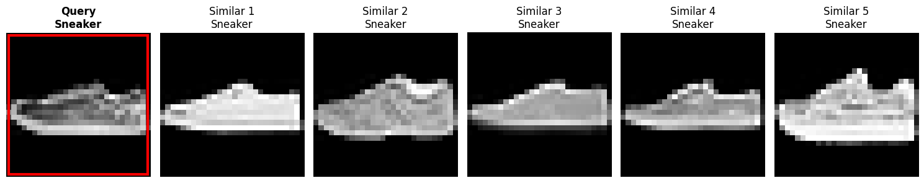
Query: Pullover | Distances: [0.04742875 0.0483702 0.05394476 0.05786155 0.06085948]
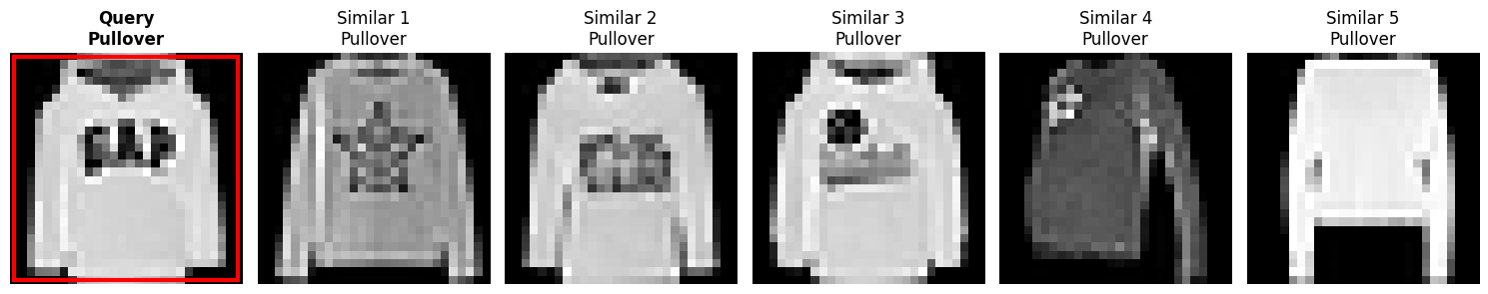
def evaluate_retrieval(embeddings, labels, k_values=[1, 3, 5, 10]):
results = {k: [] for k in k_values}
for i in tqdm(range(len(embeddings)), desc="Evaluating retrieval"):
query_label = labels[i]
distances = np.linalg.norm(embeddings - embeddings[i], axis=1)
sorted_indices = np.argsort(distances)[1:]
for k in k_values:
top_k_labels = labels[sorted_indices[:k]]
accuracy = np.mean(top_k_labels == query_label)
results[k].append(accuracy)
for k in k_values:
avg_acc = np.mean(results[k]) * 100
print(f"Top-{k} Accuracy: {avg_acc:.2f}%")
evaluate_retrieval(test_embeddings, test_labels)
Evaluating retrieval: 0%| | 0/10000 [00:00<?, ?it/s]
Top-1 Accuracy: 85.60%
Top-3 Accuracy: 85.85%
Top-5 Accuracy: 85.51%
Top-10 Accuracy: 85.30%

Part 8: t-SNE Visualization
sample_size = 5000
sample_indices = np.random.choice(len(test_embeddings), sample_size, replace=False)
sample_embeddings = test_embeddings[sample_indices]
sample_labels = test_labels[sample_indices]
print("Applying PCA for dimensionality reduction...")
pca = PCA(n_components=50)
embeddings_pca = pca.fit_transform(sample_embeddings)
print(f"PCA explained variance: {pca.explained_variance_ratio_.sum():.2%}")
print("Applying t-SNE...")
tsne = TSNE(
n_components=2, perplexity=40, learning_rate=200, random_state=42
)
embeddings_tsne = tsne.fit_transform(embeddings_pca)
Applying PCA for dimensionality reduction...
PCA explained variance: 99.99%
Applying t-SNE...
plt.figure(figsize=(14, 10))
colors = plt.cm.tab10(np.linspace(0, 1, 10))
for i, class_name in enumerate(class_names):
mask = sample_labels == i
plt.scatter(
embeddings_tsne[mask, 0],
embeddings_tsne[mask, 1],
c=[colors[i]],
label=class_name,
alpha=0.6,
s=20,
)
plt.legend(bbox_to_anchor=(1.05, 1), loc="upper left", markerscale=2)
plt.title(
"t-SNE Visualization of Siamese Network Embeddings", fontsize=16, fontweight="bold"
)
plt.xlabel("t-SNE Component 1")
plt.ylabel("t-SNE Component 2")
plt.grid(True, alpha=0.3)
plt.tight_layout()
plt.show()
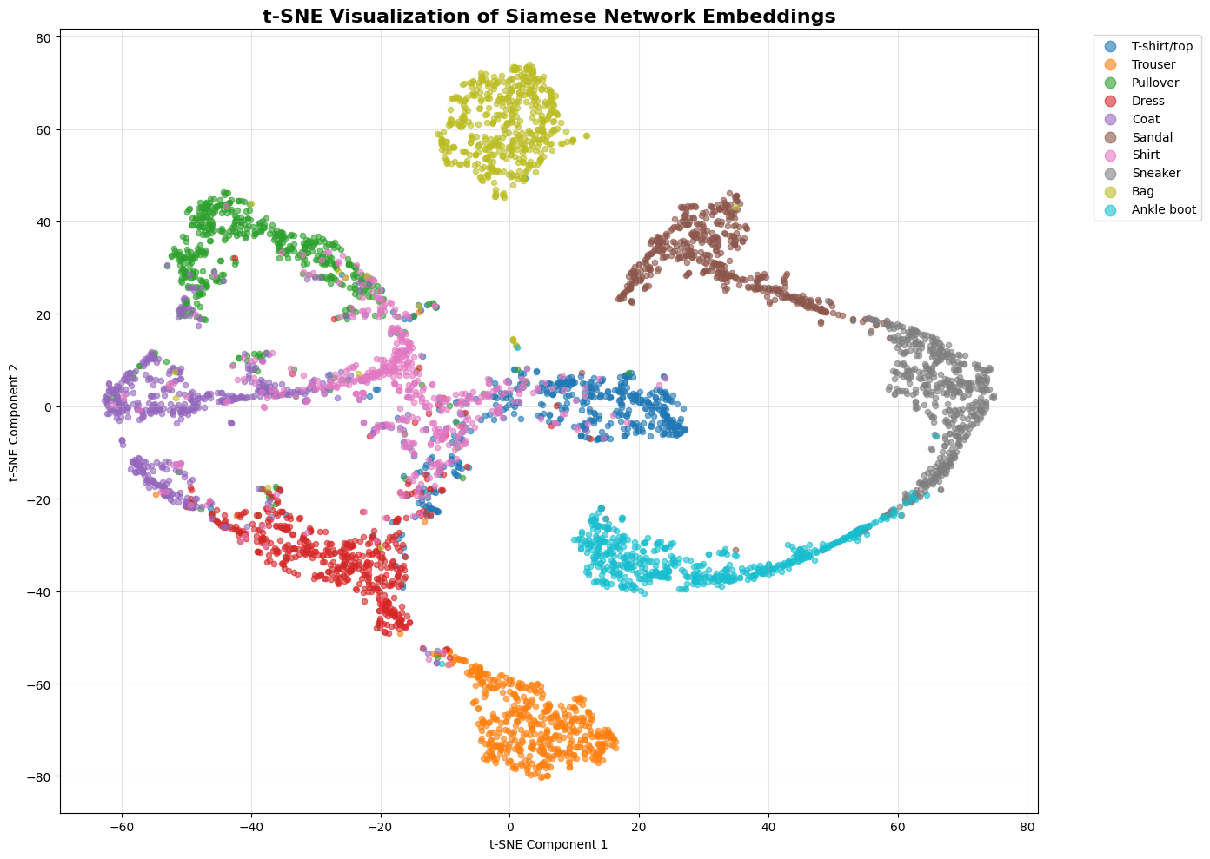

Part 9: Comparison with Raw Pixels and DenseNet Features
raw_images = test_images[sample_indices].view(sample_size, -1).numpy()
print("Extracting DenseNet features...")
model.eval()
densenet_features = []
with torch.no_grad():
for idx in tqdm(sample_indices):
img = test_images[idx : idx + 1].to(device)
features = model.get_features(img)
densenet_features.append(features.cpu().numpy())
densenet_features = np.vstack(densenet_features)
Extracting DenseNet features...
0%| | 0/5000 [00:00<?, ?it/s]
print("Applying t-SNE on raw pixels...")
pca_raw = PCA(n_components=50)
raw_pca = pca_raw.fit_transform(raw_images)
tsne_raw = TSNE(
n_components=2, perplexity=40, learning_rate=200, random_state=42
)
raw_tsne = tsne_raw.fit_transform(raw_pca)
print("Applying t-SNE on DenseNet features...")
pca_dense = PCA(n_components=50)
dense_pca = pca_dense.fit_transform(densenet_features)
tsne_dense = TSNE(
n_components=2, perplexity=40, learning_rate=200, random_state=42
)
dense_tsne = tsne_dense.fit_transform(dense_pca)
Applying t-SNE on raw pixels...
Applying t-SNE on DenseNet features...
Applying t-SNE on DenseNet features...
fig, axes = plt.subplots(1, 3, figsize=(20, 6))
titles = ["Raw Pixels", "DenseNet Features", "Siamese Embeddings"]
data = [raw_tsne, dense_tsne, embeddings_tsne]
for ax, title, tsne_data in zip(axes, titles, data):
for i, class_name in enumerate(class_names):
mask = sample_labels == i
ax.scatter(
tsne_data[mask, 0],
tsne_data[mask, 1],
c=[colors[i]],
label=class_name,
alpha=0.6,
s=15,
)
ax.set_title(title, fontsize=14, fontweight="bold")
ax.set_xlabel("t-SNE Component 1")
ax.set_ylabel("t-SNE Component 2")
ax.grid(True, alpha=0.3)
handles, labels = axes[0].get_legend_handles_labels()
fig.legend(handles, labels, loc="center left", bbox_to_anchor=(1, 0.5), markerscale=2)
plt.tight_layout()
plt.show()
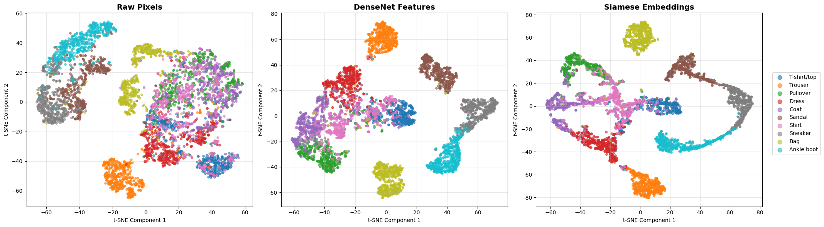

Results Summary
print("LAB 3 RESULTS SUMMARY")
print("\n1. DenseNet Classification:")
print(f" - Test Accuracy: {test_acc:.2f}%")
print(f" - Model Parameters: {sum(p.numel() for p in model.parameters()):,}")
print("\n2. Siamese Network:")
print(" - Embedding Dimension: 128")
print(f" - Final Triplet Loss: {triplet_history[-1]:.4f}")
print("\n3. Similar Image Search:")
print(" - Successfully implemented with Euclidean distance")
print(" - Top-k accuracy metrics computed")
print("\n4. t-SNE Visualization:")
print(f" - Visualized {sample_size} samples")
print(" - Compared raw pixels, DenseNet features, and Siamese embeddings")
print(" - Clear class separation observed in Siamese embeddings")
LAB 3 RESULTS SUMMARY
1. DenseNet Classification:
- Test Accuracy: 88.14%
- Model Parameters: 303,274
2. Siamese Network:
- Embedding Dimension: 128
- Final Triplet Loss: 0.0419
3. Similar Image Search:
- Successfully implemented with Euclidean distance
- Top-k accuracy metrics computed
4. t-SNE Visualization:
- Visualized 5000 samples
- Compared raw pixels, DenseNet features, and Siamese embeddings
- Clear class separation observed in Siamese embeddings

