**CS673F16 Software Engineering**

**Team 2 Meeting Minutes**

**Week 10 (12/05 - 12/11)**

**Date and Time:** Dec 11, Sunday, 12pm

**Place**: Mugar Library PAL Study Lounge

**Participants:** Daniel, Gautam, Becky, Ian, Adiba, Gabriel

**Minutes taker:** Adiba

**Timekeeper:** Adiba

**Purpose:**

**Tutoring / Review / Coding / Clarify tasks**

**Agenda:**

Standing Up (Report What we did)

Road map Report

Clarify tasks again (coding task)

Tutoring / coding with mentor

Working on slides

**Timetable:**

12:00 - 12:30: Standing Up + Road map

12:30 - 2:00: Working on tasks

2:00 - 3:30: Working on slides

3:30 - 4:00: Clarify tasks again + Tutoring / coding with mentor

**Todo:**

口 Finish tasks

口 weekly logs

**Discussions:**

* In-person - Daniel, Adiba, Gautam,Becky, Gabriel, Ian
* 12:00 pm to 12:30 pm - Everyone did stand up for the past week.
* 12:30 pm to 2:00 pm - Discussed further potential testing strategies, apart from unit testing. (chimp, mocha, selenium, chai etc.)
* 2:00 pm to 3:30 pm - Worked on slides

**Week 9 (11/28 - 12/5)**

**Date and Time:** Dec 5, Sunday, 2pm

**Place**: Mugar Library PAL Study Lounge

**Participants:** Daniel, Gautam, Becky, Ian, Adiba, Gabriel

**Minutes taker:** Gautam

**Timekeeper:** Gautam

**Purpose:**

**Tutoring / Review / Coding / Clarify tasks**

**Agenda:**

Standing Up (Report What we did)

Road map Report

Clarify tasks again (coding task)

Tutoring / coding with mentor

**Timetable:**

2:00 - 2:30: Standing Up + Road map

2:30 - 3:00: Assigning tasks

3:00 - 3:30: learning how to do tasks

3:30 - 4:00: Clarify tasks again + Tutoring / coding with mentor

**Todo:**

口 Finish tasks

口 weekly logs

**Discussions:**

* In-person - Daniel, Adiba, Gautam; Online: Becky, Gabriel, Ian
* 2:00 pm to 2:15 pm - Everyone did stand up for the past week.
* 2:10 pm to 2:20 pm - Gautam resolved Adiba’s Git branch issues and helped her push updates to repo
* 2:15 pm to 2:30 pm - Discussed further potential testing strategies, apart from unit testing. (chimp, mocha, selenium, chai etc.)
* 2:45 pm to 3:00 pm - Assigned and discussed tasks for coming week.

**Thanksgiving Break (11/20 - 11/28)**

**Week 8 (11/14 - 11/20)**

**Date and Time:** Nov.20 Sunday, 2pm- 5 pm

**Place**: Mugar Library PAL Study Lounge

**Participants:** Daniel, Gautam, Becky, Ian, Adiba, Gabriel

**Minutes taker: Adiba**

**Timekeeper: Adiba**

**Purpose:** Tutoring / Review / Coding

**Prepare before meeting:**

口 Finish your task before deadline if possible

口 Fill some SDD if possible

**Agenda:**

1. Standing Up (Report What we did)
2. Road map Report
3. Clarify tasks again (coding task)
4. Assigning next week to-do’s.
5. Tutoring / coding with mentor

**Timetable:**

2:00 - 2:30: Standing Up + Road map

2:30 - 3:00: Assigning tasks

3:00 - 3:30: Understanding tasks

3:30 - 4:00: Clarify tasks again + Tutoring / coding with mentor

**Todo:**

口 Finish tasks

口 Update SDD

口 Update Pivotal Tracker

**Discussions:**

**Week 7 (11/7 - 11/13)**

**Date and Time:** Nov.13 Sunday, 2pm- 5 pm

**Place**: Mugar Library PAL Study Lounge

**Participants:** Daniel, Gautam, Becky, Ian, Adiba, Gabriel

**Minutes taker: Daniel**

**Timekeeper: Daniel**

**Purpose:** Tutoring / Review / Coding

**Prepare before meeting:**

口 Finish your task before deadline if possible

口 Fill some SDD if possible

**Agenda:**

1. Standing Up (Report What we did)
2. Road map Report
3. Code review
4. Finish SDD
5. Presentation slides
6. Clarify tasks again (coding task)
7. Tutoring / coding with mentor

**Timetable:**

2:00 - 2:20: Standing Up + Road map

2:20 - 2:30: Code review

2:30 - 3:00: SDD

3:00 - 3:40: Presentation slides

3:40 - Clarify tasks again + Tutoring / coding with mentor

**Todo:**

口 Finish tasks

口 Fill Slide

**Discussions:**

**Week 6 (11/1 - 11/6)**

**Date and Time:** Nov.6 Sunday, 2pm- 5 pm

**Place**: Mugar Library PAL Study Lounge

**Participants:** Daniel, Gautam, Becky, Bella, Ian, Adiba, Gabriel

**Minutes taker:** Huai Chun Shih (Daniel)

**Timekeeper:** Huai Chun Shih (Daniel)

**Purpose:** Tutoring / Review / Coding

**Prepare before meeting:**

口 Finish your task before deadline if possible

口 Fill some SDD if possible

**Agenda:**

1. Standing Up (Report What we did)
2. Road map Report
3. Code review
4. Clarify tasks again (SDD task and coding task)
5. Tutoring / coding with mentor

**Timetable:**

2:00 - 2:20: Standing Up + Road map

2:20 - 2:40: Code review

2:40 - 3:00: Clarify tasks again (SDD task and coding task)

3:00 - Tutoring / coding with mentor

**Todo:**

口 Finish Task

口 Fill SDD, so next week we can discuss and finalize it

**Discussions:**

* Code Change Review
  + Presentation of Message Controller
  + Smaller Discover page photos
* SDD Responsibilities review
* Pair programming and testing tutorials

**Week 5 (10/25 - 10/31)**

**Date and Time:** Oct.30 Sunday, 2-5:30pm

**Place**: Mugar Library PAL Study Lounge

**Participants:** Daniel, Gautam, Becky, Gabriel, Bella, Ian, Adiba

**Minutes taker:** Ian

**Timekeeper:** Ian

**Purpose:** Testing / Review Code Architecture / Tutorial

**Prepare before meeting:**

1. SDD preparations

**Agenda:**

1. Report What we did (the task in last week)
2. Tutorial
3. Mentor Pupil code review / obstacle help
4. SDD walk through

**Discussions:**

* File Structure

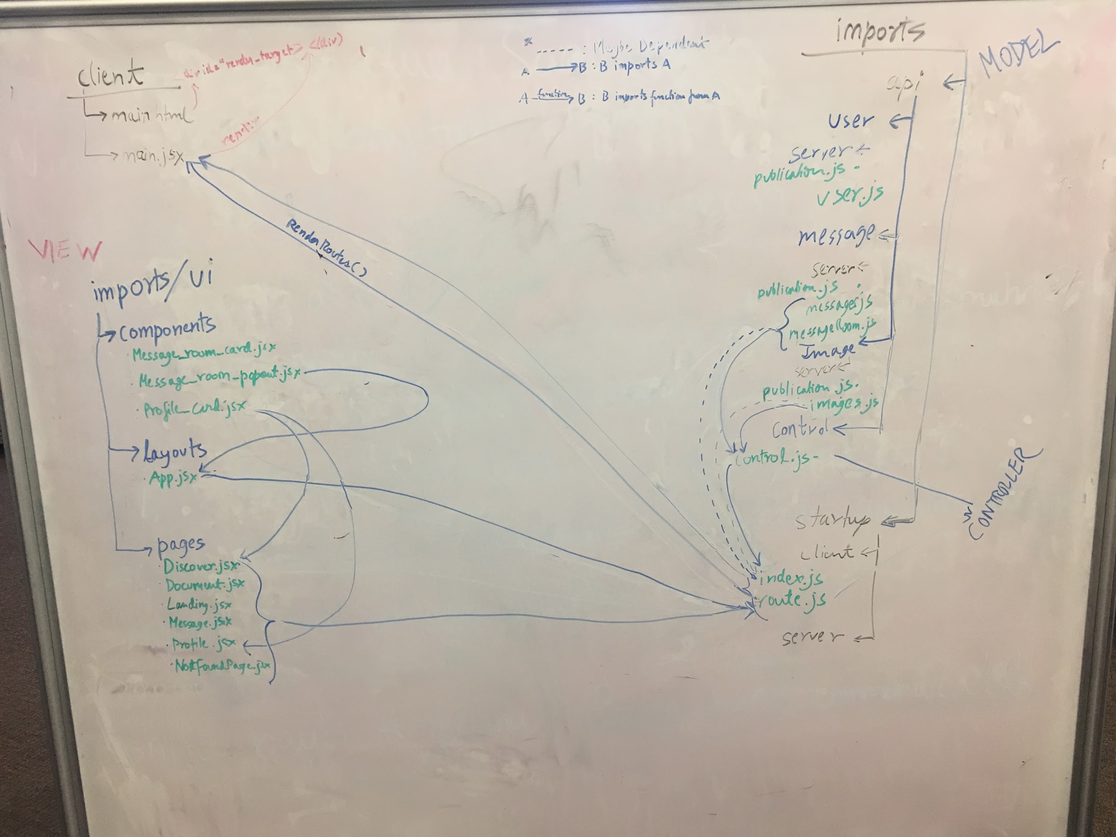

Dependency Graph with MVC

**Key Decisions**

* Mentor Pupil grouping
  + Becky - Bella
  + Daniel - Gabe, Adiba
  + Gautam - Ian

**Action Items:**

* Work on SDD
* Work on programming specific pages
  + Make test files to test code

**Week 5 (10/18 - 10/24)**

**Date and Time:** Oct.23 Sunday, 2-5pm

**Place**: Mugar Library PAL Study Lounge

**Participants:** Daniel, Gautam, Becky, Gabriel (online), Bella, Ian, Adiba

**Minutes taker:** Becky

**Timekeeper:** Becky

**Purpose:** CODING. CODING CODING CODING. Be ready for demo.

**Prepare before meeting:**

1. Have stories to work on.

**Agenda:**

1. Report What we did (the task in last week)
2. Iteration 1 presentation
3. Pair programming / obstacle help

**Discussions:**

* What are we presenting tomorrow?
  + Finish as much front-end work to show off

**Week 4 (10/11 - 10/17)**

**Date and Time:** Oct.16 Sunday, 2pm - 5pm

**Place**: Mugar library 3rd floor

**Participants:** Daniel, Gautam, Gabe, Becky, Bella, Ian, Adiba

**Minutes taker:** Gabe, Becky

**Timekeeper:** Becky

**Purpose:** ClarifyRequirement Analysis + Programming

**Prepare before meeting:**

口 Finish own stories for HW2

**Agenda:**

1. Review requirements analysis document
2. Unify Entity Review Stories
3. Clarify the tasks again.
4. programming / obstacle help

**Timetable:**

|  |  |
| --- | --- |
| **55 min** | **Review Requirement Analysis doc**  **Discuss application boundaries, page components, entity attributes & relationships**  **Discuss application flows & user stories, refine requirements** |
| 5 min | **Standing up**  1. What we did / learned? hours?  2. Obstacles? Some were having issues getting the application to work locally  3. What going to do / learned later? |
| 1 hr + | **Programming** Clarify the tasks again  programming / obstacle help  If not learn meteor/react yet, learn it. |
|  |  |

**Todo:**

口 update weekly log

口 update meeting record

口 Do react tutorial

口 Contribute to repo

**Discussions:**

* Requirements analysis document review
  + There will be entities:
    - Message
    - Image
    - User
    - MessageRoom
  + Each entity will have specific functions, as specified in the document. I.e. MessageRoom has a boolean readYet() function.
  + Boundary:
    - App contains: Discover, Profile, Message, MessageRoomList
* Git refresher

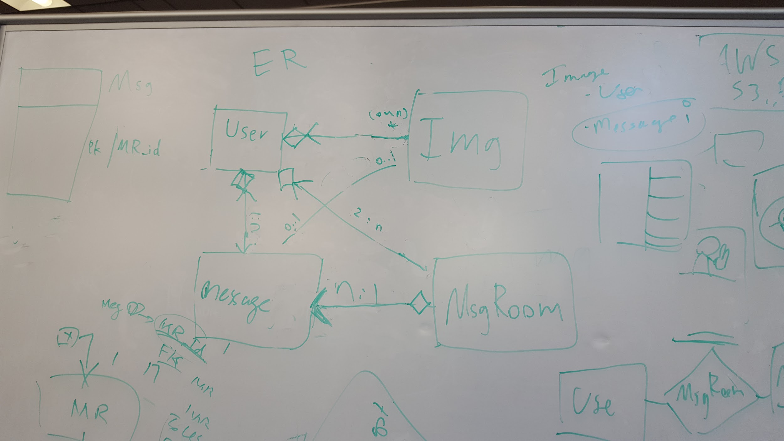

**Key Decisions**

* We will allow users to upload multiple images
  + A user does not have to have an image
* A message room
  + has to have at least two users
  + 0..N messages
* A user
  + Can belong to 0..N message rooms
* A message has .
  + one and only one user, but a user can have 0 to n messages
  + Up to one image

**Tabled Agenda Items:**

* **none**

**Action Items:**

* Everyone should attempt to contribute to the code before end of week
* Work on presentation for following week demo
* Update SPPP and other needed documentation in preparation for demo

**Week 3 (10/3 - 10/10)**

**Date and Time:** Oct.10 Monday, 6-7pm

**Place**: Slack and Google Hangouts

**Participants:** Daniel, Gautam, Gabe, Becky, Bella, Ian,Adiba

**Minutes taker:** Gabe

**Timekeeper:** Becky

**Purpose:**  Story review + Task assignment discussion - ensure everyone is on the same page, discuss obstacles

**Prepare before meeting:**

1. Have skeleton app running

**Agenda:**

1. Report What we did (the task in last week)
2. Review Stories and pick up tasks in stories to do.
3. Pair programming / obstacle help

**Timetable:**

**Timetable:**

|  |  |
| --- | --- |
| 20 min | **Standing up**  1. What we did / learned? hours?  2. Obstacles? Some were having issues getting the application to work locally  3. What going to do / learned later? |
| 30 min | **Requirement Analysis** Review Stories, Questions?  Solve Homework Pick up tasks in stories to do. |
| 30 min | **Spring Meeting** Pick up stories |

**Discussions:**

* Some users were having issues running the app locally - discuss these blockers in group setting to try to catch people up
* Ensure everyone is OK and understands their assigned tasks - discuss the difficulty of some people doing more code right now than others
* Review meteor package dependencies
* Review stories

**Key Decisions**

* Ian & Bella to partner on QA
* Bella & Gabe to partner on UML
* May need additional stories & epics - then break them down - can wait a little bit as application is still skeleton
* Determine if we need more stories around logging in

**Tabled Agenda Items:**

|  |  |
| --- | --- |
| 30 min | **First Spring Meeting**  1.Review/Generate Tasks  2.Pick Up Tasks  3.Make sure everyone know his/her own task |
| 2 hr | **Pair Programming**  Optionally Stay in library to code together. |

**Action Items:**

* Bella & Gabe to sync up on UML
* Ian & Bella to sync up on QA
* Confirm stories during 10/11 class

**Week 2 (09/27 - 10/2)**

**Date and Time:** Oct.2 Sunday, 2 - 5 pm

**Place**: Mugar library 3rd floor PAL Lounge

**Participants:** Daniel, Gautam, Gabe, Becky, Bella, Ian,Adiba

**Minutes taker:** Becky

**Timekeeper:** Becky

**Purpose:** First Sprint Meeting + SPPP + Pair Programming

**Prepare before meeting:**

1. Write SPPP
2. Install Meteor.js

**Agenda:**

1. Report What we learned (the task in last week)
2. Do SPPP and finish first version
3. Git Clone and Branch
4. First Spring Meeting
   1. Review Tasks

b. Pick Up Tasks

c. Make sure everyone know his/her own task

5. Pair Programming

6. Update Weekly Log

**Timetable:**

|  |  |
| --- | --- |
| 20 min | **Agile Meeting, Report**  1. What we did / learned? hours?  2. Obstacles?  3. What going to learn? |
| 20 min | **Do SPPP**  0.Make sure people are writing it.  1.Review and Solve Obstacles.  2.Finish first version |
| 20 min | **Git and pull request**  Make sure people can run code and push it to his/her own branch.  0.add contributor  1.clone and run.  *> git clone*  2. Update repository after I merge my pull request  *> git pull*  2.change something in README.md and commit  *> git branch [NM]branch_name*  *> git checkout [NM]branch_name*  *> git add .*  *> git commit -m “comment”*  3.Create pull request  *> git push origin [NM]branch_name*  *Write* pull request in github  *merge it to master* |
| 30 min | **First Spring Meeting**  1.Review/Generate Tasks  2.Pick Up Tasks  3.Make sure everyone know his/her own task |
| 2 hr | **Pair Programming**  Optionally Stay in library to code together. |

**Discussions:**

* Full walkthrough of SPPP
* Presentation
  + Slide flow
  + Assign slides
* Git & Github repo local setup

**Key Decisions**

* none

**Tabled Agenda Items:**

|  |  |
| --- | --- |
| 30 min | **First Spring Meeting**  1.Review/Generate Tasks  2.Pick Up Tasks  3.Make sure everyone know his/her own task |
| 2 hr | **Pair Programming**  Optionally Stay in library to code together. |

**Action Items:**

* Find emoji to use as MeetCute logo
* Members finish slides
* Meet tomorrow before class at 5 to review presentation and assign tasks
* Finish Meteor tutorials

**Week 1 (09/19 - 09/26 )**

**Date and Time:** Sep.26 Sunday, 2 - 4:00pm

**Place**: Mugar library 3rd floor PAL Lounge

**Participants:** Daniel, Gautam, Gabe, Becky, Bella, Ian,Adiba

**Minutes taker:** Becky

**Timekeeper:** Becky

**Purpose:** Initial Project Meeting

**Agenda:**

0. Self introduce  1. Framework

2. Project name

3**.** Task Generation

4. Pick Up Tasks

5. Pair Programming

**Discussions**

* Self-introductions
* Review of Google Drive Work Logs
* Review of Github Repo
  + Before we start coding everyone should fork the repo
* App Features/Docs:
  + App Flow diagram
  + Messaging/Chat Module
  + Profile
  + Gallery of Profiles
  + Optional feature: Search interests
  + Optional feature: Favorite Profiles/Friends
  + Mobile view/Mobile first
* Review of Task Backlog on Pivotal
  + Front end
    - Profile Browsing
      * Link to profile from photo
    - Landing Page
      * Background image
      * Login Link
      * Registration
      * Design
      * Logo
      * Color Scheme
  + Back end
    - Landing Page
      * Account creation
      * Session log in / log out
  + Division of Interests (as below in Key Decisions)
  + Review of upcoming class dates (holiday, due dates)

**Tabled Discussions:**

* Pair Programming

**Key Decisions**

* Story Leaders based on page:
  + Landing page - Gautam, Adiba
  + Gallery - Gabe Bella
  + Messaging - Ian
  + Profile - Becky
* Project Name - “Meetcute!”

**Action Items:**

* Finish work logs
* Start SPPP tomorrow (Monday) and finish next Sunday in group meeting