1. Basic Flow chart for Landing page:

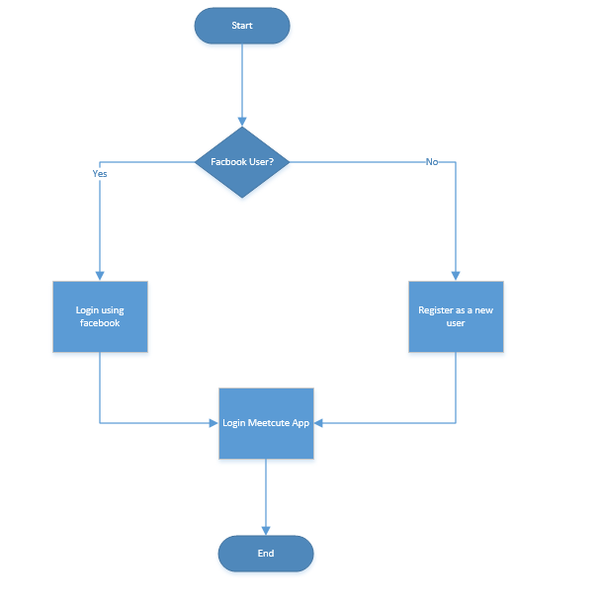

1. Flow Diagram for Discover Page:

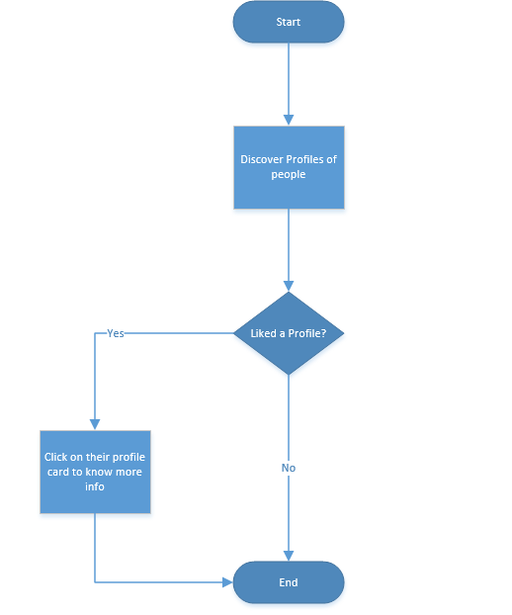

1. Flow For My Profile Page:

