Dennis Johnson
180905025
CSE-B
Batch 3

10-12-2020

CD-Lab-6: RDP

1. S - > a | > | (T)
T -> T, S | S

#include <stdio.h>
#include <stdlib.h>
#include <string.h>

int curr = 0;
char str[100];
void T();
void Tprime();
void S();

void invalid()
{
printf("-----------------ERROR!----------------\n");
exit(0);
}
void valid()
{
printf("----------------SUCCESS!---------------\n");
exit(0);
}
void T()
{ S();
Tprime();
}
void Tprime()
{ if(str[curr] == ',')
{
curr++;
S();
Tprime();
}
else {if(str[curr] == '$')
valid();
else return;
}
}
void S()
{ if(str[curr] == 'a' || str[curr]=='>')
{curr++;
return;
}
else if(str[curr]=='(')
{curr++;
T();
if(str[curr]==')')
valid();
else invalid();
}
else invalid();
}
int main()
{printf("Enter a $ terminated string: ");
scanf("%s", str);
S();
if(str[curr] == '$')
valid();
else
invalid();
return 0;
}

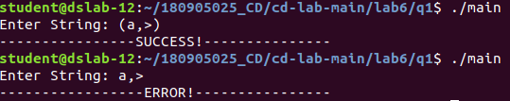

2. S -> UVW
U -> (S) | aSb | d
V -> aV | ε
W-> aW | ε

#include <stdio.h>
#include <stdlib.h>
#include <string.h>
int curr = 0;
char str[100];

void U();
void W();
void S();
void V();

void invalid()
{
printf("-----------------ERROR!----------------\n");
exit(0);
}
void valid()
{
printf("----------------SUCCESS!---------------\n");
exit(0);
}
void S()
{ U();
V();
W();
}
void U()
{
if(str[curr]=='(')
{
curr++;
S();
if(str[curr]==')')
{curr++;
return;
}
else invalid();
}
else if(str[curr]=='a')
{curr++;
S();
if(str[curr]=='b')
{ curr++;
return;
}
else invalid();
}
else if(str[curr]=='d'){
curr++;
return;
}
}
void V()
{ if(str[curr]=='a')
{
curr++;
V();
}
}
void W()
{
if(str[curr]=='c')
{
curr++;
W();
}
}

int main()
{printf("Enter a $ terminated string: ");
scanf("%s", str);
S();

if(str[curr]=='$')
valid();
else
invalid();
return 0;
}

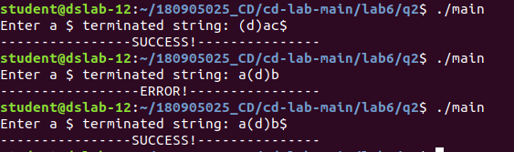

3. S -> aAcBe
A -> Ab | b
B -> d

#include <stdio.h>
#include <stdlib.h>
#include <string.h>

int curr = 0;
char str[100];
void U();
void A();
void Aprime();
void B();

void invalid(){
printf("-----------------ERROR!----------------\n");
exit(0);
}

void valid(){
printf("----------------SUCCESS!---------------\n");
exit(0);
}

void S(){
if(str[curr] == 'a'){
curr++;
A();
if(str[curr] == 'c')
{curr++;
B();
if(str[curr]=='e')
{curr++;
return;
}
else invalid();
}
else invalid();
}
else invalid();
}
void A()
{
if(str[curr]=='b')
{
curr++;
Aprime();
}
else invalid();
}

void Aprime()
{ if(str[curr]=='b')
{
curr++;
Aprime();
}
else return;
}
void B()
{
if(str[curr]=='d')
curr++;
else invalid();
}
int main()
{printf("Enter a $ terminated string: ");
scanf("%s", str);
S();
if(str[curr]=='$')
valid();
else
invalid();
return 0;
}
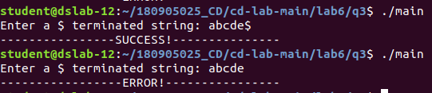

4. S -> (L) | a
L -> L,S | S

#include <stdio.h>
#include <stdlib.h>
#include <string.h>
int curr = 0;
char str[100];

void L();
void S();
void Lprime();
void invalid()

{
printf("-----------------ERROR!----------------\n");
exit(0);
}
void valid()
{
printf("----------------SUCCESS!---------------\n");
exit(0);
}
void S()
{ if(str[curr]=='(')
{ curr++;
L();
if(str[curr]==')')
curr++;
else invalid();
}
else if(str[curr]=='a')
curr++;
else invalid();
}
void L()
{
S();
Lprime();
}
void Lprime()
{ if(str[curr]==',')
{
curr++;
S();
Lprime();
}
else return;
}
int main()
{printf("Enter a $ terminated string: ");
scanf("%s", str);
S();
if(str[curr]=='$')
valid();
else
invalid();
return 0;
}

