1.

#include <sys/stat.h>
#include <sys/types.h>
#include <stdlib.h>
#include <stdio.h>
#include <string.h>
#include <unistd.h>
#include <fcntl.h>

int main(int argc, char** argv) {
int sfd;

if(argc != 3) {
printf("Insuffient Number of args\n");
exit(1);
}

sfd = open(argv[1], O_RDONLY);
if(sfd == -1) {
printf("Couldn't open file!");
exit(1);
}

char line[1024];
char ch;
int i = 0;
int line_no = 0;
while(read(sfd, &ch, sizeof(char)) > 0) {
if(ch != '\n') {
line[i++] = ch;
}
else {
line[i] = '\0';
if(strstr(line, argv[2]) != NULL) {
printf("Line %d:\t%s\n", line_no, line);
}

i = 0;
line_no++;
memset(line, '\0', sizeof(line));
}
}

close(sfd);
}

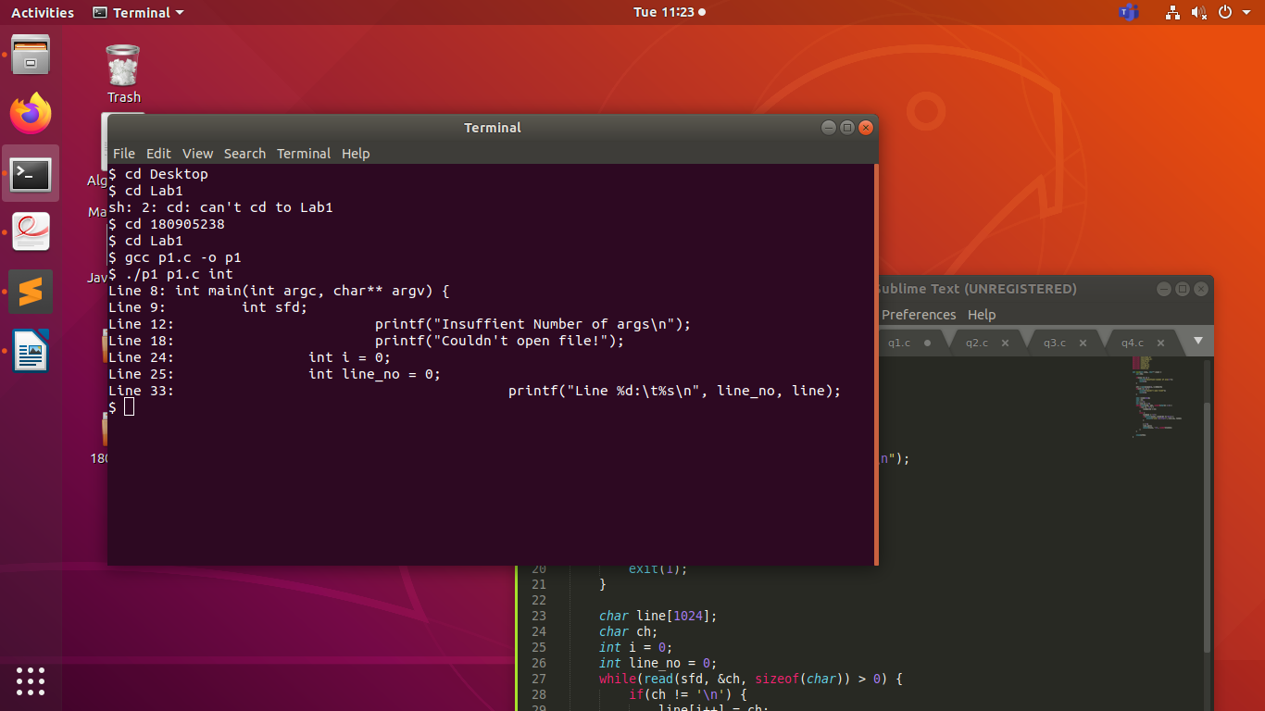

2.

#include <sys/stat.h>
#include <sys/types.h>
#include <stdlib.h>
#include <stdio.h>
#include <string.h>
#include <unistd.h>
#include <fcntl.h>
#include <string.h>

int main(int argc, char** argv) {
int sfd;
int file_counter = 1;
int line_no = 0;
while(file_counter != argc)
{
int file_line = 0;
sfd = open(argv[file_counter], O_RDONLY);
if(sfd == -1) {
printf("Couldn't open file!");
exit(1);
}

char line[1024];
char ch;
int i = 0;

while(read(sfd, &ch, sizeof(char)) > 0) {
if(ch != '\n') {
line[i++] = ch;
}
else {
line[i] = '\0';
printf("%d:\t%s\n", file_line, line);

i = 0;
line_no++;
file_line++;
char c;
if(line_no % 20 == 0) {
printf("Press any key to continue\n");
do {
c = getchar();
} while (c != '\n' && c != EOF);
}
memset(line, '\0', sizeof(line));
}
}
close(sfd);
file_counter++;
}
}

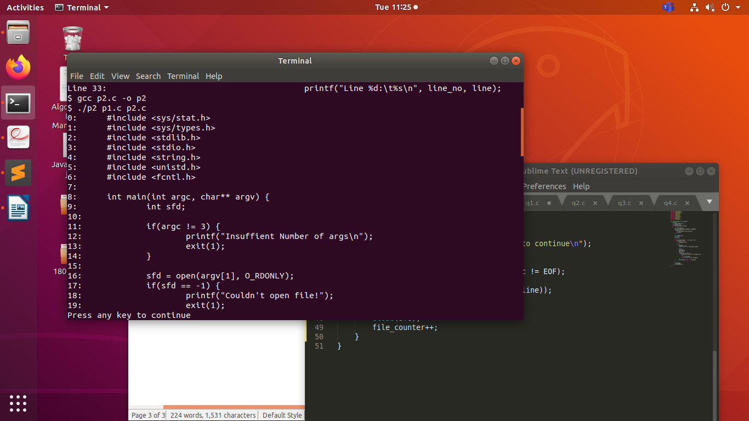

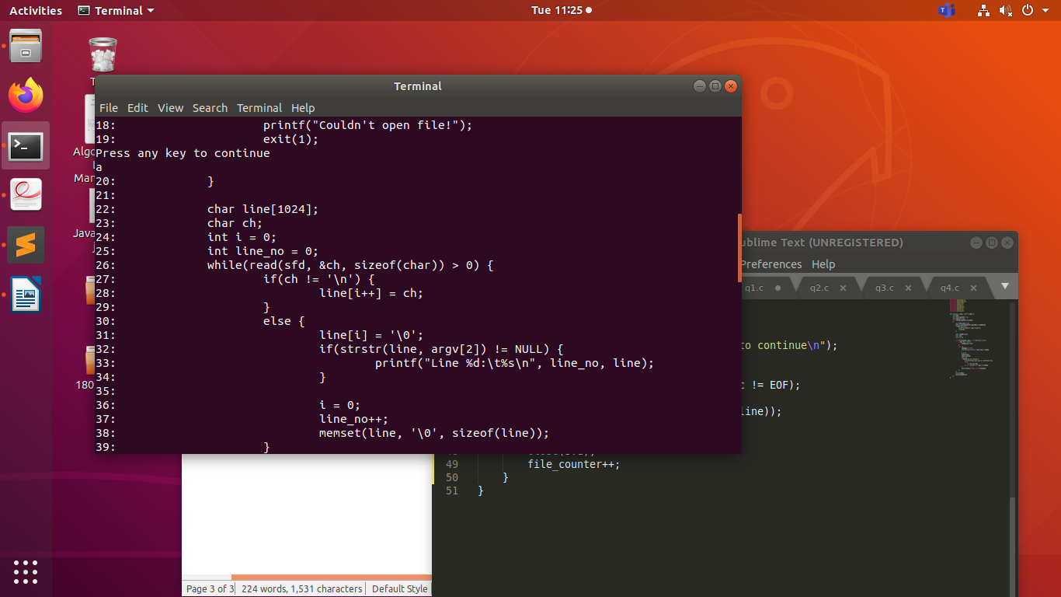

3.

#include<stdio.h>
#include<unistd.h>
#include<string.h>
#include<stdlib.h>
#include<fcntl.h>
#include<sys/types.h>
#include<sys/stat.h>
int main()
{
printf("%d \n",0xf);
printf("%s\n","hello" );
printf("%e\n",3.14);
printf("%o\n",12);
printf("%f\n",0.1 );
printf("%#x\n",1 );
open("hel",O_RDONLY);
fprintf(stderr,"%m\n");

}

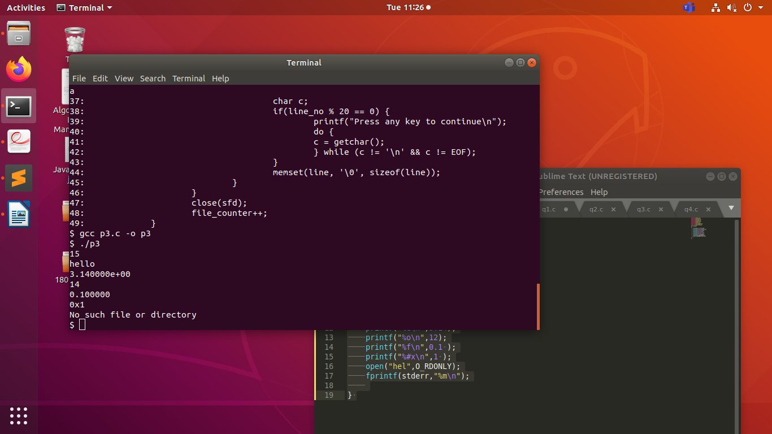

4.

#include <stdio.h>
#include <unistd.h>
#include <sys/stat.h>
#include <fcntl.h>
#include <stdlib.h>
int main(int argc, char *argv[]){

char c;
int in,out;
char buffer[128];
int nread;
if(argc!=3){
printf("Insufficient Arguments\n");
exit(1);
}
in=open(argv[1],O_RDWR);
out=open(argv[2],O_WRONLY|O_CREAT, S_IRUSR|S_IWUSR);
if( in==-1 || out==-1){
printf("File not found\n");
exit(1);
}
while(read(in,&c,1) == 1){
write(out,&c,1);

}
printf("Contents of file copied\n");
exit(0);

}

