1.

#include <unistd.h>
#include <stdio.h>
#include <sys/stat.h>
#include <sys/types.h>
#include <dirent.h>
int main()
{
DIR * dp;
struct dirent * entry;
struct stat statbuf;
if((dp = opendir(".")) == NULL)
{
printf("Cannot open directory \n");
return 0;
}
chdir(".");
while((entry = readdir(dp)) != NULL)
{
lstat(entry->d_name,&statbuf);
if(!S_ISDIR(statbuf.st_mode))
{
printf("%s \t \t",entry->d_name);

printf( (S_ISDIR(statbuf.st_mode)) ? "d" : "-");
printf( (statbuf.st_mode & S_IRUSR) ? "r" : "-");
printf( (statbuf.st_mode & S_IWUSR) ? "w" : "-");
printf( (statbuf.st_mode & S_IXUSR) ? "x" : "-");
printf( (statbuf.st_mode & S_IRGRP) ? "r" : "-");
printf( (statbuf.st_mode & S_IWGRP) ? "w" : "-");
printf( (statbuf.st_mode & S_IXGRP) ? "x" : "-");
printf( (statbuf.st_mode & S_IROTH) ? "r" : "-");
printf( (statbuf.st_mode & S_IWOTH) ? "w" : "-");
printf( (statbuf.st_mode & S_IXOTH) ? "x" : "-");
printf("\n\n");
}
}
}

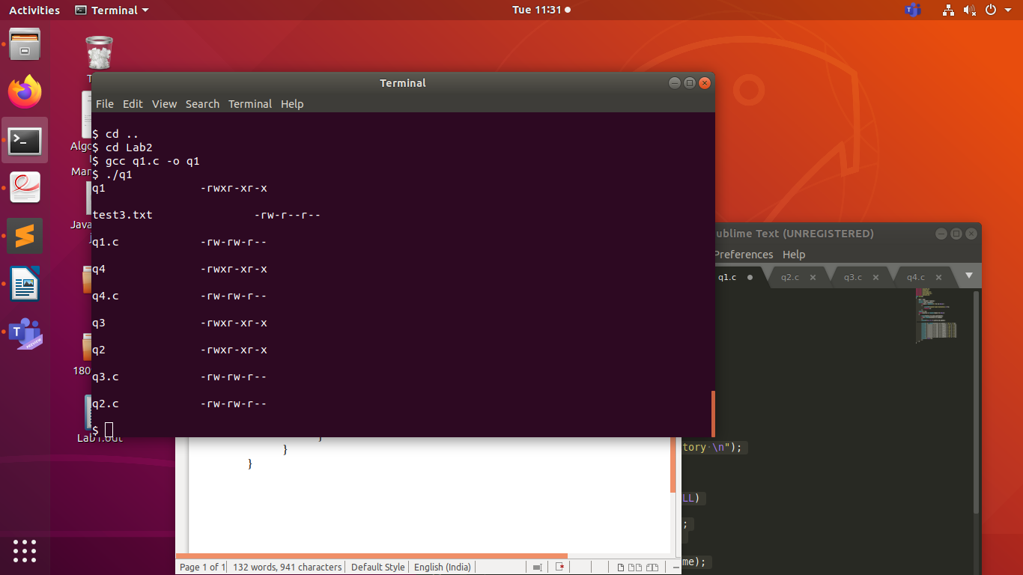

2.

#include <sys/stat.h>
#include <sys/types.h>
#include <stdlib.h>
#include <stdio.h>
#include <string.h>
#include <unistd.h>
#include <fcntl.h>
#include <string.h>
#include <dirent.h>

void printdir(char* path, int depth) {

struct dirent *entry;
DIR *dr;
dr =opendir(path);
if(dr == NULL) {

return;
}
while((entry = readdir(dr)) != NULL) {
struct stat fileStat;
lstat(entry->d_name, &fileStat);
char* str = entry->d_name;
if(S_ISDIR(fileStat.st_mode)) {
if(strcmp(str, ".") == 0 || strcmp(str, "..") == 0)
continue;
printf("%d %s\n",depth, str);
char path_recurse[1024];
memset(path_recurse, '\0', sizeof(path_recurse));
strcat(path_recurse, path);
strcat(path_recurse, "/");
strcat(path_recurse, str);
printdir(path_recurse, depth + 1);
}
else {
printf("%d %s\n",depth, str);
}

}

closedir(dr);
}

int main(int argc, char** argv)
{
struct dirent *entry; // Pointer for directory entry
DIR *dr;
struct stat fileStat;
if(argc == 1) {
printdir(".", 0);
}
else if(argc == 2) {
printdir(argv[1], 0);
}
else {
printf("Incorrect Number of Arguments\n" );
exit(1);
}

return 0;
}

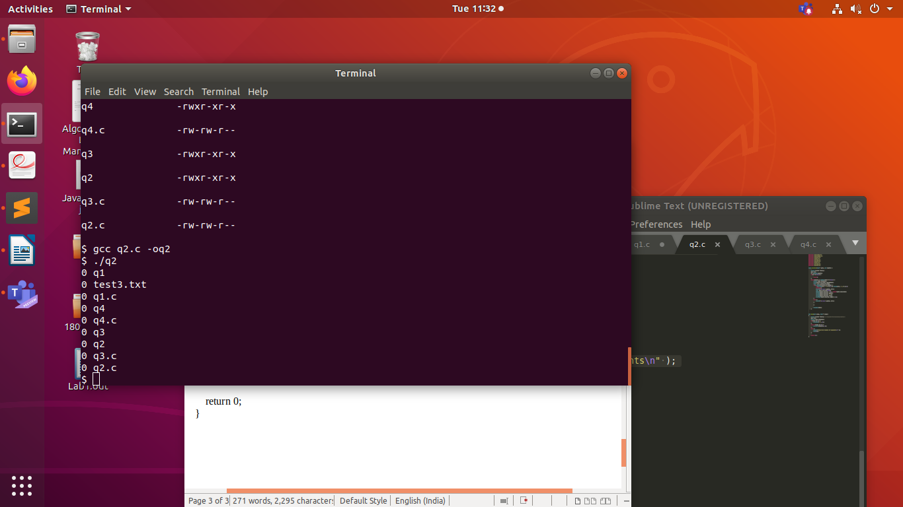

3.

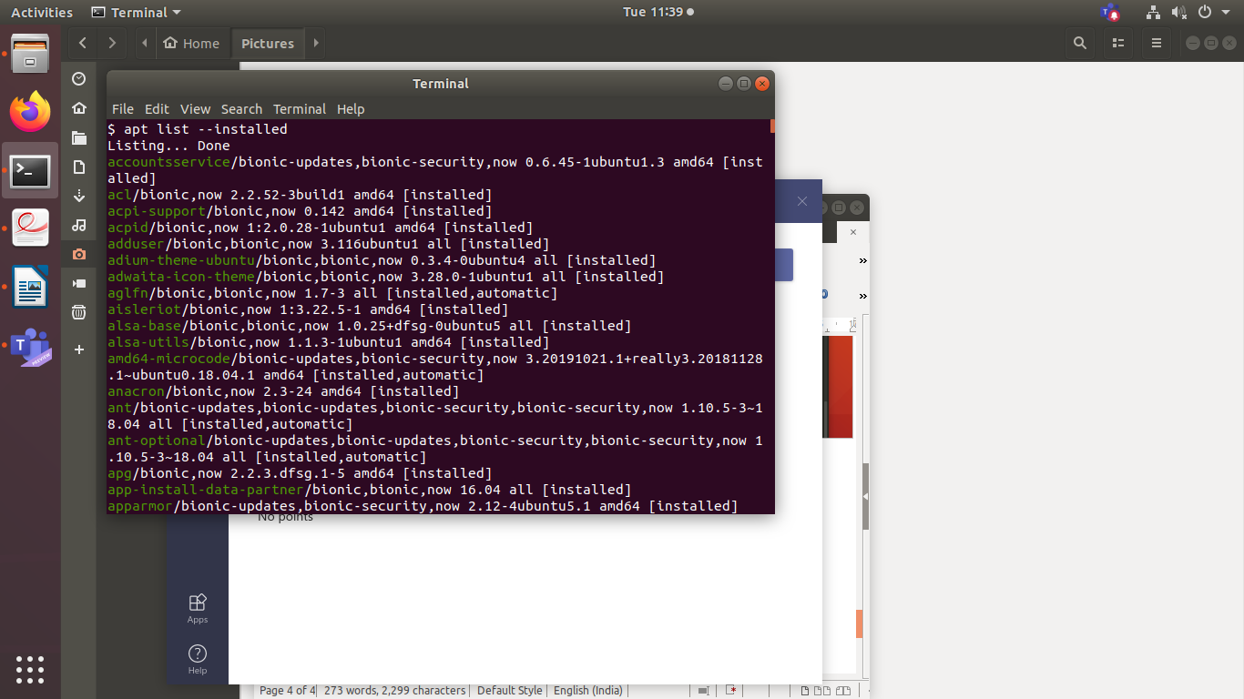

4.

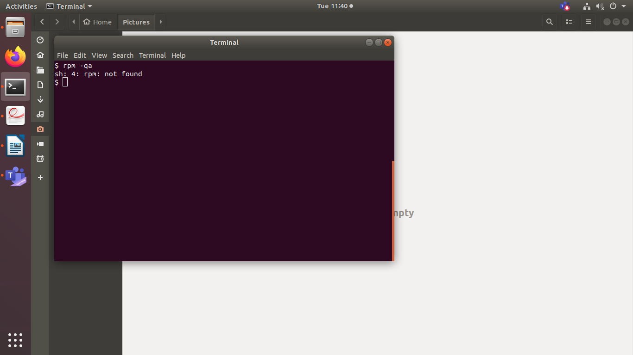
Not Installed

