Mid-Month Performance Report
Period: March 2 - March 14, 2026

1. Executive Summary & Week 2 Breakdown
Overall, the first half of March concluded with a Grand Total Sales figure of KES 27,863,866, representing 46.4% of the overarching KES 60,000,000 monthly target. Week 2 showcased strong momentum with total sales reaching KES 15,575,805, a growth of 26.8% compared to Week 1 (KES 12,288,061). Average combined profit margin tracks at 9.2%.
Week 1 Total Sales | KES 12,288,061 | Mid-Month Cumulative | KES 27,863,866
Week 2 Total Sales | KES 15,575,805 | Monthly Target | KES 60,000,000
Growth (W1 -> W2) | 26.8% | Pacing (% Achieved) | 46.4%

2. Week 1 vs Week 2 Comparisons
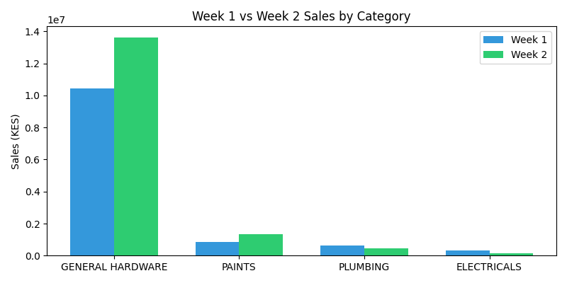
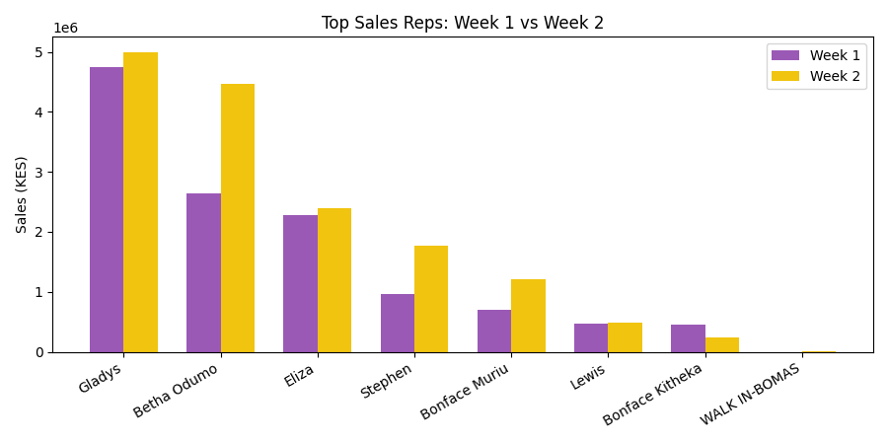

3. Target Pacing After Week 2
At the halfway mark, the branch has achieved 46.4% of the target. To hit the KES 60M goal, an additional KES 32,136,134 is required, translating to an average required run rate of approximately KES 2,472,010 per day for the remaining weeks.
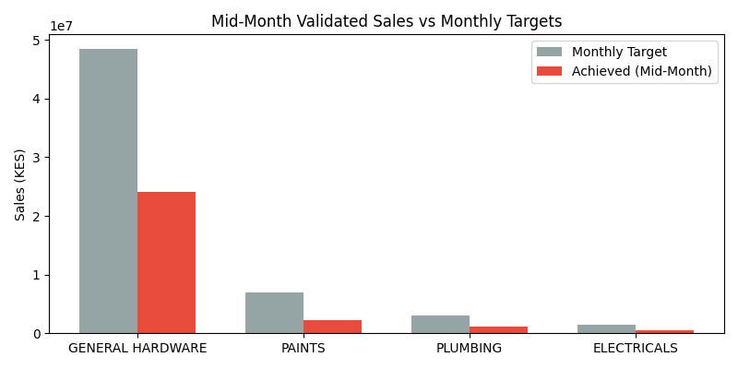
Category | W1 + W2 Achieved | Monthly Target | % Achieved
GENERAL HARDWARE | KES 24,078,098 | KES 48,500,000 | 49.6%
PAINTS | KES 2,209,155 | KES 7,000,000 | 31.6%
PLUMBING | KES 1,069,723 | KES 3,000,000 | 35.7%
ELECTRICALS | KES 506,890 | KES 1,500,000 | 33.8%

4. Informed Commentary & Recommendations

Commentary
- Momentum: Revenue saw a substantial upward spike in Week 2, jumping from 12.2M to 15.5M (+26%). This strong growth trajectory establishes an excellent foundation for the rest of the month.
- Category Performance: Most departments are pacing just under the 50% waterline, with General Hardware remaining the heavyweight contributor. However, divisions like Electricals and Plumbing may need stimulation to hit their respective strict KES 1.5M and 3M thresholds.
- Rep Dominance: The gap between the top tier (Gladys, Betha Odumo) and mid-tier reps continues to widen, showing high dependency on a few key individuals for large ticket hardware sales.

Recommendations to Achieve KES 60,000,000
- Boost the Run-Rate: The daily required run-rate rests at roughly KES 2.47 Million per day. Management should introduce daily targets to departmental heads to maintain the robust momentum seen in Week 2.
- Cross-Selling in Technical Departments: Focus reps on cross-selling Electrical and Plumbing stock alongside bulk General Hardware purchases, to pull up their pacing percentages.
- Activate Mid-Tier Reps: With top sales reps handling bulk orders, mid-tier members should be aggressively positioned to close fast-moving, high-margin items like Paints to diversify contribution risk.
- Promotional Push: A quick flash promotion or discount strategy for slow-moving Electrical items in Week 3 could yield the volume needed to push the category back on track.

