SALES PERFORMANCE ANALYSIS
BOMAS Hardware Store - March 2026, Week 2
Period: March 9-14, 2026 (6 working days)
Generated: March 15, 2026

EXECUTIVE SUMMARY
Total Sales (Incl. VAT) | KES 15,575,805
Total Profit (Incl. VAT) | KES 1,439,348
Overall Margin | 9.2%
Daily Average Sales | KES 2,595,968
Daily Average Profit | KES 239,891
Active Sales Reps | 8

MONTHLY TARGET PROGRESS
After Week 2, the branch has achieved 26.0% of the monthly target (KES 60M). This puts us AHEAD of the expected 25% pace.
Category | Monthly Target | Week 2 Actual | % Achieved | Pace
GENERAL HARDWARE | KES 48,500,000 | KES 13,630,490 | 28.1% | Ahead
PAINTS | KES 7,000,000 | KES 1,339,340 | 19.1% | Behind
PLUMBING | KES 3,000,000 | KES 442,175 | 14.7% | Behind
ELECTRICALS | KES 1,500,000 | KES 163,800 | 10.9% | Behind
OVERALL | KES 60,000,000 | KES 15,575,805 | 26.0% | Ahead

SALES REP PERFORMANCE
Rank | Sales Rep | Sales (KES) | Profit (KES) | Margin | Contribution
1 | Gladys | 4,999,990 | 292,766 | 5.9% | 32.1%
2 | Betha Odumo | 4,467,800 | 332,273 | 7.4% | 28.7%
3 | Eliza | 2,387,705 | 232,604 | 9.7% | 15.3%
4 | Stephen | 1,770,960 | 172,825 | 9.8% | 11.4%
5 | Bonface Muriu | 1,217,695 | 238,535 | 19.6% | 7.8%
6 | Lewis | 479,040 | 111,187 | 23.2% | 3.1%
7 | Bonface Kitheka | 234,705 | 56,580 | 24.1% | 1.5%
8 | WALK IN-BOMAS | 17,910 | 2,577 | 14.4% | 0.1%

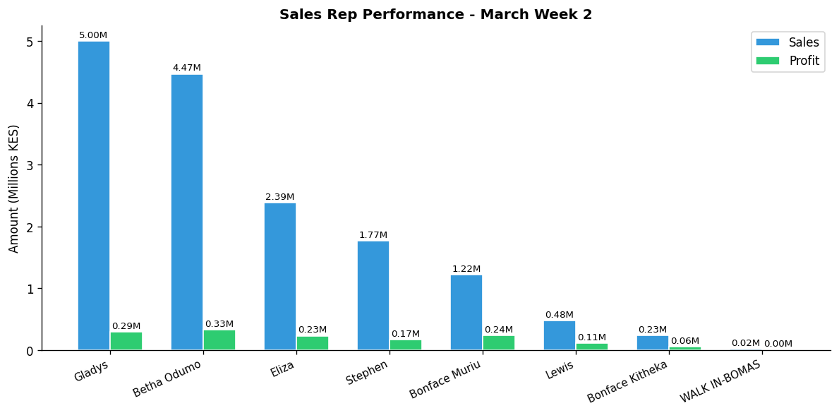

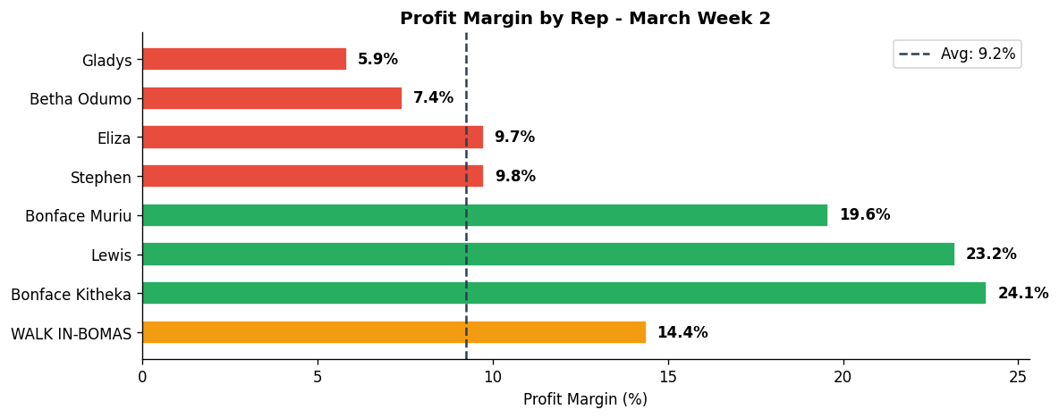

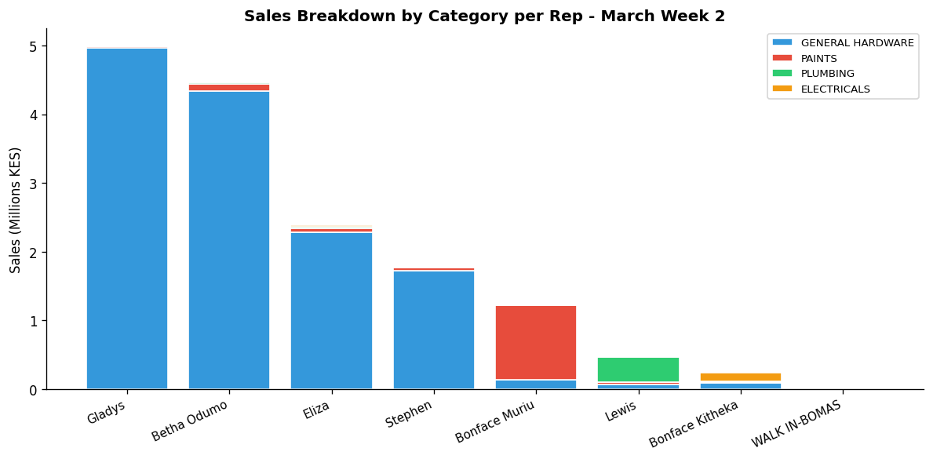

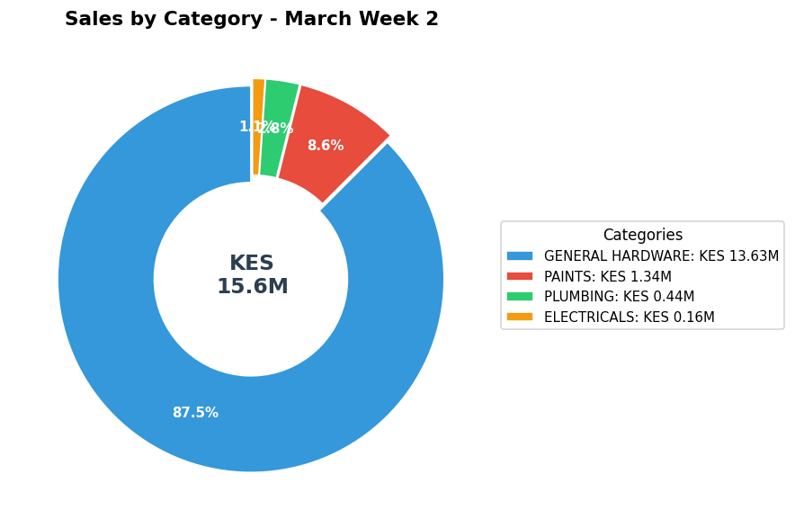

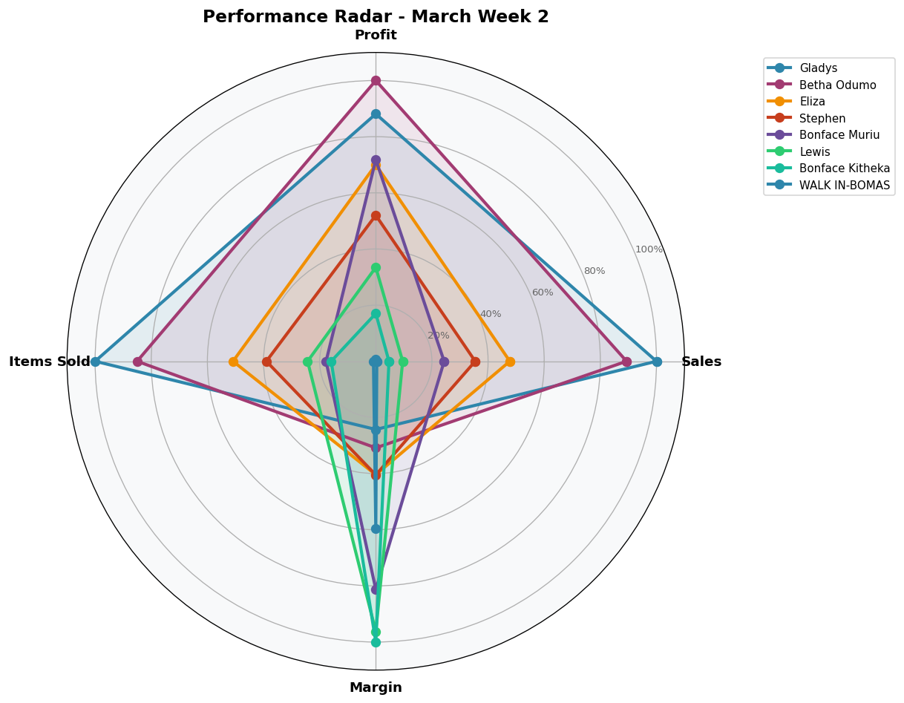

DEPARTMENT DETAILS
GENERAL HARDWARE
Department Head(s): Gladys, Betha Odumo, Eliza, Stephen
Sales: KES 13,630,490 | Profit: KES 1,039,817 | Margin: 7.6%
Rep | Sales | Profit | Margin | Share
Gladys | KES 4,971,720 | KES 286,101 | 5.8% | 36.5%
Betha Odumo | KES 4,340,790 | KES 306,511 | 7.1% | 31.8%
Eliza | KES 2,284,585 | KES 204,305 | 8.9% | 16.8%
Stephen | KES 1,721,950 | KES 162,445 | 9.4% | 12.6%
Bonface Muriu | KES 139,895 | KES 41,838 | 29.9% | 1.0%
Bonface Kitheka | KES 84,825 | KES 25,099 | 29.6% | 0.6%
Lewis | KES 72,915 | KES 11,921 | 16.3% | 0.5%
WALK IN-BOMAS | KES 13,810 | KES 1,597 | 11.6% | 0.1%

PAINTS
Department Head(s): Bonface Muriu
Sales: KES 1,339,340 | Profit: KES 249,797 | Margin: 18.7%
Rep | Sales | Profit | Margin | Share
Bonface Muriu | KES 1,075,980 | KES 196,328 | 18.2% | 80.3%
Betha Odumo | KES 99,250 | KES 17,269 | 17.4% | 7.4%
Eliza | KES 52,800 | KES 12,576 | 23.8% | 3.9%
Stephen | KES 48,610 | KES 10,188 | 21.0% | 3.6%
Lewis | KES 30,290 | KES 7,480 | 24.7% | 2.3%
Bonface Kitheka | KES 16,000 | KES 3,453 | 21.6% | 1.2%
Gladys | KES 13,910 | KES 2,082 | 15.0% | 1.0%
WALK IN-BOMAS | KES 2,500 | KES 421 | 16.9% | 0.2%

PLUMBING
Department Head(s): Lewis
Sales: KES 442,175 | Profit: KES 115,280 | Margin: 26.1%
Rep | Sales | Profit | Margin | Share
Lewis | KES 369,615 | KES 90,467 | 24.5% | 83.6%
Eliza | KES 29,320 | KES 12,255 | 41.8% | 6.6%
Betha Odumo | KES 21,540 | KES 6,582 | 30.6% | 4.9%
Bonface Kitheka | KES 11,240 | KES 3,024 | 26.9% | 2.5%
Gladys | KES 9,910 | KES 2,683 | 27.1% | 2.2%
Stephen | KES 300 | KES 180 | 60.0% | 0.1%
Bonface Muriu | KES 250 | KES 89 | 35.5% | 0.1%

ELECTRICALS
Department Head(s): Bonface Kitheka
Sales: KES 163,800 | Profit: KES 34,453 | Margin: 21.0%
Rep | Sales | Profit | Margin | Share
Bonface Kitheka | KES 122,640 | KES 25,005 | 20.4% | 74.9%
Eliza | KES 21,000 | KES 3,468 | 16.5% | 12.8%
Betha Odumo | KES 6,220 | KES 1,910 | 30.7% | 3.8%
Lewis | KES 6,220 | KES 1,318 | 21.2% | 3.8%
Gladys | KES 4,450 | KES 1,901 | 42.7% | 2.7%
WALK IN-BOMAS | KES 1,600 | KES 559 | 34.9% | 1.0%
Bonface Muriu | KES 1,570 | KES 280 | 17.8% | 1.0%
Stephen | KES 100 | KES 12 | 12.5% | 0.1%

INDIVIDUAL REP PERFORMANCE

GLADYS - General Hardware Team
TOP SELLER
Total Sales | Total Profit | Margin | Items Sold | Rank
KES 4,999,990 | KES 292,766 | 5.9% | 6,285 | #1

Category | Sales | Profit | Margin | Qty
GENERAL HARDWARE | KES 4,971,720 | KES 286,101 | 5.8% | 6,244
PAINTS | KES 13,910 | KES 2,082 | 15.0% | 14
PLUMBING | KES 9,910 | KES 2,683 | 27.1% | 8
ELECTRICALS | KES 4,450 | KES 1,901 | 42.7% | 19

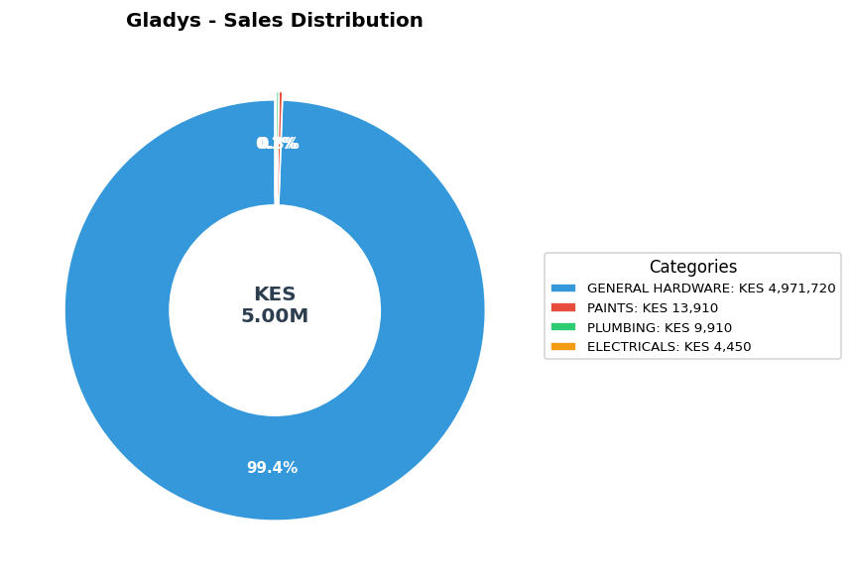

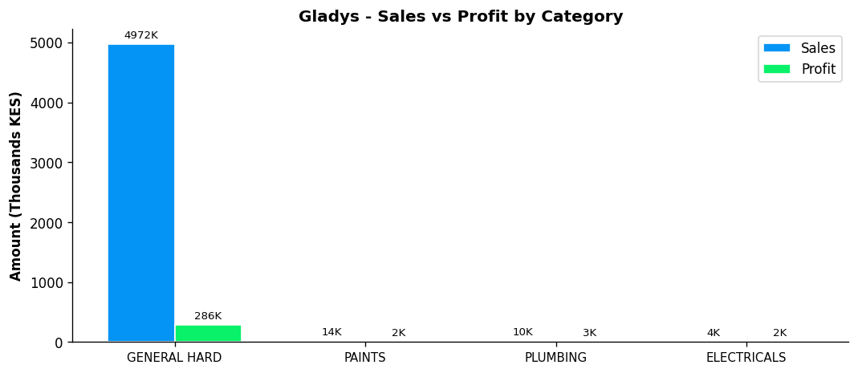
Performance Notes:
- Outstanding! Sales 157% above team average
- Margin at 5.9% below team average of 14.3%
- General Hardware: 36.5% of dept, 5.8% margin
- Selling across all 4 categories - excellent product range
- Best margin in ELECTRICALS: 42.7%

BETHA ODUMO - General Hardware Team
TOP PROFIT
Total Sales | Total Profit | Margin | Items Sold | Rank
KES 4,467,800 | KES 332,273 | 7.4% | 5,345 | #2

Category | Sales | Profit | Margin | Qty
GENERAL HARDWARE | KES 4,340,790 | KES 306,511 | 7.1% | 5,163
PAINTS | KES 99,250 | KES 17,269 | 17.4% | 116
PLUMBING | KES 21,540 | KES 6,582 | 30.6% | 44
ELECTRICALS | KES 6,220 | KES 1,910 | 30.7% | 22

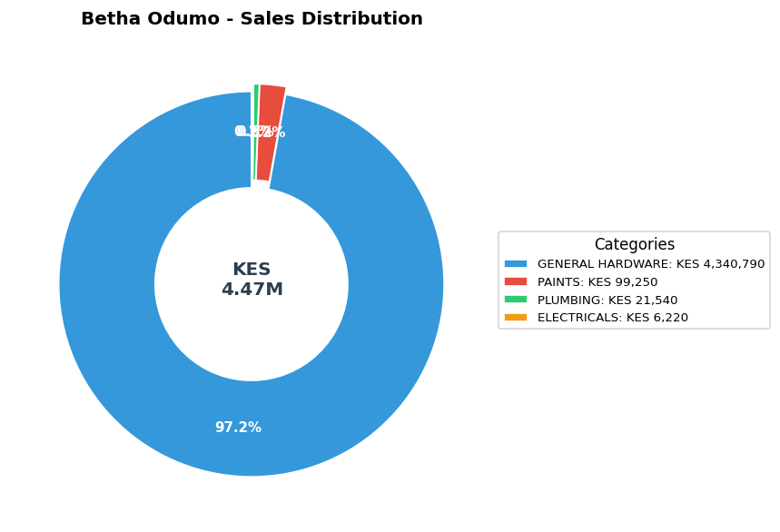

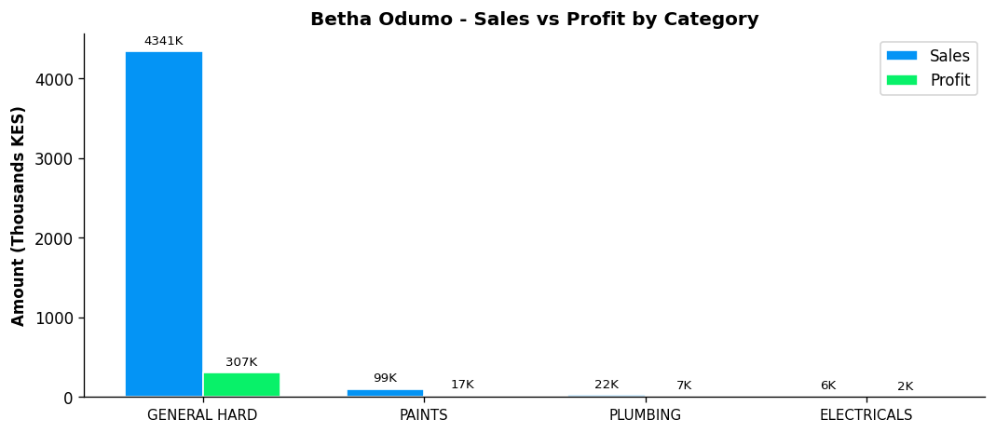
Performance Notes:
- Outstanding! Sales 129% above team average
- Margin at 7.4% below team average of 14.3%
- General Hardware: 31.8% of dept, 7.1% margin
- Selling across all 4 categories - excellent product range
- Best margin in ELECTRICALS: 30.7%

ELIZA - General Hardware Team
Total Sales | Total Profit | Margin | Items Sold | Rank
KES 2,387,705 | KES 232,604 | 9.7% | 3,198 | #3

Category | Sales | Profit | Margin | Qty
GENERAL HARDWARE | KES 2,284,585 | KES 204,305 | 8.9% | 2,980
PAINTS | KES 52,800 | KES 12,576 | 23.8% | 90
PLUMBING | KES 29,320 | KES 12,255 | 41.8% | 54
ELECTRICALS | KES 21,000 | KES 3,468 | 16.5% | 74

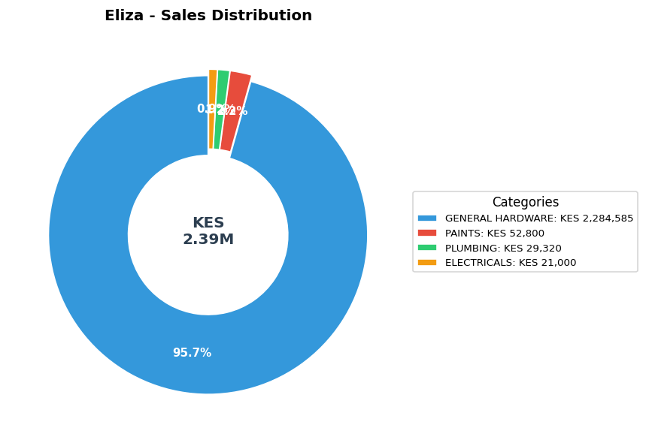

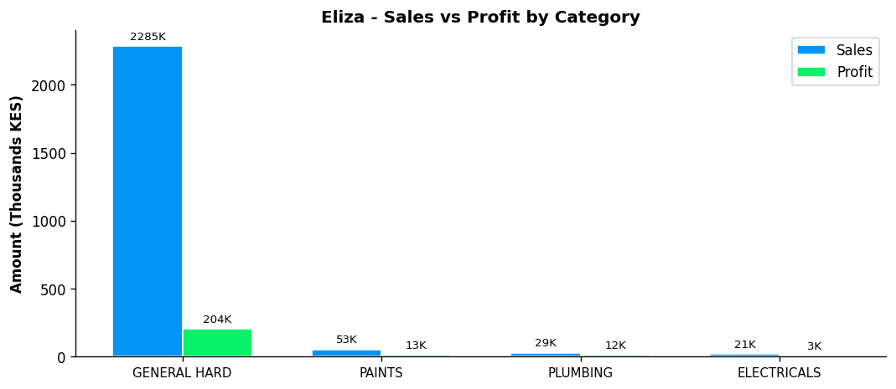
Performance Notes:
- Sales 23% above team average - solid performance
- Margin at 9.7% below team average of 14.3%
- General Hardware: 16.8% of dept, 8.9% margin
- Selling across all 4 categories - excellent product range
- Best margin in PLUMBING: 41.8%

STEPHEN - General Hardware Team
Total Sales | Total Profit | Margin | Items Sold | Rank
KES 1,770,960 | KES 172,825 | 9.8% | 2,450 | #4

Category | Sales | Profit | Margin | Qty
GENERAL HARDWARE | KES 1,721,950 | KES 162,445 | 9.4% | 2,386
PAINTS | KES 48,610 | KES 10,188 | 21.0% | 58
PLUMBING | KES 300 | KES 180 | 60.0% | 6
ELECTRICALS | KES 100 | KES 12 | 12.5% | 1

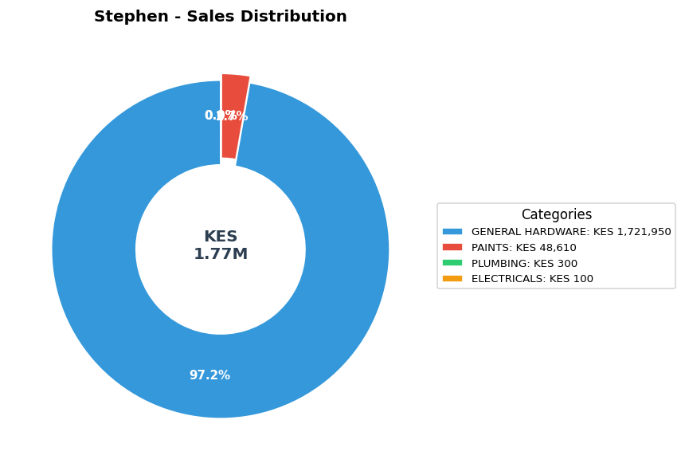

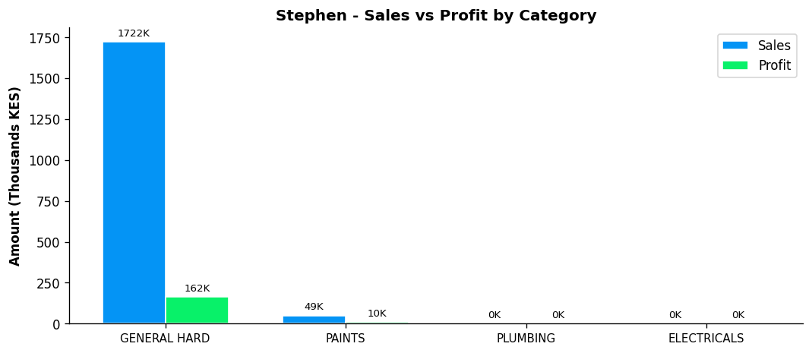
Performance Notes:
- Sales 9% below team average - needs improvement
- Margin at 9.8% below team average of 14.3%
- General Hardware: 12.6% of dept, 9.4% margin
- Selling across all 4 categories - excellent product range
- Best margin in PLUMBING: 60.0%

BONFACE MURIU - Department Head - Paints
Total Sales | Total Profit | Margin | Items Sold | Rank
KES 1,217,695 | KES 238,535 | 19.6% | 1,114 | #5

Category | Sales | Profit | Margin | Qty
GENERAL HARDWARE | KES 139,895 | KES 41,838 | 29.9% | 256
PAINTS | KES 1,075,980 | KES 196,328 | 18.2% | 851
PLUMBING | KES 250 | KES 89 | 35.5% | 1
ELECTRICALS | KES 1,570 | KES 280 | 17.8% | 6

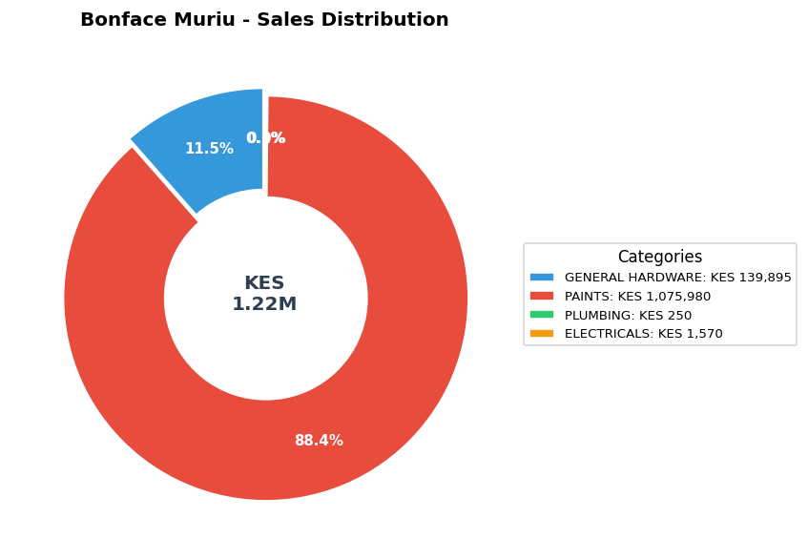

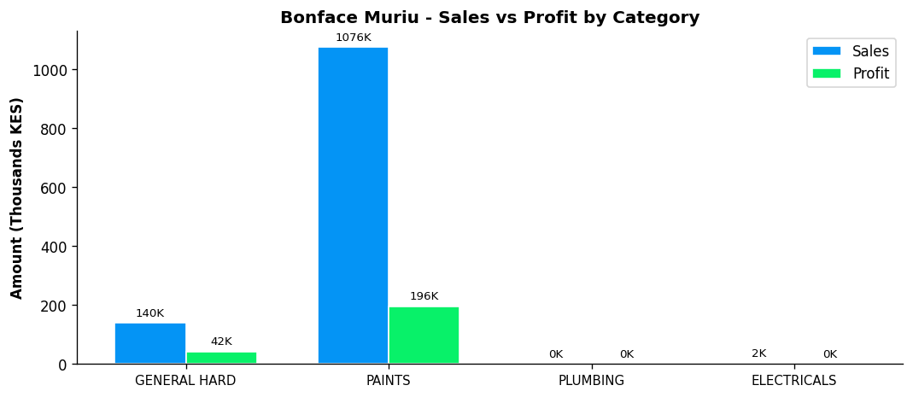
Performance Notes:
- Sales 37% below team average - needs improvement
- Excellent margin at 19.6% (Team avg: 14.3%)
- Paints Dept Head: 80.3% of dept sales, 18.2% margin
- Good paints leadership with 80.3% of dept sales
- Selling across all 4 categories - excellent product range

LEWIS - Department Head - Plumbing
Total Sales | Total Profit | Margin | Items Sold | Rank
KES 479,040 | KES 111,187 | 23.2% | 1,528 | #6

Category | Sales | Profit | Margin | Qty
GENERAL HARDWARE | KES 72,915 | KES 11,921 | 16.3% | 262
PAINTS | KES 30,290 | KES 7,480 | 24.7% | 45
PLUMBING | KES 369,615 | KES 90,467 | 24.5% | 1,201
ELECTRICALS | KES 6,220 | KES 1,318 | 21.2% | 20

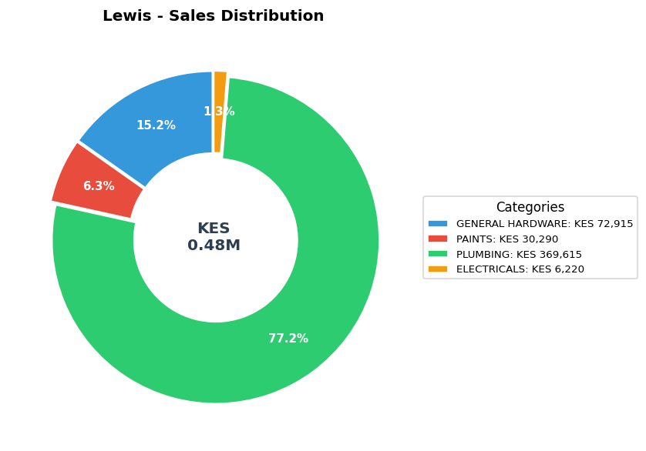

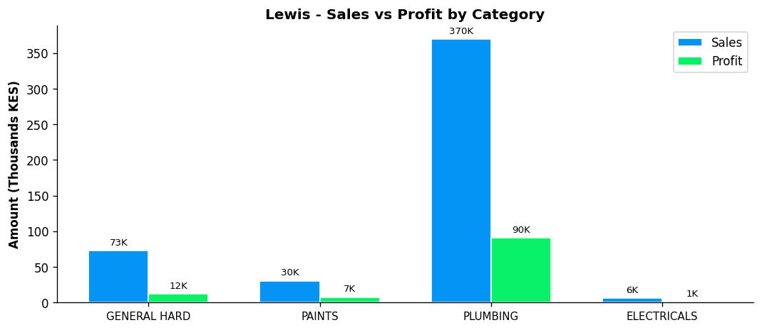
Performance Notes:
- Sales 75% below team average - needs improvement
- Excellent margin at 23.2% (Team avg: 14.3%)
- Plumbing Dept Head: 83.6% of dept sales, 24.5% margin
- Strong plumbing leadership with 83.6% of dept sales
- Selling across all 4 categories - excellent product range

BONFACE KITHEKA - Department Head - Electricals
BEST MARGIN
Total Sales | Total Profit | Margin | Items Sold | Rank
KES 234,705 | KES 56,580 | 24.1% | 999 | #7

Category | Sales | Profit | Margin | Qty
GENERAL HARDWARE | KES 84,825 | KES 25,099 | 29.6% | 3
PAINTS | KES 16,000 | KES 3,453 | 21.6% | 41
PLUMBING | KES 11,240 | KES 3,024 | 26.9% | 59
ELECTRICALS | KES 122,640 | KES 25,005 | 20.4% | 896

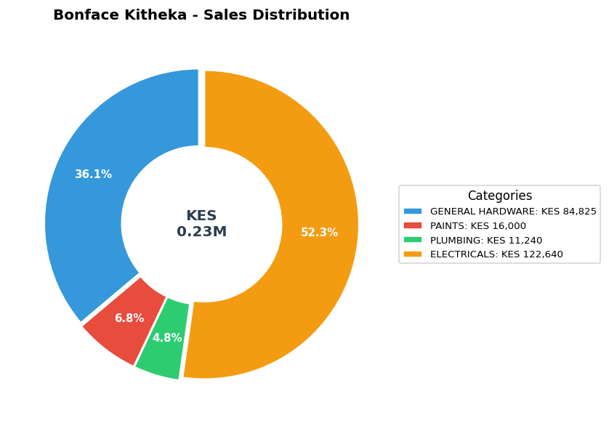

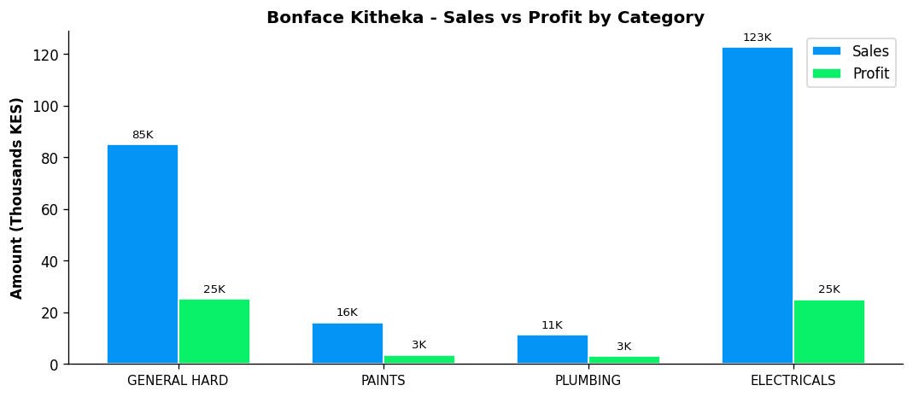
Performance Notes:
- Sales 88% below team average - needs improvement
- Excellent margin at 24.1% (Team avg: 14.3%)
- Electricals Dept Head: 74.9% of dept sales, 20.4% margin
- Strong leadership - controls 74.9% of department sales
- Selling across all 4 categories - excellent product range

WALK IN-BOMAS - General Hardware Team
Total Sales | Total Profit | Margin | Items Sold | Rank
KES 17,910 | KES 2,577 | 14.4% | 53 | #8

Category | Sales | Profit | Margin | Qty
GENERAL HARDWARE | KES 13,810 | KES 1,597 | 11.6% | 20
PAINTS | KES 2,500 | KES 421 | 16.9% | 1
ELECTRICALS | KES 1,600 | KES 559 | 34.9% | 32

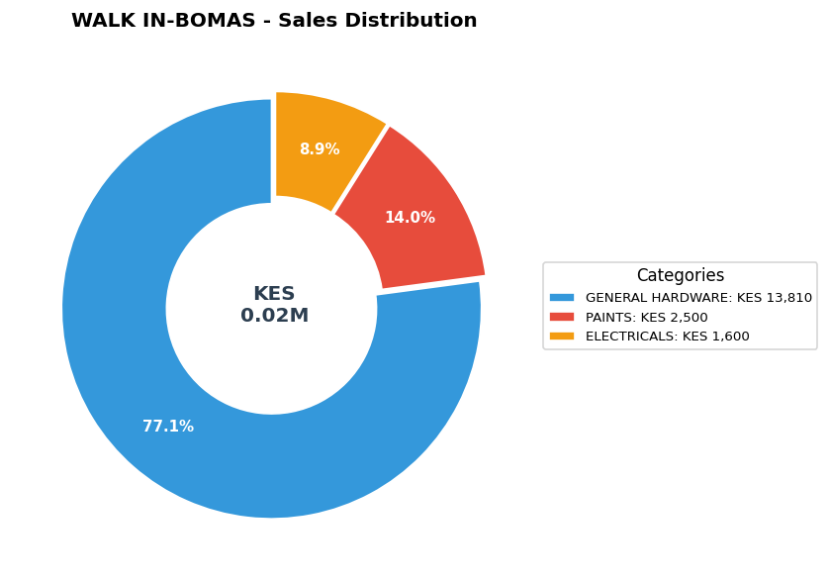

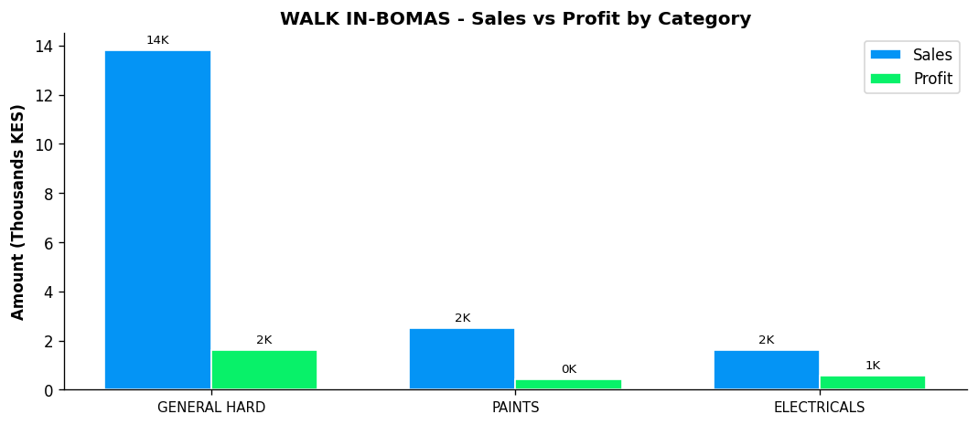
Performance Notes:
- Sales 99% below team average - needs improvement
- General Hardware: 0.1% of dept, 11.6% margin
- Consider expanding into PLUMBING
- Best margin in ELECTRICALS: 34.9%
- Low contribution at 0.1% of total branch sales - growth opportunity

