CHAPTER 4

FINDINGS OF THE STUDY

Solid Waste Management Practices Among Households
Dandora Ward

Survey Information
Total Respondents | 132
Location | Dandora Ward
Survey Type | Household Survey
Analysis Date | February 20, 2026

4.0 INTRODUCTION
This chapter presents the findings and analysis of the study on solid waste management practices among households in Dandora Ward. The data was collected through a structured questionnaire administered to 132 respondents from households within the study area. The findings are organized into five main sections: Social Demographic Factors, Knowledge and Awareness, Waste Management Practices, Challenges and Barriers, and Attitudes and Perceptions.
The collected data was analyzed using frequency distribution and percentages to establish patterns and trends. Results are presented through frequency tables, pie charts, and bar graphs, each accompanied by detailed interpretations to provide meaningful insights into the current state of solid waste management in the community.

4.1 SOCIAL DEMOGRAPHIC FACTORS
4.1.1 Gender of the Respondents

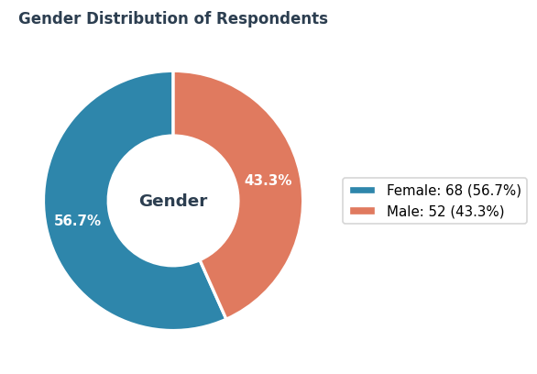
Figure 1: Gender of the Respondents

The findings indicate that the larger portion of respondents (56.7%, n=68) responded 'Female', while 43.3% (n=52) indicated 'Male'. Out of 120 total responses, this demonstrates a notable trend in the community.

4.1.2 Age of the Respondents

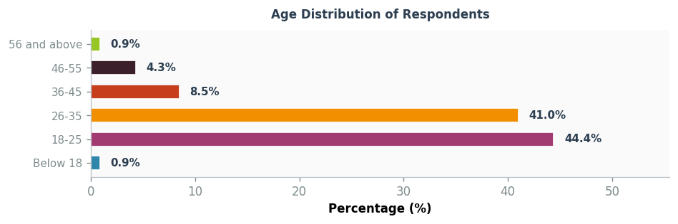
Figure 2: Age of the Respondents

The age distribution analysis reveals that the majority of respondents (0.9%, n=1) fall within the Below 18 age bracket. This is followed by the 18-25 group at 44.4%. The demographic composition suggests a relatively mature population participating in the survey, which may influence their waste management practices and awareness levels.

4.1.3 Educational Level of the Respondents

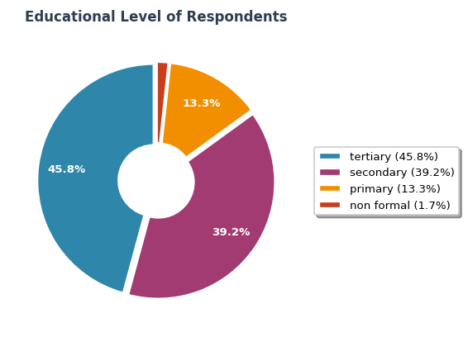
Figure 3: Educational Level of the Respondents

Analysis of the 120 responses reveals that 'tertiary' was the most prevalent response at 45.8% (n=55), followed by 'secondary' (39.2%) and 'primary' (13.3%). These findings provide valuable insights into the patterns within the surveyed population.

4.1.4 Occupation of the Respondents

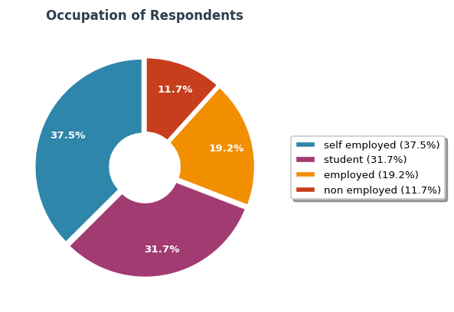
Figure 4: Occupation of the Respondents

Analysis of the 120 responses reveals that 'self employed' was the most prevalent response at 37.5% (n=45), followed by 'student' (31.7%) and 'employed' (19.2%). These findings provide valuable insights into the patterns within the surveyed population.

4.2 KNOWLEDGE AND AWARENESS
4.2.1 Understanding of the Term "Solid Waste"

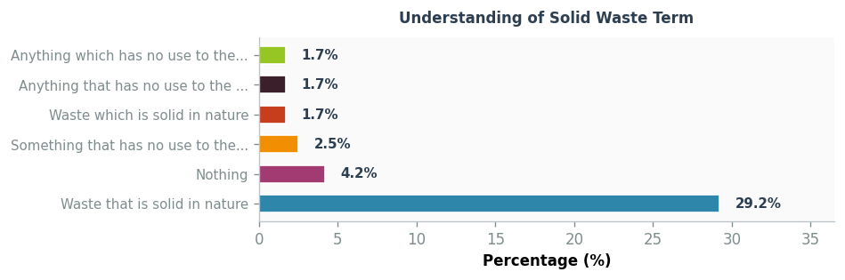
Figure 5: Understanding of the Term "Solid Waste"

The data analysis shows considerable diversity in responses. The leading response was 'Waste that is solid in nature' representing 29.2% of respondents (n=35). This was followed by 'Nothing' at 4.2%. The variety of responses across 120 participants indicates diverse perspectives on this matter within the community.

4.2.2 Knowledge of Importance of Proper Waste Management

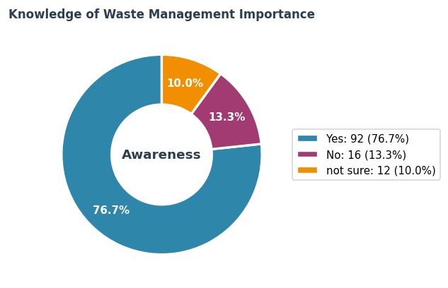
Figure 6: Knowledge of Importance of Proper Waste Management

The survey findings reveal that 76.7% of respondents (n=92) indicated 'Yes' regarding their knowledge of the importance of proper solid waste management. This demonstrates a high level of awareness about waste management significance within the Dandora Ward community, suggesting that awareness campaigns have been effective.

4.2.3 Types of Solid Waste Respondents are Familiar With

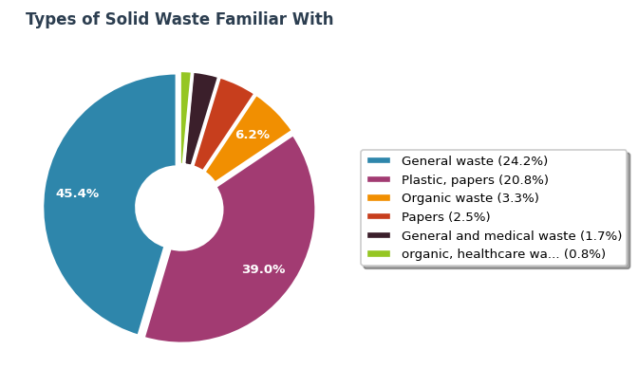
Figure 7: Types of Solid Waste Respondents are Familiar With

The data analysis shows considerable diversity in responses. The leading response was 'General waste' representing 24.2% of respondents (n=29). This was followed by 'Plastic, papers' at 20.8%. The variety of responses across 120 participants indicates diverse perspectives on this matter within the community.

4.2.4 Sources of Information on Waste Management

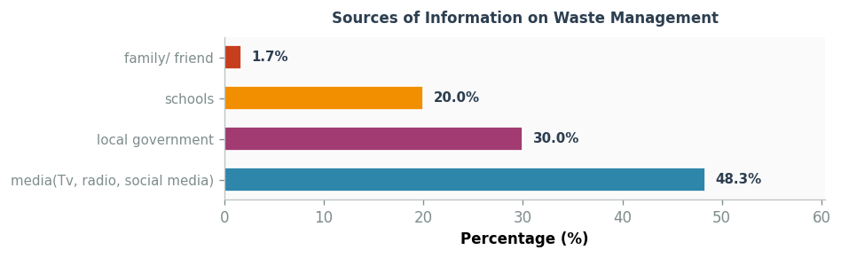
Figure 8: Sources of Information on Waste Management

Analysis of the 120 responses reveals that 'media(Tv, radio, social media)' was the most prevalent response at 48.3% (n=58), followed by 'local government' (30.0%) and 'schools' (20.0%). These findings provide valuable insights into the patterns within the surveyed population.

4.3 WASTE MANAGEMENT PRACTICES
4.3.1 Frequency of Waste Generation in Households

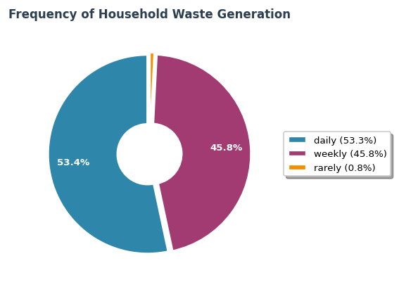
Figure 9: Frequency of Waste Generation in Households

Analysis of the 120 responses reveals that 'daily' was the most prevalent response at 53.3% (n=64), followed by 'weekly' (45.8%) and 'rarely' (0.8%). These findings provide valuable insights into the patterns within the surveyed population.

4.3.2 Waste Separation Practices

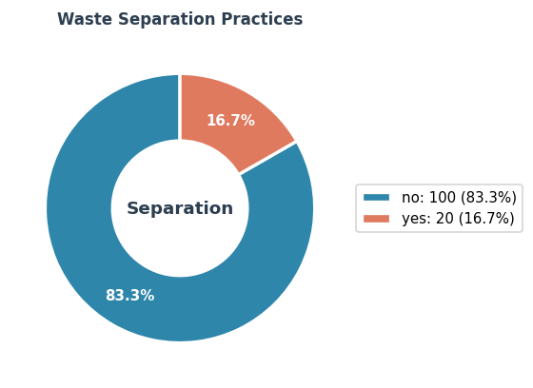
Figure 10: Waste Separation Practices

When examining waste separation practices, the data shows that 83.3% of respondents (n=100) indicated 'no'. This finding suggests that there is considerable room for improvement in waste separation at the household level in Dandora Ward, which has implications for recycling and waste processing efficiency.

4.3.3 Proper Waste Disposal Practices

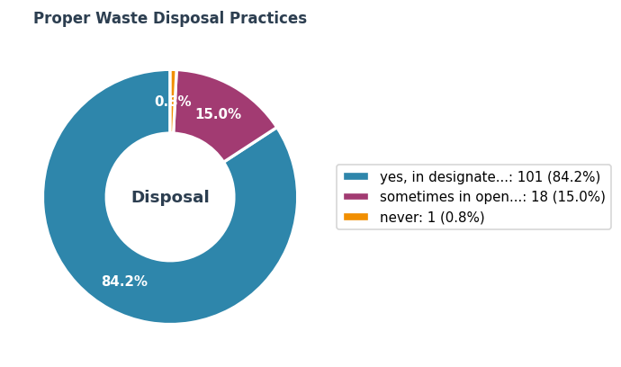
Figure 11: Proper Waste Disposal Practices

Analysis of the 120 responses reveals that 'yes, in designated bins' was the most prevalent response at 84.2% (n=101), followed by 'sometimes in open areas' (15.0%) and 'never' (0.8%). These findings provide valuable insights into the patterns within the surveyed population.

4.3.4 Recycling Practices

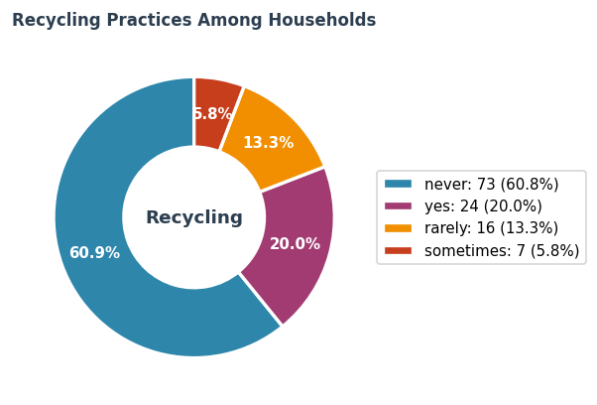
Figure 12: Recycling Practices

Regarding recycling practices among households, 60.8% of respondents (n=73) answered 'never'. These results highlight the potential for increased recycling adoption through targeted community education and improved access to recycling facilities.

4.4 CHALLENGES AND BARRIERS
4.4.1 Barriers Faced in Managing Solid Waste

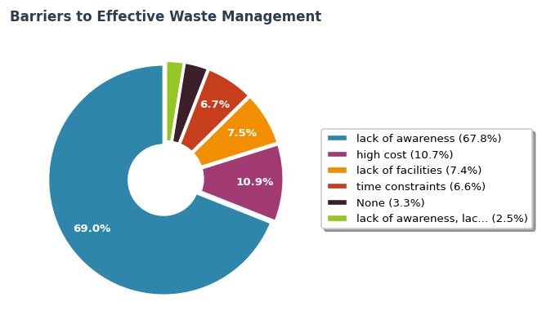
Figure 13: Barriers Faced in Managing Solid Waste

The data analysis shows considerable diversity in responses. The leading response was 'lack of awareness' representing 67.8% of respondents (n=82). This was followed by 'high cost' at 10.7%. The variety of responses across 121 participants indicates diverse perspectives on this matter within the community.

4.4.2 Factors Influencing Waste Management Practices

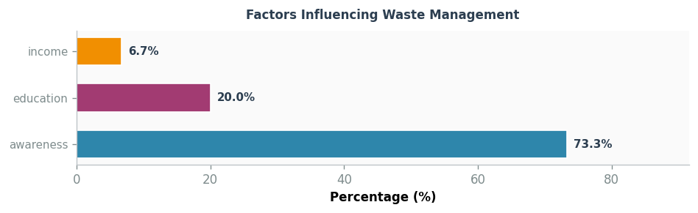
Figure 14: Factors Influencing Waste Management Practices

Analysis of the 120 responses reveals that 'awareness' was the most prevalent response at 73.3% (n=88), followed by 'education' (20.0%) and 'income' (6.7%). These findings provide valuable insights into the patterns within the surveyed population.

4.4.3 Barriers Preventing Greater Awareness

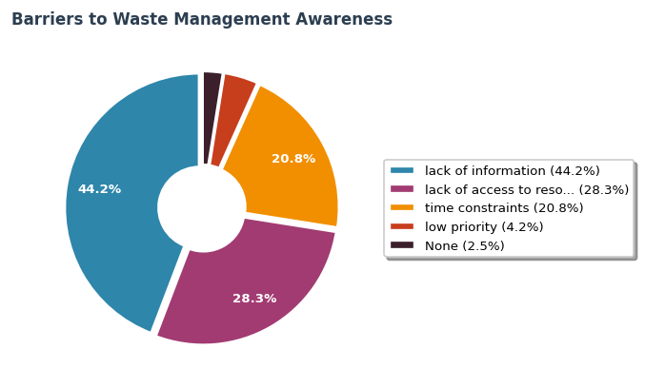
Figure 15: Barriers Preventing Greater Awareness

Analysis of the 120 responses reveals that 'lack of information' was the most prevalent response at 44.2% (n=53), followed by 'lack of access to resources' (28.3%) and 'time constraints' (20.8%). These findings provide valuable insights into the patterns within the surveyed population.

4.5 ATTITUDES AND PERCEPTIONS
4.5.1 General Attitude Toward Solid Waste Management

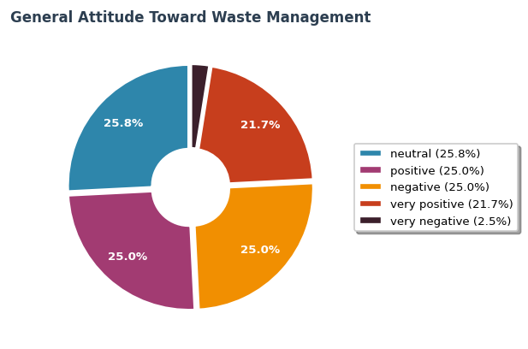
Figure 16: General Attitude Toward Solid Waste Management

Analysis of the 120 responses reveals that 'neutral' was the most prevalent response at 25.8% (n=31), followed by 'positive' (25.0%) and 'negative' (25.0%). These findings provide valuable insights into the patterns within the surveyed population.

4.5.2 Perception of Individual Responsibility

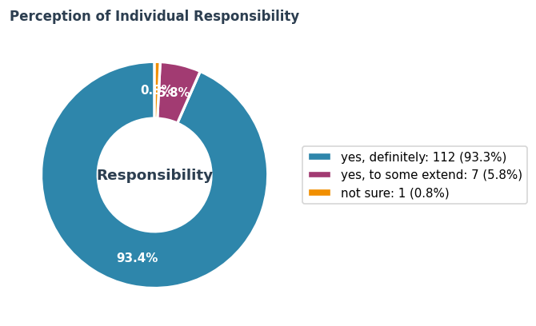
Figure 17: Perception of Individual Responsibility

A significant 93.3% of respondents (n=112) believe that individuals have a responsibility to manage waste. This indicates a strong sense of personal accountability toward waste management in the community, which is encouraging for community-based waste management initiatives.

4.5.3 Awareness of Environmental and Health Impact

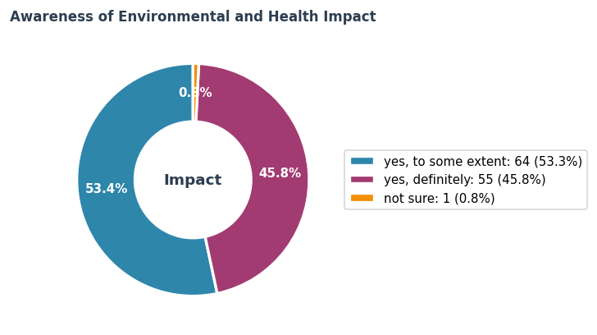
Figure 18: Awareness of Environmental and Health Impact

When asked about the impact of improper waste disposal on environment and public health, 53.3% of respondents (n=64) indicated 'yes, to some extent'. This demonstrates a moderate level of awareness regarding the environmental and public health consequences of improper waste management, suggesting that the community would benefit from more education on environmental health.

4.5.4 Perceived Main Problems with Solid Waste Management

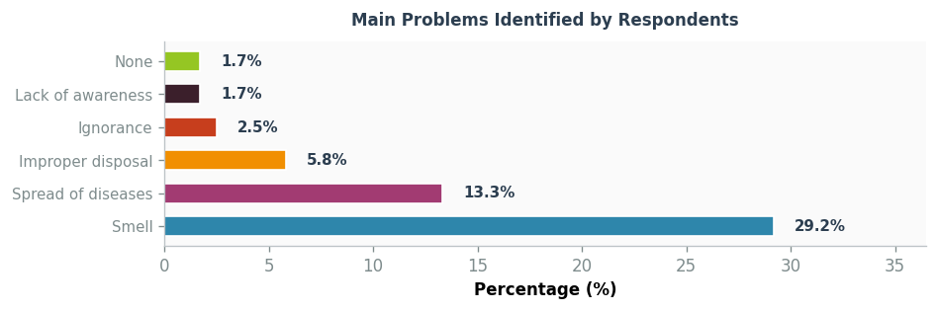
Figure 19: Perceived Main Problems with Solid Waste Management

The data analysis shows considerable diversity in responses. The leading response was 'Smell' representing 29.2% of respondents (n=35). This was followed by 'Spread of diseases' at 13.3%. The variety of responses across 120 participants indicates diverse perspectives on this matter within the community.

