SALES REP PERFORMANCE ANALYSIS
BOMAS Hardware Store - February 2026
February 1-21, 2026 (18 Working Days)
Generated: 2026-02-24 22:58:13

EXECUTIVE SUMMARY
Metric | Week 1 (Feb 1-7) | Week 2 (Feb 9-14) | Week 3 (Feb 16-21) | Combined
Total Sales | KES 14,267,092 | KES 20,065,260 | KES 15,337,385 | KES 49,669,737
Total Profit | KES 1,352,772 | KES 1,637,918 | KES 1,355,254 | KES 4,345,944
Daily Average | KES 2,377,849 | KES 3,344,210 | KES 2,556,231 | KES 2,759,430
Overall Margin | 9.5% | 8.2% | 8.8% | 8.7%

Weekly Progress
▲ W1→W2: Daily sales increased by 40.6%
▼ W2→W3: Daily sales decreased by 23.6%
📈 Overall 3-week trend: Daily sales UP 7.5% from Week 1 to Week 3

Key Insights
- ◆ Top Seller: Gladys with KES 19.34M (38.9% of total)
- ◆ Highest Margin: Lewis at 14.3%
- ◆ W1→W2 daily change: +40.6% | W2→W3 daily change: -23.6%
- ◆ Overall 3-week daily trend: +7.5%
- ◆ Total profit: KES 4.35M at 8.7% margin

VISUAL ANALYSIS

Week-over-Week Comparison
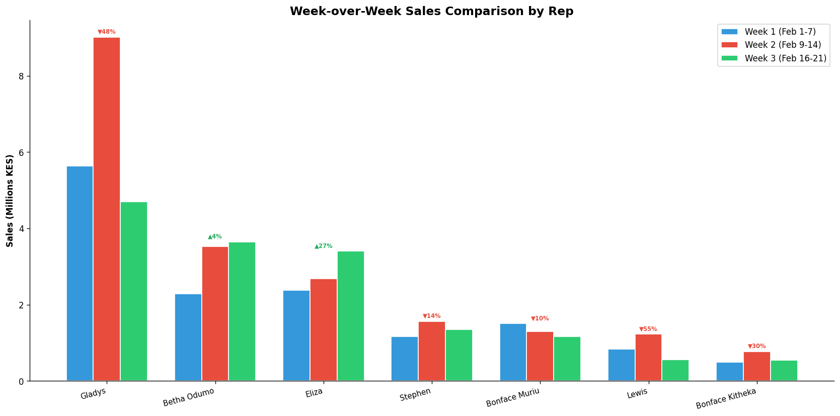

Category Breakdown by Rep
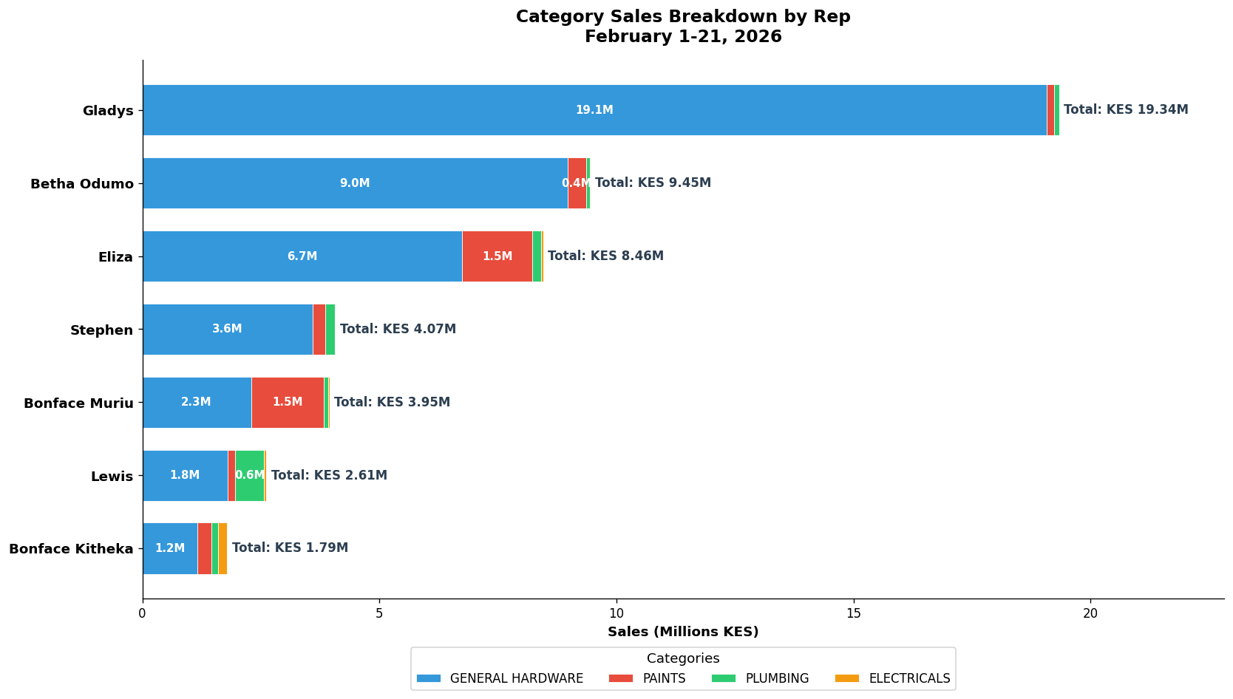

Rep Contribution Analysis
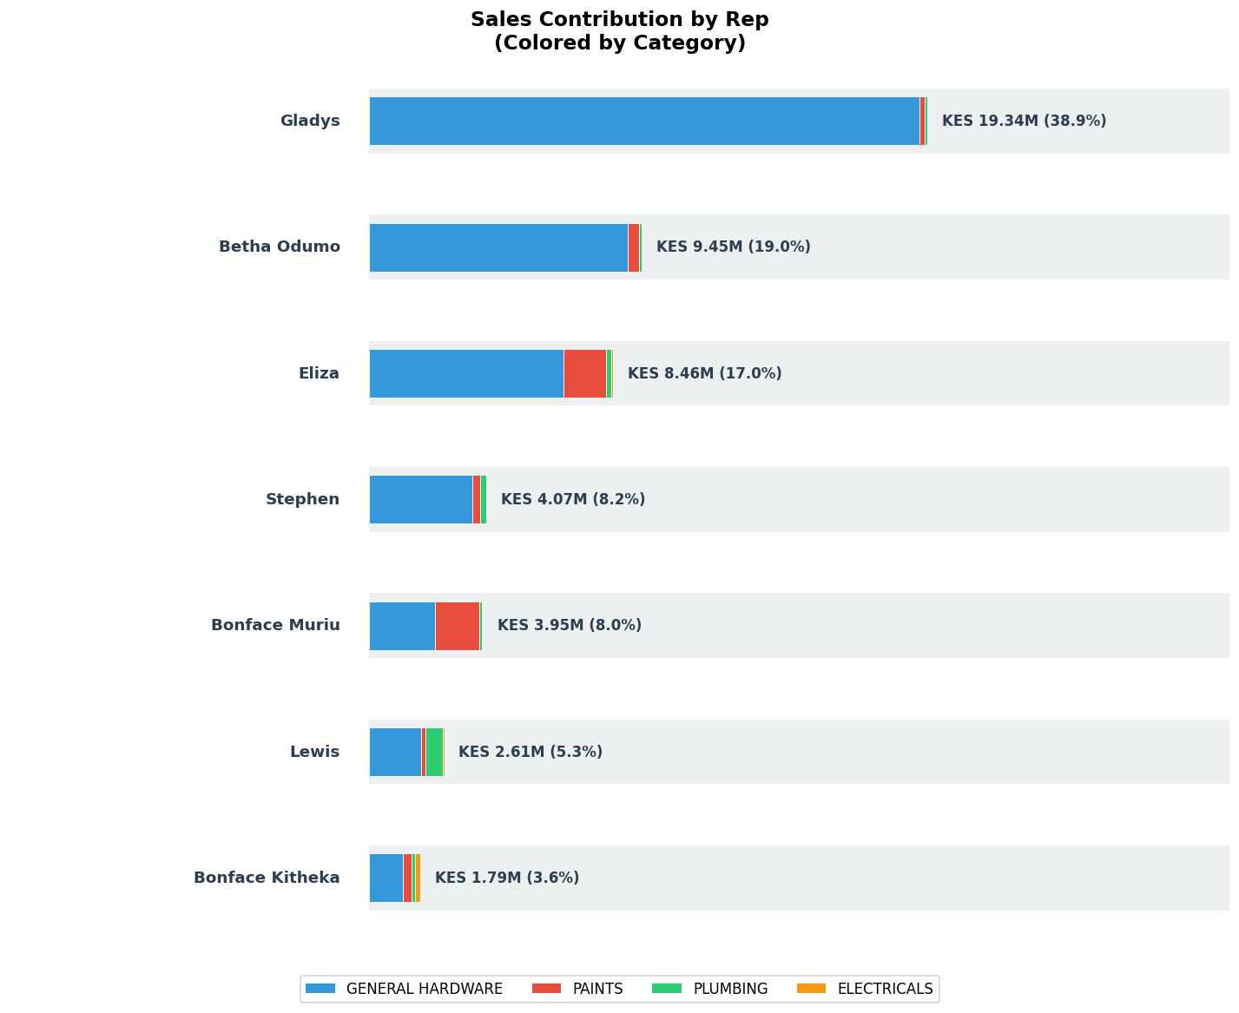

Performance Radar
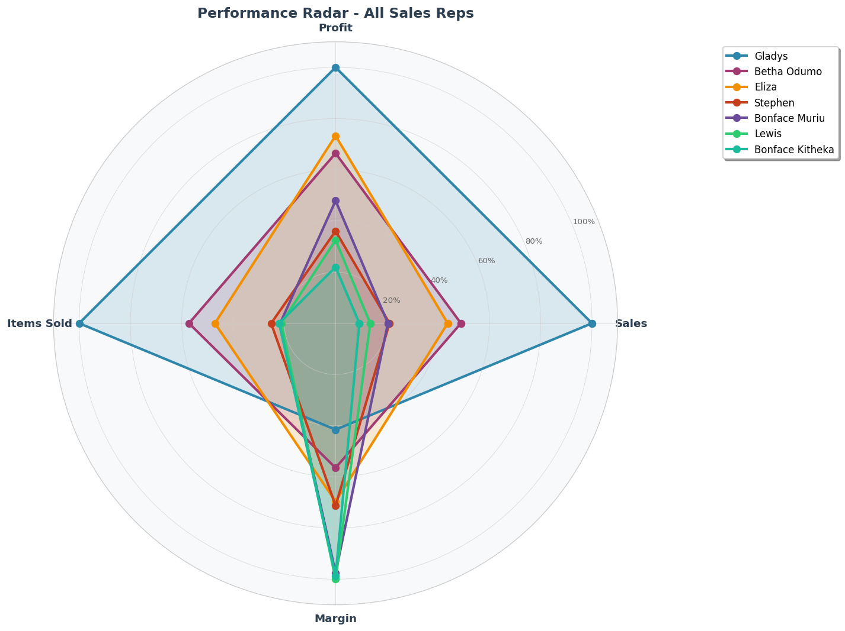

Profit Margin Heatmap
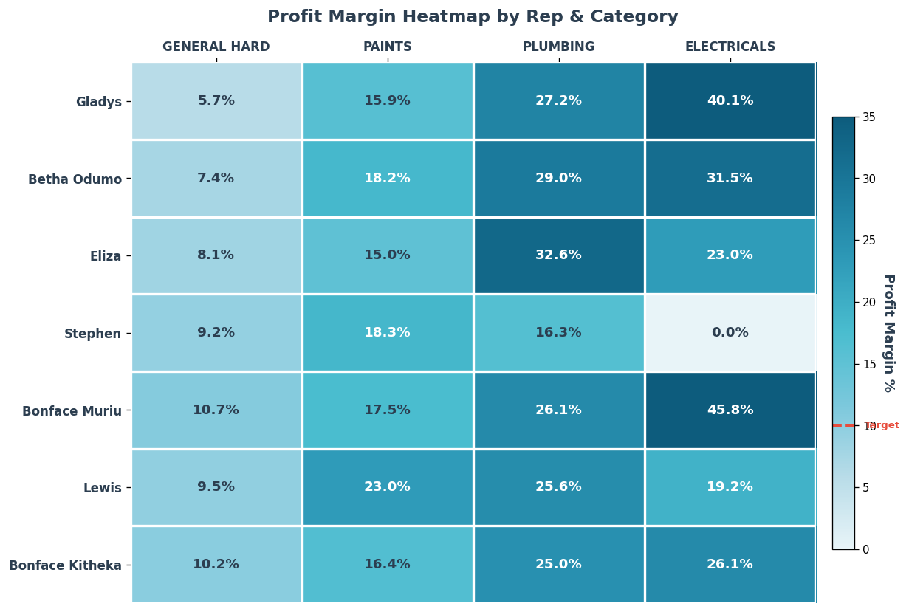

Profit Waterfall
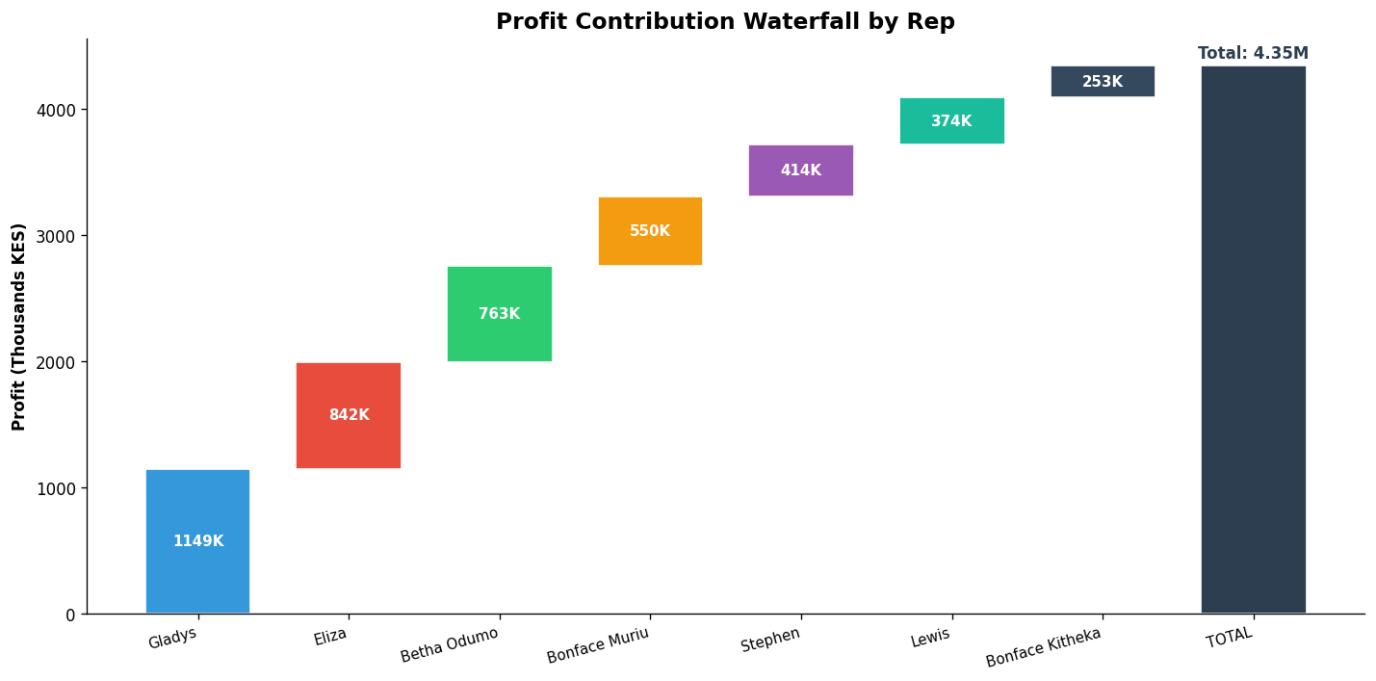

SALES REP RANKINGS
Rank | Rep Name | Role | Total Sales | Total Profit | Margin % | Items Sold
#1 | Gladys | General Hardware Team | KES 19,339,020 | KES 1,149,099 | 5.9% | 22,606
#2 | Betha Odumo | General Hardware Team | KES 9,453,025 | KES 763,498 | 8.1% | 12,927
#3 | Eliza | General Hardware Team | KES 8,456,260 | KES 842,095 | 10.0% | 10,636
#4 | Stephen | General Hardware Team | KES 4,067,316 | KES 414,349 | 10.2% | 5,683
#5 | Bonface Muriu | Department Head - Paints | KES 3,948,909 | KES 550,482 | 13.9% | 4,888
#6 | Lewis | Department Head - Plumbing | KES 2,614,482 | KES 373,746 | 14.3% | 4,791
#7 | Bonface Kitheka | Department Head - Electricals | KES 1,790,725 | KES 252,676 | 14.1% | 4,982

WEEK-OVER-WEEK COMPARISON BY REP
Rep | W1 Sales | W2 Sales | W3 Sales | W1→W2 % | W2→W3 % | Overall %
Gladys | KES 5,631,385 | KES 9,016,020 | KES 4,691,615 | +60.1% | -48.0% | -16.7%
Betha Odumo | KES 2,284,170 | KES 3,520,025 | KES 3,648,830 | +54.1% | +3.7% | +59.7%
Eliza | KES 2,370,660 | KES 2,682,395 | KES 3,403,205 | +13.1% | +26.9% | +43.6%
Stephen | KES 1,156,911 | KES 1,561,475 | KES 1,348,930 | +35.0% | -13.6% | +16.6%
Bonface Muriu | KES 1,499,769 | KES 1,291,500 | KES 1,157,640 | -13.9% | -10.4% | -22.8%
Lewis | KES 837,537 | KES 1,225,705 | KES 551,240 | +46.3% | -55.0% | -34.2%
Bonface Kitheka | KES 486,660 | KES 768,140 | KES 535,925 | +57.8% | -30.2% | +10.1%

CATEGORY BREAKDOWN
Category | Total Sales | Total Profit | Margin %
GENERAL HARDWARE | KES 43,635,024 | KES 3,178,255 | 7.3%
PAINTS | KES 4,288,916 | KES 721,012 | 16.8%
PLUMBING | KES 1,421,661 | KES 360,303 | 25.3%
ELECTRICALS | KES 324,136 | KES 86,374 | 26.6%

DEPARTMENT LEADERSHIP
Department | Head | Dept Sales | Dept Margin | Dept Share
PLUMBING | Lewis | KES 619,610 | 25.6% | 43.6%
PAINTS | Bonface Muriu | KES 1,535,360 | 17.5% | 35.8%
ELECTRICALS | Bonface Kitheka | KES 186,761 | 26.1% | 57.6%

REP-BY-REP PERFORMANCE COMMENTARY

GLADYS — General Hardware Team
🏆 TOP SELLER 💰 TOP PROFIT
Total Sales | Total Profit | Margin | Items Sold | Rank
KES 19,339,020 | KES 1,149,099 | 5.9% | 22,606 | #1

Category | Sales | Profit | Margin | Qty
GENERAL HARDWARE | KES 19,080,190 | KES 1,096,127 | 5.7% | 22,251
PAINTS | KES 155,440 | KES 24,733 | 15.9% | 114
PLUMBING | KES 102,600 | KES 27,921 | 27.2% | 234
ELECTRICALS | KES 790 | KES 317 | 40.1% | 7

PERFORMANCE NOTES
- Outstanding! Sales 173% above team average
- Margin at 5.9% below team average of 8.7%
- W1→W2: Strong growth +60.1% (KES 5,631K → 9,016K)
- W2→W3: Declined -48.0% (KES 9,016K → 4,692K)
- ⚠️ Week 3 reversal after Week 2 growth - monitor closely
- General Hardware: 43.7% of dept, 5.7% margin
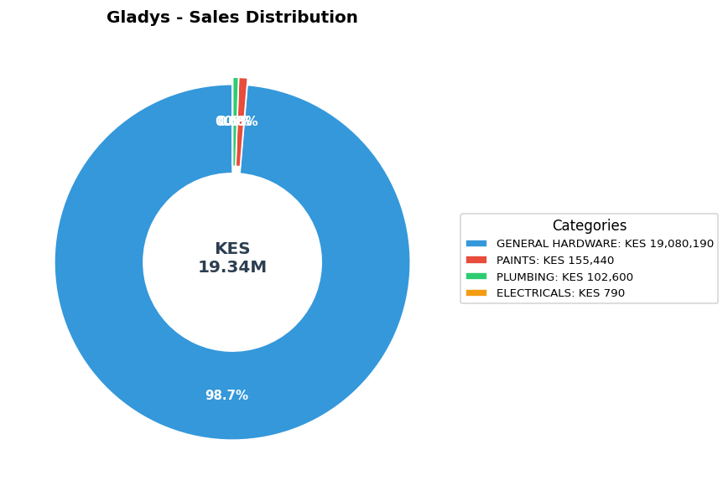
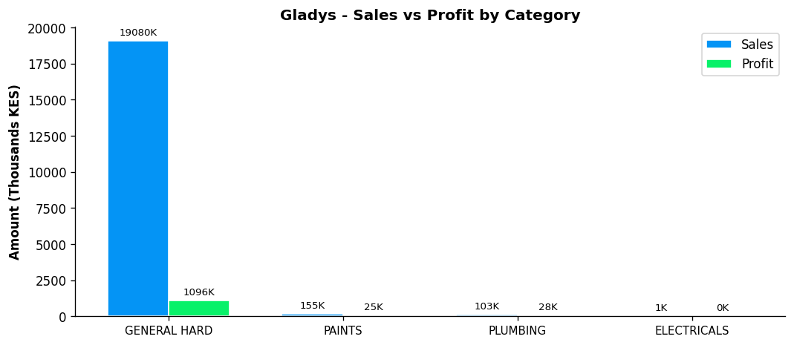

BETHA ODUMO — General Hardware Team
Total Sales | Total Profit | Margin | Items Sold | Rank
KES 9,453,025 | KES 763,498 | 8.1% | 12,927 | #2

Category | Sales | Profit | Margin | Qty
GENERAL HARDWARE | KES 8,967,025 | KES 664,794 | 7.4% | 12,044
PAINTS | KES 395,960 | KES 72,158 | 18.2% | 452
PLUMBING | KES 73,580 | KES 21,366 | 29.0% | 279
ELECTRICALS | KES 16,460 | KES 5,180 | 31.5% | 152

PERFORMANCE NOTES
- Sales 33% above team average - solid performance
- W1→W2: Strong growth +54.1% (KES 2,284K → 3,520K)
- W2→W3: Steady +3.7% (KES 3,520K → 3,649K)
- 📈 Consistent upward trend over 3 weeks (+59.7% overall)
- General Hardware: 20.6% of dept, 7.4% margin
- ✓ Selling across all 4 categories - excellent product range
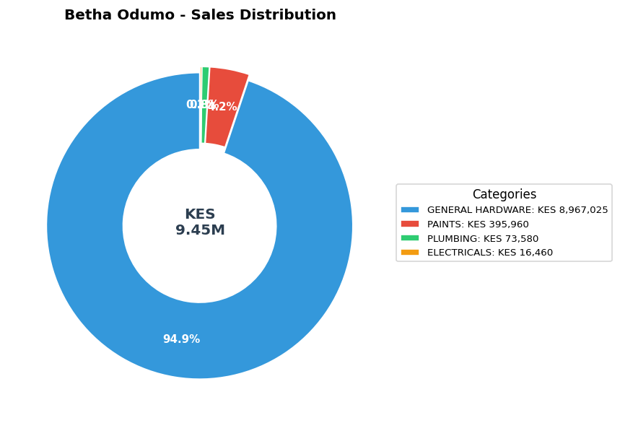
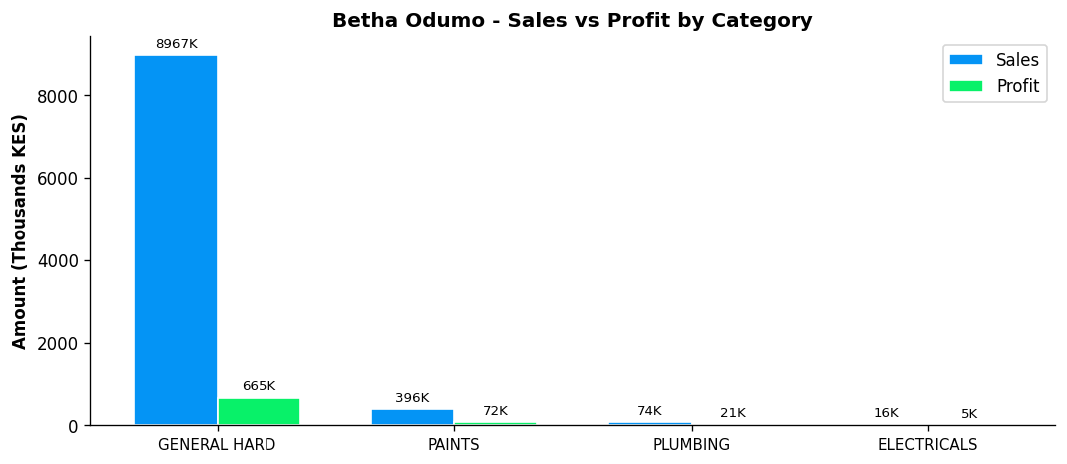

ELIZA — General Hardware Team
📈 MOST IMPROVED
Total Sales | Total Profit | Margin | Items Sold | Rank
KES 8,456,260 | KES 842,095 | 10.0% | 10,636 | #3

Category | Sales | Profit | Margin | Qty
GENERAL HARDWARE | KES 6,742,565 | KES 549,398 | 8.1% | 8,376
PAINTS | KES 1,483,420 | KES 222,538 | 15.0% | 1,236
PLUMBING | KES 180,225 | KES 58,666 | 32.6% | 624
ELECTRICALS | KES 50,050 | KES 11,493 | 23.0% | 400

PERFORMANCE NOTES
- Sales 19% above team average - solid performance
- W1→W2: Steady +13.1% (KES 2,371K → 2,682K)
- W2→W3: Steady +26.9% (KES 2,682K → 3,403K)
- 📈 Consistent upward trend over 3 weeks (+43.6% overall)
- General Hardware: 15.5% of dept, 8.1% margin
- ✓ Selling across all 4 categories - excellent product range
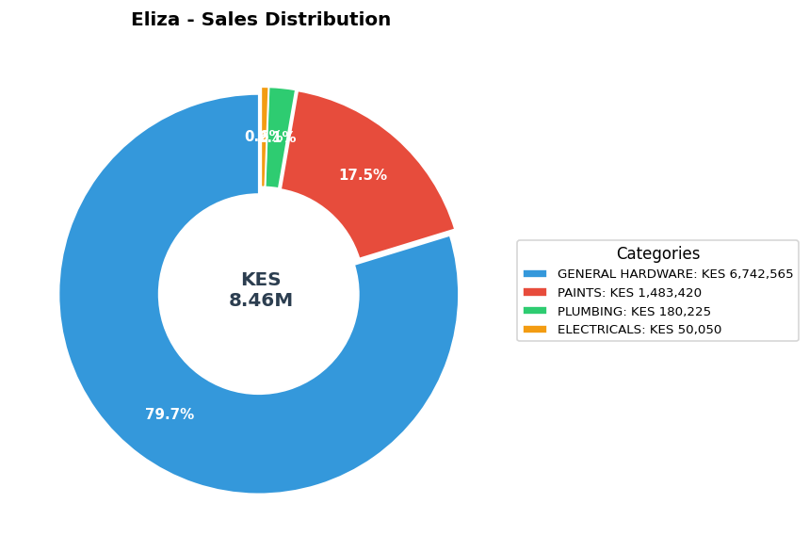
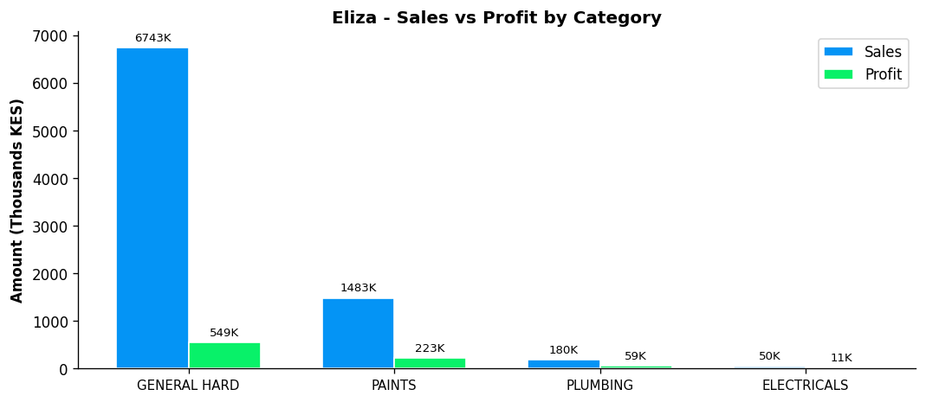

STEPHEN — General Hardware Team
Total Sales | Total Profit | Margin | Items Sold | Rank
KES 4,067,316 | KES 414,349 | 10.2% | 5,683 | #4

Category | Sales | Profit | Margin | Qty
GENERAL HARDWARE | KES 3,589,596 | KES 331,182 | 9.2% | 5,318
PAINTS | KES 266,000 | KES 48,733 | 18.3% | 265
PLUMBING | KES 211,720 | KES 34,434 | 16.3% | 100

PERFORMANCE NOTES
- Sales 43% below team average - needs improvement
- W1→W2: Strong growth +35.0% (KES 1,157K → 1,561K)
- W2→W3: Declined -13.6% (KES 1,561K → 1,349K)
- ⚠️ Week 3 reversal after Week 2 growth - monitor closely
- General Hardware: 8.2% of dept, 9.2% margin
- Consider expanding into ELECTRICALS
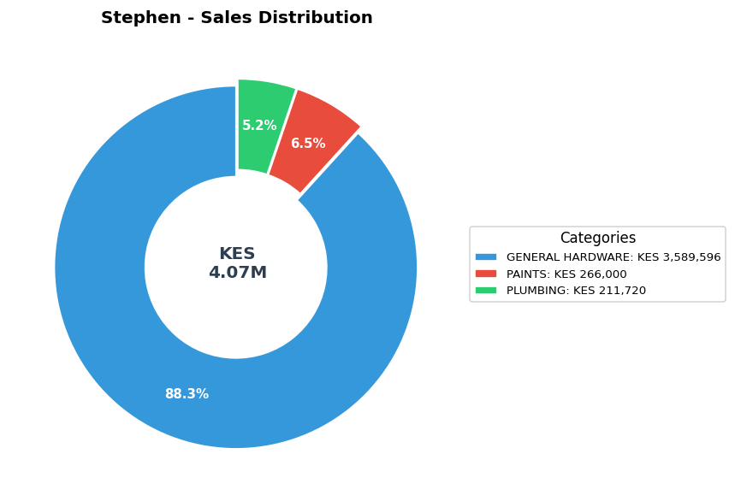
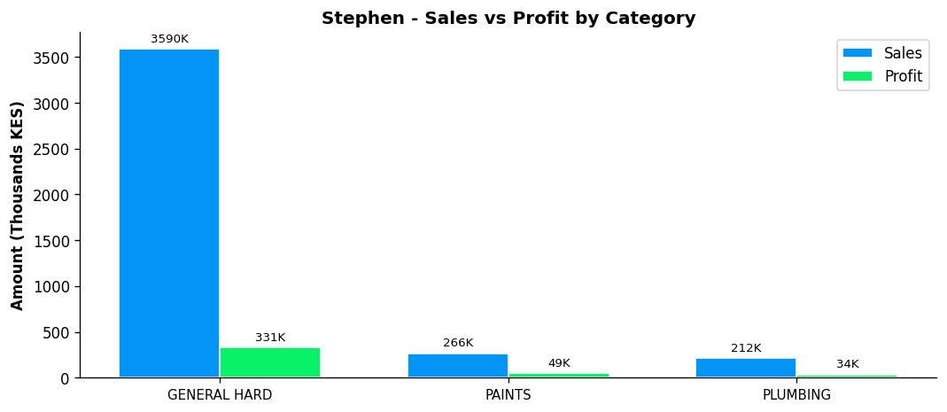

BONFACE MURIU — Department Head - Paints
Total Sales | Total Profit | Margin | Items Sold | Rank
KES 3,948,909 | KES 550,482 | 13.9% | 4,888 | #5

Category | Sales | Profit | Margin | Qty
GENERAL HARDWARE | KES 2,295,609 | KES 246,116 | 10.7% | 3,273
PAINTS | KES 1,535,360 | KES 268,264 | 17.5% | 1,291
PLUMBING | KES 90,750 | KES 23,658 | 26.1% | 218
ELECTRICALS | KES 27,190 | KES 12,443 | 45.8% | 106

PERFORMANCE NOTES
- Sales 44% below team average - needs improvement
- Excellent margin at 13.9% (Team avg: 8.7%)
- W1→W2: Declined -13.9% (KES 1,500K → 1,292K)
- W2→W3: Declined -10.4% (KES 1,292K → 1,158K)
- 📉 Declining trend over 3 weeks (-22.8% overall) - urgent review
- Paints Dept Head: 35.8% of dept sales, 17.5% margin
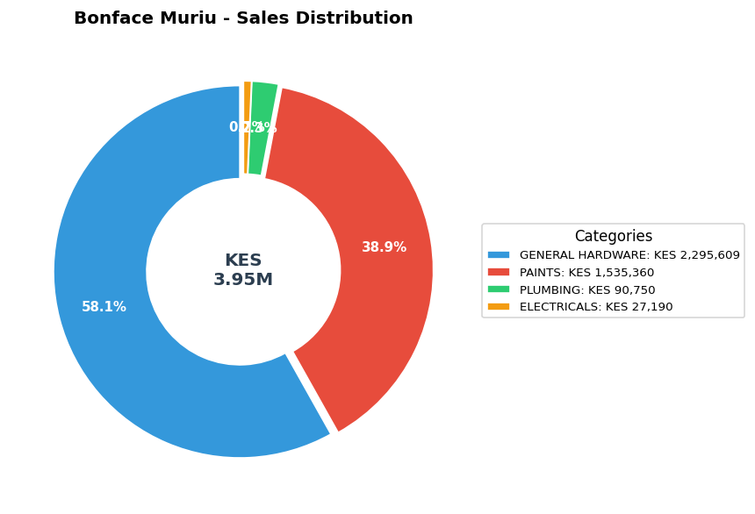
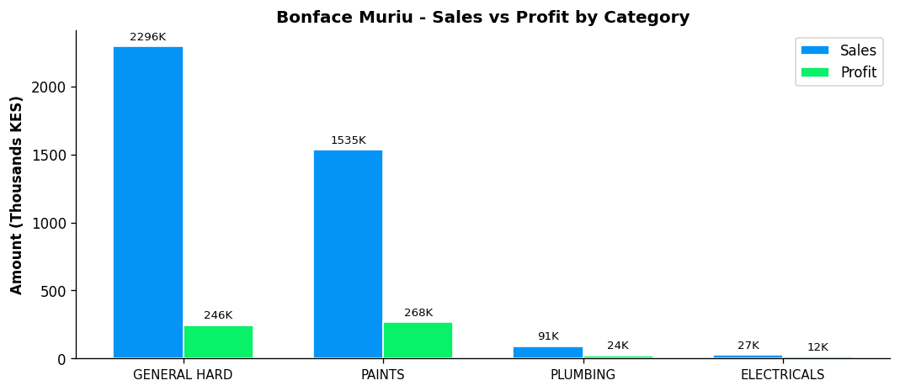

LEWIS — Department Head - Plumbing
💎 BEST MARGIN
Total Sales | Total Profit | Margin | Items Sold | Rank
KES 2,614,482 | KES 373,746 | 14.3% | 4,791 | #6

Category | Sales | Profit | Margin | Qty
GENERAL HARDWARE | KES 1,796,987 | KES 171,440 | 9.5% | 2,485
PAINTS | KES 155,000 | KES 35,624 | 23.0% | 230
PLUMBING | KES 619,610 | KES 158,458 | 25.6% | 1,902
ELECTRICALS | KES 42,885 | KES 8,224 | 19.2% | 174

PERFORMANCE NOTES
- Sales 63% below team average - needs improvement
- Excellent margin at 14.3% (Team avg: 8.7%)
- W1→W2: Strong growth +46.3% (KES 838K → 1,226K)
- W2→W3: Declined -55.0% (KES 1,226K → 551K)
- ⚠️ Week 3 reversal after Week 2 growth - monitor closely
- Plumbing Dept Head: 43.6% of dept sales, 25.6% margin
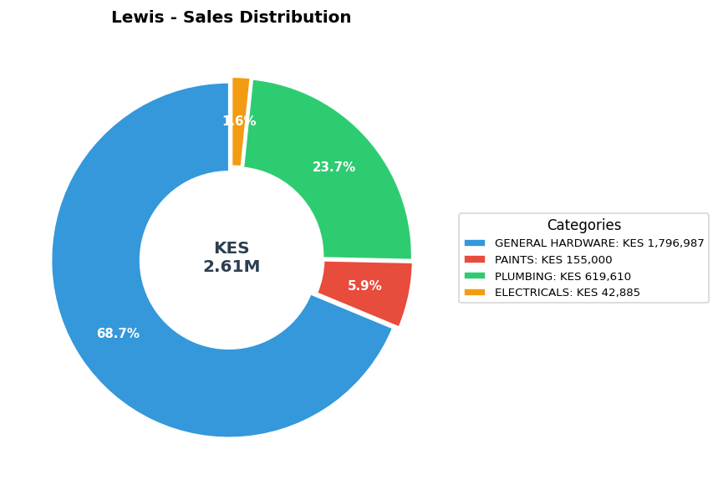
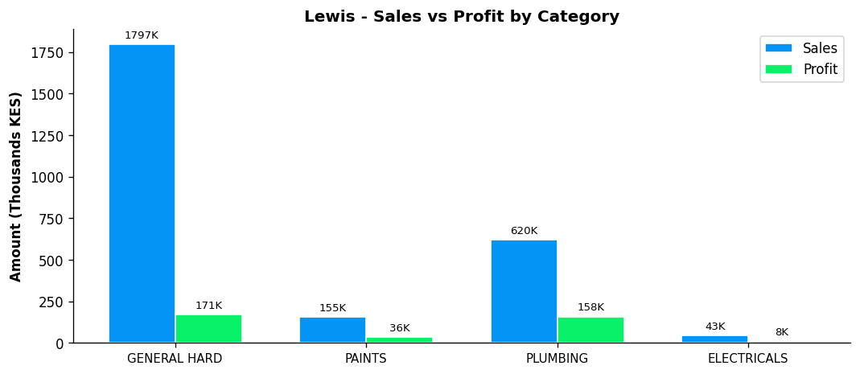

BONFACE KITHEKA — Department Head - Electricals
Total Sales | Total Profit | Margin | Items Sold | Rank
KES 1,790,725 | KES 252,676 | 14.1% | 4,982 | #7

Category | Sales | Profit | Margin | Qty
GENERAL HARDWARE | KES 1,163,052 | KES 119,199 | 10.2% | 1,762
PAINTS | KES 297,736 | KES 48,962 | 16.4% | 388
PLUMBING | KES 143,176 | KES 35,799 | 25.0% | 472
ELECTRICALS | KES 186,761 | KES 48,716 | 26.1% | 2,360

PERFORMANCE NOTES
- Sales 75% below team average - needs improvement
- Excellent margin at 14.1% (Team avg: 8.7%)
- W1→W2: Strong growth +57.8% (KES 487K → 768K)
- W2→W3: Declined -30.2% (KES 768K → 536K)
- ⚠️ Week 3 reversal after Week 2 growth - monitor closely
- Electricals Dept Head: 57.6% of dept sales, 26.1% margin
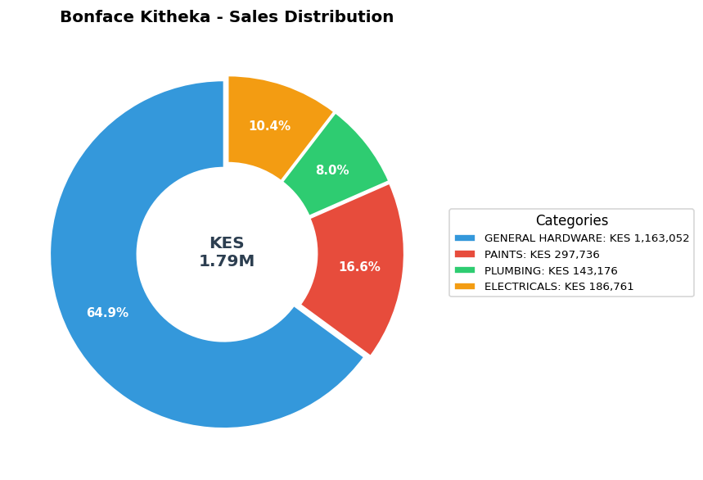
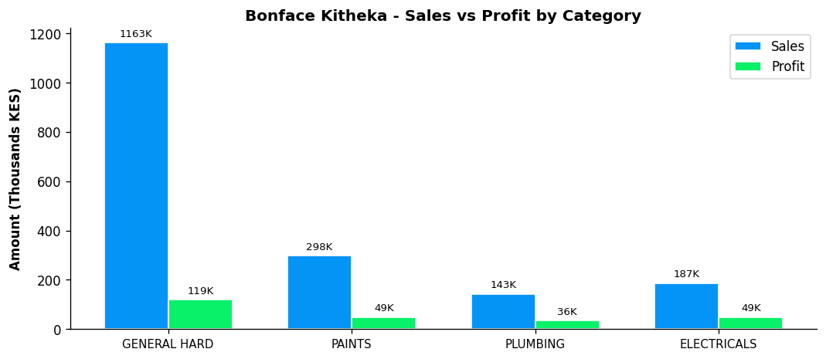

DAILY SALES AVERAGES
Average daily sales per rep across 18 working days (6 days per week × 3 weeks)
Rep | W1 Daily Avg | W2 Daily Avg | W3 Daily Avg | Overall Daily Avg
Gladys | KES 938,564 | KES 1,502,670 | KES 781,936 | KES 1,074,390
Betha Odumo | KES 380,695 | KES 586,671 | KES 608,138 | KES 525,168
Eliza | KES 395,110 | KES 447,066 | KES 567,201 | KES 469,792
Stephen | KES 192,818 | KES 260,246 | KES 224,822 | KES 225,962
Bonface Muriu | KES 249,962 | KES 215,250 | KES 192,940 | KES 219,384
Lewis | KES 139,590 | KES 204,284 | KES 91,873 | KES 145,249
Bonface Kitheka | KES 81,110 | KES 128,023 | KES 89,321 | KES 99,485
TEAM TOTAL | KES 2,377,849 | KES 3,344,210 | KES 2,556,231 | KES 2,759,430

CONCLUSION & RECOMMENDATIONS
- The team has shown modest growth over the 3-week period, with daily sales increasing by 7.5% from Week 1 to Week 3.
- Gladys leads the team with KES 19.34M in total sales (38.9% of team total).
- The overall profit margin of 8.7% is below the 10% target. Focus on higher-margin products.
- The following reps showed significant decline (>15%) in Week 3: Bonface Kitheka, Gladys, Lewis. Individual reviews recommended.
- Strong overall improvement from Betha Odumo, Eliza — up >30% from Week 1 to Week 3.

--- End of Report ---

